# Race: AQU | 2025-02-21 | Race #1 | Track: AQUEDUCT

Track: AQUEDUCT

|  |  |  |  |  |
| --- | --- | --- | --- | --- |
| Saddle Cloth # | Horse Name | Global Speed | Composite | Win Prob (%) |
| 1 | Shop Lifting * | 89.2 | 4.29 | 0.65 |
| 2 | Shirl's Delight * | 89.2 | 6.77 | 4.73 |
| 3 | Wimberly * | 111.3 | 3.28 | 24.39 |
| 4 | Wake Up Lauren * | 104.0 | -3.08 | 0.03 |
| 5 | MUTUALLY EXCLUSIVE * | 98.3 | 7.85 | 70.19 |

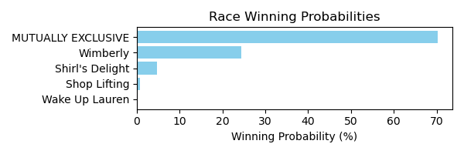

Figure: Winning Probability Distribution

NOTE: THIS RACE HAS HORSES THAT ARE MISSING CRITICAL DATA ELEMENTS

# Race: AQU | 2025-02-21 | Race #2 | Track: AQUEDUCT

Track: AQUEDUCT

|  |  |  |  |  |
| --- | --- | --- | --- | --- |
| Saddle Cloth # | Horse Name | Global Speed | Composite | Win Prob (%) |
| 1 | Whistler's Style * | 104.1 | 0.64 | 0.31 |
| 2 | Pistol Liz Ablazen * | 104.1 | 7.85 | 99.55 |
| 3 | Adeleke * | 82.5 | 1.34 | 0.01 |
| 4 | Willful Desire * | 76.4 | 5.98 | 0.09 |
| 5 | Floge * | 76.4 | 4.55 | 0.03 |
| 6 | Goldcrest * | 82.5 | 1.70 | 0.01 |

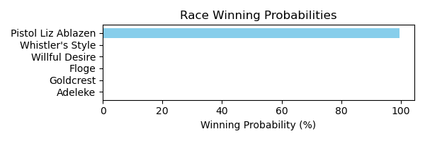

Figure: Winning Probability Distribution

NOTE: THIS RACE HAS HORSES THAT ARE MISSING CRITICAL DATA ELEMENTS

# Race: AQU | 2025-02-21 | Race #3 | Track: AQUEDUCT

Track: AQUEDUCT

|  |  |  |  |  |
| --- | --- | --- | --- | --- |
| Saddle Cloth # | Horse Name | Global Speed | Composite | Win Prob (%) |
| 1 | SMOKEY PLACES * | 92.0 | 3.29 | 99.28 |
| 2 | America's Honor * | 103.9 | -7.28 | 0.23 |
| 3 | Laird of Magnolia * | 103.9 | -8.94 | 0.06 |
| 4 | Nico's Derby Run * | 103.9 | -7.87 | 0.14 |
| 5 | Broderick * | 76.3 | -0.23 | 0.26 |
| 6 | King's Spirit * | 76.3 | -3.17 | 0.02 |

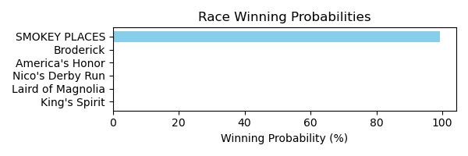

Figure: Winning Probability Distribution

NOTE: THIS RACE HAS HORSES THAT ARE MISSING CRITICAL DATA ELEMENTS

# Race: AQU | 2025-02-21 | Race #4 | Track: AQUEDUCT

Track: AQUEDUCT

|  |  |  |  |  |
| --- | --- | --- | --- | --- |
| Saddle Cloth # | Horse Name | Global Speed | Composite | Win Prob (%) |
| 1 | Taparino * | 103.9 | 6.76 | 67.70 |
| 2 | Solo Empire * | 89.1 | -6.86 | 0.00 |
| 3 | Brown Don't Stop * | 118.1 | 1.51 | 17.46 |
| 4 | D Day Sky * | 118.1 | 1.31 | 14.82 |
| 5 | Big Rich * | 76.3 | -2.41 | 0.00 |
| 6 | Neptune Beach * | 103.9 | -7.99 | 0.00 |
| 7 | Ollie Can Dance * | 103.9 | -3.36 | 0.02 |

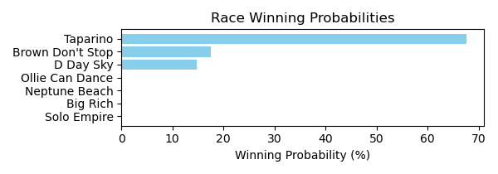

Figure: Winning Probability Distribution

NOTE: THIS RACE HAS HORSES THAT ARE MISSING CRITICAL DATA ELEMENTS

# Race: AQU | 2025-02-21 | Race #5 | Track: AQUEDUCT

Track: AQUEDUCT

|  |  |  |  |  |
| --- | --- | --- | --- | --- |
| Saddle Cloth # | Horse Name | Global Speed | Composite | Win Prob (%) |
| 1 | I See You Lookin * | 89.1 | 3.07 | 22.26 |
| 2 | Zeebear * | 76.3 | 2.42 | 1.02 |
| 3 | Perfect Flight * | 76.3 | 6.04 | 18.46 |
| 4 | Whenlovetakesover * | 76.3 | 3.08 | 1.74 |
| 5 | Aleah Aleah * | 89.1 | 4.22 | 55.93 |
| 6 | Pineapple Man * | 76.3 | 1.51 | 0.49 |
| 7 | King Moonracer * | 89.1 | -3.68 | 0.10 |

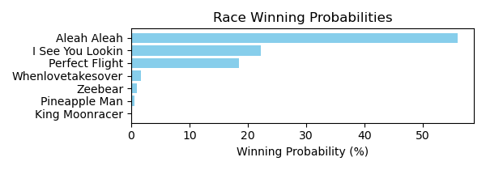

Figure: Winning Probability Distribution

NOTE: THIS RACE HAS HORSES THAT ARE MISSING CRITICAL DATA ELEMENTS

# Race: AQU | 2025-02-21 | Race #6 | Track: AQUEDUCT

Track: AQUEDUCT

|  |  |  |  |  |
| --- | --- | --- | --- | --- |
| Saddle Cloth # | Horse Name | Global Speed | Composite | Win Prob (%) |
| 1 | Stewie * | 76.4 | -7.29 | 0.00 |
| 2 | Abadin * | 89.3 | 3.67 | 0.37 |
| 3 | Courageoous Oh La * | 76.4 | -1.17 | 0.00 |
| 4 | Amundson * | 89.3 | 8.97 | 25.35 |
| 5 | Tetsu * | 104.1 | 6.61 | 74.27 |
| 6 | Mister J T * | 76.4 | -4.30 | 0.00 |
| 7 | Dot's Dollar * | 76.4 | 2.11 | 0.01 |

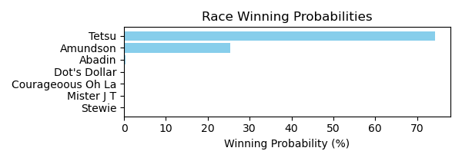

Figure: Winning Probability Distribution

NOTE: THIS RACE HAS HORSES THAT ARE MISSING CRITICAL DATA ELEMENTS

# Race: AQU | 2025-02-21 | Race #7 | Track: AQUEDUCT

Track: AQUEDUCT

|  |  |  |  |  |
| --- | --- | --- | --- | --- |
| Saddle Cloth # | Horse Name | Global Speed | Composite | Win Prob (%) |
| 1 | Scoot Daddy * | 76.6 | -1.13 | 0.00 |
| 2 | Dangerous Ride * | 76.6 | 0.65 | 0.01 |
| 3 | Crazy Mason * | 82.7 | 6.75 | 5.67 |
| 4 | Spun and Won * | 76.6 | -3.35 | 0.00 |
| 5 | Toxic Gray * | 76.6 | 0.95 | 0.02 |
| 6 | Victory Way * | 104.4 | 4.85 | 94.30 |

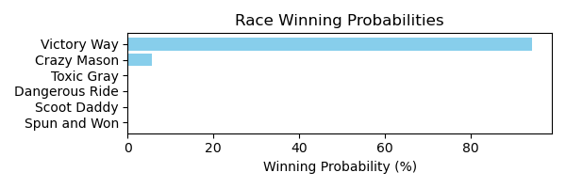

Figure: Winning Probability Distribution

NOTE: THIS RACE HAS HORSES THAT ARE MISSING CRITICAL DATA ELEMENTS

# Race: AQU | 2025-02-21 | Race #8 | Track: AQUEDUCT

Track: AQUEDUCT

|  |  |  |  |  |
| --- | --- | --- | --- | --- |
| Saddle Cloth # | Horse Name | Global Speed | Composite | Win Prob (%) |
| 1 | Have a Cigar * | 103.9 | -3.34 | 0.61 |
| 10 | State Park * | 76.3 | -8.37 | 0.00 |
| 2 | Total Silence * | 82.4 | 2.71 | 1.05 |
| 3 | Kismeholdmethrlme * | 76.3 | -5.94 | 0.00 |
| 4 | TIOTE * | 83.5 | 3.02 | 1.68 |
| 5 | ALZERO * | 83.5 | 3.27 | 2.04 |
| 6 | MO FOR THE KING * | 83.5 | 3.34 | 2.15 |
| 7 | RECURRING REVENUE * | 83.5 | 2.91 | 1.54 |
| 8 | First Pitch * | 76.3 | -9.66 | 0.00 |
| 9 | Grand Cash * | 89.1 | 6.60 | 90.93 |

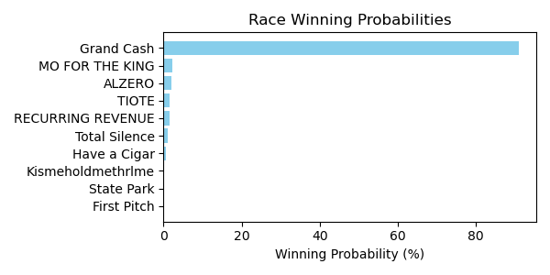

Figure: Winning Probability Distribution

NOTE: THIS RACE HAS HORSES THAT ARE MISSING CRITICAL DATA ELEMENTS

# Race: DED | 2025-02-21 | Race #1 | Track: DELTA DOWNS

Track: DELTA DOWNS

|  |  |  |  |  |
| --- | --- | --- | --- | --- |
| Saddle Cloth # | Horse Name | Global Speed | Composite | Win Prob (%) |
| 1 | Flying I * | 66.5 | -8.33 | 0.00 |
| 10 | Hopeshecanrun * | 66.5 | -3.83 | 0.01 |
| 11 | Moion * | 66.5 | -1.10 | 0.09 |
| 2 | Tarkington Girl * | 66.5 | -5.48 | 0.00 |
| 3 | Destiny's Grace * | 66.5 | -3.97 | 0.01 |
| 4 | Long Shot Louise * | 66.5 | -9.94 | 0.00 |
| 5 | Nownowdancer * | 66.5 | 0.23 | 0.26 |
| 6 | Customerunhappy * | 66.5 | -6.23 | 0.00 |
| 7 | Mydealoftheday * | 66.5 | -4.44 | 0.01 |
| 8 | Saberfight * | 66.5 | 5.47 | 17.49 |
| 9 | La Deal * | 66.5 | 7.41 | 82.13 |

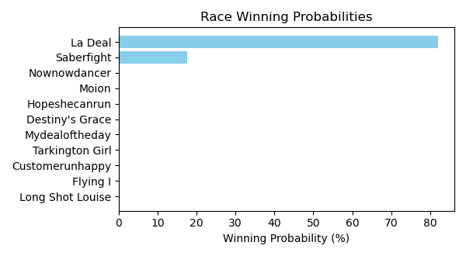

Figure: Winning Probability Distribution

NOTE: THIS RACE HAS HORSES THAT ARE MISSING CRITICAL DATA ELEMENTS

# Race: DED | 2025-02-21 | Race #2 | Track: DELTA DOWNS

Track: DELTA DOWNS

|  |  |  |  |  |
| --- | --- | --- | --- | --- |
| Saddle Cloth # | Horse Name | Global Speed | Composite | Win Prob (%) |
| 1 | So Jordan * | 66.5 | 6.28 | 3.11 |
| 2 | Ocean Jet * | 66.5 | 3.46 | 0.33 |
| 3 | Go Ishla * | 66.5 | 1.43 | 0.06 |
| 4 | Who's Madie * | 66.5 | 4.35 | 0.66 |
| 5 | Kip the Distance * | 66.5 | -3.60 | 0.00 |
| 6 | Lagunera * | 66.5 | 3.75 | 0.41 |
| 7 | Lady Cheryl's Song * | 66.5 | 10.56 | 95.43 |

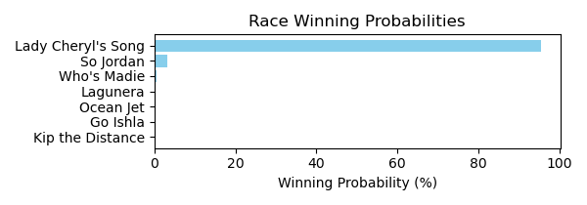

Figure: Winning Probability Distribution

NOTE: THIS RACE HAS HORSES THAT ARE MISSING CRITICAL DATA ELEMENTS

# Race: DED | 2025-02-21 | Race #3 | Track: DELTA DOWNS

Track: DELTA DOWNS

|  |  |  |  |  |
| --- | --- | --- | --- | --- |
| Saddle Cloth # | Horse Name | Global Speed | Composite | Win Prob (%) |
| 1 | Tommie's True * | 89.0 | -4.26 | 0.01 |
| 10 | PISTOL RIDGE KID * | 89.0 | 5.10 | 24.88 |
| 11 | Deelitesandimsum * | 89.0 | 3.38 | 6.24 |
| 12 | Yankeestrolgy * | 89.0 | -5.97 | 0.00 |
| 2 | SAILOR DE ACES * | 89.0 | 5.16 | 26.04 |
| 3 | Real Thrill * | 89.0 | 4.20 | 12.05 |
| 4 | COOL GUITAR * | 89.0 | 5.08 | 24.47 |
| 5 | Ayden's Edge * | 89.0 | -7.74 | 0.00 |
| 6 | My Special Star * | 89.0 | -5.67 | 0.00 |
| 7 | Hold My Hat * | 89.0 | 3.36 | 6.15 |
| 8 | Bella's Boss * | 89.0 | -4.59 | 0.01 |
| 9 | My First Deal * | 89.0 | -1.37 | 0.14 |

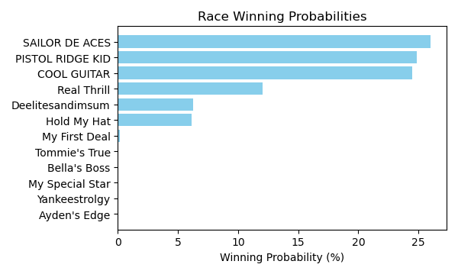

Figure: Winning Probability Distribution

NOTE: THIS RACE HAS HORSES THAT ARE MISSING CRITICAL DATA ELEMENTS

# Race: DED | 2025-02-21 | Race #4 | Track: DELTA DOWNS

Track: DELTA DOWNS

|  |  |  |  |  |
| --- | --- | --- | --- | --- |
| Saddle Cloth # | Horse Name | Global Speed | Composite | Win Prob (%) |
| 1 | Maximus Freedom * | 66.7 | -0.11 | 0.08 |
| 2 | Sharp Charlie * | 66.7 | 5.27 | 5.83 |
| 3 | Alterana * | 66.7 | 3.62 | 1.55 |
| 4 | Guitar Doctor * | 66.7 | -0.92 | 0.04 |
| 5 | Bind Faith * | 66.7 | 2.24 | 0.52 |
| 6 | Prado's Priority * | 66.7 | 8.71 | 91.42 |
| 7 | Matzoh Ball * | 66.7 | -6.84 | 0.00 |
| 8 | Speightful One * | 66.7 | 2.36 | 0.57 |

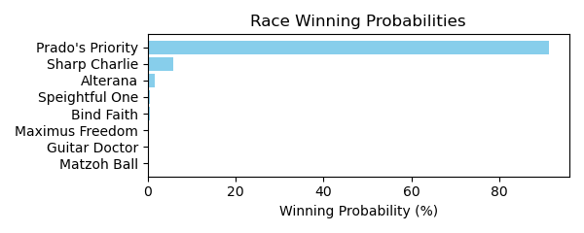

Figure: Winning Probability Distribution

NOTE: THIS RACE HAS HORSES THAT ARE MISSING CRITICAL DATA ELEMENTS

# Race: DED | 2025-02-21 | Race #5 | Track: DELTA DOWNS

Track: DELTA DOWNS

|  |  |  |  |  |
| --- | --- | --- | --- | --- |
| Saddle Cloth # | Horse Name | Global Speed | Composite | Win Prob (%) |
| 1 | Sheer Luck * | 82.0 | 4.50 | 11.67 |
| 10 | Meeting Jenny * | 82.0 | 5.98 | 38.05 |
| 11 | Imperial Assault * | 82.0 | -9.18 | 0.00 |
| 12 | Mopac Traffic * | 82.0 | 2.39 | 2.16 |
| 2 | SHE'S WILD AGAIN * | 82.0 | 3.29 | 4.43 |
| 3 | Laryslittleracer * | 82.0 | 6.02 | 39.48 |
| 4 | SAYYOULOVEMEBABY * | 82.0 | 3.22 | 4.20 |
| 5 | Back Nine * | 82.0 | -7.97 | 0.00 |
| 6 | Acadiana * | 82.0 | -8.88 | 0.00 |
| 7 | Desired Fantasies * | 82.0 | -9.94 | 0.00 |
| 8 | Laoban's Carat * | 82.0 | -6.18 | 0.00 |
| 9 | Whodoyoulikehere * | 82.0 | -7.05 | 0.00 |

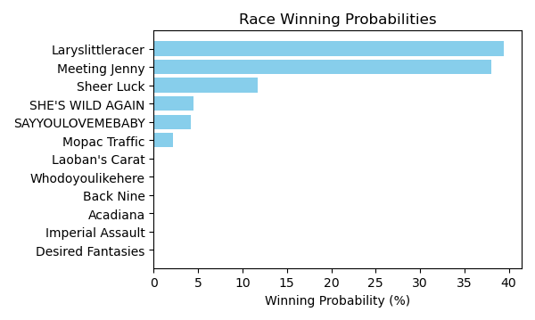

Figure: Winning Probability Distribution

NOTE: THIS RACE HAS HORSES THAT ARE MISSING CRITICAL DATA ELEMENTS

# Race: DED | 2025-02-21 | Race #6 | Track: DELTA DOWNS

Track: DELTA DOWNS

|  |  |  |  |  |
| --- | --- | --- | --- | --- |
| Saddle Cloth # | Horse Name | Global Speed | Composite | Win Prob (%) |
| 1 | The Rage of Art * | 82.5 | -3.93 | 0.07 |
| 10 | Black Ace * | 82.5 | -1.87 | 0.38 |
| 11 | Berlaine * | 82.5 | 2.32 | 10.79 |
| 12 | Blueberry Eyes * | 82.5 | 3.86 | 36.96 |
| 2 | Gee Gee * | 82.5 | 1.52 | 5.69 |
| 3 | Jess's Rainbow * | 82.5 | -5.79 | 0.02 |
| 4 | Eli's Girl * | 82.5 | -4.26 | 0.06 |
| 5 | Czar's Ballerina * | 82.5 | 0.98 | 3.70 |
| 6 | Bold Exaggeration * | 82.5 | -1.29 | 0.60 |
| 7 | Legal Deceiver * | 82.5 | -0.26 | 1.37 |
| 8 | Dr Stricklands Ace * | 82.5 | 3.53 | 28.37 |
| 9 | Be Bo * | 82.5 | 2.45 | 11.99 |

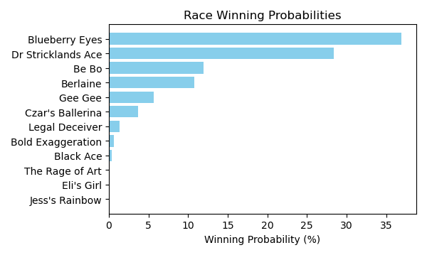

Figure: Winning Probability Distribution

NOTE: THIS RACE HAS HORSES THAT ARE MISSING CRITICAL DATA ELEMENTS

# Race: DED | 2025-02-21 | Race #7 | Track: DELTA DOWNS

Track: DELTA DOWNS

|  |  |  |  |  |
| --- | --- | --- | --- | --- |
| Saddle Cloth # | Horse Name | Global Speed | Composite | Win Prob (%) |
| 1 | Adios Carlos * | 66.6 | -2.13 | 0.01 |
| 10 | Bobby Boy * | 66.6 | -4.55 | 0.00 |
| 11 | Hostile Afleet * | 66.6 | -0.37 | 0.06 |
| 2 | Donna's Court * | 66.6 | -9.03 | 0.00 |
| 3 | Whatta Life * | 66.6 | 8.88 | 89.93 |
| 4 | Oceola * | 66.6 | -4.03 | 0.00 |
| 5 | Skippa * | 66.6 | 3.22 | 0.97 |
| 6 | Slither * | 66.6 | 5.96 | 8.71 |
| 7 | Goldenlute * | 66.6 | -8.40 | 0.00 |
| 8 | Empire Kid * | 66.6 | 1.42 | 0.23 |
| 9 | Half Full * | 66.6 | 0.17 | 0.08 |

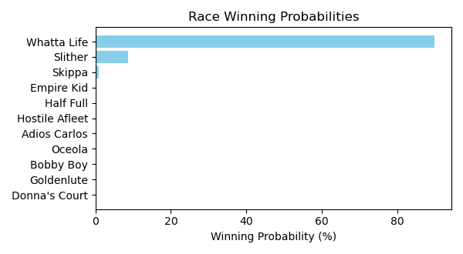

Figure: Winning Probability Distribution

NOTE: THIS RACE HAS HORSES THAT ARE MISSING CRITICAL DATA ELEMENTS

# Race: DED | 2025-02-21 | Race #8 | Track: DELTA DOWNS

Track: DELTA DOWNS

|  |  |  |  |  |
| --- | --- | --- | --- | --- |
| Saddle Cloth # | Horse Name | Global Speed | Composite | Win Prob (%) |
| 1 | Beat the Double * | 88.9 | -3.64 | 0.03 |
| 10 | Awesome Becca * | 88.9 | -1.61 | 0.13 |
| 11 | My Idea * | 88.9 | -6.62 | 0.00 |
| 12 | Gypsy Jackpot * | 88.9 | -8.55 | 0.00 |
| 2 | Sparkle City * | 88.9 | -8.54 | 0.00 |
| 3 | Holiday Double * | 88.9 | -0.17 | 0.42 |
| 4 | Dylan's Dream * | 88.9 | -1.73 | 0.12 |
| 5 | Surrey * | 88.9 | -6.13 | 0.00 |
| 6 | Leucadia * | 88.9 | 6.33 | 76.20 |
| 7 | She's Extra * | 88.9 | 4.76 | 21.61 |
| 8 | Mda Senorita Run * | 88.9 | -5.78 | 0.00 |
| 9 | Merrily Rush * | 88.9 | 1.40 | 1.47 |

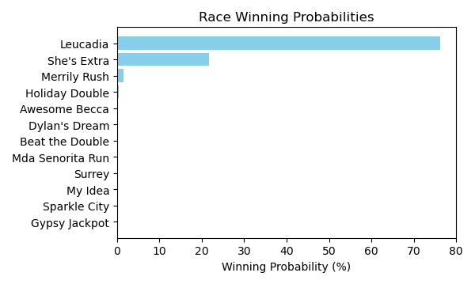

Figure: Winning Probability Distribution

NOTE: THIS RACE HAS HORSES THAT ARE MISSING CRITICAL DATA ELEMENTS

# Race: DED | 2025-02-21 | Race #9 | Track: DELTA DOWNS

Track: DELTA DOWNS

|  |  |  |  |  |
| --- | --- | --- | --- | --- |
| Saddle Cloth # | Horse Name | Global Speed | Composite | Win Prob (%) |
| 1 | Prettywell Stacked * | 82.4 | 2.06 | 0.89 |
| 2 | Good N Sassy * | 82.4 | -7.56 | 0.00 |
| 3 | Overcast * | 82.4 | -1.55 | 0.05 |
| 4 | Get Ready Gal * | 82.4 | 7.86 | 91.94 |
| 5 | Lord Harmony * | 82.4 | 3.27 | 2.33 |
| 6 | Double Cute * | 82.4 | 1.60 | 0.61 |
| 7 | La Palabra * | 82.4 | 1.10 | 0.41 |
| 8 | Bayou Chick * | 82.4 | 3.85 | 3.72 |
| 9 | Congratulera * | 82.4 | -1.76 | 0.04 |

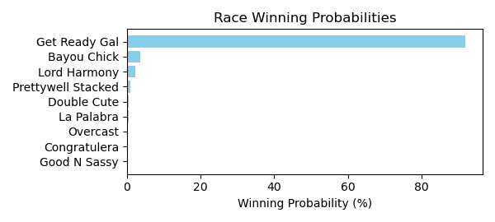

Figure: Winning Probability Distribution

NOTE: THIS RACE HAS HORSES THAT ARE MISSING CRITICAL DATA ELEMENTS

# Race: DED | 2025-02-21 | Race #10 | Track: DELTA DOWNS

Track: DELTA DOWNS

|  |  |  |  |  |
| --- | --- | --- | --- | --- |
| Saddle Cloth # | Horse Name | Global Speed | Composite | Win Prob (%) |
| 1 | Cat County * | 82.2 | 7.95 | 63.00 |
| 10 | Wicked Punches * | 82.2 | -5.36 | 0.00 |
| 11 | C F Cantgoforthat * | 82.2 | -9.35 | 0.00 |
| 12 | Zestiny * | 82.2 | -5.77 | 0.00 |
| 2 | Texoma * | 82.2 | 7.27 | 36.72 |
| 3 | Kah Nigh * | 82.2 | -6.07 | 0.00 |
| 4 | Hay Lover Boy * | 82.2 | -8.45 | 0.00 |
| 5 | Beaudean * | 82.2 | -2.23 | 0.02 |
| 6 | Baby Zong * | 82.2 | 0.88 | 0.22 |
| 7 | Scallywag * | 82.2 | -2.18 | 0.02 |
| 8 | Island Cabana * | 82.2 | -2.03 | 0.02 |
| 9 | Embrace My Heart * | 82.2 | -9.72 | 0.00 |

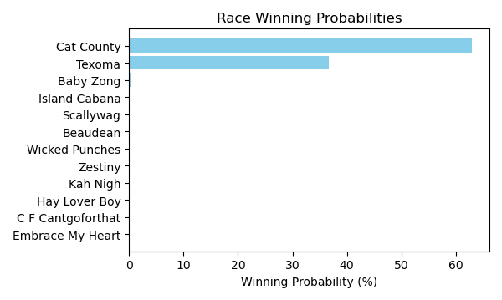

Figure: Winning Probability Distribution

NOTE: THIS RACE HAS HORSES THAT ARE MISSING CRITICAL DATA ELEMENTS

# Race: DED | 2025-02-22 | Race #1 | Track: DELTA DOWNS

Track: DELTA DOWNS

|  |  |  |  |  |
| --- | --- | --- | --- | --- |
| Saddle Cloth # | Horse Name | Global Speed | Composite | Win Prob (%) |
| 1 | Baby Jane * | 88.8 | -0.14 | 0.32 |
| 10 | My Idea * | 88.8 | -4.95 | 0.01 |
| 11 | Wings Like Eagles * | 88.8 | 6.77 | 80.01 |
| 12 | Costa Lady * | 88.8 | -3.38 | 0.02 |
| 2 | Dr. Boo * | 88.8 | -7.66 | 0.00 |
| 3 | World of Hurt * | 88.8 | -2.75 | 0.04 |
| 4 | Gypsy Jackpot * | 88.8 | -7.43 | 0.00 |
| 5 | She's the Sheriff * | 88.8 | -9.69 | 0.00 |
| 6 | Charged Up Rose * | 88.8 | -9.48 | 0.00 |
| 7 | Beulah K * | 88.8 | -5.42 | 0.00 |
| 8 | High Donna * | 88.8 | 4.86 | 17.40 |
| 9 | Coal Dancer * | 88.8 | 2.28 | 2.20 |

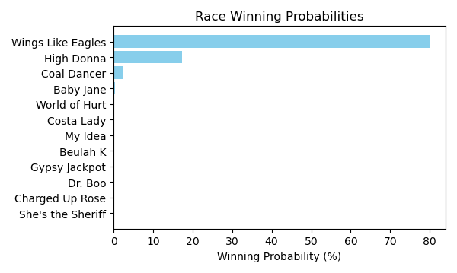

Figure: Winning Probability Distribution

NOTE: THIS RACE HAS HORSES THAT ARE MISSING CRITICAL DATA ELEMENTS

# Race: DED | 2025-02-22 | Race #2 | Track: DELTA DOWNS

Track: DELTA DOWNS

|  |  |  |  |  |
| --- | --- | --- | --- | --- |
| Saddle Cloth # | Horse Name | Global Speed | Composite | Win Prob (%) |
| 1 | Moor to Conquer * | 82.0 | -1.11 | 0.01 |
| 2 | Unaffiliated * | 82.0 | 8.50 | 24.33 |
| 3 | UNION CARD * | 82.0 | 9.08 | 38.83 |
| 4 | Wabash * | 82.0 | 4.71 | 1.17 |
| 5 | Olympia Harbor * | 82.0 | -5.43 | 0.00 |
| 6 | LEMON FIZZ * | 82.0 | 8.93 | 34.38 |
| 7 | Simplicated * | 82.0 | 4.81 | 1.27 |

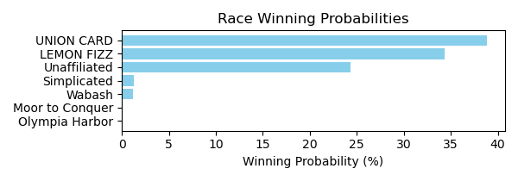

Figure: Winning Probability Distribution

NOTE: THIS RACE HAS HORSES THAT ARE MISSING CRITICAL DATA ELEMENTS

# Race: DED | 2025-02-22 | Race #3 | Track: DELTA DOWNS

Track: DELTA DOWNS

|  |  |  |  |  |
| --- | --- | --- | --- | --- |
| Saddle Cloth # | Horse Name | Global Speed | Composite | Win Prob (%) |
| 1 | ZANTERIA * | 88.9 | 4.01 | 8.30 |
| 10 | Thats Unbelievable * | 88.9 | -1.28 | 0.12 |
| 2 | Mopac Traffic * | 88.9 | -2.69 | 0.04 |
| 3 | Dreamchaser Jewels * | 88.9 | -3.66 | 0.02 |
| 4 | Kalil * | 88.9 | 6.78 | 76.07 |
| 5 | Wicked Sailor * | 88.9 | 0.32 | 0.43 |
| 6 | Platinumus Maximus * | 88.9 | -0.67 | 0.20 |
| 7 | Tizzira * | 88.9 | -8.47 | 0.00 |
| 8 | Frisee * | 88.9 | -7.88 | 0.00 |
| 9 | Cc Cola * | 88.9 | 4.74 | 14.82 |

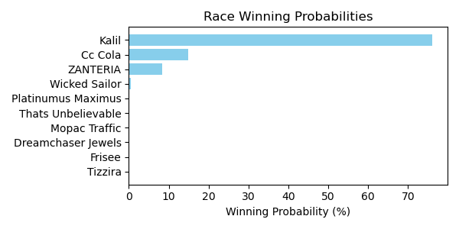

Figure: Winning Probability Distribution

NOTE: THIS RACE HAS HORSES THAT ARE MISSING CRITICAL DATA ELEMENTS

# Race: DED | 2025-02-22 | Race #4 | Track: DELTA DOWNS

Track: DELTA DOWNS

|  |  |  |  |  |
| --- | --- | --- | --- | --- |
| Saddle Cloth # | Horse Name | Global Speed | Composite | Win Prob (%) |
| 1 | The Donegal Clan * | 104.5 | 1.49 | 0.20 |
| 2 | Without a Trace * | 104.5 | 2.62 | 0.50 |
| 3 | Iron in the Fire * | 104.5 | 7.74 | 30.10 |
| 4 | Uxmal * | 104.5 | 5.50 | 5.00 |
| 5 | All About Croge * | 104.5 | -7.23 | 0.00 |
| 6 | Brite Outlook * | 104.5 | 7.29 | 20.98 |
| 7 | Special Stormy * | 104.5 | 6.88 | 15.12 |
| 8 | Unified Dreams * | 104.5 | 7.66 | 28.09 |

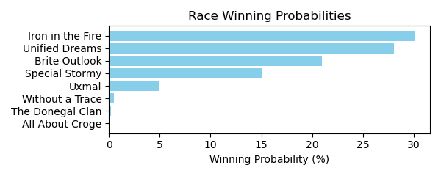

Figure: Winning Probability Distribution

NOTE: THIS RACE HAS HORSES THAT ARE MISSING CRITICAL DATA ELEMENTS

# Race: DED | 2025-02-22 | Race #5 | Track: DELTA DOWNS

Track: DELTA DOWNS

|  |  |  |  |  |
| --- | --- | --- | --- | --- |
| Saddle Cloth # | Horse Name | Global Speed | Composite | Win Prob (%) |
| 1 | G E H Giants Way * | 66.5 | -6.09 | 0.00 |
| 10 | Catalina Day * | 66.5 | -3.97 | 0.01 |
| 2 | Love a Fighter * | 66.5 | -8.96 | 0.00 |
| 3 | Vobiscum * | 66.5 | 7.57 | 92.51 |
| 4 | Baby's Last Dance * | 66.5 | -9.66 | 0.00 |
| 5 | Quick Zong * | 66.5 | -7.56 | 0.00 |
| 6 | True and Ready * | 66.5 | 2.33 | 1.40 |
| 7 | Tiz Fabulous * | 66.5 | 1.34 | 0.63 |
| 8 | Top Priority * | 66.5 | 2.26 | 1.32 |
| 9 | Relic Hunter * | 66.5 | 3.68 | 4.12 |

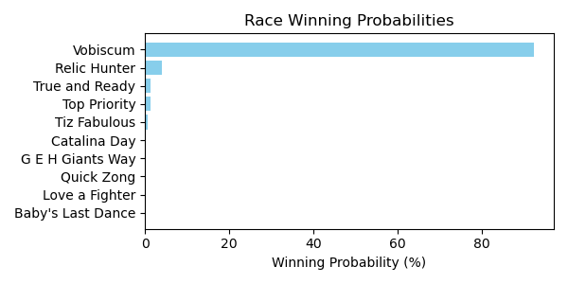

Figure: Winning Probability Distribution

NOTE: THIS RACE HAS HORSES THAT ARE MISSING CRITICAL DATA ELEMENTS

# Race: DED | 2025-02-22 | Race #6 | Track: DELTA DOWNS

Track: DELTA DOWNS

|  |  |  |  |  |
| --- | --- | --- | --- | --- |
| Saddle Cloth # | Horse Name | Global Speed | Composite | Win Prob (%) |
| 1 | New Destiny * | 111.6 | -5.78 | 0.00 |
| 10 | Northernreflection * | 111.6 | 5.01 | 1.72 |
| 11 | Guitar Boy * | 111.6 | 5.00 | 1.71 |
| 12 | Rockall * | 111.6 | 2.77 | 0.29 |
| 2 | Butler Cabin * | 111.6 | 4.63 | 1.27 |
| 3 | My Uncle Leon * | 111.6 | 10.02 | 94.79 |
| 4 | Confucius * | 111.6 | -0.25 | 0.03 |
| 5 | Cajun Mischief * | 111.6 | -2.06 | 0.01 |
| 6 | Sonneman * | 111.6 | 1.96 | 0.15 |
| 7 | Into Wishing * | 111.6 | -2.71 | 0.00 |
| 8 | Bayou Jam * | 111.6 | 0.47 | 0.05 |
| 9 | Dare to Fail * | 111.6 | -7.18 | 0.00 |

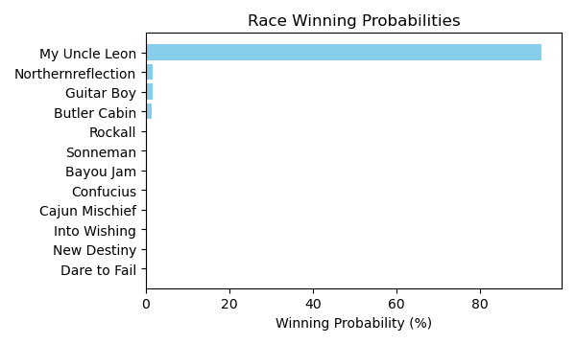

Figure: Winning Probability Distribution

NOTE: THIS RACE HAS HORSES THAT ARE MISSING CRITICAL DATA ELEMENTS

# Race: DED | 2025-02-22 | Race #7 | Track: DELTA DOWNS

Track: DELTA DOWNS

|  |  |  |  |  |
| --- | --- | --- | --- | --- |
| Saddle Cloth # | Horse Name | Global Speed | Composite | Win Prob (%) |
| 1 | Tap to Connect * | 88.9 | 8.15 | 50.32 |
| 10 | Nephi * | 88.9 | 3.06 | 0.86 |
| 11 | F J's Flaco * | 88.9 | 2.63 | 0.61 |
| 12 | Bobby Merlot * | 88.9 | -2.31 | 0.01 |
| 2 | Aller Vite * | 88.9 | -0.11 | 0.07 |
| 3 | Out Making Treble * | 88.9 | -5.30 | 0.00 |
| 4 | Roulette * | 88.9 | 1.65 | 0.28 |
| 5 | Cowboy Cause * | 88.9 | 7.54 | 30.92 |
| 6 | Classy Shipman * | 88.9 | -2.62 | 0.01 |
| 7 | All Saints * | 88.9 | 6.79 | 16.93 |
| 8 | Saucy Argument * | 88.9 | -5.53 | 0.00 |
| 9 | Gloria's Boy * | 88.9 | -7.64 | 0.00 |

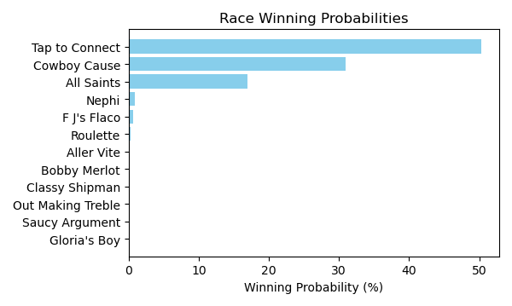

Figure: Winning Probability Distribution

NOTE: THIS RACE HAS HORSES THAT ARE MISSING CRITICAL DATA ELEMENTS

# Race: DED | 2025-02-22 | Race #8 | Track: DELTA DOWNS

Track: DELTA DOWNS

|  |  |  |  |  |
| --- | --- | --- | --- | --- |
| Saddle Cloth # | Horse Name | Global Speed | Composite | Win Prob (%) |
| 1 | Eagle Point * | 96.1 | -2.97 | 0.01 |
| 10 | FLINT'S SPARKY * | 96.1 | 5.84 | 8.13 |
| 11 | C F Jimmy Ray * | 96.1 | -1.23 | 0.03 |
| 12 | Prince Perfecta * | 96.1 | 5.38 | 5.62 |
| 2 | Mischievous Smile * | 96.1 | 1.29 | 0.21 |
| 3 | North of Bali * | 96.1 | 7.45 | 29.51 |
| 4 | After the Game * | 96.1 | 0.32 | 0.10 |
| 5 | M L Brody's Gem * | 96.1 | 3.41 | 1.16 |
| 6 | BARR'S BAY * | 96.1 | 5.82 | 8.01 |
| 7 | Steen * | 96.1 | -7.39 | 0.00 |
| 8 | Mariachi Man * | 96.1 | 8.04 | 47.23 |
| 9 | Zestiny * | 96.1 | -4.40 | 0.00 |

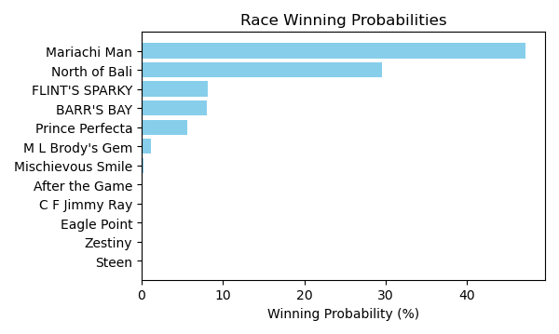

Figure: Winning Probability Distribution

NOTE: THIS RACE HAS HORSES THAT ARE MISSING CRITICAL DATA ELEMENTS

# Race: DED | 2025-02-22 | Race #9 | Track: DELTA DOWNS

Track: DELTA DOWNS

|  |  |  |  |  |
| --- | --- | --- | --- | --- |
| Saddle Cloth # | Horse Name | Global Speed | Composite | Win Prob (%) |
| 1 | Chad's Flashy Ways * | 82.4 | 8.19 | 5.96 |
| 10 | Koodie * | 82.4 | -0.96 | 0.00 |
| 11 | Gabbys Bling * | 82.4 | -2.42 | 0.00 |
| 12 | Gray Dane * | 82.4 | 0.48 | 0.01 |
| 2 | El Dan * | 82.4 | 7.64 | 3.84 |
| 3 | Connectique * | 82.4 | 1.62 | 0.03 |
| 4 | Majestic Palace * | 82.4 | 1.47 | 0.03 |
| 5 | Same Play * | 82.4 | -1.96 | 0.00 |
| 6 | Pennys Deal * | 82.4 | -3.95 | 0.00 |
| 7 | Tincan Cat * | 82.4 | -0.53 | 0.01 |
| 8 | Majority Opinion * | 82.4 | 6.02 | 1.05 |
| 9 | Country Hit * | 82.4 | 11.57 | 89.07 |

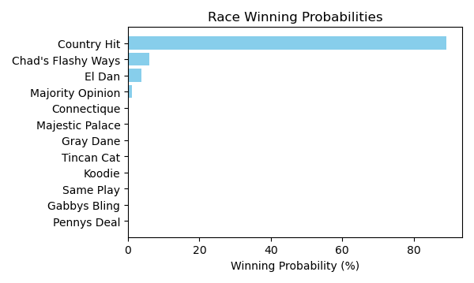

Figure: Winning Probability Distribution

NOTE: THIS RACE HAS HORSES THAT ARE MISSING CRITICAL DATA ELEMENTS

# Race: DED | 2025-02-22 | Race #10 | Track: DELTA DOWNS

Track: DELTA DOWNS

|  |  |  |  |  |
| --- | --- | --- | --- | --- |
| Saddle Cloth # | Horse Name | Global Speed | Composite | Win Prob (%) |
| 1 | Crusin Like a Cat * | 66.6 | 2.10 | 0.98 |
| 2 | Cajun Catalina * | 66.6 | 4.96 | 9.64 |
| 3 | Ironit * | 66.6 | -9.75 | 0.00 |
| 4 | Usain d'Oro * | 66.6 | 7.44 | 69.80 |
| 5 | Fitzy * | 66.6 | 5.13 | 11.02 |
| 6 | Myfriendsawinner * | 66.6 | 2.72 | 1.60 |
| 7 | Country Lady * | 66.6 | -2.09 | 0.03 |
| 8 | Custom Sunshine * | 66.6 | 4.16 | 5.08 |
| 9 | Miss Dealority * | 66.6 | 2.89 | 1.84 |

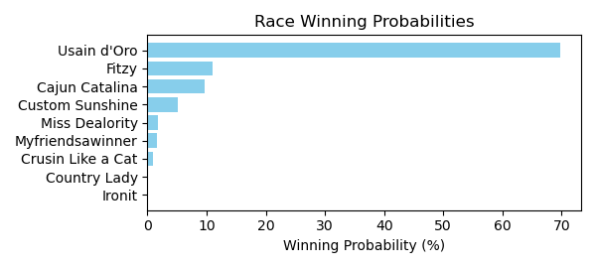

Figure: Winning Probability Distribution

NOTE: THIS RACE HAS HORSES THAT ARE MISSING CRITICAL DATA ELEMENTS

# Race: DED | 2025-02-22 | Race #11 | Track: DELTA DOWNS

Track: DELTA DOWNS

|  |  |  |  |  |
| --- | --- | --- | --- | --- |
| Saddle Cloth # | Horse Name | Global Speed | Composite | Win Prob (%) |
| 1 | Hard Candy Kisses * | 82.1 | 3.80 | 9.16 |
| 10 | Miss Gypsy * | 82.1 | -3.13 | 0.04 |
| 11 | Chimes Lake * | 82.1 | -10.29 | 0.00 |
| 2 | Surprise Sunrise * | 82.1 | -2.32 | 0.07 |
| 3 | Cat Ate the Canary * | 82.1 | -2.38 | 0.06 |
| 4 | Break Out Sister * | 82.1 | -8.03 | 0.00 |
| 5 | Tiz a Breakup * | 82.1 | 1.98 | 2.12 |
| 6 | Brand Bois * | 82.1 | -7.09 | 0.00 |
| 7 | Taka * | 82.1 | 6.61 | 86.37 |
| 8 | Round in Circles * | 82.1 | 2.00 | 2.17 |
| 9 | Abbey Cakes * | 82.1 | -8.91 | 0.00 |

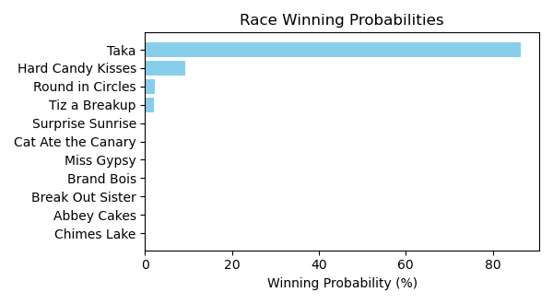

Figure: Winning Probability Distribution

NOTE: THIS RACE HAS HORSES THAT ARE MISSING CRITICAL DATA ELEMENTS

# Race: TFG | 2025-02-21 | Race #1 | Track: FAIR GROUNDS

Track: FAIR GROUNDS

|  |  |  |  |  |
| --- | --- | --- | --- | --- |
| Saddle Cloth # | Horse Name | Global Speed | Composite | Win Prob (%) |
| 1 | Kinsman Redeemer * | 76.2 | 8.56 | 73.09 |
| 2 | Metronome * | 76.2 | -1.67 | 0.02 |
| 3 | Knock'em Out Jerry * | 76.2 | 7.29 | 26.41 |
| 4 | C F Cantgoforthat * | 76.2 | -9.66 | 0.00 |
| 5 | Wholeheartedly * | 76.2 | 2.02 | 0.39 |
| 6 | Tamashi * | 76.2 | -7.88 | 0.00 |
| 7 | Ragnow * | 76.2 | 0.14 | 0.09 |

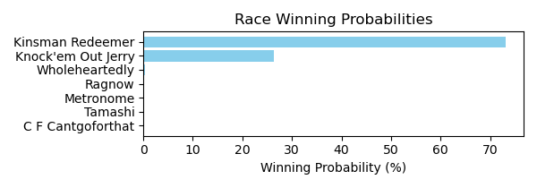

Figure: Winning Probability Distribution

NOTE: THIS RACE HAS HORSES THAT ARE MISSING CRITICAL DATA ELEMENTS

# Race: TFG | 2025-02-21 | Race #2 | Track: FAIR GROUNDS

Track: FAIR GROUNDS

|  |  |  |  |  |
| --- | --- | --- | --- | --- |
| Saddle Cloth # | Horse Name | Global Speed | Composite | Win Prob (%) |
| 1 | Call My Banker * | 76.5 | 10.35 | 68.83 |
| 2 | Peso in My Pocket * | 76.5 | 7.38 | 6.40 |
| 3 | Notion * | 76.5 | 4.32 | 0.55 |
| 4 | Scooteranddabigman * | 76.5 | 5.55 | 1.49 |
| 5 | Oncoming Train * | 76.5 | -5.89 | 0.00 |
| 6 | Global Pride * | 76.5 | 8.95 | 22.52 |
| 7 | Cryptozonic * | 76.5 | 3.06 | 0.20 |
| 8 | Twirling Roses * | 76.5 | -1.27 | 0.01 |

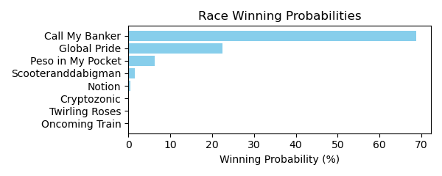

Figure: Winning Probability Distribution

NOTE: THIS RACE HAS HORSES THAT ARE MISSING CRITICAL DATA ELEMENTS

# Race: TFG | 2025-02-21 | Race #3 | Track: FAIR GROUNDS

Track: FAIR GROUNDS

|  |  |  |  |  |
| --- | --- | --- | --- | --- |
| Saddle Cloth # | Horse Name | Global Speed | Composite | Win Prob (%) |
| 1 | Kazillion * | 96.4 | -5.32 | 0.11 |
| 10 | Promdatebonnie * | 96.4 | -4.08 | 0.29 |
| 2 | Cheval B * | 96.4 | 0.49 | 11.15 |
| 3 | Star Anise * | 96.4 | 1.84 | 32.83 |
| 4 | Lynna * | 96.4 | -7.75 | 0.02 |
| 5 | Ash Wednesday * | 96.4 | 2.49 | 55.45 |
| 6 | Wayzata * | 96.4 | -5.51 | 0.09 |
| 7 | Daring Hope * | 96.4 | -6.46 | 0.04 |
| 8 | Mischief Lily * | 96.4 | -7.41 | 0.02 |
| 9 | Trust Fund Baby * | 96.4 | -10.17 | 0.00 |

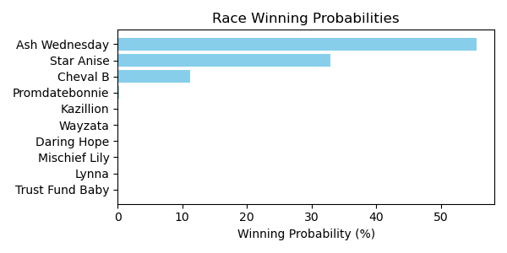

Figure: Winning Probability Distribution

NOTE: THIS RACE HAS HORSES THAT ARE MISSING CRITICAL DATA ELEMENTS

# Race: TFG | 2025-02-21 | Race #4 | Track: FAIR GROUNDS

Track: FAIR GROUNDS

|  |  |  |  |  |
| --- | --- | --- | --- | --- |
| Saddle Cloth # | Horse Name | Global Speed | Composite | Win Prob (%) |
| 1 | Cairo Charm * | 76.2 | -9.87 | 0.00 |
| 10 | Radiant Rebel * | 76.2 | 6.49 | 23.58 |
| 11 | Mia Antonia * | 76.2 | 3.27 | 1.79 |
| 2 | Wannawholelottaluv * | 76.2 | -6.13 | 0.00 |
| 3 | Copper Crush * | 76.2 | -7.11 | 0.00 |
| 4 | Aspen Link * | 76.2 | -3.32 | 0.01 |
| 5 | Honor His Half * | 76.2 | -3.27 | 0.01 |
| 6 | Runtolive * | 76.2 | -4.55 | 0.00 |
| 7 | Dreamy Deal * | 76.2 | -5.26 | 0.00 |
| 8 | Sassy Spry * | 76.2 | 7.68 | 61.11 |
| 9 | Mika Ella Pika * | 76.2 | 5.79 | 13.49 |

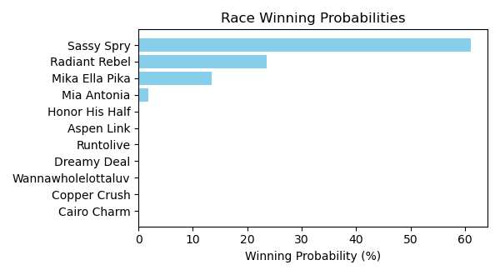

Figure: Winning Probability Distribution

NOTE: THIS RACE HAS HORSES THAT ARE MISSING CRITICAL DATA ELEMENTS

# Race: TFG | 2025-02-21 | Race #5 | Track: FAIR GROUNDS

Track: FAIR GROUNDS

|  |  |  |  |  |
| --- | --- | --- | --- | --- |
| Saddle Cloth # | Horse Name | Global Speed | Composite | Win Prob (%) |
| 1 | Just Jimmy * | 104.3 | -1.63 | 0.03 |
| 10 | Gentle Soul * | 104.3 | 6.77 | 28.51 |
| 2 | Bourbon Life * | 104.3 | -1.80 | 0.03 |
| 3 | Battle Scars * | 104.3 | 2.17 | 0.72 |
| 4 | Sivako * | 104.3 | 5.06 | 7.24 |
| 5 | Optimus Kat * | 104.3 | 7.55 | 53.01 |
| 6 | Rowdy Jess * | 104.3 | -8.89 | 0.00 |
| 7 | South Side * | 104.3 | 5.34 | 9.09 |
| 8 | Clarestown * | 104.3 | 2.97 | 1.36 |
| 9 | Prowling Tiger * | 104.3 | -3.68 | 0.01 |

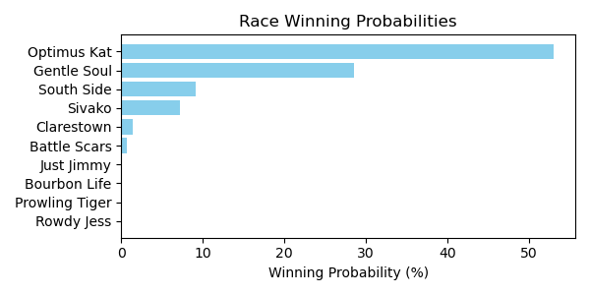

Figure: Winning Probability Distribution

NOTE: THIS RACE HAS HORSES THAT ARE MISSING CRITICAL DATA ELEMENTS

# Race: TFG | 2025-02-21 | Race #6 | Track: FAIR GROUNDS

Track: FAIR GROUNDS

|  |  |  |  |  |
| --- | --- | --- | --- | --- |
| Saddle Cloth # | Horse Name | Global Speed | Composite | Win Prob (%) |
| 1 | Hesper * | 71.2 | 4.18 | 2.54 |
| 2 | Hawija * | 71.2 | 8.60 | 86.79 |
| 3 | Classic Time * | 71.2 | -1.19 | 0.03 |
| 4 | Gabbys Bling * | 71.2 | -3.63 | 0.00 |
| 5 | Pair of Socks * | 71.2 | 5.17 | 5.62 |
| 6 | Voila Magic * | 71.2 | 4.95 | 4.71 |
| 7 | Distinctly Golden * | 71.2 | 1.51 | 0.30 |

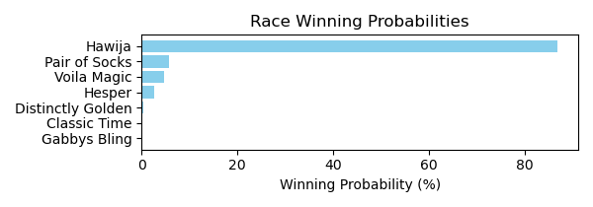

Figure: Winning Probability Distribution

NOTE: THIS RACE HAS HORSES THAT ARE MISSING CRITICAL DATA ELEMENTS

# Race: TFG | 2025-02-21 | Race #7 | Track: FAIR GROUNDS

Track: FAIR GROUNDS

|  |  |  |  |  |
| --- | --- | --- | --- | --- |
| Saddle Cloth # | Horse Name | Global Speed | Composite | Win Prob (%) |
| 1 | Rampagius * | 111.5 | 2.97 | 0.92 |
| 10 | Tickled Quist * | 111.5 | -1.10 | 0.04 |
| 11 | THE COMMACK KID * | 111.5 | 6.93 | 21.92 |
| 12 | Pretty Capable * | 111.5 | 5.92 | 9.77 |
| 13 | Global Quote * | 111.5 | -3.52 | 0.01 |
| 2 | King Rosso * | 111.5 | 6.92 | 21.69 |
| 3 | Seaville * | 111.5 | -4.16 | 0.00 |
| 4 | Elko County * | 111.5 | -0.18 | 0.07 |
| 5 | El Magnifico * | 111.5 | 7.58 | 36.64 |
| 6 | English Chunnel * | 111.5 | 5.76 | 8.60 |
| 7 | Hard Par * | 111.5 | -5.78 | 0.00 |
| 8 | Finn McSorley * | 111.5 | -4.82 | 0.00 |
| 9 | Initialize * | 111.5 | 1.72 | 0.34 |

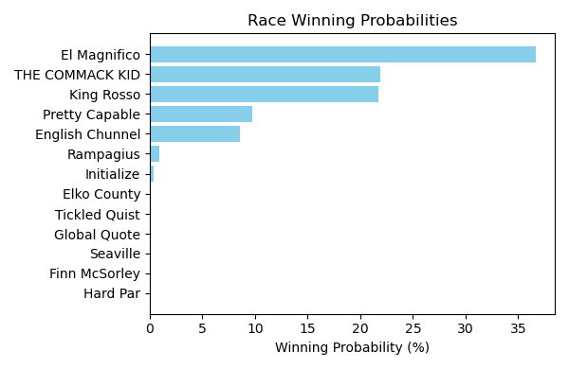

Figure: Winning Probability Distribution

NOTE: THIS RACE HAS HORSES THAT ARE MISSING CRITICAL DATA ELEMENTS

# Race: TFG | 2025-02-21 | Race #8 | Track: FAIR GROUNDS

Track: FAIR GROUNDS

|  |  |  |  |  |
| --- | --- | --- | --- | --- |
| Saddle Cloth # | Horse Name | Global Speed | Composite | Win Prob (%) |
| 1 | Razz * | 70.9 | -4.26 | 0.00 |
| 10 | Righteous Freedom * | 70.9 | 6.22 | 19.15 |
| 11 | Josan * | 70.9 | -3.15 | 0.01 |
| 2 | Rebind * | 70.9 | -7.65 | 0.00 |
| 3 | Bobby Two Shot's * | 70.9 | 6.75 | 29.27 |
| 4 | Puppeteer * | 70.9 | -0.40 | 0.10 |
| 5 | Its Wild Again * | 70.9 | 2.30 | 0.83 |
| 6 | Colt's Brim * | 70.9 | 1.89 | 0.60 |
| 7 | Sophie's Painter * | 70.9 | -3.58 | 0.01 |
| 8 | Maximum Grace * | 70.9 | -3.91 | 0.01 |
| 9 | Lost My Bag * | 70.9 | 7.42 | 50.02 |

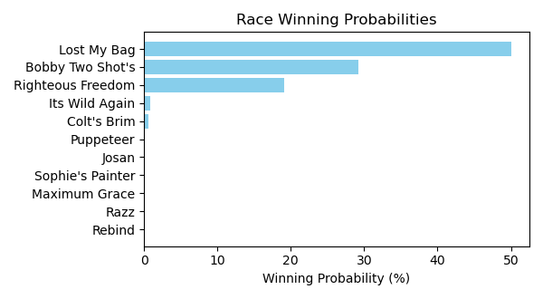

Figure: Winning Probability Distribution

NOTE: THIS RACE HAS HORSES THAT ARE MISSING CRITICAL DATA ELEMENTS

# Race: FON | 2025-02-22 | Race #1 | Track: FONNER PARK

Track: FONNER PARK

|  |  |  |  |  |
| --- | --- | --- | --- | --- |
| Saddle Cloth # | Horse Name | Global Speed | Composite | Win Prob (%) |
| 1 | Legend of Gold * | 103.9 | 0.11 | 14.37 |
| 2 | Joey's Valentine * | 76.3 | 5.00 | 2.89 |
| 3 | Caleb On the Go * | 76.3 | -7.24 | 0.00 |
| 4 | Ships Log * | 82.4 | 5.33 | 12.71 |
| 5 | Firespitten Kitten * | 103.9 | 1.87 | 58.65 |
| 6 | Phlash Drive * | 76.3 | 6.71 | 11.38 |

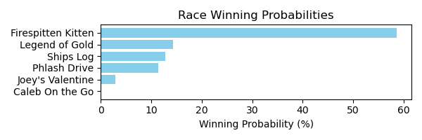

Figure: Winning Probability Distribution

NOTE: THIS RACE HAS HORSES THAT ARE MISSING CRITICAL DATA ELEMENTS

# Race: FON | 2025-02-22 | Race #2 | Track: FONNER PARK

Track: FONNER PARK

|  |  |  |  |  |
| --- | --- | --- | --- | --- |
| Saddle Cloth # | Horse Name | Global Speed | Composite | Win Prob (%) |
| 1 | Youngdumbandbroke * | 71.1 | 1.84 | 0.00 |
| 2 | Big Boss Ben * | 59.7 | -2.61 | 0.00 |
| 3 | Reginald Aurelius * | 66.5 | -3.66 | 0.00 |
| 4 | Palace Attained * | 71.1 | -2.22 | 0.00 |
| 5 | dh-Steel Link * | 76.4 | 8.46 | 2.13 |
| 6 | Willet Kinda Night * | 59.7 | -8.09 | 0.00 |
| 7 | Lt. Norm * | 96.5 | 8.22 | 97.87 |

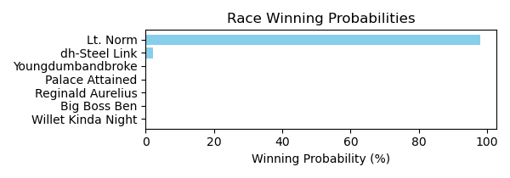

Figure: Winning Probability Distribution

NOTE: THIS RACE HAS HORSES THAT ARE MISSING CRITICAL DATA ELEMENTS

# Race: FON | 2025-02-22 | Race #3 | Track: FONNER PARK

Track: FONNER PARK

|  |  |  |  |  |
| --- | --- | --- | --- | --- |
| Saddle Cloth # | Horse Name | Global Speed | Composite | Win Prob (%) |
| 1 | My Buddy Mel * | 66.6 | 6.57 | 5.51 |
| 2 | Forced Ranking * | 104.3 | -3.44 | 3.39 |
| 3 | Exacting * | 76.5 | 7.23 | 66.90 |
| 4 | dh-Drivehappy * | 66.6 | 7.05 | 8.04 |
| 5 | Mister Chairman * | 76.5 | -0.36 | 0.15 |
| 6 | Absolute Chaos * | 76.5 | -2.83 | 0.02 |
| 7 | Falsely Accused * | 104.3 | -1.50 | 15.99 |

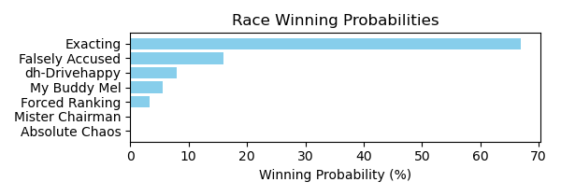

Figure: Winning Probability Distribution

NOTE: THIS RACE HAS HORSES THAT ARE MISSING CRITICAL DATA ELEMENTS

# Race: FON | 2025-02-22 | Race #4 | Track: FONNER PARK

Track: FONNER PARK

|  |  |  |  |  |
| --- | --- | --- | --- | --- |
| Saddle Cloth # | Horse Name | Global Speed | Composite | Win Prob (%) |
| 1 | Ferociously * | 66.6 | 2.99 | 0.08 |
| 2 | Time Machine * | 66.6 | -0.78 | 0.00 |
| 3 | Creative Miracle * | 71.1 | 8.64 | 17.12 |
| 4 | Mucho Gifted * | 71.1 | -1.56 | 0.00 |
| 5 | Kaely's Brother * | 89.3 | 5.98 | 77.12 |
| 6 | Magnet and Steel * | 76.4 | 5.76 | 4.94 |
| 7 | Daddy's Finest * | 66.6 | 5.85 | 0.74 |
| 8 | Jamming Eddy * | 59.7 | -4.70 | 0.00 |

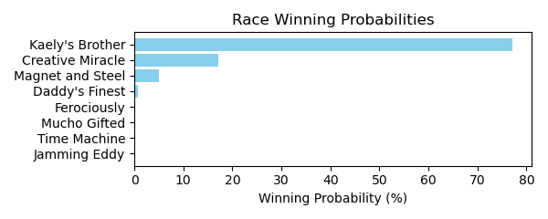

Figure: Winning Probability Distribution

NOTE: THIS RACE HAS HORSES THAT ARE MISSING CRITICAL DATA ELEMENTS

# Race: FON | 2025-02-22 | Race #5 | Track: FONNER PARK

Track: FONNER PARK

|  |  |  |  |  |
| --- | --- | --- | --- | --- |
| Saddle Cloth # | Horse Name | Global Speed | Composite | Win Prob (%) |
| 1 | J's Little Man * | 82.3 | -3.13 | 0.08 |
| 2 | The Greatest Eagle * | 108.5 | -5.21 | 2.97 |
| 3 | Schleicher * | 76.2 | 6.20 | 42.90 |
| 4 | Northwind * | 103.8 | -0.46 | 51.09 |
| 5 | Tap Dance Tango * | 71.0 | -3.17 | 0.01 |
| 6 | Hangin' Tuff * | 59.7 | 5.30 | 0.75 |
| 7 | Ring Tailed Tooter * | 76.2 | 2.26 | 1.83 |
| 8 | Prince Is My Boy * | 108.5 | -7.85 | 0.36 |
| 9 | Hard Luck Henry * | 82.3 | -5.43 | 0.01 |

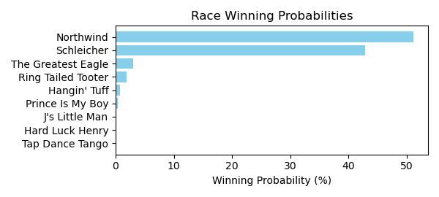

Figure: Winning Probability Distribution

NOTE: THIS RACE HAS HORSES THAT ARE MISSING CRITICAL DATA ELEMENTS

# Race: FON | 2025-02-22 | Race #6 | Track: FONNER PARK

Track: FONNER PARK

|  |  |  |  |  |
| --- | --- | --- | --- | --- |
| Saddle Cloth # | Horse Name | Global Speed | Composite | Win Prob (%) |
| 1 | Go Lilly Go * | 76.0 | 1.06 | 4.00 |
| 2 | The Bigger Bear * | 70.8 | -0.01 | 0.60 |
| 3 | Beautiful Judge * | 103.3 | -4.95 | 7.72 |
| 4 | Thatta Peppa * | 103.3 | -9.85 | 0.15 |
| 5 | Goldies Claim * | 66.3 | -4.24 | 0.01 |
| 6 | May B Better * | 76.0 | 2.02 | 8.65 |
| 7 | Judge Jennings * | 66.3 | -1.64 | 0.07 |
| 8 | Lady Mazatlan * | 76.0 | 4.78 | 78.80 |

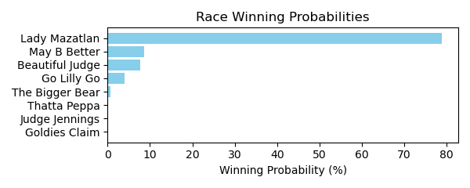

Figure: Winning Probability Distribution

NOTE: THIS RACE HAS HORSES THAT ARE MISSING CRITICAL DATA ELEMENTS

# Race: FON | 2025-02-22 | Race #7 | Track: FONNER PARK

Track: FONNER PARK

|  |  |  |  |  |
| --- | --- | --- | --- | --- |
| Saddle Cloth # | Horse Name | Global Speed | Composite | Win Prob (%) |
| 1 | Braybray * | 66.5 | -6.56 | 0.00 |
| 2 | Toska's Ruler * | 71.0 | 4.36 | 11.20 |
| 3 | Wilbert * | 89.1 | -9.42 | 0.01 |
| 4 | Robert Who * | 82.4 | -3.26 | 0.25 |
| 5 | Serendip Ruler * | 66.5 | -3.85 | 0.01 |
| 6 | Rahm * | 59.7 | -0.20 | 0.03 |
| 7 | Captain Don * | 71.0 | 6.94 | 88.51 |
| 8 | Prince of Luck * | 71.0 | -9.61 | 0.00 |
| 9 | Kahaal * | 76.3 | -8.37 | 0.00 |

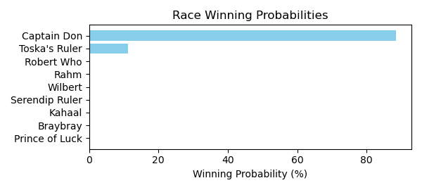

Figure: Winning Probability Distribution

NOTE: THIS RACE HAS HORSES THAT ARE MISSING CRITICAL DATA ELEMENTS

# Race: FON | 2025-02-22 | Race #8 | Track: FONNER PARK

Track: FONNER PARK

|  |  |  |  |  |
| --- | --- | --- | --- | --- |
| Saddle Cloth # | Horse Name | Global Speed | Composite | Win Prob (%) |
| 1 | Timehascome * | 76.4 | -7.68 | 0.00 |
| 2 | Party Foul * | 66.6 | 5.08 | 2.02 |
| 3 | Prizeless * | 66.6 | -1.41 | 0.01 |
| 4 | Fayette Warrior * | 66.6 | -3.00 | 0.00 |
| 5 | Rivzonaroll * | 76.4 | -0.62 | 0.15 |
| 6 | Full Authority * | 76.4 | 7.46 | 97.20 |
| 7 | Hurts So Good * | 62.8 | 3.85 | 0.36 |
| 8 | Storm Catcher * | 76.4 | 0.05 | 0.26 |
| 9 | Gold Punch * | 76.4 | -9.20 | 0.00 |

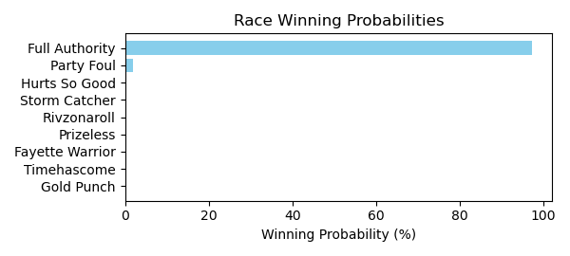

Figure: Winning Probability Distribution

NOTE: THIS RACE HAS HORSES THAT ARE MISSING CRITICAL DATA ELEMENTS

# Race: FON | 2025-02-22 | Race #9 | Track: FONNER PARK

Track: FONNER PARK

|  |  |  |  |  |
| --- | --- | --- | --- | --- |
| Saddle Cloth # | Horse Name | Global Speed | Composite | Win Prob (%) |
| 1 | Bluegrass Breeze * | 89.5 | -3.31 | 0.00 |
| 2 | Toomanynames * | 111.7 | 3.71 | 98.31 |
| 3 | Axel Steel * | 66.7 | 9.56 | 1.31 |
| 4 | Hacker * | 71.2 | -1.02 | 0.00 |
| 5 | Spirit's Mischief * | 71.2 | 6.81 | 0.36 |
| 6 | Mysterious Tale * | 66.7 | 3.70 | 0.01 |
| 7 | Diamond City * | 82.7 | -3.72 | 0.00 |
| 8 | Under Oath * | 62.9 | 3.90 | 0.01 |
| 9 | Adios Gary * | 76.6 | -1.35 | 0.00 |

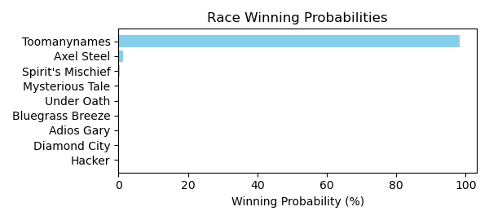

Figure: Winning Probability Distribution

NOTE: THIS RACE HAS HORSES THAT ARE MISSING CRITICAL DATA ELEMENTS

# Race: FON | 2025-02-22 | Race #10 | Track: FONNER PARK

Track: FONNER PARK

|  |  |  |  |  |
| --- | --- | --- | --- | --- |
| Saddle Cloth # | Horse Name | Global Speed | Composite | Win Prob (%) |
| 1 | Notacry * | 76.2 | -3.41 | 0.00 |
| 2 | Mongolian Moon * | 59.7 | -2.27 | 0.00 |
| 3 | Zultan * | 103.8 | 1.23 | 9.65 |
| 4 | Sol Del Sur * | 76.2 | 0.63 | 0.02 |
| 5 | Brilliant Colors * | 76.2 | 5.29 | 1.01 |
| 6 | Jahez * | 103.8 | 2.39 | 24.26 |
| 7 | Broadway Pete * | 66.5 | 7.77 | 1.04 |
| 8 | Rosie's Boy * | 103.8 | 2.93 | 37.35 |
| 9 | Leaoflittlefaith * | 76.2 | 9.39 | 26.68 |

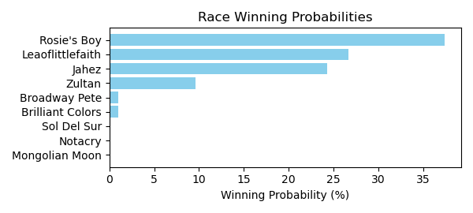

Figure: Winning Probability Distribution

NOTE: THIS RACE HAS HORSES THAT ARE MISSING CRITICAL DATA ELEMENTS

# Race: TGP | 2025-02-21 | Race #1 | Track: GULFSTREAM PARK

Track: GULFSTREAM PARK

|  |  |  |  |  |
| --- | --- | --- | --- | --- |
| Saddle Cloth # | Horse Name | Global Speed | Composite | Win Prob (%) |
| 1 | Pharoahs Baby Gyal * | 76.3 | -6.96 | 0.00 |
| 2 | Gratia * | 71.0 | -9.50 | 0.00 |
| 3 | Go Big Green * | 111.2 | 0.76 | 72.64 |
| 4 | Dubstep * | 108.6 | -8.21 | 0.03 |
| 5 | Motown Mika * | 82.3 | 3.44 | 1.94 |
| 6 | Current Situation * | 108.6 | 0.08 | 25.01 |
| 7 | Red Hot Spark * | 71.0 | 4.25 | 0.38 |

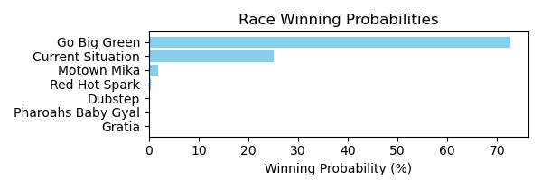

Figure: Winning Probability Distribution

NOTE: THIS RACE HAS HORSES THAT ARE MISSING CRITICAL DATA ELEMENTS

# Race: TGP | 2025-02-21 | Race #2 | Track: GULFSTREAM PARK

Track: GULFSTREAM PARK

|  |  |  |  |  |
| --- | --- | --- | --- | --- |
| Saddle Cloth # | Horse Name | Global Speed | Composite | Win Prob (%) |
| 1 | Sarah's Dream * | 111.6 | 8.05 | 91.95 |
| 2 | My Blessing * | 104.2 | -4.99 | 0.00 |
| 3 | Fantasy Performer * | 104.2 | -1.30 | 0.01 |
| 4 | Goodbetterbest * | 104.2 | 5.25 | 2.24 |
| 5 | Surprenant Cocca * | 111.6 | 4.52 | 5.44 |
| 6 | Tinki Abarrio * | 104.2 | -3.62 | 0.00 |
| 7 | On the Nile * | 104.2 | -6.10 | 0.00 |
| 8 | Escape Room * | 104.2 | 2.17 | 0.19 |
| 9 | Boston Rose (IRE) * | 111.6 | 0.17 | 0.17 |

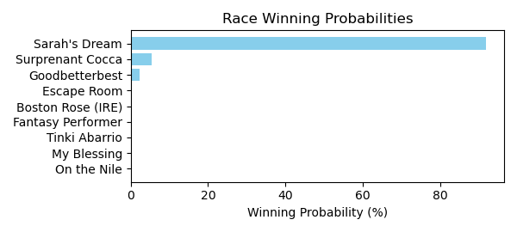

Figure: Winning Probability Distribution

NOTE: THIS RACE HAS HORSES THAT ARE MISSING CRITICAL DATA ELEMENTS

# Race: TGP | 2025-02-21 | Race #3 | Track: GULFSTREAM PARK

Track: GULFSTREAM PARK

|  |  |  |  |  |
| --- | --- | --- | --- | --- |
| Saddle Cloth # | Horse Name | Global Speed | Composite | Win Prob (%) |
| 1 | Secret Revenge * | 66.5 | 0.52 | 0.05 |
| 2 | Lunetta Jak * | 103.8 | -6.20 | 0.36 |
| 3 | BASHFUL DAISY * | 82.3 | 5.08 | 40.79 |
| 4 | La Girvina * | 66.5 | -4.21 | 0.00 |
| 5 | WIFFLETREE SERRY * | 82.3 | 5.33 | 50.09 |
| 6 | Speranzosa * | 103.8 | -2.23 | 8.71 |

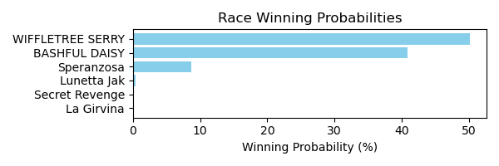

Figure: Winning Probability Distribution

NOTE: THIS RACE HAS HORSES THAT ARE MISSING CRITICAL DATA ELEMENTS

# Race: TGP | 2025-02-21 | Race #4 | Track: GULFSTREAM PARK

Track: GULFSTREAM PARK

|  |  |  |  |  |
| --- | --- | --- | --- | --- |
| Saddle Cloth # | Horse Name | Global Speed | Composite | Win Prob (%) |
| 1 | Come Dream With Me * | 89.1 | 6.02 | 55.93 |
| 2 | Mohay Please * | 103.9 | 1.72 | 34.40 |
| 3 | Otto * | 76.3 | 3.70 | 0.67 |
| 4 | Southern Dream * | 76.3 | -3.38 | 0.00 |
| 5 | Amazing Woo * | 76.3 | -2.54 | 0.00 |
| 6 | Performante * | 103.9 | -3.49 | 0.53 |
| 7 | Golden Sombrero * | 76.3 | 2.57 | 0.27 |
| 8 | Go Billy Go * | 76.3 | 6.82 | 8.19 |

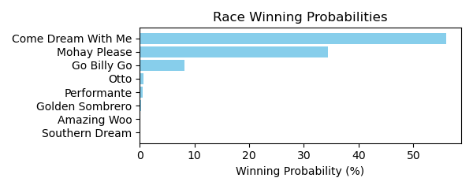

Figure: Winning Probability Distribution

NOTE: THIS RACE HAS HORSES THAT ARE MISSING CRITICAL DATA ELEMENTS

# Race: TGP | 2025-02-21 | Race #5 | Track: GULFSTREAM PARK

Track: GULFSTREAM PARK

|  |  |  |  |  |
| --- | --- | --- | --- | --- |
| Saddle Cloth # | Horse Name | Global Speed | Composite | Win Prob (%) |
| 1 | Lou the Body * | 111.3 | 5.36 | 6.15 |
| 2 | Kuwait Towers * | 111.3 | -0.56 | 0.05 |
| 3 | Dixie Preach * | 111.3 | -0.61 | 0.05 |
| 4 | Take Your Seats (IRE) * | 118.2 | 5.84 | 35.32 |
| 5 | Racket * | 103.9 | 6.23 | 2.82 |
| 6 | Last U Turn * | 111.3 | 1.61 | 0.31 |
| 7 | Franks Mimi * | 111.3 | 7.41 | 31.80 |
| 8 | Star of the Beast * | 108.7 | 7.69 | 23.49 |
| 9 | Split Strike * | 71.0 | 3.17 | 0.00 |

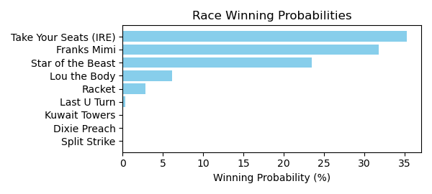

Figure: Winning Probability Distribution

NOTE: THIS RACE HAS HORSES THAT ARE MISSING CRITICAL DATA ELEMENTS

# Race: TGP | 2025-02-21 | Race #6 | Track: GULFSTREAM PARK

Track: GULFSTREAM PARK

|  |  |  |  |  |
| --- | --- | --- | --- | --- |
| Saddle Cloth # | Horse Name | Global Speed | Composite | Win Prob (%) |
| 1 | Right Angle * | 71.0 | 7.54 | 0.19 |
| 2 | Spirited Boss * | 71.0 | 8.29 | 0.35 |
| 3 | Designer Bag * | 103.9 | 0.52 | 0.50 |
| 4 | Money Bouquet * | 111.3 | 4.78 | 66.41 |
| 5 | Miss Mary Nell * | 111.3 | 3.66 | 27.01 |
| 6 | La Gioconda * | 111.3 | 1.64 | 5.39 |
| 7 | Mojo Rising * | 76.3 | 5.88 | 0.15 |

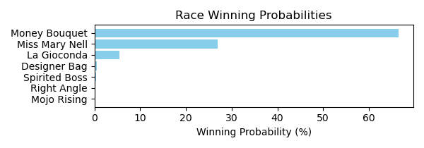

Figure: Winning Probability Distribution

NOTE: THIS RACE HAS HORSES THAT ARE MISSING CRITICAL DATA ELEMENTS

# Race: TGP | 2025-02-21 | Race #7 | Track: GULFSTREAM PARK

Track: GULFSTREAM PARK

|  |  |  |  |  |
| --- | --- | --- | --- | --- |
| Saddle Cloth # | Horse Name | Global Speed | Composite | Win Prob (%) |
| 1 | Waittilmidnitehour * | 66.6 | 8.11 | 22.00 |
| 2 | One of One * | 66.6 | 7.24 | 10.91 |
| 3 | Warda * | 66.6 | 6.16 | 4.63 |
| 4 | Chloe's Toy * | 71.1 | 6.63 | 16.60 |
| 5 | Kikitsa * | 66.6 | -4.08 | 0.00 |
| 6 | Mywifeknowsitall * | 66.6 | 8.80 | 37.98 |
| 7 | Party Shaker * | 71.1 | 0.99 | 0.18 |
| 8 | Fortuna Belle * | 66.6 | 6.80 | 7.70 |

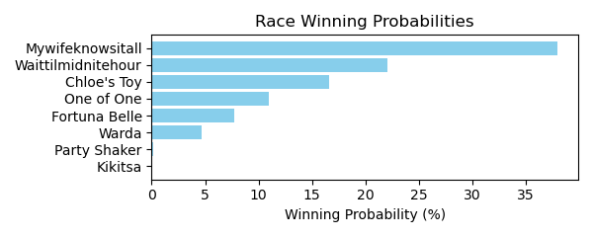

Figure: Winning Probability Distribution

NOTE: THIS RACE HAS HORSES THAT ARE MISSING CRITICAL DATA ELEMENTS

# Race: TGP | 2025-02-21 | Race #8 | Track: GULFSTREAM PARK

Track: GULFSTREAM PARK

|  |  |  |  |  |
| --- | --- | --- | --- | --- |
| Saddle Cloth # | Horse Name | Global Speed | Composite | Win Prob (%) |
| 1 | Into You * | 104.2 | 4.48 | 47.25 |
| 2 | Jack Kerouac * | 66.6 | 5.80 | 0.07 |
| 3 | Titan * | 109.0 | 0.07 | 3.62 |
| 4 | Awesome Beast * | 89.4 | 6.68 | 14.24 |
| 5 | Manhattan Boy * | 111.6 | 2.20 | 33.55 |
| 6 | Grande Soiree * | 111.6 | -2.21 | 0.98 |
| 7 | Themanupfront * | 104.2 | -1.90 | 0.29 |

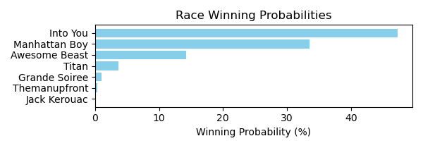

Figure: Winning Probability Distribution

NOTE: THIS RACE HAS HORSES THAT ARE MISSING CRITICAL DATA ELEMENTS

# Race: TGP | 2025-02-21 | Race #9 | Track: GULFSTREAM PARK

Track: GULFSTREAM PARK

|  |  |  |  |  |
| --- | --- | --- | --- | --- |
| Saddle Cloth # | Horse Name | Global Speed | Composite | Win Prob (%) |
| 1 | Royal Poppy * | 82.5 | 5.43 | 0.64 |
| 2 | Stormy Mitole * | 89.3 | 4.29 | 1.01 |
| 3 | Miles of Smiles * | 82.5 | 5.80 | 0.87 |
| 4 | Olga * | 82.5 | 4.89 | 0.42 |
| 5 | I'm Into Mischief * | 111.4 | -2.63 | 0.33 |
| 6 | Pemberley * | 111.4 | 4.42 | 93.68 |
| 7 | Both Sides * | 82.5 | 7.32 | 2.94 |
| 8 | Major Pryce * | 82.5 | 2.53 | 0.06 |
| 9 | Gallop d'Hermes * | 82.5 | 2.05 | 0.04 |

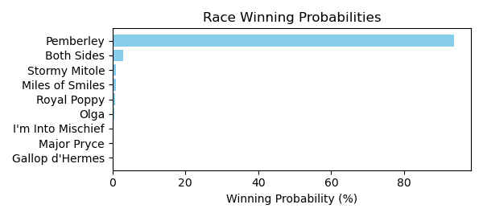

Figure: Winning Probability Distribution

NOTE: THIS RACE HAS HORSES THAT ARE MISSING CRITICAL DATA ELEMENTS

# Race: TGP | 2025-02-21 | Race #10 | Track: GULFSTREAM PARK

Track: GULFSTREAM PARK

|  |  |  |  |  |
| --- | --- | --- | --- | --- |
| Saddle Cloth # | Horse Name | Global Speed | Composite | Win Prob (%) |
| 1 | LA NAYA FACE (CHI) * | 66.4 | 4.51 | 2.98 |
| 10 | FIJO DAY (CHI) * | 66.4 | 4.24 | 2.40 |
| 11 | UNO CERO (CHI) * | 66.4 | 4.40 | 2.73 |
| 12 | RUCIA DEL DOC (CHI) * | 76.0 | 4.44 | 19.63 |
| 13 | BENDITA LOCURA (CHI) * | 68.7 | 4.15 | 3.55 |
| 14 | BARBIE DREAMS (CHI) * | 66.4 | 4.41 | 2.75 |
| 15 | PALMAS SORDITAS (ARG) * | 76.0 | 4.25 | 16.89 |
| 2 | ACHAPLINA (CHI) * | 66.4 | 4.70 | 3.49 |
| 3 | KING NICOLAS (CHI) * | 66.4 | 4.58 | 3.16 |
| 4 | CIOCOLATTA (CHI) * | 76.0 | 4.49 | 20.38 |
| 5 | NIETA DEL MONTY (CHI) * | 66.4 | 4.58 | 3.15 |
| 6 | SECRET DUBAI (CHI) * | 70.8 | 4.57 | 7.60 |
| 7 | MAZINGER Z (CHI) * | 68.7 | 4.55 | 4.87 |
| 8 | ATEX (CHI) * | 66.4 | 4.61 | 3.23 |
| 9 | SORAILA (CHI) * | 66.4 | 4.59 | 3.19 |

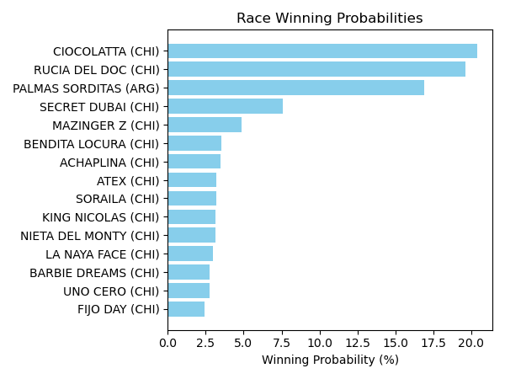

Figure: Winning Probability Distribution

NOTE: THIS RACE HAS HORSES THAT ARE MISSING CRITICAL DATA ELEMENTS

# Race: TGP | 2025-02-21 | Race #11 | Track: GULFSTREAM PARK

Track: GULFSTREAM PARK

|  |  |  |  |  |
| --- | --- | --- | --- | --- |
| Saddle Cloth # | Horse Name | Global Speed | Composite | Win Prob (%) |
| 1 | INTRIGANT (CHI) * | 66.3 | 4.64 | 3.32 |
| 10 | EL GOLAZO (CHI) * | 66.3 | 4.86 | 3.96 |
| 11 | YO PAGO TODO (CHI) * | 66.3 | 4.63 | 3.30 |
| 12 | JOHANNESBULL (CHI) * | 66.3 | 4.58 | 3.16 |
| 13 | ASTROAZURRO (CHI) * | 66.3 | 4.77 | 3.69 |
| 14 | CIAO JUANITA (CHI) * | 66.3 | 4.83 | 3.87 |
| 15 | PRINCESS MARGARET (CHI) * | 68.0 | 4.49 | 4.07 |
| 2 | AMAYNA (CHI) * | 70.8 | 4.77 | 8.98 |
| 3 | HUACARNECO (CHI) * | 66.3 | 4.47 | 2.90 |
| 4 | DOMINGO ISLENO (CHI) * | 76.0 | 4.65 | 23.22 |
| 5 | PORTO BELAGGIO (CHI) * | 66.3 | 4.72 | 3.54 |
| 6 | YANE YI (CHI) * | 68.0 | 4.66 | 4.66 |
| 7 | LA PIOLA (CHI) * | 76.0 | 4.75 | 25.10 |
| 8 | AMBROSE (CHI) * | 66.3 | 4.60 | 3.21 |
| 9 | ORAZIA (CHI) * | 66.3 | 4.52 | 3.01 |

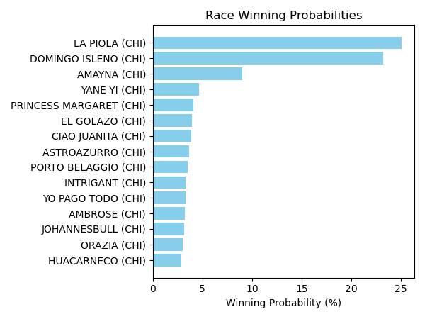

Figure: Winning Probability Distribution

NOTE: THIS RACE HAS HORSES THAT ARE MISSING CRITICAL DATA ELEMENTS

# Race: TGP | 2025-02-21 | Race #12 | Track: GULFSTREAM PARK

Track: GULFSTREAM PARK

|  |  |  |  |  |
| --- | --- | --- | --- | --- |
| Saddle Cloth # | Horse Name | Global Speed | Composite | Win Prob (%) |
| 1 | GEMOLOGA (CHI) * | 66.4 | 4.37 | 0.00 |
| 10 | CHIVARO (CHI) * | 123.7 | 4.60 | 99.99 |
| 11 | MAYSAK (CHI) * | 66.4 | 4.46 | 0.00 |
| 12 | GENUINE COMAND (CHI) * | 66.4 | 4.45 | 0.00 |
| 13 | DEAR SISTER (CHI) * | 66.4 | 4.40 | 0.00 |
| 14 | CAMMARATA (CHI) * | 66.4 | 4.23 | 0.00 |
| 15 | MO FARAH (CHI) * | 66.4 | 4.54 | 0.00 |
| 2 | NEGRITA ANDREA (CHI) * | 66.4 | 4.30 | 0.00 |
| 3 | DESTINO SECRETO (CHI) * | 66.4 | 4.49 | 0.00 |
| 4 | C'EST VRAI (CHI) * | 66.4 | 4.29 | 0.00 |
| 5 | JAIMINI (CHI) * | 66.4 | 4.27 | 0.00 |
| 6 | PEGGY NICE (CHI) * | 66.4 | 4.31 | 0.00 |
| 7 | GOLDEN MIST (CHI) * | 66.4 | 4.42 | 0.00 |
| 8 | CARINOSITO (CHI) * | 66.4 | 4.26 | 0.00 |
| 9 | GRAN RAI (CHI) * | 66.4 | 4.47 | 0.00 |

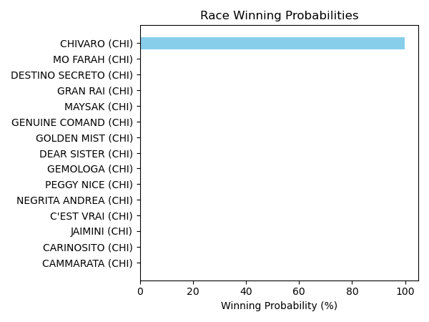

Figure: Winning Probability Distribution

NOTE: THIS RACE HAS HORSES THAT ARE MISSING CRITICAL DATA ELEMENTS

# Race: TGP | 2025-02-21 | Race #13 | Track: GULFSTREAM PARK

Track: GULFSTREAM PARK

|  |  |  |  |  |
| --- | --- | --- | --- | --- |
| Saddle Cloth # | Horse Name | Global Speed | Composite | Win Prob (%) |
| 1 | LATEN GOOD (CHI) * | 66.3 | 4.75 | 3.56 |
| 10 | DE ORO Y COBRE (CHI) * | 76.0 | 4.49 | 20.07 |
| 11 | ROGER RED (CHI) * | 66.3 | 4.54 | 3.02 |
| 12 | MISS LADY CLASSIC (CHI) * | 70.8 | 4.64 | 7.95 |
| 13 | BLUE KENTUCKY GIRL (CHI) * | 66.3 | 4.60 | 3.16 |
| 14 | CASABLANCA FUNNY (CHI) * | 66.3 | 4.65 | 3.30 |
| 15 | MI MARTUCA (CHI) * | 66.3 | 4.59 | 3.14 |
| 2 | TREN DE LA QUINTA (CHI) * | 76.0 | 4.68 | 23.49 |
| 3 | IMPERIO BABILONICO (CHI) * | 70.8 | 4.20 | 5.59 |
| 4 | FEELING BLESSED (CHI) * | 66.3 | 4.67 | 3.34 |
| 5 | MAKINEN (CHI) * | 70.8 | 4.45 | 6.81 |
| 6 | PRIMA TOWN (CHI) * | 66.3 | 4.68 | 3.37 |
| 7 | LA CHAMBEKA (CHI) * | 70.8 | 4.47 | 6.95 |
| 8 | AMELITA (CHI) * | 66.3 | 4.49 | 2.91 |
| 9 | TWO FLAGS (CHI) * | 66.3 | 4.67 | 3.36 |

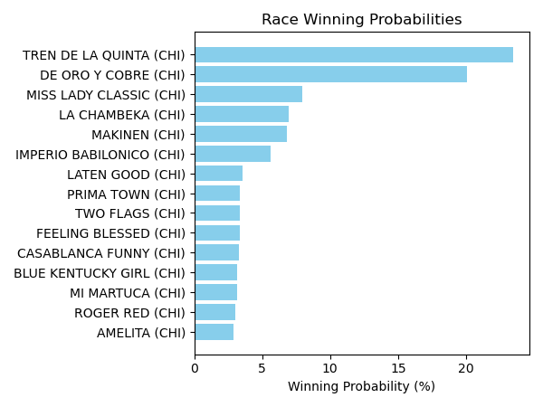

Figure: Winning Probability Distribution

NOTE: THIS RACE HAS HORSES THAT ARE MISSING CRITICAL DATA ELEMENTS

# Race: TGP | 2025-02-21 | Race #14 | Track: GULFSTREAM PARK

Track: GULFSTREAM PARK

|  |  |  |  |  |
| --- | --- | --- | --- | --- |
| Saddle Cloth # | Horse Name | Global Speed | Composite | Win Prob (%) |
| 1 | ELEGANT KATZE (CHI) * | 66.4 | 4.26 | 1.92 |
| 10 | QUIERO TODO (CHI) * | 76.1 | 4.07 | 11.53 |
| 11 | FLACO TITO (CHI) * | 66.4 | 4.01 | 1.57 |
| 12 | SUGAR DADDY (CHI) * | 66.4 | 4.22 | 1.86 |
| 13 | DALIKA (CHI) * | 66.4 | 3.96 | 1.51 |
| 14 | ME HA MIRADO (CHI) * | 76.1 | 3.89 | 9.96 |
| 15 | SENOR TRONCOSO (CHI) * | 76.1 | 4.16 | 12.36 |
| 2 | EL SOM CENTAURO (CHI) * | 76.1 | 4.19 | 12.62 |
| 3 | SUN OF ZAZAU (CHI) * | 76.1 | 4.12 | 11.94 |
| 4 | NEGRO DE ORO (CHI) * | 66.4 | 4.00 | 1.56 |
| 5 | RIONA (CHI) * | 76.1 | 4.23 | 13.09 |
| 6 | TEODORA (CHI) * | 70.8 | 4.14 | 4.26 |
| 7 | QUE PASA (CHI) * | 66.4 | 4.28 | 1.96 |
| 8 | NOVAK (CHI) * | 66.4 | 4.28 | 1.96 |
| 9 | TIRABOSCHI (CHI) * | 76.1 | 4.11 | 11.90 |

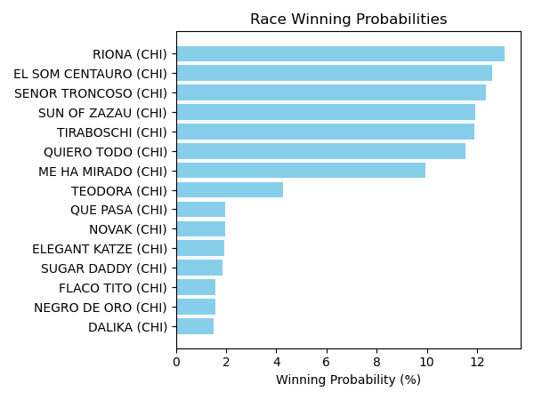

Figure: Winning Probability Distribution

NOTE: THIS RACE HAS HORSES THAT ARE MISSING CRITICAL DATA ELEMENTS

# Race: TCT | 2025-02-21 | Race #1 | Track: HOLLYWOOD CASINO AT CHARLES TOWN RACES

Track: HOLLYWOOD CASINO AT CHARLES TOWN RACES

|  |  |  |  |  |
| --- | --- | --- | --- | --- |
| Saddle Cloth # | Horse Name | Global Speed | Composite | Win Prob (%) |
| 1 | She So Cool * | 88.8 | -1.27 | 0.11 |
| 2 | Sweet Sensation * | 82.1 | 2.60 | 0.65 |
| 3 | Shewearsstilettos * | 88.8 | 7.09 | 91.12 |
| 4 | Shoopthereitis * | 88.8 | -6.78 | 0.00 |
| 5 | Somebody Loves Me * | 82.1 | -3.45 | 0.01 |
| 6 | Music Lass * | 82.1 | 5.75 | 8.11 |

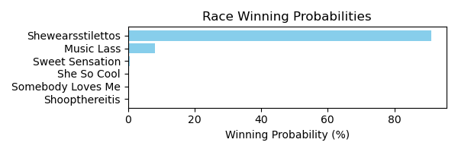

Figure: Winning Probability Distribution

NOTE: THIS RACE HAS HORSES THAT ARE MISSING CRITICAL DATA ELEMENTS

# Race: TCT | 2025-02-21 | Race #2 | Track: HOLLYWOOD CASINO AT CHARLES TOWN RACES

Track: HOLLYWOOD CASINO AT CHARLES TOWN RACES

|  |  |  |  |  |
| --- | --- | --- | --- | --- |
| Saddle Cloth # | Horse Name | Global Speed | Composite | Win Prob (%) |
| 1 | No Time to Boogie * | 89.2 | -1.71 | 0.14 |
| 2 | Radar Alert * | 89.2 | 4.50 | 19.85 |
| 3 | Lawyer Up Riley * | 82.5 | 7.91 | 78.87 |
| 4 | In the Chase * | 82.5 | 1.53 | 0.48 |
| 5 | Costner * | 89.2 | -1.61 | 0.15 |
| 6 | Artwell * | 76.4 | 3.15 | 0.52 |

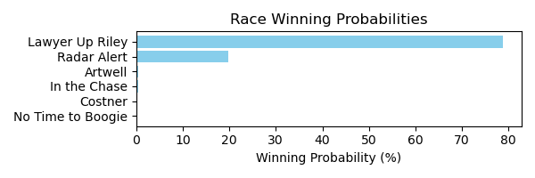

Figure: Winning Probability Distribution

NOTE: THIS RACE HAS HORSES THAT ARE MISSING CRITICAL DATA ELEMENTS

# Race: TCT | 2025-02-21 | Race #3 | Track: HOLLYWOOD CASINO AT CHARLES TOWN RACES

Track: HOLLYWOOD CASINO AT CHARLES TOWN RACES

|  |  |  |  |  |
| --- | --- | --- | --- | --- |
| Saddle Cloth # | Horse Name | Global Speed | Composite | Win Prob (%) |
| 1 | Connect the Dots * | 82.1 | -6.20 | 0.04 |
| 10 | MEXICALI MIKE * | 65.3 | 4.67 | 7.32 |
| 11 | Wish On Juba * | 62.7 | 4.74 | 4.57 |
| 12 | A Reason to Party * | 62.7 | -6.43 | 0.00 |
| 13 | Charlienite * | 62.7 | -5.48 | 0.00 |
| 14 | RAY OF SUNSHINE * | 62.7 | 4.54 | 3.89 |
| 2 | JAZMAN CAN * | 65.3 | 4.74 | 7.73 |
| 3 | Jubacantfixthis * | 62.7 | -7.15 | 0.00 |
| 4 | Bonds Revenge * | 62.7 | 6.33 | 16.26 |
| 5 | Slew the Lion * | 62.7 | -4.39 | 0.00 |
| 6 | Forbidden Spirit * | 62.7 | 5.49 | 8.30 |
| 7 | Rock of Ages * | 82.1 | 2.71 | 44.03 |
| 8 | Just a Wizard * | 62.7 | 0.30 | 0.13 |
| 9 | CHIPPEWA BAY * | 65.3 | 4.74 | 7.74 |

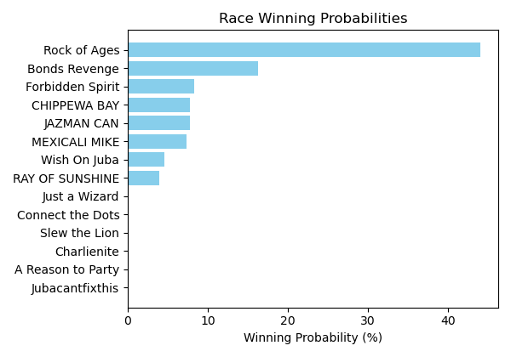

Figure: Winning Probability Distribution

NOTE: THIS RACE HAS HORSES THAT ARE MISSING CRITICAL DATA ELEMENTS

# Race: TCT | 2025-02-21 | Race #4 | Track: HOLLYWOOD CASINO AT CHARLES TOWN RACES

Track: HOLLYWOOD CASINO AT CHARLES TOWN RACES

|  |  |  |  |  |
| --- | --- | --- | --- | --- |
| Saddle Cloth # | Horse Name | Global Speed | Composite | Win Prob (%) |
| 1 | Ms Gloria Jean * | 76.2 | -7.77 | 0.00 |
| 2 | Dixie Rag * | 88.9 | -9.22 | 0.00 |
| 3 | Tangerineginger * | 82.2 | 7.38 | 57.23 |
| 4 | Catalina Cruzin * | 88.9 | -1.73 | 0.15 |
| 5 | Red Priestess * | 62.7 | -6.89 | 0.00 |
| 6 | Maltese Rose * | 82.2 | 6.98 | 41.54 |
| 7 | Margaret's Lady * | 88.9 | -3.95 | 0.03 |
| 8 | Gone With the Wyn * | 82.2 | 2.39 | 1.06 |

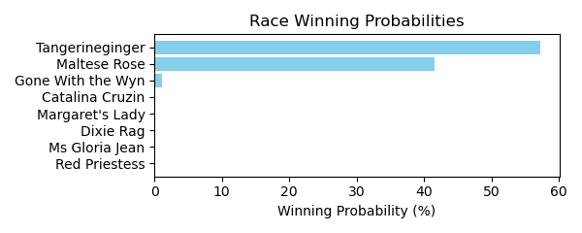

Figure: Winning Probability Distribution

NOTE: THIS RACE HAS HORSES THAT ARE MISSING CRITICAL DATA ELEMENTS

# Race: TCT | 2025-02-21 | Race #5 | Track: HOLLYWOOD CASINO AT CHARLES TOWN RACES

Track: HOLLYWOOD CASINO AT CHARLES TOWN RACES

|  |  |  |  |  |
| --- | --- | --- | --- | --- |
| Saddle Cloth # | Horse Name | Global Speed | Composite | Win Prob (%) |
| 1 | Moonshine Mama * | 62.6 | -8.32 | 0.00 |
| 2 | Ivyleaguedropout * | 88.8 | -6.61 | 1.39 |
| 3 | Unbridled Chopt * | 62.6 | -9.14 | 0.00 |
| 4 | Eyesonthecandy * | 62.6 | -6.42 | 0.01 |
| 5 | Tiger's Candy * | 88.8 | -6.52 | 1.49 |
| 6 | Ruby Bay * | 82.1 | -6.26 | 0.48 |
| 7 | All Aboard * | 88.8 | -7.16 | 0.89 |
| 8 | Alice's Moon * | 82.1 | 0.36 | 95.74 |

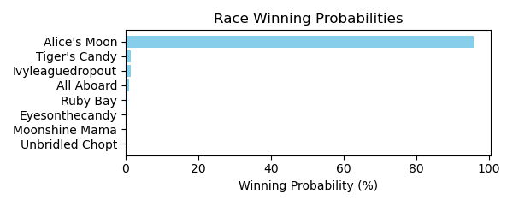

Figure: Winning Probability Distribution

NOTE: THIS RACE HAS HORSES THAT ARE MISSING CRITICAL DATA ELEMENTS

# Race: TCT | 2025-02-21 | Race #6 | Track: HOLLYWOOD CASINO AT CHARLES TOWN RACES

Track: HOLLYWOOD CASINO AT CHARLES TOWN RACES

|  |  |  |  |  |
| --- | --- | --- | --- | --- |
| Saddle Cloth # | Horse Name | Global Speed | Composite | Win Prob (%) |
| 1 | Ozone * | 111.7 | 9.19 | 99.47 |
| 2 | Gran Andrews * | 89.5 | 7.82 | 0.39 |
| 3 | Smooth Rico * | 82.7 | 2.52 | 0.00 |
| 4 | Goodluckchuck * | 76.5 | 7.12 | 0.02 |
| 5 | The Khozan One * | 89.5 | 5.56 | 0.06 |
| 6 | Al Loves Josie * | 89.5 | 5.37 | 0.06 |
| 7 | Jackie A * | 76.5 | -1.85 | 0.00 |

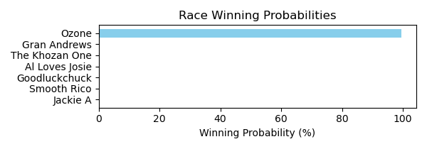

Figure: Winning Probability Distribution

NOTE: THIS RACE HAS HORSES THAT ARE MISSING CRITICAL DATA ELEMENTS

# Race: TCT | 2025-02-21 | Race #7 | Track: HOLLYWOOD CASINO AT CHARLES TOWN RACES

Track: HOLLYWOOD CASINO AT CHARLES TOWN RACES

|  |  |  |  |  |
| --- | --- | --- | --- | --- |
| Saddle Cloth # | Horse Name | Global Speed | Composite | Win Prob (%) |
| 1 | Dorado * | 89.4 | 7.74 | 85.57 |
| 2 | Gabriel Seven * | 82.6 | -0.96 | 0.02 |
| 3 | Rol Again Dancer * | 89.4 | 3.45 | 2.76 |
| 4 | Besotted * | 82.6 | 0.16 | 0.05 |
| 5 | Nancy Made My Day * | 76.5 | 5.59 | 1.15 |
| 6 | Logstradamus * | 89.4 | 5.11 | 10.45 |

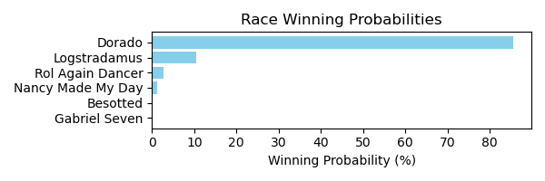

Figure: Winning Probability Distribution

NOTE: THIS RACE HAS HORSES THAT ARE MISSING CRITICAL DATA ELEMENTS

# Race: TCT | 2025-02-21 | Race #8 | Track: HOLLYWOOD CASINO AT CHARLES TOWN RACES

Track: HOLLYWOOD CASINO AT CHARLES TOWN RACES

|  |  |  |  |  |
| --- | --- | --- | --- | --- |
| Saddle Cloth # | Horse Name | Global Speed | Composite | Win Prob (%) |
| 1 | Just Murphy * | 62.7 | -2.93 | 0.02 |
| 2 | Diva's Demon * | 62.7 | 6.45 | 43.75 |
| 3 | Ride the Brand * | 82.1 | -5.68 | 0.13 |
| 4 | Tup's to Take * | 62.7 | -3.58 | 0.01 |
| 5 | Gettin Spicy * | 62.7 | -2.94 | 0.02 |
| 6 | Why Winchill Why * | 62.7 | -4.54 | 0.01 |
| 7 | El Morito * | 62.7 | 6.46 | 44.25 |
| 8 | Salty Starkey * | 62.7 | 4.81 | 11.79 |
| 9 | Shiney Ghost * | 62.7 | -4.80 | 0.01 |

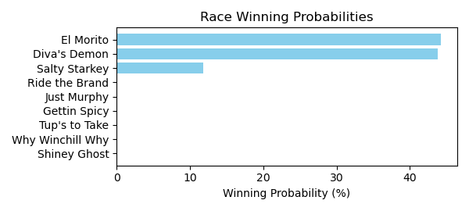

Figure: Winning Probability Distribution

NOTE: THIS RACE HAS HORSES THAT ARE MISSING CRITICAL DATA ELEMENTS

# Race: LRL | 2025-02-21 | Race #1 | Track: LAUREL PARK

Track: LAUREL PARK

|  |  |  |  |  |
| --- | --- | --- | --- | --- |
| Saddle Cloth # | Horse Name | Global Speed | Composite | Win Prob (%) |
| 1 | Fast Talkin Man * | 76.1 | 2.21 | 0.39 |
| 2 | Severn Run * | 70.8 | 5.53 | 1.94 |
| 3 | Tetched * | 88.8 | 3.45 | 13.33 |
| 4 | Real Talented * | 88.8 | -5.24 | 0.01 |
| 5 | WHERE'S MY CHEW * | 70.8 | 7.39 | 8.59 |
| 6 | FURIOUS GEORGE * | 78.4 | 7.44 | 40.48 |
| 7 | ZIO LINO * | 78.4 | 7.26 | 35.26 |

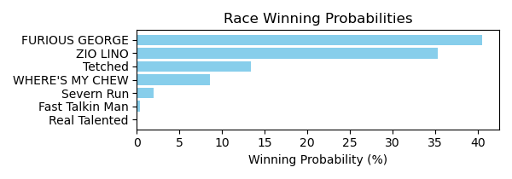

Figure: Winning Probability Distribution

NOTE: THIS RACE HAS HORSES THAT ARE MISSING CRITICAL DATA ELEMENTS

# Race: LRL | 2025-02-21 | Race #2 | Track: LAUREL PARK

Track: LAUREL PARK

|  |  |  |  |  |
| --- | --- | --- | --- | --- |
| Saddle Cloth # | Horse Name | Global Speed | Composite | Win Prob (%) |
| 1 | Square Slice * | 76.3 | 5.57 | 7.28 |
| 2 | Maliblue * | 71.0 | 9.31 | 50.46 |
| 3 | Twice Gold * | 103.9 | 0.51 | 31.67 |
| 4 | Rapidity * | 76.3 | 6.02 | 10.44 |
| 5 | Scrappy T Lee * | 76.3 | -8.67 | 0.00 |
| 6 | Medagooch * | 76.3 | -0.19 | 0.07 |
| 7 | Thedingoateyobaby * | 111.3 | -8.82 | 0.08 |

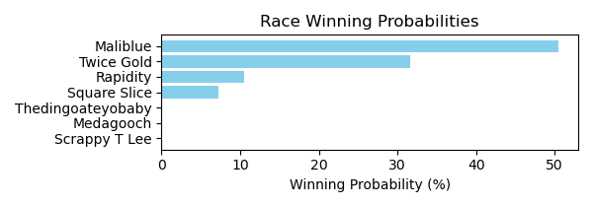

Figure: Winning Probability Distribution

NOTE: THIS RACE HAS HORSES THAT ARE MISSING CRITICAL DATA ELEMENTS

# Race: LRL | 2025-02-21 | Race #3 | Track: LAUREL PARK

Track: LAUREL PARK

|  |  |  |  |  |
| --- | --- | --- | --- | --- |
| Saddle Cloth # | Horse Name | Global Speed | Composite | Win Prob (%) |
| 1 | Tina Tina Tina * | 89.1 | -1.59 | 0.04 |
| 2 | Princess Lucia * | 111.2 | 1.34 | 36.82 |
| 3 | Voodoo Priestess * | 103.8 | 0.22 | 3.43 |
| 4 | Lilly Lightning * | 76.3 | -8.02 | 0.00 |
| 5 | Maximo Madness * | 89.1 | -0.53 | 0.10 |
| 6 | Looking for Water * | 103.8 | 3.79 | 59.61 |
| 7 | Determined Blue * | 89.1 | -5.37 | 0.00 |

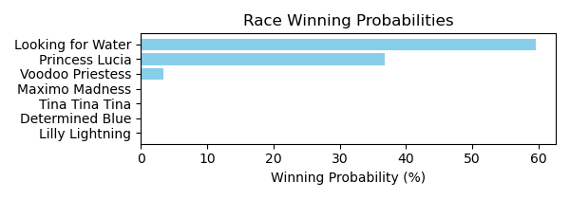

Figure: Winning Probability Distribution

NOTE: THIS RACE HAS HORSES THAT ARE MISSING CRITICAL DATA ELEMENTS

# Race: LRL | 2025-02-21 | Race #4 | Track: LAUREL PARK

Track: LAUREL PARK

|  |  |  |  |  |
| --- | --- | --- | --- | --- |
| Saddle Cloth # | Horse Name | Global Speed | Composite | Win Prob (%) |
| 1 | BRAND NEW DANCE * | 95.7 | 6.43 | 6.03 |
| 2 | BIRDIEJUICE * | 95.7 | 5.94 | 4.07 |
| 3 | Chattolanee Spring * | 103.7 | 5.88 | 19.26 |
| 4 | Wikolia Lady * | 103.7 | 0.73 | 0.31 |
| 5 | Late Nite Call * | 108.4 | 6.31 | 70.25 |
| 6 | Ready for Magic * | 89.0 | -1.19 | 0.00 |
| 7 | Passage East * | 76.2 | 5.79 | 0.07 |

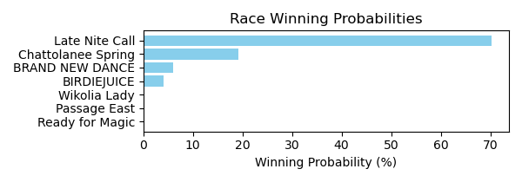

Figure: Winning Probability Distribution

NOTE: THIS RACE HAS HORSES THAT ARE MISSING CRITICAL DATA ELEMENTS

# Race: LRL | 2025-02-21 | Race #5 | Track: LAUREL PARK

Track: LAUREL PARK

|  |  |  |  |  |
| --- | --- | --- | --- | --- |
| Saddle Cloth # | Horse Name | Global Speed | Composite | Win Prob (%) |
| 1 | Irish Warlock * | 76.5 | 4.36 | 94.45 |
| 2 | B West * | 76.5 | -1.84 | 0.66 |
| 3 | Mister Agent * | 76.5 | -0.27 | 2.32 |
| 4 | He's Orientate * | 76.5 | -5.06 | 0.05 |
| 5 | The Judge and Jury * | 82.7 | -2.36 | 1.48 |
| 6 | Whiskey and You * | 76.5 | -3.80 | 0.14 |
| 7 | Shape Note * | 76.5 | -2.43 | 0.41 |
| 8 | Magic Spin * | 89.5 | -5.44 | 0.49 |

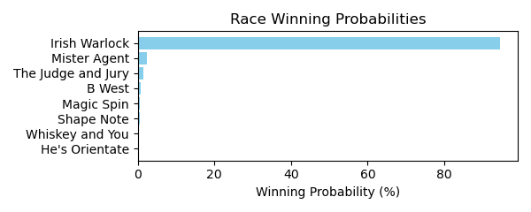

Figure: Winning Probability Distribution

NOTE: THIS RACE HAS HORSES THAT ARE MISSING CRITICAL DATA ELEMENTS

# Race: LRL | 2025-02-21 | Race #6 | Track: LAUREL PARK

Track: LAUREL PARK

|  |  |  |  |  |
| --- | --- | --- | --- | --- |
| Saddle Cloth # | Horse Name | Global Speed | Composite | Win Prob (%) |
| 1 | Gaga's Hamsome * | 76.2 | 5.91 | 1.86 |
| 2 | Esroh * | 76.2 | 1.36 | 0.05 |
| 3 | Itsamonstamash * | 70.9 | 8.22 | 4.12 |
| 4 | Rapido Rosa * | 70.9 | -2.85 | 0.00 |
| 5 | Can Do * | 76.2 | 4.27 | 0.50 |
| 6 | Green Eyed Monster * | 76.2 | 6.73 | 3.58 |
| 7 | Ade * | 70.9 | 5.86 | 0.63 |
| 8 | First Pearl * | 103.6 | 3.88 | 89.27 |

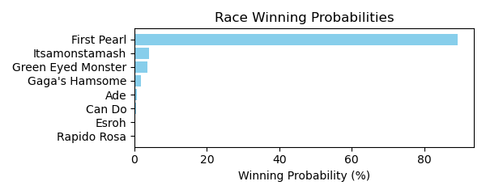

Figure: Winning Probability Distribution

NOTE: THIS RACE HAS HORSES THAT ARE MISSING CRITICAL DATA ELEMENTS

# Race: LRL | 2025-02-21 | Race #7 | Track: LAUREL PARK

Track: LAUREL PARK

|  |  |  |  |  |
| --- | --- | --- | --- | --- |
| Saddle Cloth # | Horse Name | Global Speed | Composite | Win Prob (%) |
| 1 | Mor Mor Mor * | 76.4 | 6.57 | 25.15 |
| 2 | Graceful Rose * | 82.4 | -9.35 | 0.00 |
| 3 | Dissolute * | 89.2 | 4.71 | 74.63 |
| 4 | Dwelling Legacy * | 76.4 | -0.71 | 0.07 |
| 5 | Feelin So Lucky * | 76.4 | -3.24 | 0.01 |
| 6 | Vicountess * | 82.4 | -6.16 | 0.00 |
| 7 | Kilo Road * | 76.4 | 0.04 | 0.14 |

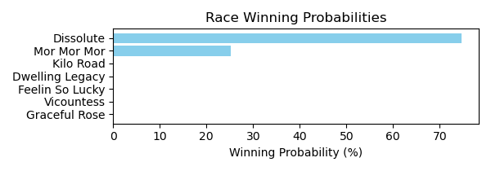

Figure: Winning Probability Distribution

NOTE: THIS RACE HAS HORSES THAT ARE MISSING CRITICAL DATA ELEMENTS

# Race: LRL | 2025-02-21 | Race #8 | Track: LAUREL PARK

Track: LAUREL PARK

|  |  |  |  |  |
| --- | --- | --- | --- | --- |
| Saddle Cloth # | Horse Name | Global Speed | Composite | Win Prob (%) |
| 1 | Magic Michael * | 111.8 | 2.63 | 0.55 |
| 1A | Just Call Ray * | 104.5 | -4.01 | 0.00 |
| 2 | Secret Zipper * | 111.8 | 9.02 | 90.47 |
| 3 | Crossland * | 104.5 | 7.58 | 6.57 |
| 4 | Curlin's Malibu * | 89.6 | 4.43 | 0.03 |
| 5 | Your Analysis * | 104.5 | 5.83 | 1.62 |
| 6 | Little Lance * | 104.5 | 4.90 | 0.77 |

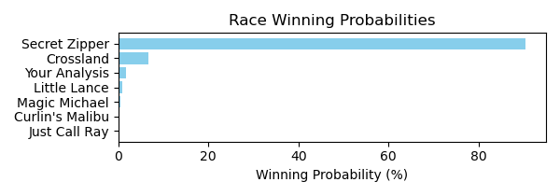

Figure: Winning Probability Distribution

NOTE: THIS RACE HAS HORSES THAT ARE MISSING CRITICAL DATA ELEMENTS

# Race: LRL | 2025-02-21 | Race #9 | Track: LAUREL PARK

Track: LAUREL PARK

|  |  |  |  |  |
| --- | --- | --- | --- | --- |
| Saddle Cloth # | Horse Name | Global Speed | Composite | Win Prob (%) |
| 1 | Autumn in Vermont * | 62.6 | -4.03 | 0.00 |
| 2 | Third Tuesday * | 75.9 | 2.68 | 0.01 |
| 3 | Storm Creed * | 110.5 | -1.48 | 0.41 |
| 4 | Tia Mayin * | 110.5 | -5.96 | 0.01 |
| 5 | Cundi * | 110.5 | -2.25 | 0.22 |
| 6 | Rascallion * | 110.5 | 5.38 | 99.35 |
| 7 | Aunt Margaret * | 70.7 | -5.39 | 0.00 |

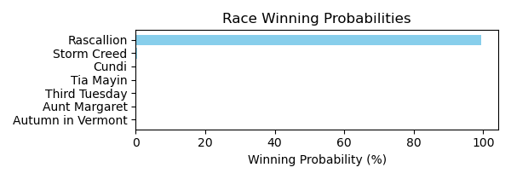

Figure: Winning Probability Distribution

NOTE: THIS RACE HAS HORSES THAT ARE MISSING CRITICAL DATA ELEMENTS

# Race: LRL | 2025-02-21 | Race #10 | Track: LAUREL PARK

Track: LAUREL PARK

|  |  |  |  |  |
| --- | --- | --- | --- | --- |
| Saddle Cloth # | Horse Name | Global Speed | Composite | Win Prob (%) |
| 1 | DONA HOPE (ARG) * | 72.4 | 5.15 | 10.21 |
| 2 | DUDA LUCK (ARG) * | 72.4 | 5.34 | 11.81 |
| 3 | PARTY LAKE (ARG) * | 72.4 | 4.87 | 8.13 |
| 4 | CON RIMOUT (ARG) * | 72.4 | 4.88 | 8.17 |
| 5 | ELLA VENDRA (ARG) * | 72.4 | 4.79 | 7.66 |
| 6 | DONNA STELLA (ARG) * | 75.9 | 5.08 | 19.61 |
| 7 | ESTRELLA DE ROCK (ARG) * | 75.9 | 5.24 | 22.28 |
| 8 | MASK LAND (ARG) * | 72.4 | 4.93 | 8.52 |
| 9 | SI AMOR (ARG) * | 66.3 | 5.37 | 3.61 |

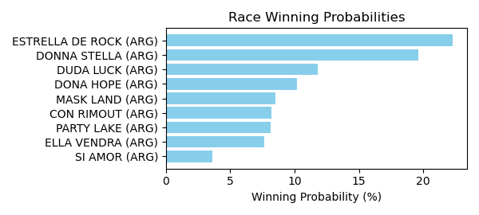

Figure: Winning Probability Distribution

NOTE: THIS RACE HAS HORSES THAT ARE MISSING CRITICAL DATA ELEMENTS

# Race: LRL | 2025-02-21 | Race #11 | Track: LAUREL PARK

Track: LAUREL PARK

|  |  |  |  |  |
| --- | --- | --- | --- | --- |
| Saddle Cloth # | Horse Name | Global Speed | Composite | Win Prob (%) |
| 1 | BLUE DOLLAR (ARG) * | 88.8 | 3.71 | 3.66 |
| 2 | LORD FORTUNE (ARG) * | 88.8 | 4.01 | 4.65 |
| 3 | SIRO'S KING (ARG) * | 88.8 | 4.02 | 4.68 |
| 4 | ATOMIC LEVEL (ARG) * | 88.8 | 4.01 | 4.67 |
| 5 | LOUIS CK (ARG) * | 103.4 | 3.85 | 76.85 |
| 6 | HABLA DE GLORIA (ARG) * | 76.0 | 4.01 | 0.37 |
| 7 | SFORZINI (ARG) * | 88.8 | 4.13 | 5.13 |

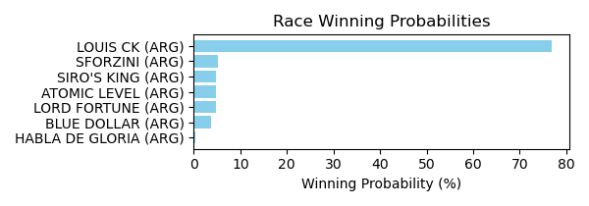

Figure: Winning Probability Distribution

NOTE: THIS RACE HAS HORSES THAT ARE MISSING CRITICAL DATA ELEMENTS

# Race: LRL | 2025-02-21 | Race #12 | Track: LAUREL PARK

Track: LAUREL PARK

|  |  |  |  |  |
| --- | --- | --- | --- | --- |
| Saddle Cloth # | Horse Name | Global Speed | Composite | Win Prob (%) |
| 1 | GIANT RIMOUT (ARG) * | 103.5 | 3.39 | 66.48 |
| 2 | MR BAUTI (ARG) * | 92.4 | 3.86 | 10.49 |
| 3 | TRIGO CANDEAL (ARG) * | 88.8 | 4.15 | 6.49 |
| 4 | FLYING TO THE SKY (ARG) * | 88.8 | 3.68 | 4.44 |
| 5 | SENOR DAN (ARG) * | 88.8 | 3.96 | 5.59 |
| 6 | JARDIN DEL POETA (ARG) * | 92.4 | 3.26 | 6.51 |

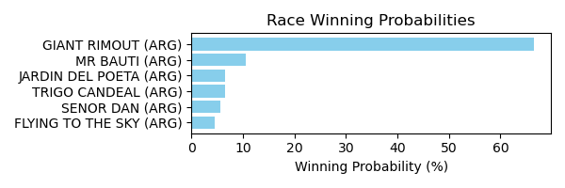

Figure: Winning Probability Distribution

NOTE: THIS RACE HAS HORSES THAT ARE MISSING CRITICAL DATA ELEMENTS

# Race: LRL | 2025-02-21 | Race #13 | Track: LAUREL PARK

Track: LAUREL PARK

|  |  |  |  |  |
| --- | --- | --- | --- | --- |
| Saddle Cloth # | Horse Name | Global Speed | Composite | Win Prob (%) |
| 1 | DENISKA (ARG) * | 88.7 | 4.65 | 43.78 |
| 2 | EXAMINED (ARG) * | 82.0 | 4.96 | 14.70 |
| 3 | PEQUENA MOROCHA (ARG) * | 80.4 | 4.75 | 9.05 |
| 4 | BELLA PATRICIA (ARG) * | 80.4 | 4.40 | 6.86 |
| 5 | GIFTED GIRL (ARG) * | 76.0 | 4.70 | 3.58 |
| 6 | ESCONDIDAS (ARG) * | 76.0 | 4.63 | 3.39 |
| 7 | ISLA MISTICA (ARG) * | 80.4 | 4.24 | 6.01 |
| 8 | LOBA NIMERIA (ARG) * | 80.4 | 4.44 | 7.06 |
| 9 | QUEEN CAUSE (ARG) * | 80.4 | 4.14 | 5.55 |

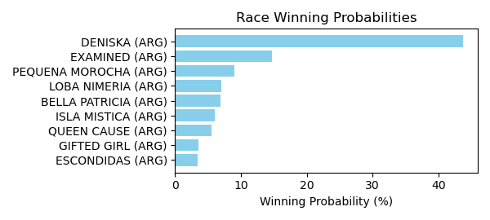

Figure: Winning Probability Distribution

NOTE: THIS RACE HAS HORSES THAT ARE MISSING CRITICAL DATA ELEMENTS

# Race: LRL | 2025-02-21 | Race #14 | Track: LAUREL PARK

Track: LAUREL PARK

|  |  |  |  |  |
| --- | --- | --- | --- | --- |
| Saddle Cloth # | Horse Name | Global Speed | Composite | Win Prob (%) |
| 1 | CAPRICHO MIO (ARG) * | 76.0 | 4.38 | 5.21 |
| 10 | ASTEGIANO (ARG) * | 76.0 | 4.37 | 5.19 |
| 11 | PERSIAN ISLAND (ARG) * | 76.0 | 4.64 | 6.42 |
| 12 | DELI WINNER (ARG) * | 74.6 | 4.11 | 3.18 |
| 2 | CRUSH (ARG) * | 74.6 | 4.02 | 2.98 |
| 3 | MANE GARRINCHA (ARG) * | 76.0 | 4.44 | 5.47 |
| 4 | ADRIATICAN (ARG) * | 74.6 | 4.42 | 4.10 |
| 5 | DADO VISION (ARG) * | 76.0 | 4.64 | 6.44 |
| 6 | CORSICO (ARG) * | 66.3 | 4.64 | 0.93 |
| 7 | ECLOS (ARG) * | 88.7 | 4.18 | 56.43 |
| 8 | ELITE RIMOUT (ARG) * | 74.6 | 3.97 | 2.85 |
| 9 | MOVER LIGERO (ARG) * | 66.3 | 4.44 | 0.79 |

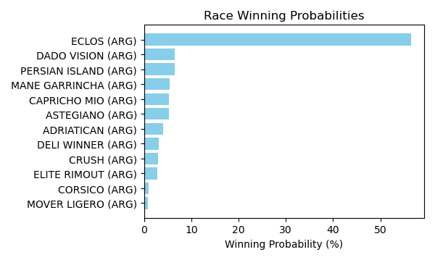

Figure: Winning Probability Distribution

NOTE: THIS RACE HAS HORSES THAT ARE MISSING CRITICAL DATA ELEMENTS

# Race: MVR | 2025-02-24 | Race #1 | Track: MAHONING VALLEY RACE COURSE

Track: MAHONING VALLEY RACE COURSE

|  |  |  |  |  |
| --- | --- | --- | --- | --- |
| Saddle Cloth # | Horse Name | Global Speed | Composite | Win Prob (%) |
| 1 | Divine Empire * | 76.2 | 4.45 | 22.92 |
| 2 | CAESAREA * | 76.2 | 3.73 | 12.93 |
| 3 | Blustering Breeze * | 76.2 | -2.53 | 0.09 |
| 4 | Galpin Sunday * | 76.2 | -5.18 | 0.01 |
| 5 | Great Revelation * | 76.2 | -9.14 | 0.00 |
| 6 | Beer Time * | 76.2 | -7.35 | 0.00 |
| 7 | Red in Front * | 76.2 | 5.73 | 64.05 |

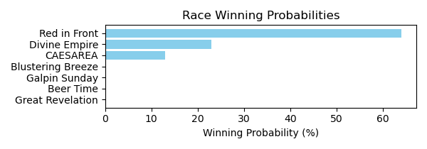

Figure: Winning Probability Distribution

NOTE: THIS RACE HAS HORSES THAT ARE MISSING CRITICAL DATA ELEMENTS

# Race: MVR | 2025-02-24 | Race #2 | Track: MAHONING VALLEY RACE COURSE

Track: MAHONING VALLEY RACE COURSE

|  |  |  |  |  |
| --- | --- | --- | --- | --- |
| Saddle Cloth # | Horse Name | Global Speed | Composite | Win Prob (%) |
| 1 | Dark Baron * | 104.0 | -4.37 | 0.00 |
| 2 | Capturethelaughter * | 104.0 | 8.10 | 73.46 |
| 3 | Torrefactor * | 104.0 | 4.47 | 4.03 |
| 4 | Verbier * | 104.0 | 2.61 | 0.91 |
| 5 | Gut Instinct * | 104.0 | 6.53 | 20.86 |
| 6 | Bayou Magic * | 104.0 | 0.26 | 0.14 |
| 7 | Sicilian Style Two * | 104.0 | 2.07 | 0.59 |

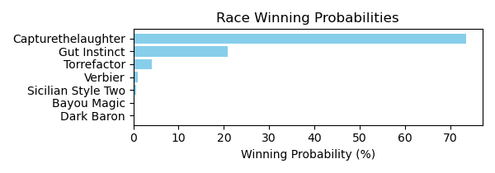

Figure: Winning Probability Distribution

NOTE: THIS RACE HAS HORSES THAT ARE MISSING CRITICAL DATA ELEMENTS

# Race: MVR | 2025-02-24 | Race #3 | Track: MAHONING VALLEY RACE COURSE

Track: MAHONING VALLEY RACE COURSE

|  |  |  |  |  |
| --- | --- | --- | --- | --- |
| Saddle Cloth # | Horse Name | Global Speed | Composite | Win Prob (%) |
| 1 | Bourbon Wisdom * | 104.1 | 7.46 | 20.04 |
| 2 | Cugine * | 104.1 | 6.43 | 8.83 |
| 3 | Morethanreadyeddie * | 104.1 | 8.78 | 57.49 |
| 4 | Napa Dude * | 104.1 | -0.97 | 0.02 |
| 5 | Credit River * | 104.1 | -4.24 | 0.00 |
| 6 | Bless the Kitten * | 104.1 | 6.65 | 10.47 |
| 7 | Royal Dragoon * | 104.1 | 1.22 | 0.14 |
| 8 | Hitsville * | 104.1 | -2.53 | 0.01 |
| 9 | See Spot Run * | 104.1 | 5.09 | 3.01 |

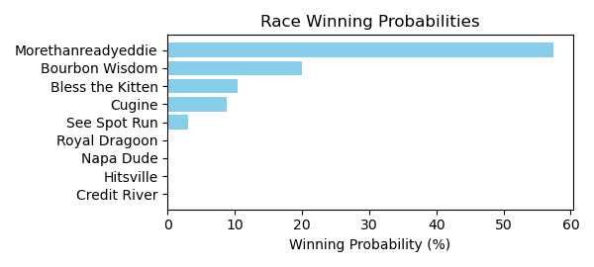

Figure: Winning Probability Distribution

NOTE: THIS RACE HAS HORSES THAT ARE MISSING CRITICAL DATA ELEMENTS

# Race: MVR | 2025-02-24 | Race #4 | Track: MAHONING VALLEY RACE COURSE

Track: MAHONING VALLEY RACE COURSE

|  |  |  |  |  |
| --- | --- | --- | --- | --- |
| Saddle Cloth # | Horse Name | Global Speed | Composite | Win Prob (%) |
| 1 | Doctor Wu * | 76.5 | 9.52 | 62.96 |
| 2 | Road to Stardom * | 76.5 | -5.47 | 0.00 |
| 3 | Southern Sense * | 76.5 | 1.34 | 0.09 |
| 4 | Game Boy Benny * | 76.5 | 7.94 | 17.83 |
| 5 | Scratchoff * | 76.5 | 3.15 | 0.38 |
| 6 | Outkissed * | 76.5 | 7.23 | 10.05 |
| 7 | Over the Hills * | 76.5 | -9.03 | 0.00 |
| 8 | P Money * | 76.5 | 7.04 | 8.68 |

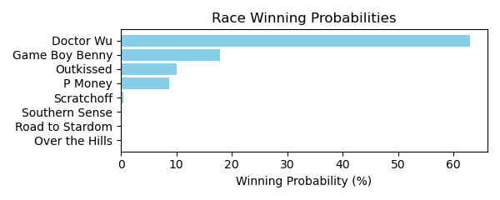

Figure: Winning Probability Distribution

NOTE: THIS RACE HAS HORSES THAT ARE MISSING CRITICAL DATA ELEMENTS

# Race: MVR | 2025-02-24 | Race #5 | Track: MAHONING VALLEY RACE COURSE

Track: MAHONING VALLEY RACE COURSE

|  |  |  |  |  |
| --- | --- | --- | --- | --- |
| Saddle Cloth # | Horse Name | Global Speed | Composite | Win Prob (%) |
| 1 | Ice Blast * | 104.0 | 3.35 | 2.73 |
| 10 | Leo and Royal * | 104.0 | 7.37 | 68.04 |
| 2 | Boss Bear * | 104.0 | -5.61 | 0.00 |
| 3 | Exonerated Prez * | 104.0 | -7.91 | 0.00 |
| 4 | Had Right * | 104.0 | -0.49 | 0.13 |
| 5 | Mamba Forever * | 104.0 | -0.00 | 0.19 |
| 6 | Jarlian * | 104.0 | 6.11 | 24.77 |
| 7 | Kadesh * | 104.0 | 3.60 | 3.33 |
| 8 | Millard's Smile * | 104.0 | 1.84 | 0.81 |
| 9 | Small Sailor * | 104.0 | -4.58 | 0.00 |

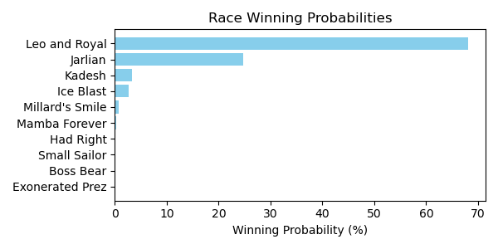

Figure: Winning Probability Distribution

NOTE: THIS RACE HAS HORSES THAT ARE MISSING CRITICAL DATA ELEMENTS

# Race: MVR | 2025-02-24 | Race #6 | Track: MAHONING VALLEY RACE COURSE

Track: MAHONING VALLEY RACE COURSE

|  |  |  |  |  |
| --- | --- | --- | --- | --- |
| Saddle Cloth # | Horse Name | Global Speed | Composite | Win Prob (%) |
| 1 | Money Room * | 104.1 | 1.35 | 1.15 |
| 2 | Delta Ridge * | 104.1 | -2.68 | 0.05 |
| 3 | Big Popper * | 104.1 | -4.42 | 0.01 |
| 4 | Last Cookie * | 104.1 | 6.57 | 74.93 |
| 5 | Tiz Speedy * | 104.1 | -1.03 | 0.17 |
| 6 | Mitole's Wish * | 104.1 | -4.93 | 0.01 |
| 7 | Law of the Jungle * | 104.1 | 5.13 | 23.65 |
| 8 | Panthera's Fate * | 104.1 | -3.01 | 0.04 |

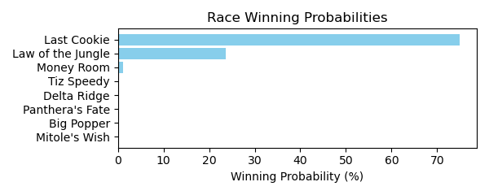

Figure: Winning Probability Distribution

NOTE: THIS RACE HAS HORSES THAT ARE MISSING CRITICAL DATA ELEMENTS

# Race: MVR | 2025-02-24 | Race #7 | Track: MAHONING VALLEY RACE COURSE

Track: MAHONING VALLEY RACE COURSE

|  |  |  |  |  |
| --- | --- | --- | --- | --- |
| Saddle Cloth # | Horse Name | Global Speed | Composite | Win Prob (%) |
| 1 | My Girl Kew * | 76.2 | 6.00 | 24.97 |
| 2 | Kiss Valentina * | 76.2 | 2.09 | 1.09 |
| 3 | Kiss Me Quick * | 76.2 | 6.87 | 49.76 |
| 4 | Beautiful Score * | 76.2 | -3.24 | 0.02 |
| 5 | Olympic Wings * | 76.2 | 2.38 | 1.38 |
| 6 | Hot Princess * | 76.2 | -2.98 | 0.02 |
| 7 | My Kinda Party * | 76.2 | 5.89 | 22.77 |

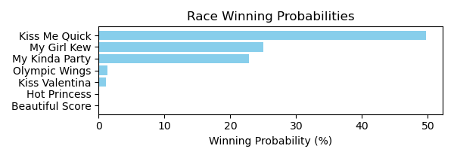

Figure: Winning Probability Distribution

NOTE: THIS RACE HAS HORSES THAT ARE MISSING CRITICAL DATA ELEMENTS

# Race: MVR | 2025-02-24 | Race #8 | Track: MAHONING VALLEY RACE COURSE

Track: MAHONING VALLEY RACE COURSE

|  |  |  |  |  |
| --- | --- | --- | --- | --- |
| Saddle Cloth # | Horse Name | Global Speed | Composite | Win Prob (%) |
| 1 | Princessofthenorth * | 76.3 | 7.29 | 27.59 |
| 10 | Emerson Jones * | 76.3 | 1.74 | 0.32 |
| 2 | Az We Speak * | 76.3 | 7.88 | 44.26 |
| 3 | Kerlo's Cause * | 76.3 | -4.81 | 0.00 |
| 4 | Princess Is Olivia * | 76.3 | 7.15 | 24.64 |
| 5 | Go Girl * | 76.3 | 4.31 | 2.54 |
| 6 | Beatiful Karla * | 76.3 | 0.14 | 0.09 |
| 7 | Devra Warrior * | 76.3 | -3.23 | 0.01 |
| 8 | Ashlee's Ring * | 76.3 | 2.09 | 0.43 |
| 9 | Sacred Connection * | 76.3 | 0.45 | 0.12 |

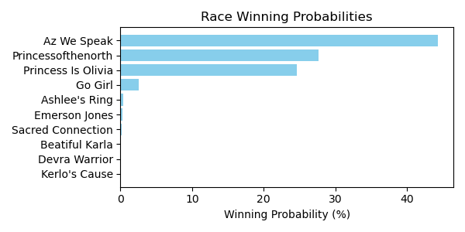

Figure: Winning Probability Distribution

NOTE: THIS RACE HAS HORSES THAT ARE MISSING CRITICAL DATA ELEMENTS

# Race: MVR | 2025-02-25 | Race #1 | Track: MAHONING VALLEY RACE COURSE

Track: MAHONING VALLEY RACE COURSE

|  |  |  |  |  |
| --- | --- | --- | --- | --- |
| Saddle Cloth # | Horse Name | Global Speed | Composite | Win Prob (%) |
| 1 | Master of the Nite * | 103.9 | 2.86 | 0.93 |
| 2 | Breakout Star * | 103.9 | 7.05 | 26.45 |
| 3 | Ranseur * | 103.9 | -1.09 | 0.04 |
| 4 | Writeitontheice * | 103.9 | -0.68 | 0.05 |
| 5 | Puff'smagicdragon * | 103.9 | 7.79 | 47.84 |
| 6 | Royally Flushed * | 103.9 | 6.91 | 23.52 |
| 7 | Chaps Knight * | 103.9 | 3.16 | 1.18 |
| 8 | Euphoria Star * | 103.9 | -6.07 | 0.00 |

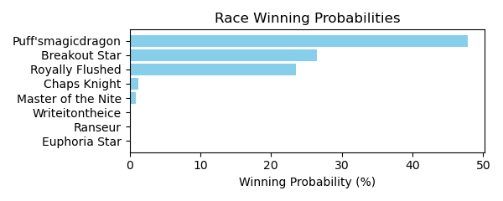

Figure: Winning Probability Distribution

NOTE: THIS RACE HAS HORSES THAT ARE MISSING CRITICAL DATA ELEMENTS

# Race: MVR | 2025-02-25 | Race #2 | Track: MAHONING VALLEY RACE COURSE

Track: MAHONING VALLEY RACE COURSE

|  |  |  |  |  |
| --- | --- | --- | --- | --- |
| Saddle Cloth # | Horse Name | Global Speed | Composite | Win Prob (%) |
| 1 | Kerri's Miracle * | 76.3 | 2.38 | 0.12 |
| 2 | Cause of Love * | 76.3 | 3.50 | 0.30 |
| 3 | Better Half * | 108.6 | 0.62 | 19.27 |
| 4 | Goodness Sakes * | 76.3 | -4.42 | 0.00 |
| 5 | High Fire * | 108.6 | 2.38 | 78.31 |
| 6 | Crossed Up * | 76.3 | 2.70 | 0.16 |
| 7 | The Miracle Kiut * | 76.3 | 5.77 | 1.84 |

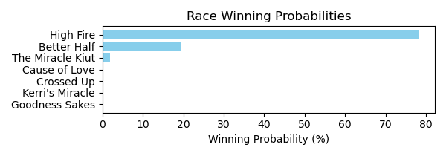

Figure: Winning Probability Distribution

NOTE: THIS RACE HAS HORSES THAT ARE MISSING CRITICAL DATA ELEMENTS

# Race: MVR | 2025-02-25 | Race #3 | Track: MAHONING VALLEY RACE COURSE

Track: MAHONING VALLEY RACE COURSE

|  |  |  |  |  |
| --- | --- | --- | --- | --- |
| Saddle Cloth # | Horse Name | Global Speed | Composite | Win Prob (%) |
| 1 | Lucky Penny Rose * | 104.0 | 1.61 | 0.37 |
| 2 | Gila * | 104.0 | 8.34 | 82.03 |
| 3 | Lady Jasper * | 104.0 | 0.84 | 0.20 |
| 4 | Lofty Cowtown * | 104.0 | 5.52 | 8.56 |
| 5 | Divine Fashion * | 104.0 | 3.47 | 1.66 |
| 6 | Mobil Chic * | 104.0 | -4.96 | 0.00 |
| 7 | Mobil Lady * | 104.0 | 5.29 | 7.16 |

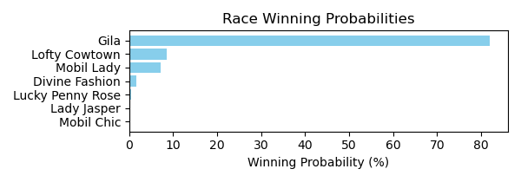

Figure: Winning Probability Distribution

NOTE: THIS RACE HAS HORSES THAT ARE MISSING CRITICAL DATA ELEMENTS

# Race: MVR | 2025-02-25 | Race #4 | Track: MAHONING VALLEY RACE COURSE

Track: MAHONING VALLEY RACE COURSE

|  |  |  |  |  |
| --- | --- | --- | --- | --- |
| Saddle Cloth # | Horse Name | Global Speed | Composite | Win Prob (%) |
| 1 | Play Ball * | 76.1 | -5.38 | 0.01 |
| 2 | Kid Russell * | 76.1 | -7.12 | 0.00 |
| 3 | Marvin's Express * | 103.6 | -4.97 | 3.43 |
| 4 | El Marro * | 76.1 | 2.75 | 6.85 |
| 5 | dh-Spin Doctor * | 76.1 | 3.33 | 10.87 |
| 6 | Honor the D * | 76.1 | -4.75 | 0.02 |
| 7 | Bad Boy Boogie * | 82.1 | -9.63 | 0.00 |
| 8 | Keeping Score * | 76.1 | -9.01 | 0.00 |
| 9 | Beat the Dealer * | 76.1 | 5.80 | 78.82 |

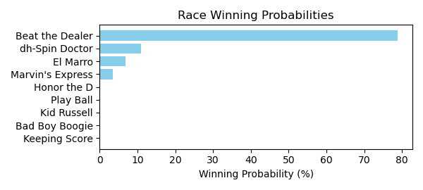

Figure: Winning Probability Distribution

NOTE: THIS RACE HAS HORSES THAT ARE MISSING CRITICAL DATA ELEMENTS

# Race: MVR | 2025-02-25 | Race #5 | Track: MAHONING VALLEY RACE COURSE

Track: MAHONING VALLEY RACE COURSE

|  |  |  |  |  |
| --- | --- | --- | --- | --- |
| Saddle Cloth # | Horse Name | Global Speed | Composite | Win Prob (%) |
| 1 | Lovebug * | 76.1 | 6.91 | 70.02 |
| 2 | Rose's Wish * | 76.1 | 2.86 | 2.75 |
| 3 | Orgullosa Pacifica * | 76.1 | 2.07 | 1.46 |
| 4 | DEVILSGOLDENFIDDLE * | 74.6 | 4.32 | 6.41 |
| 5 | Miss Little Bit * | 66.4 | -9.30 | 0.00 |
| 6 | Wicked Eyes * | 76.1 | -0.29 | 0.22 |
| 7 | FLYING PHOENIX * | 74.6 | 4.32 | 6.45 |
| 8 | Solo Surprise * | 76.1 | 3.13 | 3.40 |
| 9 | TURMALINA * | 76.1 | 4.39 | 9.29 |

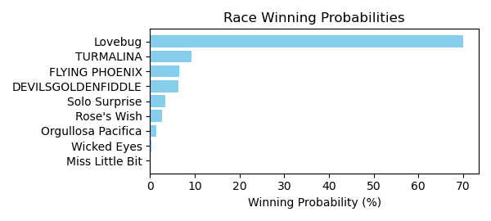

Figure: Winning Probability Distribution

NOTE: THIS RACE HAS HORSES THAT ARE MISSING CRITICAL DATA ELEMENTS

# Race: MVR | 2025-02-25 | Race #6 | Track: MAHONING VALLEY RACE COURSE

Track: MAHONING VALLEY RACE COURSE

|  |  |  |  |  |
| --- | --- | --- | --- | --- |
| Saddle Cloth # | Horse Name | Global Speed | Composite | Win Prob (%) |
| 1 | Bythenumbers * | 103.9 | -4.48 | 0.23 |
| 2 | Garden Secrets * | 103.9 | -2.20 | 1.39 |
| 3 | Elko * | 103.9 | -6.81 | 0.03 |
| 4 | Queen Lexi * | 103.9 | 2.96 | 86.21 |
| 5 | Islandinthestream * | 103.9 | -3.22 | 0.61 |
| 6 | Hebrides * | 103.9 | -0.10 | 7.48 |
| 7 | Rumours Fly * | 103.9 | -5.76 | 0.08 |
| 8 | Mary Katherine * | 103.9 | -0.90 | 3.94 |
| 9 | Mangorita * | 103.9 | -6.92 | 0.03 |

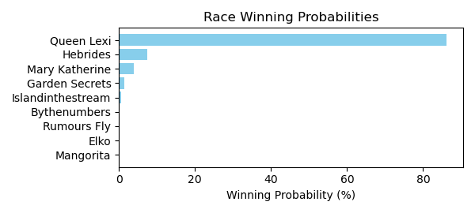

Figure: Winning Probability Distribution

NOTE: THIS RACE HAS HORSES THAT ARE MISSING CRITICAL DATA ELEMENTS

# Race: MVR | 2025-02-25 | Race #7 | Track: MAHONING VALLEY RACE COURSE

Track: MAHONING VALLEY RACE COURSE

|  |  |  |  |  |
| --- | --- | --- | --- | --- |
| Saddle Cloth # | Horse Name | Global Speed | Composite | Win Prob (%) |
| 1 | Battle of Bastogne * | 82.5 | -6.60 | 0.00 |
| 10 | Hub * | 76.4 | 5.21 | 11.58 |
| 11 | One Way Traffic * | 82.5 | -1.94 | 0.13 |
| 2 | Deus Ex Machina * | 76.4 | -1.78 | 0.04 |
| 3 | Lucky Nineteen * | 76.4 | -1.03 | 0.08 |
| 4 | Bucket List * | 76.4 | 2.34 | 1.17 |
| 5 | Buehler's Day Off * | 76.4 | 7.37 | 64.76 |
| 6 | Destino * | 76.4 | -6.76 | 0.00 |
| 7 | Sir * | 76.4 | 4.78 | 8.19 |
| 8 | Bailamos * | 76.4 | 5.20 | 11.48 |
| 9 | Mshindi * | 76.4 | 3.33 | 2.57 |

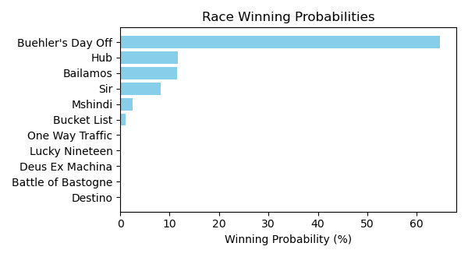

Figure: Winning Probability Distribution

NOTE: THIS RACE HAS HORSES THAT ARE MISSING CRITICAL DATA ELEMENTS

# Race: MVR | 2025-02-25 | Race #8 | Track: MAHONING VALLEY RACE COURSE

Track: MAHONING VALLEY RACE COURSE

|  |  |  |  |  |
| --- | --- | --- | --- | --- |
| Saddle Cloth # | Horse Name | Global Speed | Composite | Win Prob (%) |
| 1 | Domi * | 108.5 | -1.49 | 0.12 |
| 2 | Spuns Son * | 108.5 | 5.88 | 43.76 |
| 3 | Convert * | 103.8 | 4.10 | 4.06 |
| 4 | Availability * | 108.5 | -2.81 | 0.04 |
| 5 | Ramsey * | 103.8 | -1.34 | 0.05 |
| 6 | Sage Runner * | 108.5 | 0.83 | 0.77 |
| 7 | Lt's Jacknthebox * | 108.5 | 6.08 | 51.19 |
| 8 | Bamby Boom * | 71.0 | -2.17 | 0.00 |
| 9 | Golden Al * | 108.5 | -6.37 | 0.00 |

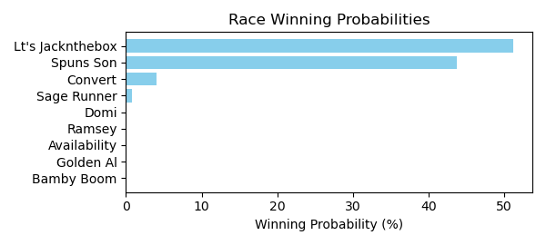

Figure: Winning Probability Distribution

NOTE: THIS RACE HAS HORSES THAT ARE MISSING CRITICAL DATA ELEMENTS

# Race: MVR | 2025-02-25 | Race #9 | Track: MAHONING VALLEY RACE COURSE

Track: MAHONING VALLEY RACE COURSE

|  |  |  |  |  |
| --- | --- | --- | --- | --- |
| Saddle Cloth # | Horse Name | Global Speed | Composite | Win Prob (%) |
| 1 | Dude the Legend * | 103.0 | -0.83 | 1.51 |
| 2 | Wild Domain * | 75.8 | 5.64 | 1.17 |
| 3 | Remix From Phoenix * | 75.8 | -0.51 | 0.01 |
| 4 | Skunk Ape * | 75.8 | -2.29 | 0.00 |
| 5 | Hidden Heart * | 103.0 | 4.35 | 95.13 |
| 6 | Indy's Hope * | 103.0 | -1.89 | 0.65 |
| 7 | RED CHIPS * | 75.8 | 5.01 | 0.70 |
| 8 | BUMPER STICKER * | 75.8 | 5.23 | 0.84 |

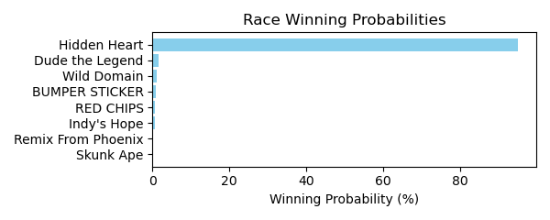

Figure: Winning Probability Distribution

NOTE: THIS RACE HAS HORSES THAT ARE MISSING CRITICAL DATA ELEMENTS

# Race: MVR | 2025-02-25 | Race #10 | Track: MAHONING VALLEY RACE COURSE

Track: MAHONING VALLEY RACE COURSE

|  |  |  |  |  |
| --- | --- | --- | --- | --- |
| Saddle Cloth # | Horse Name | Global Speed | Composite | Win Prob (%) |
| 1 | SILENT DRILL * | 75.9 | 4.01 | 10.68 |
| 2 | HIS ROYAL HIGHNESS * | 78.8 | 4.04 | 19.49 |
| 3 | Blue Blood Cowboy * | 75.9 | -4.03 | 0.02 |
| 4 | Vernon's Best * | 75.9 | 4.10 | 11.46 |
| 5 | P J's Boy * | 75.9 | 5.17 | 26.93 |
| 6 | Flaring Song * | 75.9 | 0.90 | 0.88 |
| 7 | Formyboys * | 103.1 | -1.49 | 30.52 |
| 8 | He Is Dynamic * | 75.9 | -6.42 | 0.00 |
| 9 | Lucky Kater * | 75.9 | -7.92 | 0.00 |

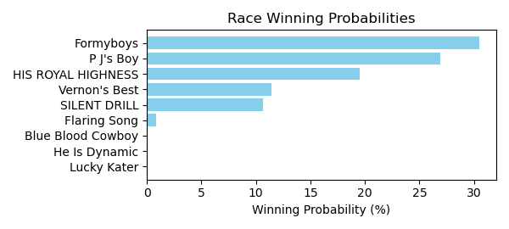

Figure: Winning Probability Distribution

NOTE: THIS RACE HAS HORSES THAT ARE MISSING CRITICAL DATA ELEMENTS

# Race: TOP | 2025-02-21 | Race #1 | Track: OAKLAWN PARK

Track: OAKLAWN PARK

|  |  |  |  |  |
| --- | --- | --- | --- | --- |
| Saddle Cloth # | Horse Name | Global Speed | Composite | Win Prob (%) |
| 1 | Max Mischief * | 76.3 | -8.07 | 0.01 |
| 2 | Levee Was Dry * | 76.3 | 1.70 | 17.85 |
| 3 | HECKAMIGHTY * | 76.3 | 3.57 | 79.47 |
| 4 | Tactical Man * | 76.3 | -7.05 | 0.02 |
| 5 | Chun Money * | 76.3 | -5.21 | 0.07 |
| 6 | Arjun for Karz * | 76.3 | -9.75 | 0.00 |
| 7 | Good News Rocket * | 76.3 | -1.05 | 1.97 |
| 8 | World Fair * | 76.3 | -2.52 | 0.61 |

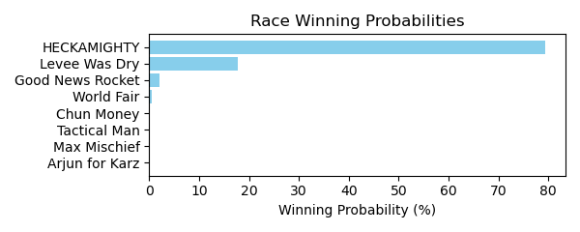

Figure: Winning Probability Distribution

NOTE: THIS RACE HAS HORSES THAT ARE MISSING CRITICAL DATA ELEMENTS

# Race: TOP | 2025-02-21 | Race #2 | Track: OAKLAWN PARK

Track: OAKLAWN PARK

|  |  |  |  |  |
| --- | --- | --- | --- | --- |
| Saddle Cloth # | Horse Name | Global Speed | Composite | Win Prob (%) |
| 1 | Paint Baller * | 76.4 | 8.29 | 85.07 |
| 2 | Handsome Herb * | 76.4 | -7.00 | 0.00 |
| 3 | Walstib * | 76.4 | 1.25 | 0.30 |
| 4 | Trusted Image * | 76.4 | -5.97 | 0.00 |
| 5 | JINXZI * | 76.4 | 5.86 | 12.17 |
| 6 | Tiz My Hero * | 76.4 | -3.74 | 0.01 |
| 7 | Spielman * | 76.4 | 0.31 | 0.14 |
| 8 | Simovic * | 76.4 | 3.42 | 1.73 |
| 9 | Nyquist Frequency * | 76.4 | 2.03 | 0.57 |

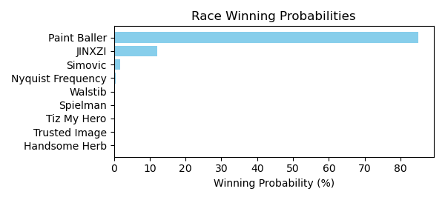

Figure: Winning Probability Distribution

NOTE: THIS RACE HAS HORSES THAT ARE MISSING CRITICAL DATA ELEMENTS

# Race: TOP | 2025-02-21 | Race #3 | Track: OAKLAWN PARK

Track: OAKLAWN PARK

|  |  |  |  |  |
| --- | --- | --- | --- | --- |
| Saddle Cloth # | Horse Name | Global Speed | Composite | Win Prob (%) |
| 1 | Peace Dog * | 76.4 | 6.09 | 24.52 |
| 10 | Dicey Wager * | 76.4 | -7.32 | 0.00 |
| 11 | Reef's Destiny * | 76.4 | 1.07 | 0.44 |
| 12 | Colonel Barton * | 76.4 | -6.57 | 0.00 |
| 2 | Choctaw Zip * | 76.4 | 7.31 | 65.20 |
| 3 | Blessed Vision * | 76.4 | -0.94 | 0.09 |
| 4 | Miri a Coincidence * | 76.4 | -6.29 | 0.00 |
| 5 | Cooler King * | 76.4 | -3.97 | 0.01 |
| 6 | You Vee Cee * | 76.4 | 4.93 | 9.73 |
| 7 | Changing Times * | 76.4 | -8.30 | 0.00 |
| 8 | Macho Ronnie * | 76.4 | -5.78 | 0.00 |
| 9 | I'm an Oak * | 76.4 | -3.30 | 0.01 |

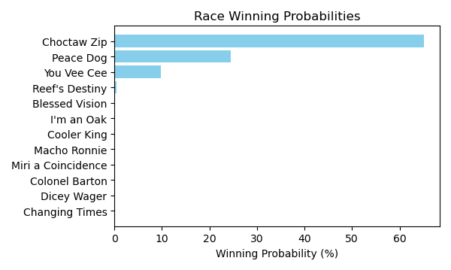

Figure: Winning Probability Distribution

NOTE: THIS RACE HAS HORSES THAT ARE MISSING CRITICAL DATA ELEMENTS

# Race: TOP | 2025-02-21 | Race #4 | Track: OAKLAWN PARK

Track: OAKLAWN PARK

|  |  |  |  |  |
| --- | --- | --- | --- | --- |
| Saddle Cloth # | Horse Name | Global Speed | Composite | Win Prob (%) |
| 1 | She's Solid Silver * | 76.3 | 0.39 | 0.25 |
| 10 | Spin the Breeze * | 76.3 | -2.12 | 0.03 |
| 11 | Twas Lola * | 76.3 | -0.61 | 0.11 |
| 2 | Sparkly * | 76.3 | 6.78 | 42.17 |
| 3 | Hot Day * | 76.3 | 5.47 | 14.75 |
| 4 | Lady Riley * | 76.3 | -4.66 | 0.00 |
| 5 | Babe in the Woods * | 76.3 | -3.22 | 0.01 |
| 6 | Be My Huckleberry * | 76.3 | -9.20 | 0.00 |
| 7 | Wampus Kitten * | 76.3 | -7.43 | 0.00 |
| 8 | Chica Arma * | 76.3 | 6.80 | 42.65 |
| 9 | My Kinda Trouble * | 76.3 | -5.17 | 0.00 |

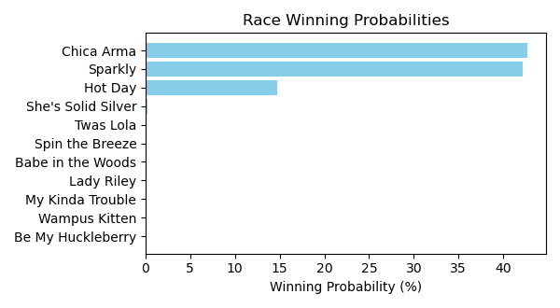

Figure: Winning Probability Distribution

NOTE: THIS RACE HAS HORSES THAT ARE MISSING CRITICAL DATA ELEMENTS

# Race: TOP | 2025-02-21 | Race #5 | Track: OAKLAWN PARK

Track: OAKLAWN PARK

|  |  |  |  |  |
| --- | --- | --- | --- | --- |
| Saddle Cloth # | Horse Name | Global Speed | Composite | Win Prob (%) |
| 1 | Preacher's Kid * | 76.2 | -4.67 | 0.01 |
| 10 | Run Deano Run * | 76.2 | -8.66 | 0.00 |
| 11 | Gentle Ben * | 76.2 | -10.08 | 0.00 |
| 2 | Big Bourbon River * | 76.2 | -6.58 | 0.00 |
| 3 | Museum Quality * | 76.2 | 5.57 | 26.93 |
| 4 | Rerun * | 76.2 | -7.12 | 0.00 |
| 5 | Austin's Map * | 76.2 | -1.88 | 0.07 |
| 6 | Shot At Pure Peace * | 76.2 | -10.32 | 0.00 |
| 7 | Mo Heartaches * | 76.2 | -5.10 | 0.01 |
| 8 | Safe Bet * | 76.2 | 6.78 | 70.84 |
| 9 | Penrod * | 76.2 | 2.41 | 2.15 |

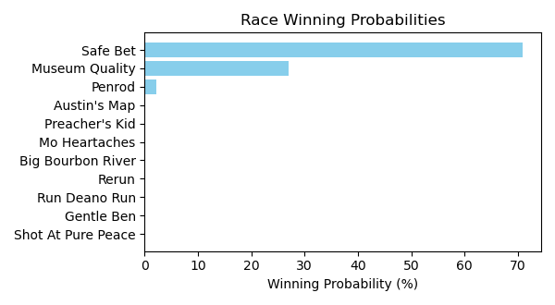

Figure: Winning Probability Distribution

NOTE: THIS RACE HAS HORSES THAT ARE MISSING CRITICAL DATA ELEMENTS

# Race: TOP | 2025-02-21 | Race #6 | Track: OAKLAWN PARK

Track: OAKLAWN PARK

|  |  |  |  |  |
| --- | --- | --- | --- | --- |
| Saddle Cloth # | Horse Name | Global Speed | Composite | Win Prob (%) |
| 1 | She's Not a Joke * | 76.4 | 8.43 | 78.22 |
| 2 | Xyngin Spitfire * | 76.4 | 5.28 | 6.31 |
| 3 | Our Keepsake * | 76.4 | 2.85 | 0.90 |
| 4 | Scrupulous * | 76.4 | 4.87 | 4.53 |
| 5 | What's to Do * | 76.4 | 2.79 | 0.85 |
| 6 | Spirit Rules * | 76.4 | -0.81 | 0.05 |
| 7 | Chojo * | 76.4 | -5.52 | 0.00 |
| 8 | Sweet Mother Mary * | 76.4 | 2.74 | 0.82 |
| 9 | Q's Your Mama * | 76.4 | 5.63 | 8.31 |

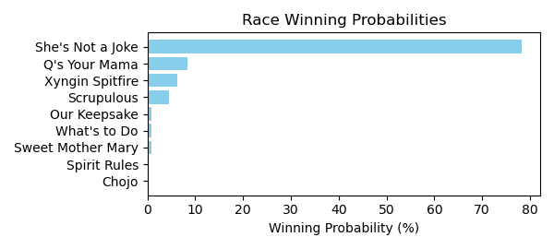

Figure: Winning Probability Distribution

NOTE: THIS RACE HAS HORSES THAT ARE MISSING CRITICAL DATA ELEMENTS

# Race: TOP | 2025-02-21 | Race #7 | Track: OAKLAWN PARK

Track: OAKLAWN PARK

|  |  |  |  |  |
| --- | --- | --- | --- | --- |
| Saddle Cloth # | Horse Name | Global Speed | Composite | Win Prob (%) |
| 1 | Viveca * | 111.2 | -5.69 | 0.00 |
| 10 | Cat Pays the Toll * | 111.2 | -8.98 | 0.00 |
| 2 | Pink Ruby * | 111.2 | -7.91 | 0.00 |
| 3 | LOTTERY TICKET * | 111.2 | 4.28 | 3.80 |
| 4 | Zen Dreams * | 111.2 | -3.16 | 0.01 |
| 5 | St. Albans Raid * | 111.2 | -8.64 | 0.00 |
| 6 | My Shot * | 111.2 | -1.24 | 0.05 |
| 7 | Vino Tiempo * | 111.2 | -3.03 | 0.01 |
| 8 | Kerry's Kiss * | 111.2 | 8.26 | 91.52 |
| 9 | FALL IN LOVE * | 111.2 | 4.53 | 4.62 |

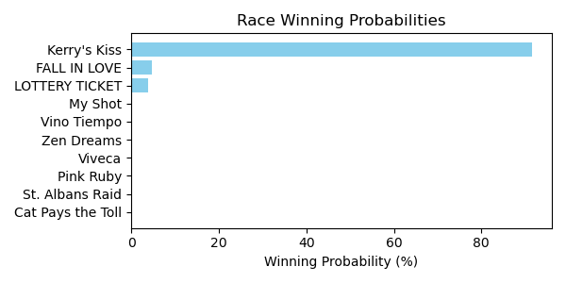

Figure: Winning Probability Distribution

NOTE: THIS RACE HAS HORSES THAT ARE MISSING CRITICAL DATA ELEMENTS

# Race: TOP | 2025-02-21 | Race #8 | Track: OAKLAWN PARK

Track: OAKLAWN PARK

|  |  |  |  |  |
| --- | --- | --- | --- | --- |
| Saddle Cloth # | Horse Name | Global Speed | Composite | Win Prob (%) |
| 1 | Golden Luna * | 76.6 | -5.12 | 0.00 |
| 10 | Ian Glass * | 76.6 | 4.53 | 0.45 |
| 2 | El Diablo Rojo * | 76.6 | 8.22 | 8.56 |
| 3 | Russian to Win * | 76.6 | 8.76 | 13.18 |
| 4 | Pressure * | 76.6 | -2.53 | 0.00 |
| 5 | Top Gun Tommy * | 76.6 | 6.80 | 2.74 |
| 6 | Eternally Grateful * | 76.6 | 9.62 | 26.18 |
| 7 | Vale * | 76.6 | 2.10 | 0.06 |
| 8 | Raymond * | 76.6 | 10.40 | 48.79 |
| 9 | Drill's Li'l Man * | 76.6 | 1.37 | 0.04 |

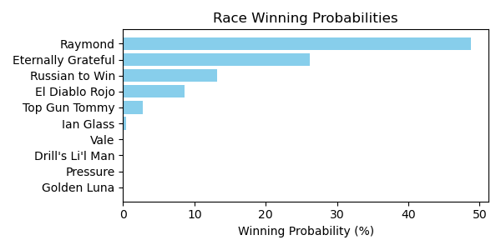

Figure: Winning Probability Distribution

NOTE: THIS RACE HAS HORSES THAT ARE MISSING CRITICAL DATA ELEMENTS

# Race: TOP | 2025-02-21 | Race #9 | Track: OAKLAWN PARK

Track: OAKLAWN PARK

|  |  |  |  |  |
| --- | --- | --- | --- | --- |
| Saddle Cloth # | Horse Name | Global Speed | Composite | Win Prob (%) |
| 1 | I'm McDreamy * | 104.4 | 0.13 | 0.13 |
| 10 | Anthonian * | 104.4 | 0.15 | 0.14 |
| 2 | Daily Grind * | 104.4 | 6.68 | 25.42 |
| 3 | Millers Rite * | 104.4 | 3.23 | 1.60 |
| 4 | Gun Party * | 104.4 | -3.49 | 0.01 |
| 5 | Indy Magic * | 104.4 | -5.34 | 0.00 |
| 6 | Liam's Journey * | 104.4 | -6.54 | 0.00 |
| 7 | Gold Sweep * | 104.4 | 1.31 | 0.35 |
| 8 | Caper's Hooley * | 104.4 | 3.35 | 1.77 |
| 9 | Lat Long * | 104.4 | 7.96 | 70.57 |

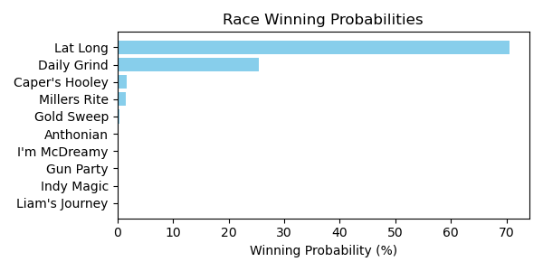

Figure: Winning Probability Distribution

NOTE: THIS RACE HAS HORSES THAT ARE MISSING CRITICAL DATA ELEMENTS

# Race: TOP | 2025-02-21 | Race #10 | Track: OAKLAWN PARK

Track: OAKLAWN PARK

|  |  |  |  |  |
| --- | --- | --- | --- | --- |
| Saddle Cloth # | Horse Name | Global Speed | Composite | Win Prob (%) |
| 1 | Ice Again * | 111.4 | 2.85 | 1.12 |
| 10 | Fear of Union * | 111.4 | 8.25 | 84.82 |
| 11 | Famous Final Scene * | 111.4 | 5.89 | 12.75 |
| 2 | Hollywood Ending * | 111.4 | -3.18 | 0.01 |
| 3 | Mount Craig * | 111.4 | 1.51 | 0.39 |
| 4 | Charbon * | 111.4 | -0.84 | 0.06 |
| 5 | dh-Redbird Nation * | 111.4 | -3.68 | 0.01 |
| 6 | Gluckstadt * | 111.4 | 0.82 | 0.22 |
| 7 | Reveille Valley * | 111.4 | 2.04 | 0.59 |
| 8 | Rivetage * | 111.4 | -1.38 | 0.04 |
| 9 | dh-Fastened * | 111.4 | -3.91 | 0.01 |

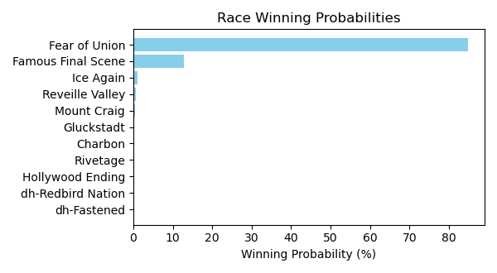

Figure: Winning Probability Distribution

NOTE: THIS RACE HAS HORSES THAT ARE MISSING CRITICAL DATA ELEMENTS

# Race: TOP | 2025-02-22 | Race #1 | Track: OAKLAWN PARK

Track: OAKLAWN PARK

|  |  |  |  |  |
| --- | --- | --- | --- | --- |
| Saddle Cloth # | Horse Name | Global Speed | Composite | Win Prob (%) |
| 1 | Fever Night * | 111.6 | 2.79 | 1.61 |
| 10 | Ripped * | 111.6 | 3.71 | 3.37 |
| 2 | Zardun * | 111.6 | 6.10 | 22.84 |
| 3 | Clever Again * | 111.6 | 6.88 | 42.48 |
| 4 | Just Classic * | 111.6 | -6.36 | 0.00 |
| 5 | Shepherd * | 111.6 | -3.35 | 0.01 |
| 6 | Baobab * | 111.6 | 4.94 | 8.97 |
| 7 | Doroteo * | 111.6 | 5.82 | 18.17 |
| 8 | Crisis Manager * | 111.6 | 2.96 | 1.85 |
| 9 | Hired Gun * | 111.6 | 1.75 | 0.70 |

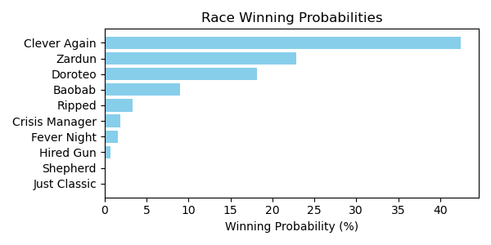

Figure: Winning Probability Distribution

NOTE: THIS RACE HAS HORSES THAT ARE MISSING CRITICAL DATA ELEMENTS

# Race: TOP | 2025-02-22 | Race #2 | Track: OAKLAWN PARK

Track: OAKLAWN PARK

|  |  |  |  |  |
| --- | --- | --- | --- | --- |
| Saddle Cloth # | Horse Name | Global Speed | Composite | Win Prob (%) |
| 1 | Distorted Pro * | 76.7 | 5.98 | 1.78 |
| 10 | Sitka * | 76.7 | 9.25 | 24.52 |
| 11 | Red State * | 76.7 | 4.14 | 0.41 |
| 2 | I'm Wide Awake * | 76.7 | 9.76 | 36.77 |
| 3 | Rowdy Riot * | 76.7 | 4.69 | 0.64 |
| 4 | Great Richie M * | 76.7 | 6.98 | 3.98 |
| 5 | B Sudd * | 76.7 | 6.85 | 3.59 |
| 6 | Manta Rey * | 76.7 | 3.16 | 0.19 |
| 7 | Goodasiwonswas * | 76.7 | 7.06 | 4.26 |
| 8 | Breslau * | 76.7 | 2.46 | 0.11 |
| 9 | Run Jalen Run * | 76.7 | 9.21 | 23.75 |

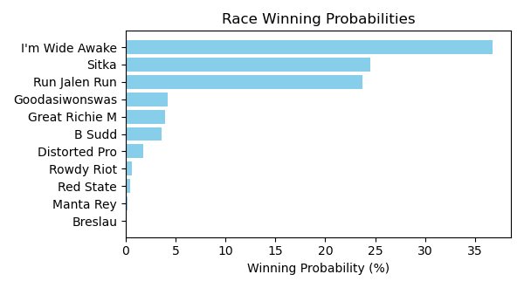

Figure: Winning Probability Distribution

NOTE: THIS RACE HAS HORSES THAT ARE MISSING CRITICAL DATA ELEMENTS

# Race: TOP | 2025-02-22 | Race #3 | Track: OAKLAWN PARK

Track: OAKLAWN PARK

|  |  |  |  |  |
| --- | --- | --- | --- | --- |
| Saddle Cloth # | Horse Name | Global Speed | Composite | Win Prob (%) |
| 1 | Ashburn Alley * | 76.5 | 9.88 | 80.22 |
| 10 | Theresasilverlinin * | 76.5 | -5.93 | 0.00 |
| 11 | Brooklynn Drew * | 76.5 | -4.49 | 0.00 |
| 12 | Gloriette * | 76.5 | 6.15 | 4.07 |
| 13 | Managing Mischief * | 76.5 | 1.28 | 0.08 |
| 14 | Popperina * | 76.5 | 1.90 | 0.14 |
| 2 | Queen's Martini * | 76.5 | -0.30 | 0.02 |
| 3 | Princess Is Olivia * | 76.5 | 1.67 | 0.11 |
| 4 | Bennykayandsuzytoo * | 76.5 | 7.35 | 10.68 |
| 5 | Tiffany Twist * | 76.5 | 0.25 | 0.04 |
| 6 | Laurie's Secret * | 76.5 | -9.16 | 0.00 |
| 7 | Insightful Miss * | 76.5 | 6.31 | 4.64 |
| 8 | That's Our Vision * | 76.5 | -8.10 | 0.00 |
| 9 | Music Mistress * | 76.5 | -4.84 | 0.00 |

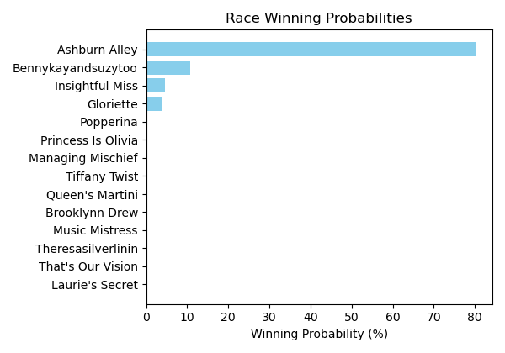

Figure: Winning Probability Distribution

NOTE: THIS RACE HAS HORSES THAT ARE MISSING CRITICAL DATA ELEMENTS

# Race: TOP | 2025-02-22 | Race #4 | Track: OAKLAWN PARK

Track: OAKLAWN PARK

|  |  |  |  |  |
| --- | --- | --- | --- | --- |
| Saddle Cloth # | Horse Name | Global Speed | Composite | Win Prob (%) |
| 1 | Benedetta * | 76.6 | 6.83 | 20.36 |
| 2 | Mazoku * | 76.6 | 7.89 | 47.66 |
| 3 | Justique * | 76.6 | 5.76 | 8.66 |
| 4 | Sandy Bottom * | 76.6 | 1.89 | 0.39 |
| 5 | Miss Arlington * | 76.6 | -3.47 | 0.01 |
| 6 | Ms. Bucchero * | 76.6 | 2.76 | 0.79 |
| 7 | American Band * | 76.6 | 1.74 | 0.35 |
| 8 | Lady Moscato * | 76.6 | 6.90 | 21.55 |
| 9 | Pistol * | 76.6 | 1.31 | 0.25 |

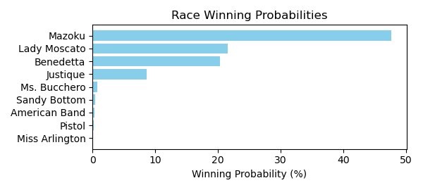

Figure: Winning Probability Distribution

NOTE: THIS RACE HAS HORSES THAT ARE MISSING CRITICAL DATA ELEMENTS

# Race: TOP | 2025-02-22 | Race #5 | Track: OAKLAWN PARK

Track: OAKLAWN PARK

|  |  |  |  |  |
| --- | --- | --- | --- | --- |
| Saddle Cloth # | Horse Name | Global Speed | Composite | Win Prob (%) |
| 1 | Oy Gevald * | 76.5 | 3.67 | 1.72 |
| 10 | Max Got Excited * | 76.5 | 8.41 | 76.41 |
| 11 | Gun Runner Charlie * | 76.5 | -8.73 | 0.00 |
| 12 | Oil Capital * | 76.5 | -3.34 | 0.01 |
| 2 | Faust * | 76.5 | 6.61 | 18.12 |
| 3 | Sixtyseven Mustang * | 76.5 | 2.12 | 0.50 |
| 4 | Secret Legend * | 76.5 | -1.42 | 0.03 |
| 5 | ZERO SUGAR * | 76.5 | 3.53 | 1.55 |
| 6 | Chases Magic * | 76.5 | -7.91 | 0.00 |
| 7 | CORNUCOPIAN * | 76.5 | 2.99 | 1.00 |
| 8 | Wise Decision * | 76.5 | -5.97 | 0.00 |
| 9 | dh-Ready to Seize * | 76.5 | 2.48 | 0.67 |

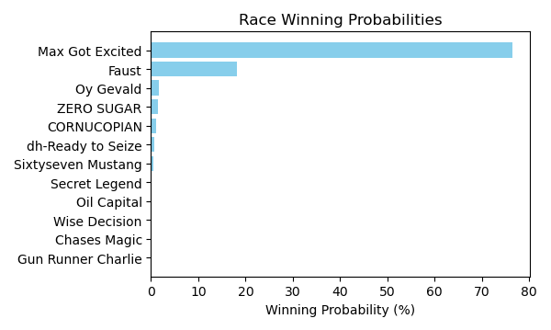

Figure: Winning Probability Distribution

NOTE: THIS RACE HAS HORSES THAT ARE MISSING CRITICAL DATA ELEMENTS

# Race: TOP | 2025-02-22 | Race #6 | Track: OAKLAWN PARK

Track: OAKLAWN PARK

|  |  |  |  |  |
| --- | --- | --- | --- | --- |
| Saddle Cloth # | Horse Name | Global Speed | Composite | Win Prob (%) |
| 1 | Elusive Target * | 111.8 | 0.61 | 0.04 |
| 10 | Ethan Energy * | 111.8 | 9.11 | 39.59 |
| 11 | Spoiler * | 111.8 | 0.27 | 0.03 |
| 12 | Dynamis * | 111.8 | 0.76 | 0.05 |
| 2 | Shot of Courage * | 111.8 | 5.44 | 2.12 |
| 3 | One Giant Leap * | 111.8 | -0.26 | 0.02 |
| 4 | B D Saints * | 111.8 | 0.66 | 0.05 |
| 5 | Touch Of Glam (ARG) * | 111.8 | 1.33 | 0.08 |
| 6 | Nullify * | 111.8 | 9.48 | 53.37 |
| 7 | Lambeth * | 111.8 | 5.74 | 2.68 |
| 8 | Harleezy * | 111.8 | 5.35 | 1.97 |
| 9 | Imperial Gun * | 111.8 | -8.25 | 0.00 |

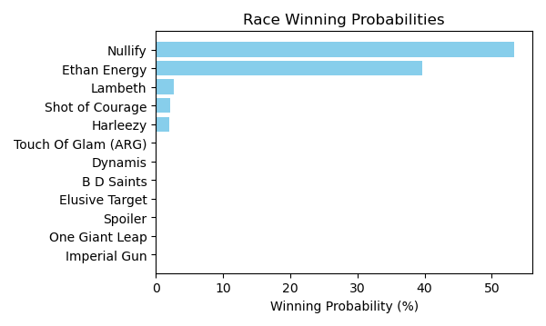

Figure: Winning Probability Distribution

NOTE: THIS RACE HAS HORSES THAT ARE MISSING CRITICAL DATA ELEMENTS

# Race: TOP | 2025-02-22 | Race #7 | Track: OAKLAWN PARK

Track: OAKLAWN PARK

|  |  |  |  |  |
| --- | --- | --- | --- | --- |
| Saddle Cloth # | Horse Name | Global Speed | Composite | Win Prob (%) |
| 1 | Carbone * | 76.7 | 0.12 | 0.03 |
| 10 | Ninja Warrior * | 76.7 | 7.20 | 7.80 |
| 2 | Just Steel * | 76.7 | 0.34 | 0.03 |
| 3 | Attache * | 76.7 | 7.83 | 12.94 |
| 4 | Nasty Habit * | 76.7 | 2.96 | 0.26 |
| 5 | Excitable Boy * | 76.7 | 5.62 | 2.21 |
| 6 | Invulnerable * | 76.7 | 6.19 | 3.48 |
| 7 | Eglise * | 76.7 | 8.78 | 27.57 |
| 8 | Big City * | 76.7 | 9.03 | 33.68 |
| 9 | Runaway Jack * | 76.7 | 7.74 | 12.00 |

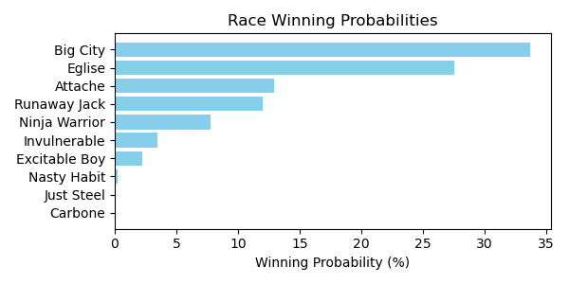

Figure: Winning Probability Distribution

NOTE: THIS RACE HAS HORSES THAT ARE MISSING CRITICAL DATA ELEMENTS

# Race: TOP | 2025-02-22 | Race #8 | Track: OAKLAWN PARK

Track: OAKLAWN PARK

|  |  |  |  |  |
| --- | --- | --- | --- | --- |
| Saddle Cloth # | Horse Name | Global Speed | Composite | Win Prob (%) |
| 1 | Under the Palms * | 111.8 | 6.18 | 3.39 |
| 10 | Amber Cascade * | 111.8 | 7.53 | 9.96 |
| 11 | In Just My Heels * | 111.8 | 10.09 | 77.00 |
| 2 | Bru Na Boinne * | 111.8 | 1.27 | 0.07 |
| 3 | Broughty Ferry * | 111.8 | 4.32 | 0.76 |
| 4 | Gold Medal Anna * | 111.8 | -1.18 | 0.01 |
| 5 | Peignoir * | 111.8 | 6.81 | 5.60 |
| 6 | Majestic Oops * | 111.8 | 3.13 | 0.29 |
| 7 | Bow Draw * | 111.8 | 1.12 | 0.06 |
| 8 | Indy Label * | 111.8 | 5.97 | 2.86 |
| 9 | Neom Beach * | 111.8 | -4.32 | 0.00 |

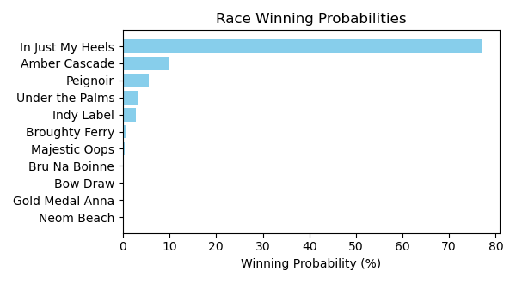

Figure: Winning Probability Distribution

NOTE: THIS RACE HAS HORSES THAT ARE MISSING CRITICAL DATA ELEMENTS

# Race: TOP | 2025-02-22 | Race #9 | Track: OAKLAWN PARK

Track: OAKLAWN PARK

|  |  |  |  |  |
| --- | --- | --- | --- | --- |
| Saddle Cloth # | Horse Name | Global Speed | Composite | Win Prob (%) |
| 1 | Muhimma * | 111.6 | 8.19 | 15.69 |
| 10 | Flash Wear * | 111.6 | -0.81 | 0.01 |
| 11 | Anonima * | 111.6 | 6.89 | 5.55 |
| 12 | Quietside * | 111.6 | 5.76 | 2.26 |
| 13 | Five G * | 111.6 | 4.78 | 1.03 |
| 2 | Necessity * | 111.6 | 8.18 | 15.65 |
| 3 | Jenkin * | 111.6 | 4.20 | 0.65 |
| 4 | Classic Appeal * | 111.6 | 8.55 | 21.01 |
| 5 | Quickick * | 111.6 | 4.99 | 1.22 |
| 6 | Take Charge Milady * | 111.6 | 8.55 | 20.94 |
| 7 | Gunite Max * | 111.6 | 3.16 | 0.28 |
| 8 | Going Steady * | 111.6 | 3.89 | 0.51 |
| 9 | Look Forward * | 111.6 | 8.15 | 15.20 |

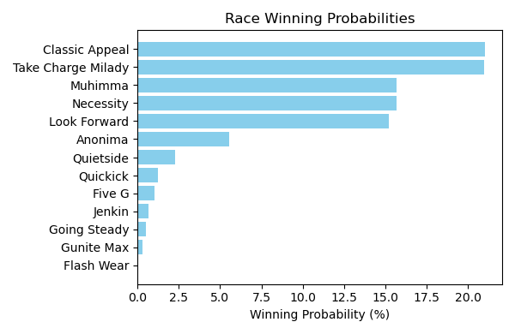

Figure: Winning Probability Distribution

NOTE: THIS RACE HAS HORSES THAT ARE MISSING CRITICAL DATA ELEMENTS

# Race: TOP | 2025-02-22 | Race #10 | Track: OAKLAWN PARK

Track: OAKLAWN PARK

|  |  |  |  |  |
| --- | --- | --- | --- | --- |
| Saddle Cloth # | Horse Name | Global Speed | Composite | Win Prob (%) |
| 1 | Crupi * | 112.0 | 4.17 | 0.33 |
| 10 | Cooke Creek * | 112.0 | 6.76 | 2.65 |
| 11 | Tonka Warrior * | 112.0 | 3.90 | 0.27 |
| 12 | Red Route One * | 112.0 | 3.12 | 0.14 |
| 13 | Creative Minister * | 112.0 | 5.76 | 1.19 |
| 14 | Seize the Night * | 112.0 | -1.94 | 0.00 |
| 2 | Banishing * | 112.0 | 10.47 | 51.44 |
| 3 | First Mission * | 112.0 | 2.67 | 0.10 |
| 4 | Alexander Helios * | 112.0 | 9.08 | 16.91 |
| 5 | Skinner * | 112.0 | 7.46 | 4.62 |
| 6 | Full Screen * | 112.0 | 3.39 | 0.18 |
| 7 | Dimatic * | 112.0 | 2.20 | 0.07 |
| 8 | Baddest Good Boy * | 112.0 | 9.38 | 21.59 |
| 9 | Henro * | 112.0 | 4.62 | 0.48 |

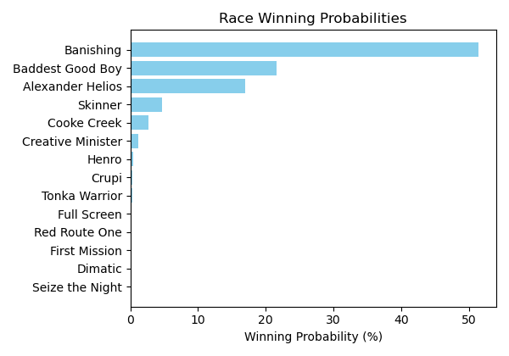

Figure: Winning Probability Distribution

NOTE: THIS RACE HAS HORSES THAT ARE MISSING CRITICAL DATA ELEMENTS

# Race: TOP | 2025-02-22 | Race #11 | Track: OAKLAWN PARK

Track: OAKLAWN PARK

|  |  |  |  |  |
| --- | --- | --- | --- | --- |
| Saddle Cloth # | Horse Name | Global Speed | Composite | Win Prob (%) |
| 1 | Coal Battle * | 111.9 | 3.71 | 0.17 |
| 10 | Bullard * | 111.9 | 4.80 | 0.40 |
| 11 | Speed King * | 111.9 | 10.09 | 27.27 |
| 12 | Brereton's Baytown * | 111.9 | -1.05 | 0.00 |
| 13 | Tiztastic * | 111.9 | 7.49 | 3.43 |
| 14 | Hot Gunner * | 111.9 | -1.29 | 0.00 |
| 2 | Admiral Dennis * | 111.9 | 4.12 | 0.23 |
| 3 | Sandman * | 111.9 | 8.96 | 11.10 |
| 4 | Hypnus * | 111.9 | 7.71 | 4.09 |
| 5 | Madaket Road * | 111.9 | 8.05 | 5.37 |
| 6 | Publisher * | 111.9 | -0.99 | 0.00 |
| 7 | Dreaminblue * | 111.9 | 9.73 | 20.57 |
| 8 | Innovator * | 111.9 | 1.24 | 0.02 |
| 9 | Smoken Wicked * | 111.9 | 10.09 | 27.34 |

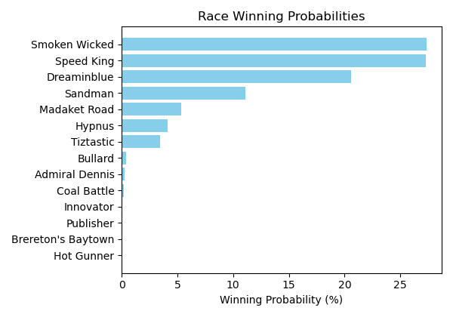

Figure: Winning Probability Distribution

NOTE: THIS RACE HAS HORSES THAT ARE MISSING CRITICAL DATA ELEMENTS

# Race: TOP | 2025-02-22 | Race #12 | Track: OAKLAWN PARK

Track: OAKLAWN PARK

|  |  |  |  |  |
| --- | --- | --- | --- | --- |
| Saddle Cloth # | Horse Name | Global Speed | Composite | Win Prob (%) |
| 1 | Butch * | 76.2 | -8.46 | 0.00 |
| 10 | A P Ruly * | 76.2 | 5.85 | 19.28 |
| 11 | Touchdown Arkansas * | 76.2 | -6.28 | 0.00 |
| 12 | Miracle Mack * | 76.2 | -7.09 | 0.00 |
| 13 | Pearcy Road * | 76.2 | -1.64 | 0.05 |
| 14 | God's Country * | 76.2 | 2.43 | 1.25 |
| 2 | MAYOR * | 76.2 | 4.14 | 4.91 |
| 3 | Cutting Class * | 76.2 | -8.74 | 0.00 |
| 4 | Bote * | 76.2 | -2.71 | 0.02 |
| 5 | Cowboycents * | 76.2 | -5.59 | 0.00 |
| 6 | My Russian * | 76.2 | -6.99 | 0.00 |
| 7 | DAWSON JAMES * | 76.2 | 4.23 | 5.30 |
| 8 | Two Dollar Eddie * | 76.2 | 6.81 | 41.57 |
| 9 | Tizmarkus * | 76.2 | 6.30 | 27.62 |

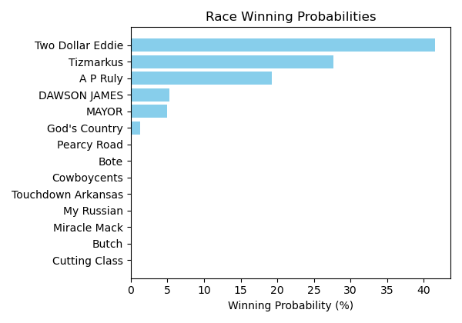

Figure: Winning Probability Distribution

NOTE: THIS RACE HAS HORSES THAT ARE MISSING CRITICAL DATA ELEMENTS

# Race: TOP | 2025-02-23 | Race #1 | Track: OAKLAWN PARK

Track: OAKLAWN PARK

|  |  |  |  |  |
| --- | --- | --- | --- | --- |
| Saddle Cloth # | Horse Name | Global Speed | Composite | Win Prob (%) |
| 1 | Fever Night * | 111.6 | 2.65 | 1.45 |
| 10 | Ripped * | 111.6 | 3.66 | 3.24 |
| 2 | Zardun * | 111.6 | 6.08 | 22.54 |
| 3 | Clever Again * | 111.6 | 6.89 | 42.89 |
| 4 | Just Classic * | 111.6 | -6.40 | 0.00 |
| 5 | Shepherd * | 111.6 | -3.36 | 0.01 |
| 6 | Baobab * | 111.6 | 4.95 | 9.15 |
| 7 | Doroteo * | 111.6 | 5.81 | 18.18 |
| 8 | Crisis Manager * | 111.6 | 2.94 | 1.82 |
| 9 | Hired Gun * | 111.6 | 1.75 | 0.71 |

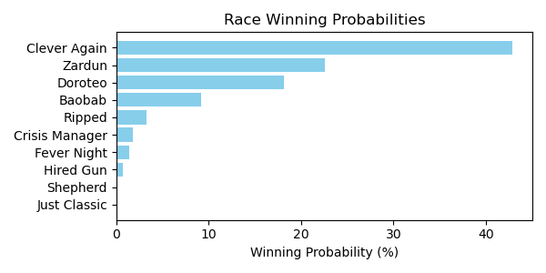

Figure: Winning Probability Distribution

NOTE: THIS RACE HAS HORSES THAT ARE MISSING CRITICAL DATA ELEMENTS

# Race: TOP | 2025-02-23 | Race #2 | Track: OAKLAWN PARK

Track: OAKLAWN PARK

|  |  |  |  |  |
| --- | --- | --- | --- | --- |
| Saddle Cloth # | Horse Name | Global Speed | Composite | Win Prob (%) |
| 1 | Distorted Pro * | 76.7 | 6.16 | 2.03 |
| 10 | Sitka * | 76.7 | 9.32 | 25.34 |
| 11 | Red State * | 76.7 | 4.18 | 0.41 |
| 2 | I'm Wide Awake * | 76.7 | 9.71 | 34.62 |
| 3 | Rowdy Riot * | 76.7 | 4.91 | 0.75 |
| 4 | Great Richie M * | 76.7 | 7.23 | 4.76 |
| 5 | B Sudd * | 76.7 | 6.90 | 3.66 |
| 6 | Manta Rey * | 76.7 | 3.16 | 0.18 |
| 7 | Goodasiwonswas * | 76.7 | 6.99 | 3.94 |
| 8 | Breslau * | 76.7 | 2.49 | 0.11 |
| 9 | Run Jalen Run * | 76.7 | 9.26 | 24.21 |

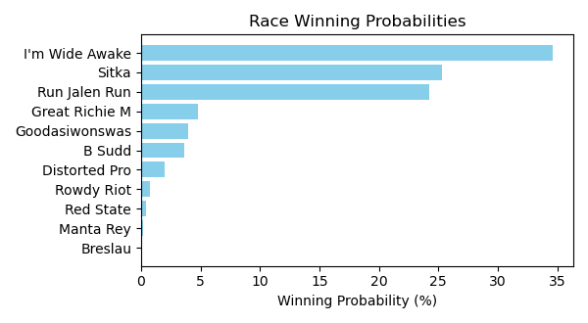

Figure: Winning Probability Distribution

NOTE: THIS RACE HAS HORSES THAT ARE MISSING CRITICAL DATA ELEMENTS

# Race: TOP | 2025-02-23 | Race #3 | Track: OAKLAWN PARK

Track: OAKLAWN PARK

|  |  |  |  |  |
| --- | --- | --- | --- | --- |
| Saddle Cloth # | Horse Name | Global Speed | Composite | Win Prob (%) |
| 1 | Ashburn Alley * | 76.5 | 9.84 | 79.21 |
| 10 | Theresasilverlinin * | 76.5 | -5.90 | 0.00 |
| 11 | Brooklynn Drew * | 76.5 | -4.51 | 0.00 |
| 12 | Gloriette * | 76.5 | 6.28 | 4.58 |
| 13 | Managing Mischief * | 76.5 | 1.28 | 0.08 |
| 14 | Popperina * | 76.5 | 1.95 | 0.14 |
| 2 | Queen's Martini * | 76.5 | -0.18 | 0.03 |
| 3 | Princess Is Olivia * | 76.5 | 1.76 | 0.12 |
| 4 | Bennykayandsuzytoo * | 76.5 | 7.37 | 10.93 |
| 5 | Tiffany Twist * | 76.5 | 0.35 | 0.04 |
| 6 | Laurie's Secret * | 76.5 | -9.16 | 0.00 |
| 7 | Insightful Miss * | 76.5 | 6.35 | 4.85 |
| 8 | That's Our Vision * | 76.5 | -8.12 | 0.00 |
| 9 | Music Mistress * | 76.5 | -4.78 | 0.00 |

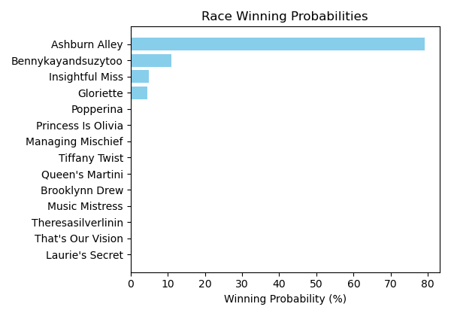

Figure: Winning Probability Distribution

NOTE: THIS RACE HAS HORSES THAT ARE MISSING CRITICAL DATA ELEMENTS

# Race: TOP | 2025-02-23 | Race #4 | Track: OAKLAWN PARK

Track: OAKLAWN PARK

|  |  |  |  |  |
| --- | --- | --- | --- | --- |
| Saddle Cloth # | Horse Name | Global Speed | Composite | Win Prob (%) |
| 1 | Benedetta * | 76.6 | 6.88 | 20.94 |
| 2 | Mazoku * | 76.6 | 7.92 | 47.85 |
| 3 | Justique * | 76.6 | 5.76 | 8.52 |
| 4 | Sandy Bottom * | 76.6 | 2.03 | 0.43 |
| 5 | Miss Arlington * | 76.6 | -3.48 | 0.01 |
| 6 | Ms. Bucchero * | 76.6 | 2.85 | 0.83 |
| 7 | American Band * | 76.6 | 1.65 | 0.32 |
| 8 | Lady Moscato * | 76.6 | 6.88 | 20.81 |
| 9 | Pistol * | 76.6 | 1.50 | 0.28 |

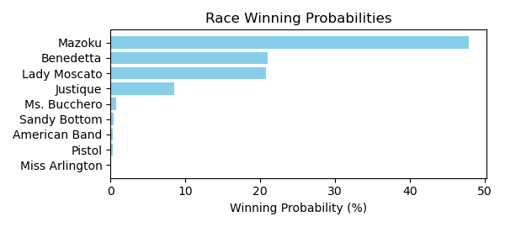

Figure: Winning Probability Distribution

NOTE: THIS RACE HAS HORSES THAT ARE MISSING CRITICAL DATA ELEMENTS

# Race: TOP | 2025-02-23 | Race #5 | Track: OAKLAWN PARK

Track: OAKLAWN PARK

|  |  |  |  |  |
| --- | --- | --- | --- | --- |
| Saddle Cloth # | Horse Name | Global Speed | Composite | Win Prob (%) |
| 1 | Oy Gevald * | 76.5 | 3.62 | 1.60 |
| 10 | Max Got Excited * | 76.5 | 8.44 | 76.00 |
| 11 | Gun Runner Charlie * | 76.5 | -8.76 | 0.00 |
| 12 | Oil Capital * | 76.5 | -3.36 | 0.01 |
| 2 | Faust * | 76.5 | 6.68 | 18.60 |
| 3 | Sixtyseven Mustang * | 76.5 | 2.35 | 0.58 |
| 4 | Secret Legend * | 76.5 | -1.27 | 0.03 |
| 5 | ZERO SUGAR * | 76.5 | 3.60 | 1.57 |
| 6 | Chases Magic * | 76.5 | -7.91 | 0.00 |
| 7 | CORNUCOPIAN * | 76.5 | 3.04 | 1.01 |
| 8 | Wise Decision * | 76.5 | -5.96 | 0.00 |
| 9 | dh-Ready to Seize * | 76.5 | 2.37 | 0.59 |

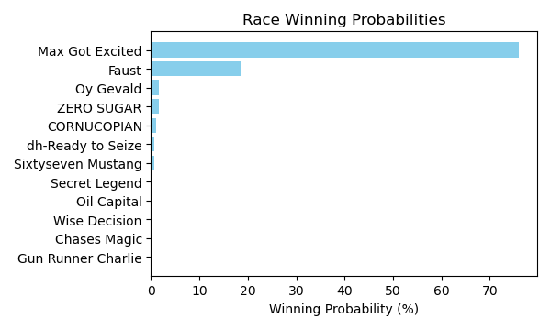

Figure: Winning Probability Distribution

NOTE: THIS RACE HAS HORSES THAT ARE MISSING CRITICAL DATA ELEMENTS

# Race: TOP | 2025-02-23 | Race #6 | Track: OAKLAWN PARK

Track: OAKLAWN PARK

|  |  |  |  |  |
| --- | --- | --- | --- | --- |
| Saddle Cloth # | Horse Name | Global Speed | Composite | Win Prob (%) |
| 1 | Elusive Target * | 111.8 | 0.63 | 0.04 |
| 10 | Ethan Energy * | 111.8 | 9.12 | 40.00 |
| 11 | Spoiler * | 111.8 | 0.26 | 0.03 |
| 12 | Dynamis * | 111.8 | 0.65 | 0.05 |
| 2 | Shot of Courage * | 111.8 | 5.45 | 2.12 |
| 3 | One Giant Leap * | 111.8 | -0.32 | 0.02 |
| 4 | B D Saints * | 111.8 | 0.66 | 0.05 |
| 5 | Touch Of Glam (ARG) * | 111.8 | 1.33 | 0.08 |
| 6 | Nullify * | 111.8 | 9.47 | 52.83 |
| 7 | Lambeth * | 111.8 | 5.84 | 2.90 |
| 8 | Harleezy * | 111.8 | 5.30 | 1.88 |
| 9 | Imperial Gun * | 111.8 | -8.26 | 0.00 |

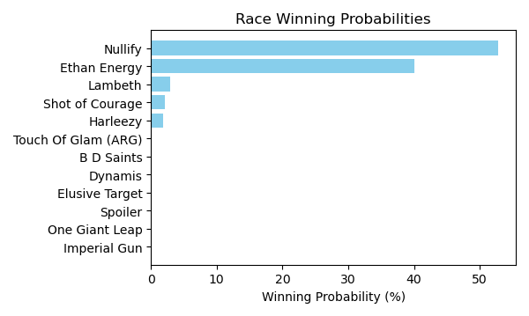

Figure: Winning Probability Distribution

NOTE: THIS RACE HAS HORSES THAT ARE MISSING CRITICAL DATA ELEMENTS

# Race: TOP | 2025-02-23 | Race #7 | Track: OAKLAWN PARK

Track: OAKLAWN PARK

|  |  |  |  |  |
| --- | --- | --- | --- | --- |
| Saddle Cloth # | Horse Name | Global Speed | Composite | Win Prob (%) |
| 1 | Carbone * | 76.7 | 0.19 | 0.03 |
| 10 | Ninja Warrior * | 76.7 | 7.20 | 7.56 |
| 2 | Just Steel * | 76.7 | 0.41 | 0.03 |
| 3 | Attache * | 76.7 | 7.92 | 13.47 |
| 4 | Nasty Habit * | 76.7 | 2.99 | 0.26 |
| 5 | Excitable Boy * | 76.7 | 5.62 | 2.14 |
| 6 | Invulnerable * | 76.7 | 6.18 | 3.36 |
| 7 | Eglise * | 76.7 | 8.79 | 27.04 |
| 8 | Big City * | 76.7 | 9.09 | 34.44 |
| 9 | Runaway Jack * | 76.7 | 7.74 | 11.66 |

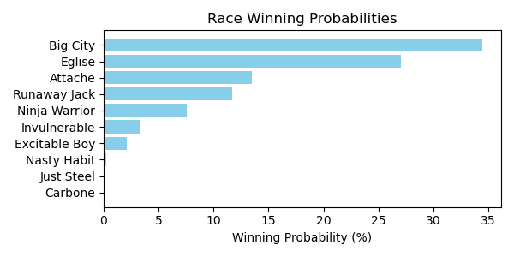

Figure: Winning Probability Distribution

NOTE: THIS RACE HAS HORSES THAT ARE MISSING CRITICAL DATA ELEMENTS

# Race: TOP | 2025-02-23 | Race #8 | Track: OAKLAWN PARK

Track: OAKLAWN PARK

|  |  |  |  |  |
| --- | --- | --- | --- | --- |
| Saddle Cloth # | Horse Name | Global Speed | Composite | Win Prob (%) |
| 1 | Under the Palms * | 111.8 | 6.20 | 3.41 |
| 10 | Amber Cascade * | 111.8 | 7.55 | 10.10 |
| 11 | In Just My Heels * | 111.8 | 10.09 | 76.64 |
| 2 | Bru Na Boinne * | 111.8 | 1.52 | 0.08 |
| 3 | Broughty Ferry * | 111.8 | 4.39 | 0.80 |
| 4 | Gold Medal Anna * | 111.8 | -1.43 | 0.01 |
| 5 | Peignoir * | 111.8 | 6.85 | 5.74 |
| 6 | Majestic Oops * | 111.8 | 3.06 | 0.28 |
| 7 | Bow Draw * | 111.8 | 1.15 | 0.06 |
| 8 | Indy Label * | 111.8 | 5.99 | 2.89 |
| 9 | Neom Beach * | 111.8 | -4.33 | 0.00 |

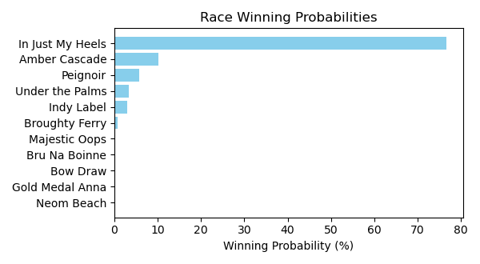

Figure: Winning Probability Distribution

NOTE: THIS RACE HAS HORSES THAT ARE MISSING CRITICAL DATA ELEMENTS

# Race: TOP | 2025-02-23 | Race #9 | Track: OAKLAWN PARK

Track: OAKLAWN PARK

|  |  |  |  |  |
| --- | --- | --- | --- | --- |
| Saddle Cloth # | Horse Name | Global Speed | Composite | Win Prob (%) |
| 1 | Muhimma * | 111.6 | 8.19 | 15.99 |
| 10 | Flash Wear * | 111.6 | -0.79 | 0.01 |
| 11 | Anonima * | 111.6 | 6.87 | 5.57 |
| 12 | Quietside * | 111.6 | 5.76 | 2.30 |
| 13 | Five G * | 111.6 | 4.78 | 1.05 |
| 2 | Necessity * | 111.6 | 8.19 | 16.03 |
| 3 | Jenkin * | 111.6 | 4.19 | 0.65 |
| 4 | Classic Appeal * | 111.6 | 8.43 | 19.50 |
| 5 | Quickick * | 111.6 | 4.99 | 1.24 |
| 6 | Take Charge Milady * | 111.6 | 8.55 | 21.32 |
| 7 | Gunite Max * | 111.6 | 3.08 | 0.27 |
| 8 | Going Steady * | 111.6 | 3.81 | 0.48 |
| 9 | Look Forward * | 111.6 | 8.15 | 15.58 |

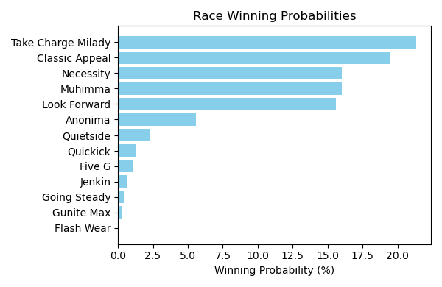

Figure: Winning Probability Distribution

NOTE: THIS RACE HAS HORSES THAT ARE MISSING CRITICAL DATA ELEMENTS

# Race: TOP | 2025-02-23 | Race #10 | Track: OAKLAWN PARK

Track: OAKLAWN PARK

|  |  |  |  |  |
| --- | --- | --- | --- | --- |
| Saddle Cloth # | Horse Name | Global Speed | Composite | Win Prob (%) |
| 1 | Crupi * | 112.0 | 4.17 | 0.33 |
| 10 | Cooke Creek * | 112.0 | 6.79 | 2.69 |
| 11 | Tonka Warrior * | 112.0 | 4.00 | 0.29 |
| 12 | Red Route One * | 112.0 | 3.13 | 0.14 |
| 13 | Creative Minister * | 112.0 | 5.77 | 1.19 |
| 14 | Seize the Night * | 112.0 | -1.93 | 0.00 |
| 2 | Banishing * | 112.0 | 10.48 | 51.44 |
| 3 | First Mission * | 112.0 | 2.54 | 0.09 |
| 4 | Alexander Helios * | 112.0 | 9.10 | 17.03 |
| 5 | Skinner * | 112.0 | 7.47 | 4.65 |
| 6 | Full Screen * | 112.0 | 3.32 | 0.17 |
| 7 | Dimatic * | 112.0 | 2.20 | 0.07 |
| 8 | Baddest Good Boy * | 112.0 | 9.38 | 21.43 |
| 9 | Henro * | 112.0 | 4.64 | 0.48 |

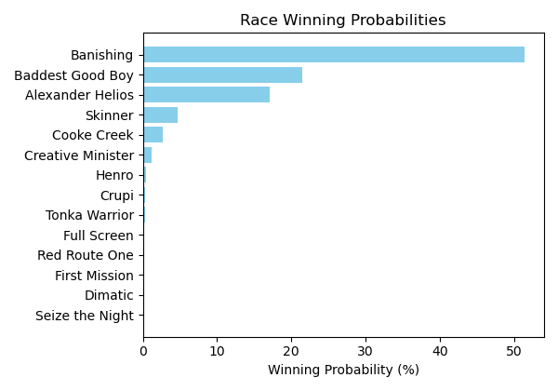

Figure: Winning Probability Distribution

NOTE: THIS RACE HAS HORSES THAT ARE MISSING CRITICAL DATA ELEMENTS

# Race: TOP | 2025-02-23 | Race #11 | Track: OAKLAWN PARK

Track: OAKLAWN PARK

|  |  |  |  |  |
| --- | --- | --- | --- | --- |
| Saddle Cloth # | Horse Name | Global Speed | Composite | Win Prob (%) |
| 1 | Coal Battle * | 111.9 | 3.76 | 0.17 |
| 10 | Bullard * | 111.9 | 4.81 | 0.40 |
| 11 | Speed King * | 111.9 | 10.09 | 27.08 |
| 12 | Brereton's Baytown * | 111.9 | -1.20 | 0.00 |
| 13 | Tiztastic * | 111.9 | 7.49 | 3.40 |
| 14 | Hot Gunner * | 111.9 | -1.30 | 0.00 |
| 2 | Admiral Dennis * | 111.9 | 4.12 | 0.23 |
| 3 | Sandman * | 111.9 | 9.00 | 11.37 |
| 4 | Hypnus * | 111.9 | 7.71 | 4.05 |
| 5 | Madaket Road * | 111.9 | 8.05 | 5.32 |
| 6 | Publisher * | 111.9 | -0.98 | 0.00 |
| 7 | Dreaminblue * | 111.9 | 9.73 | 20.31 |
| 8 | Innovator * | 111.9 | 1.21 | 0.02 |
| 9 | Smoken Wicked * | 111.9 | 10.11 | 27.64 |

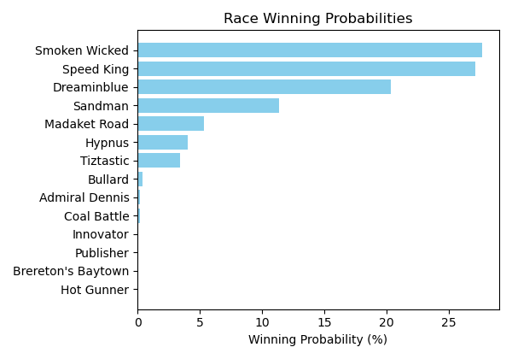

Figure: Winning Probability Distribution

NOTE: THIS RACE HAS HORSES THAT ARE MISSING CRITICAL DATA ELEMENTS

# Race: TOP | 2025-02-23 | Race #12 | Track: OAKLAWN PARK

Track: OAKLAWN PARK

|  |  |  |  |  |
| --- | --- | --- | --- | --- |
| Saddle Cloth # | Horse Name | Global Speed | Composite | Win Prob (%) |
| 1 | Butch * | 76.2 | -8.47 | 0.00 |
| 10 | A P Ruly * | 76.2 | 5.84 | 18.85 |
| 11 | Touchdown Arkansas * | 76.2 | -6.30 | 0.00 |
| 12 | Miracle Mack * | 76.2 | -7.08 | 0.00 |
| 13 | Pearcy Road * | 76.2 | -1.61 | 0.05 |
| 14 | God's Country * | 76.2 | 2.53 | 1.34 |
| 2 | MAYOR * | 76.2 | 4.19 | 5.02 |
| 3 | Cutting Class * | 76.2 | -8.76 | 0.00 |
| 4 | Bote * | 76.2 | -2.73 | 0.02 |
| 5 | Cowboycents * | 76.2 | -5.60 | 0.00 |
| 6 | My Russian * | 76.2 | -7.01 | 0.00 |
| 7 | DAWSON JAMES * | 76.2 | 4.34 | 5.68 |
| 8 | Two Dollar Eddie * | 76.2 | 6.85 | 42.15 |
| 9 | Tizmarkus * | 76.2 | 6.29 | 26.89 |

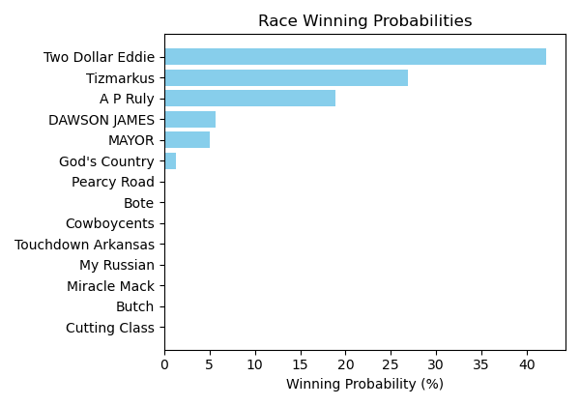

Figure: Winning Probability Distribution

NOTE: THIS RACE HAS HORSES THAT ARE MISSING CRITICAL DATA ELEMENTS

# Race: PRX | 2025-02-24 | Race #1 | Track: PARX RACING

Track: PARX RACING

|  |  |  |  |  |
| --- | --- | --- | --- | --- |
| Saddle Cloth # | Horse Name | Global Speed | Composite | Win Prob (%) |
| 1 | Five Star Fran * | 76.1 | 7.48 | 73.20 |
| 10 | Far Heart * | 82.1 | -5.99 | 0.01 |
| 2 | No Fake * | 88.8 | 2.88 | 23.39 |
| 3 | Aztec Bay * | 82.1 | -3.21 | 0.05 |
| 4 | Brooklyn Heights * | 82.1 | -8.52 | 0.00 |
| 5 | Union Belle * | 82.1 | -6.77 | 0.00 |
| 6 | Kaymus * | 76.1 | 3.27 | 2.52 |
| 7 | Far too Foxy * | 70.8 | 3.09 | 0.77 |
| 8 | Lady Annabelle * | 76.1 | -1.22 | 0.07 |
| 9 | Chit Chat Chub * | 82.1 | -6.04 | 0.00 |

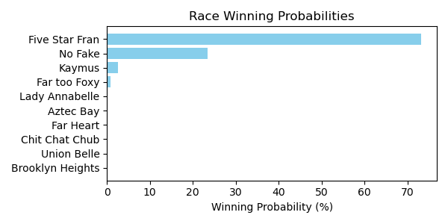

Figure: Winning Probability Distribution

NOTE: THIS RACE HAS HORSES THAT ARE MISSING CRITICAL DATA ELEMENTS

# Race: PRX | 2025-02-24 | Race #2 | Track: PARX RACING

Track: PARX RACING

|  |  |  |  |  |
| --- | --- | --- | --- | --- |
| Saddle Cloth # | Horse Name | Global Speed | Composite | Win Prob (%) |
| 1 | Private Cabana * | 89.1 | -6.52 | 0.00 |
| 2 | Four Eyes * | 82.3 | -5.59 | 0.00 |
| 3 | Omaha Eight * | 71.0 | 0.80 | 0.00 |
| 4 | Whitewalker * | 108.6 | 7.77 | 100.00 |
| 5 | Bustino Santino * | 82.3 | 0.40 | 0.00 |
| 6 | Capitan George * | 71.0 | 1.59 | 0.00 |
| 7 | Stay Funny * | 71.0 | -5.11 | 0.00 |
| 8 | Hyper Inflation * | 76.3 | -2.61 | 0.00 |
| 9 | Raleigh St. Clair * | 82.3 | -0.48 | 0.00 |

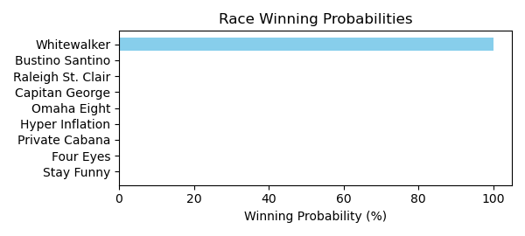

Figure: Winning Probability Distribution

NOTE: THIS RACE HAS HORSES THAT ARE MISSING CRITICAL DATA ELEMENTS

# Race: PRX | 2025-02-24 | Race #3 | Track: PARX RACING

Track: PARX RACING

|  |  |  |  |  |
| --- | --- | --- | --- | --- |
| Saddle Cloth # | Horse Name | Global Speed | Composite | Win Prob (%) |
| 1 | Missouri River * | 108.8 | -1.09 | 0.06 |
| 2 | Sheer Dominance * | 108.8 | -0.92 | 0.07 |
| 3 | Master Munnings * | 108.8 | 7.55 | 58.11 |
| 4 | Heat Alert * | 108.8 | 7.14 | 41.76 |
| 5 | Spinning Heart * | 89.2 | -4.29 | 0.00 |
| 6 | Financial District * | 104.0 | -6.98 | 0.00 |
| 7 | Hatmaker Gizmo * | 108.8 | -9.07 | 0.00 |

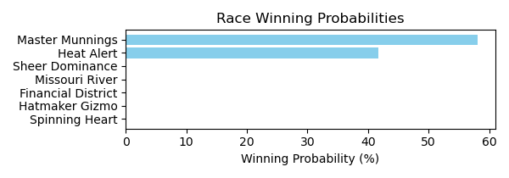

Figure: Winning Probability Distribution

NOTE: THIS RACE HAS HORSES THAT ARE MISSING CRITICAL DATA ELEMENTS

# Race: PRX | 2025-02-24 | Race #4 | Track: PARX RACING

Track: PARX RACING

|  |  |  |  |  |
| --- | --- | --- | --- | --- |
| Saddle Cloth # | Horse Name | Global Speed | Composite | Win Prob (%) |
| 1 | Vanellope * | 103.8 | 1.99 | 97.54 |
| 2 | Channel Loop * | 103.8 | -3.42 | 1.29 |
| 3 | Zoning Order * | 82.3 | -8.91 | 0.00 |
| 4 | Breezy Dance * | 108.6 | -9.40 | 0.03 |
| 5 | Love Like Crazy * | 76.3 | 3.30 | 1.13 |
| 6 | Red Haired Gal * | 82.3 | -7.86 | 0.00 |
| 7 | Classic Mystery * | 76.3 | -2.97 | 0.01 |

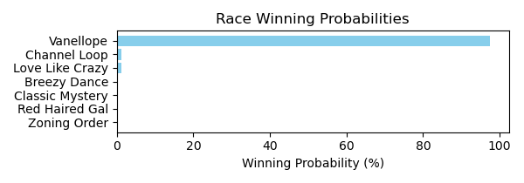

Figure: Winning Probability Distribution

NOTE: THIS RACE HAS HORSES THAT ARE MISSING CRITICAL DATA ELEMENTS

# Race: PRX | 2025-02-24 | Race #5 | Track: PARX RACING

Track: PARX RACING

|  |  |  |  |  |
| --- | --- | --- | --- | --- |
| Saddle Cloth # | Horse Name | Global Speed | Composite | Win Prob (%) |
| 1 | Creme Caramel * | 82.2 | -2.76 | 0.00 |
| 10 | Melodia * | 82.2 | -7.35 | 0.00 |
| 2 | Boca Royalty * | 76.2 | -6.11 | 0.00 |
| 3 | La Tourista * | 82.2 | -3.40 | 0.00 |
| 4 | Goldieness * | 82.2 | -6.97 | 0.00 |
| 5 | Mended We Stand * | 82.2 | 6.90 | 2.04 |
| 6 | Jezebel Jade * | 76.2 | 4.19 | 0.07 |
| 7 | Between Dreams * | 82.2 | -9.07 | 0.00 |
| 8 | Bonita Lassie * | 108.4 | 5.19 | 97.88 |
| 9 | Luna T * | 76.2 | -6.22 | 0.00 |

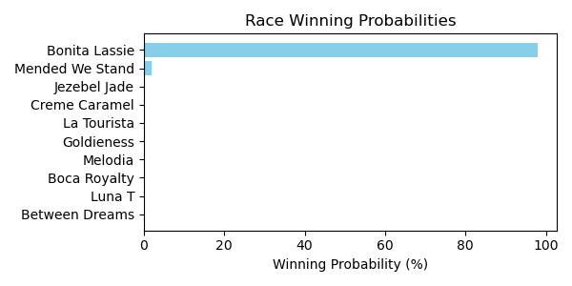

Figure: Winning Probability Distribution

NOTE: THIS RACE HAS HORSES THAT ARE MISSING CRITICAL DATA ELEMENTS

# Race: PRX | 2025-02-24 | Race #6 | Track: PARX RACING

Track: PARX RACING

|  |  |  |  |  |
| --- | --- | --- | --- | --- |
| Saddle Cloth # | Horse Name | Global Speed | Composite | Win Prob (%) |
| 1 | Awesome for Sure * | 82.5 | 0.77 | 0.74 |
| 2 | Rejected Again * | 82.5 | 0.33 | 0.52 |
| 3 | Kate's Golden Dude * | 82.5 | 6.02 | 49.68 |
| 4 | Jw's Third Mischie * | 82.5 | 2.65 | 3.36 |
| 5 | Sal N Louie * | 82.5 | 5.89 | 44.88 |
| 6 | Harley's Charly * | 82.5 | -2.58 | 0.05 |
| 7 | Copperhead Creek * | 108.8 | -8.62 | 0.08 |
| 8 | Liberty Star * | 82.5 | 0.51 | 0.61 |
| 9 | Captain Chazz * | 71.1 | 0.69 | 0.07 |

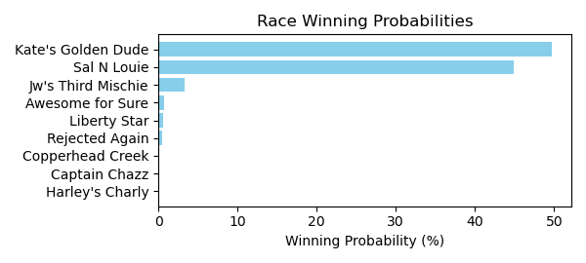

Figure: Winning Probability Distribution

NOTE: THIS RACE HAS HORSES THAT ARE MISSING CRITICAL DATA ELEMENTS

# Race: PRX | 2025-02-24 | Race #7 | Track: PARX RACING

Track: PARX RACING

|  |  |  |  |  |
| --- | --- | --- | --- | --- |
| Saddle Cloth # | Horse Name | Global Speed | Composite | Win Prob (%) |
| 1 | Lucky Dude * | 111.6 | 8.88 | 51.42 |
| 10 | Warrior's Vendetta * | 109.0 | -4.16 | 0.00 |
| 11 | Batter Up Bud * | 111.6 | 0.64 | 0.07 |
| 2 | Zippy Gizmo * | 109.0 | -7.22 | 0.00 |
| 3 | More Vino * | 82.6 | -5.72 | 0.00 |
| 4 | Group Hug * | 76.5 | 2.01 | 0.00 |
| 5 | Tycoon * | 109.0 | 7.82 | 13.05 |
| 6 | Assembly Point (BRZ) * | 109.0 | 8.16 | 17.07 |
| 7 | Youbetterbejoking * | 109.0 | 7.39 | 9.26 |
| 8 | Jewels in the Bay * | 111.6 | 6.72 | 9.13 |
| 9 | Check My Six * | 109.0 | -4.12 | 0.00 |

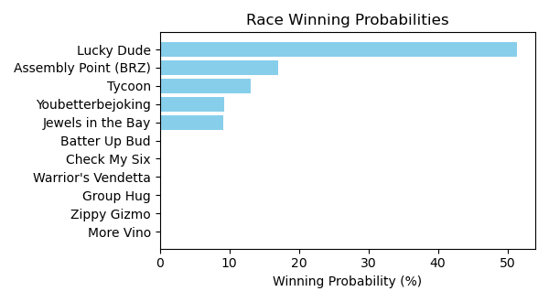

Figure: Winning Probability Distribution

NOTE: THIS RACE HAS HORSES THAT ARE MISSING CRITICAL DATA ELEMENTS

# Race: PRX | 2025-02-24 | Race #8 | Track: PARX RACING

Track: PARX RACING

|  |  |  |  |  |
| --- | --- | --- | --- | --- |
| Saddle Cloth # | Horse Name | Global Speed | Composite | Win Prob (%) |
| 1 | Smoke Wagon * | 109.1 | 4.47 | 0.94 |
| 2 | Ira the Icon * | 109.1 | -0.40 | 0.02 |
| 3 | Mo Rewards * | 109.1 | 6.88 | 6.45 |
| 4 | Ike's Gamble * | 109.1 | 9.65 | 59.43 |
| 5 | Prince Colton * | 76.6 | 5.44 | 0.00 |
| 6 | Double Your Money * | 109.1 | 8.92 | 33.16 |

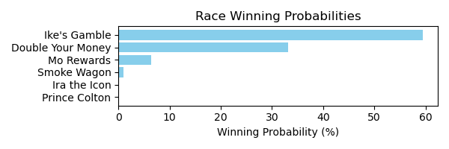

Figure: Winning Probability Distribution

NOTE: THIS RACE HAS HORSES THAT ARE MISSING CRITICAL DATA ELEMENTS

# Race: PRX | 2025-02-24 | Race #9 | Track: PARX RACING

Track: PARX RACING

|  |  |  |  |  |
| --- | --- | --- | --- | --- |
| Saddle Cloth # | Horse Name | Global Speed | Composite | Win Prob (%) |
| 1 | Tara's Talent * | 82.5 | 4.58 | 20.36 |
| 2 | True Phenomenon * | 82.5 | -5.24 | 0.01 |
| 3 | Aegean Sea * | 82.5 | 0.46 | 0.76 |
| 4 | Dream Chaser * | 89.2 | 4.58 | 78.78 |
| 5 | Empress Deona * | 76.4 | -6.66 | 0.00 |
| 6 | Et's Moon Maiden * | 82.5 | -4.13 | 0.02 |
| 7 | Bustin Down Doors * | 82.5 | -2.42 | 0.08 |
| 8 | Ree Nee's Six * | 82.5 | -5.43 | 0.01 |

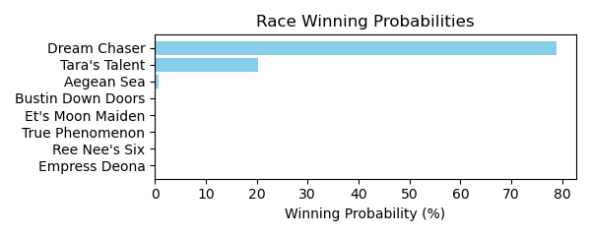

Figure: Winning Probability Distribution

NOTE: THIS RACE HAS HORSES THAT ARE MISSING CRITICAL DATA ELEMENTS

# Race: PRX | 2025-02-24 | Race #10 | Track: PARX RACING

Track: PARX RACING

|  |  |  |  |  |
| --- | --- | --- | --- | --- |
| Saddle Cloth # | Horse Name | Global Speed | Composite | Win Prob (%) |
| 1 | This Run's for You * | 76.5 | -0.34 | 0.00 |
| 10 | Commingling * | 82.6 | 2.49 | 0.00 |
| 11 | A Dangerous Guy * | 82.6 | -8.56 | 0.00 |
| 12 | Roan Burgundy * | 89.4 | 6.38 | 0.15 |
| 2 | Yuletide Gallop * | 82.6 | -8.40 | 0.00 |
| 3 | Level Up * | 111.5 | 8.96 | 99.80 |
| 4 | Disturbed * | 76.5 | 6.82 | 0.02 |
| 5 | Tatum * | 82.6 | -4.45 | 0.00 |
| 6 | Noble Gaston * | 71.1 | 3.63 | 0.00 |
| 7 | Olliemeister * | 76.5 | 0.16 | 0.00 |
| 8 | Runyonesque * | 82.6 | 5.86 | 0.03 |
| 9 | Ninja Prize * | 76.5 | 5.00 | 0.00 |

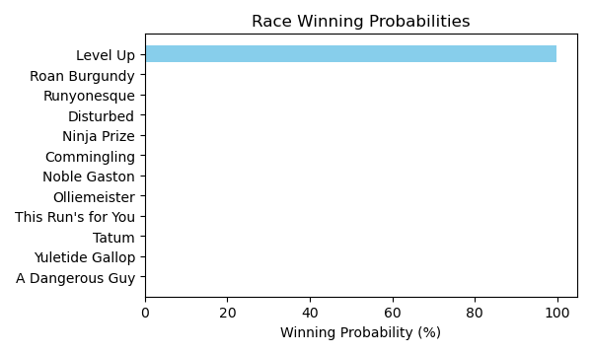

Figure: Winning Probability Distribution

NOTE: THIS RACE HAS HORSES THAT ARE MISSING CRITICAL DATA ELEMENTS

# Race: PEN | 2025-02-21 | Race #1 | Track: PENN NATIONAL

Track: PENN NATIONAL

|  |  |  |  |  |
| --- | --- | --- | --- | --- |
| Saddle Cloth # | Horse Name | Global Speed | Composite | Win Prob (%) |
| 1 | We're Even * | 104.0 | 1.13 | 0.33 |
| 2 | Make Me Lucky * | 104.0 | 4.38 | 4.47 |
| 3 | Bronx Boys * | 104.0 | 8.04 | 84.14 |
| 4 | Bejuco * | 104.0 | 3.79 | 2.79 |
| 5 | Midnight Tempesta * | 104.0 | -0.00 | 0.13 |
| 6 | Tiz Marks Spirit * | 104.0 | 5.12 | 8.13 |
| 7 | Tony's Mo * | 104.0 | -5.71 | 0.00 |

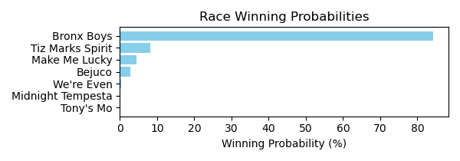

Figure: Winning Probability Distribution

NOTE: THIS RACE HAS HORSES THAT ARE MISSING CRITICAL DATA ELEMENTS

# Race: PEN | 2025-02-21 | Race #2 | Track: PENN NATIONAL

Track: PENN NATIONAL

|  |  |  |  |  |
| --- | --- | --- | --- | --- |
| Saddle Cloth # | Horse Name | Global Speed | Composite | Win Prob (%) |
| 1 | Whiskey Row * | 103.6 | 3.95 | 2.94 |
| 10 | Have No Regrets * | 103.6 | -0.68 | 0.07 |
| 11 | Sweet Spite * | 103.6 | -2.06 | 0.02 |
| 2 | Free Folk * | 103.6 | -1.19 | 0.05 |
| 3 | Warrior On Tap * | 103.6 | 5.16 | 7.77 |
| 4 | Uncle Georgy * | 103.6 | 2.68 | 1.06 |
| 5 | Brady * | 103.6 | -7.20 | 0.00 |
| 6 | Jiggery Pokery * | 103.6 | -9.25 | 0.00 |
| 7 | dh-Town Kisser * | 103.6 | 8.18 | 86.46 |
| 8 | Letsgetluckytonite * | 103.6 | 3.20 | 1.62 |
| 9 | Social Joe * | 103.6 | -4.33 | 0.00 |

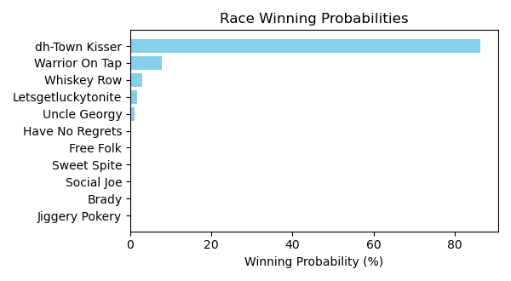

Figure: Winning Probability Distribution

NOTE: THIS RACE HAS HORSES THAT ARE MISSING CRITICAL DATA ELEMENTS

# Race: PEN | 2025-02-21 | Race #3 | Track: PENN NATIONAL

Track: PENN NATIONAL

|  |  |  |  |  |
| --- | --- | --- | --- | --- |
| Saddle Cloth # | Horse Name | Global Speed | Composite | Win Prob (%) |
| 1 | Causalistic * | 108.6 | -7.10 | 0.00 |
| 10 | Critical Thinking * | 108.6 | -4.86 | 0.00 |
| 11 | Rockin the Palace * | 108.6 | 2.19 | 1.03 |
| 12 | Berks * | 108.6 | -5.78 | 0.00 |
| 2 | Textpectation * | 108.6 | -3.60 | 0.01 |
| 3 | Honorable Avenue * | 108.6 | -5.34 | 0.00 |
| 4 | Mighty Minion * | 108.6 | 1.80 | 0.76 |
| 5 | Eye On the Candy * | 108.6 | -1.90 | 0.04 |
| 6 | Spinning Musician * | 108.6 | -1.27 | 0.07 |
| 7 | Lafitte's Fleet * | 108.6 | 7.84 | 95.10 |
| 8 | Rustys Gfivefifty * | 108.6 | 3.51 | 2.98 |
| 9 | Box Office Warrior * | 108.6 | -8.70 | 0.00 |

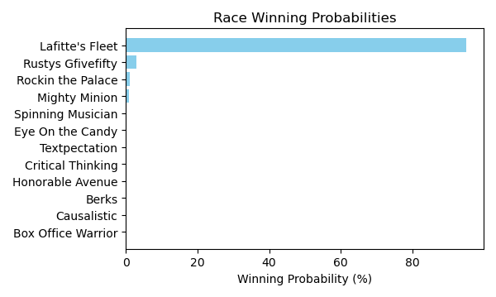

Figure: Winning Probability Distribution

NOTE: THIS RACE HAS HORSES THAT ARE MISSING CRITICAL DATA ELEMENTS

# Race: PEN | 2025-02-21 | Race #4 | Track: PENN NATIONAL

Track: PENN NATIONAL

|  |  |  |  |  |
| --- | --- | --- | --- | --- |
| Saddle Cloth # | Horse Name | Global Speed | Composite | Win Prob (%) |
| 1 | Dance a Dini * | 104.2 | -0.83 | 0.07 |
| 2 | Jump for the Win * | 104.2 | 2.10 | 0.71 |
| 3 | First Glimpse * | 104.2 | -7.74 | 0.00 |
| 4 | Roadtriptonowhere * | 104.2 | 7.95 | 75.97 |
| 5 | Entrust * | 104.2 | 4.97 | 7.02 |
| 6 | Tallahatchiebridge * | 104.2 | 2.79 | 1.23 |
| 7 | Tubtimsiam * | 104.2 | 5.92 | 15.00 |

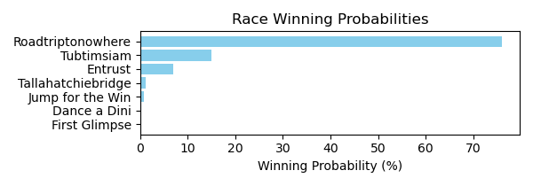

Figure: Winning Probability Distribution

NOTE: THIS RACE HAS HORSES THAT ARE MISSING CRITICAL DATA ELEMENTS

# Race: PEN | 2025-02-21 | Race #5 | Track: PENN NATIONAL

Track: PENN NATIONAL

|  |  |  |  |  |
| --- | --- | --- | --- | --- |
| Saddle Cloth # | Horse Name | Global Speed | Composite | Win Prob (%) |
| 1 | Uptown Charly Girl * | 103.6 | 5.59 | 39.75 |
| 10 | Silent Diva * | 103.6 | -10.24 | 0.00 |
| 2 | Smiles for David * | 103.6 | -8.08 | 0.00 |
| 3 | Floraloats * | 103.6 | -5.06 | 0.01 |
| 4 | Adios Meister * | 103.6 | -9.76 | 0.00 |
| 5 | Maggie K * | 103.6 | -2.36 | 0.07 |
| 6 | Jayce and Liam * | 103.6 | 4.66 | 18.87 |
| 7 | Urban Dancer * | 103.6 | 5.63 | 41.24 |
| 8 | Pull No Punches * | 103.6 | -5.35 | 0.01 |
| 9 | Forever Fifi * | 103.6 | -2.54 | 0.06 |

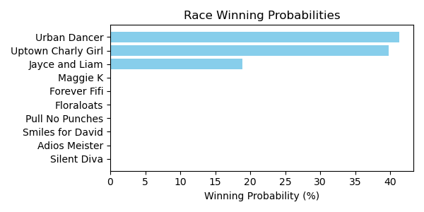

Figure: Winning Probability Distribution

NOTE: THIS RACE HAS HORSES THAT ARE MISSING CRITICAL DATA ELEMENTS

# Race: PEN | 2025-02-21 | Race #6 | Track: PENN NATIONAL

Track: PENN NATIONAL

|  |  |  |  |  |
| --- | --- | --- | --- | --- |
| Saddle Cloth # | Horse Name | Global Speed | Composite | Win Prob (%) |
| 1 | Whiskeyromeosierra * | 104.3 | 7.98 | 10.27 |
| 10 | Egot a Poker Face * | 104.3 | -7.88 | 0.00 |
| 11 | Battuta d'Oro * | 104.3 | -5.55 | 0.00 |
| 2 | Synonym * | 104.3 | -5.62 | 0.00 |
| 3 | Brother Brad * | 104.3 | -0.33 | 0.01 |
| 4 | Take the Pledge * | 104.3 | 10.15 | 58.13 |
| 5 | Stormquist * | 104.3 | 2.68 | 0.15 |
| 6 | Socially Awkward * | 104.3 | 7.50 | 7.02 |
| 7 | Easter Bet * | 104.3 | 1.60 | 0.06 |
| 8 | Tarsus Warrior * | 104.3 | 1.20 | 0.05 |
| 9 | Skimble Shanks * | 104.3 | 9.06 | 24.31 |

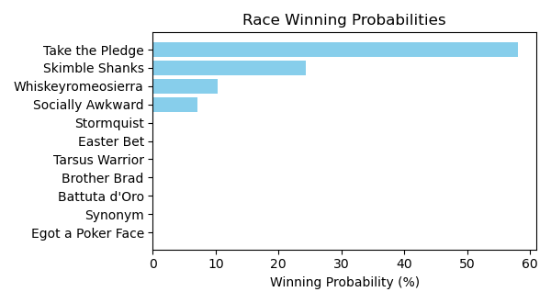

Figure: Winning Probability Distribution

NOTE: THIS RACE HAS HORSES THAT ARE MISSING CRITICAL DATA ELEMENTS

# Race: PEN | 2025-02-21 | Race #7 | Track: PENN NATIONAL

Track: PENN NATIONAL

|  |  |  |  |  |
| --- | --- | --- | --- | --- |
| Saddle Cloth # | Horse Name | Global Speed | Composite | Win Prob (%) |
| 1 | Grated Coconut * | 108.6 | -6.31 | 0.00 |
| 10 | Grumpy Brooksie * | 108.6 | -2.93 | 0.03 |
| 11 | Sugar Gray Leonard * | 108.6 | -3.87 | 0.01 |
| 2 | Watasha * | 108.6 | 5.08 | 17.66 |
| 3 | Lucky Lucky Luke * | 108.6 | 4.38 | 10.07 |
| 4 | Moonset * | 108.6 | 3.75 | 6.06 |
| 5 | Long Tom * | 108.6 | -9.78 | 0.00 |
| 6 | Chucka Moon * | 108.6 | 3.20 | 3.91 |
| 7 | Sheltrfromthestorm * | 108.6 | 6.65 | 62.06 |
| 8 | Riverboat Bandit * | 108.6 | -0.62 | 0.18 |
| 9 | Graft * | 108.6 | -6.63 | 0.00 |

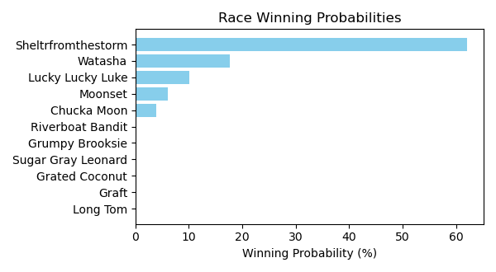

Figure: Winning Probability Distribution

NOTE: THIS RACE HAS HORSES THAT ARE MISSING CRITICAL DATA ELEMENTS

# Race: PEN | 2025-02-21 | Race #8 | Track: PENN NATIONAL

Track: PENN NATIONAL

|  |  |  |  |  |
| --- | --- | --- | --- | --- |
| Saddle Cloth # | Horse Name | Global Speed | Composite | Win Prob (%) |
| 1 | Ninja Kitty * | 70.8 | 3.85 | 54.61 |
| 2 | It's Saul Goodman * | 70.8 | -2.26 | 0.41 |
| 3 | Mobot * | 70.8 | -0.42 | 1.79 |
| 4 | Dave Did It * | 70.8 | -6.84 | 0.01 |
| 5 | Wild Nugget * | 70.8 | 3.56 | 43.16 |
| 6 | Search for Hope * | 70.8 | -6.73 | 0.01 |
| 7 | Michaelshatrick * | 70.8 | -10.36 | 0.00 |

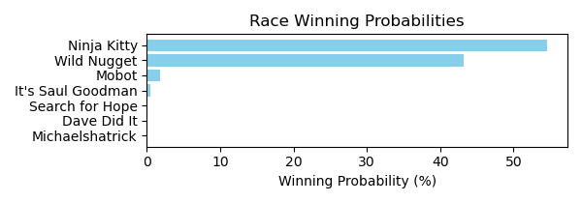

Figure: Winning Probability Distribution

NOTE: THIS RACE HAS HORSES THAT ARE MISSING CRITICAL DATA ELEMENTS

# Race: PEN | 2025-02-21 | Race #9 | Track: PENN NATIONAL

Track: PENN NATIONAL

|  |  |  |  |  |
| --- | --- | --- | --- | --- |
| Saddle Cloth # | Horse Name | Global Speed | Composite | Win Prob (%) |
| 1 | Carly Hustle * | 76.3 | -7.20 | 0.00 |
| 10 | Uptown Seraphina * | 76.3 | -9.57 | 0.00 |
| 2 | I'm Heading East * | 76.3 | -7.13 | 0.00 |
| 3 | Melodious Singer * | 76.3 | -6.99 | 0.00 |
| 4 | Stormy Spell * | 76.3 | -6.75 | 0.00 |
| 5 | Tilted Tiara * | 76.3 | 3.73 | 1.85 |
| 6 | Kelly's Party Girl * | 76.3 | -4.84 | 0.00 |
| 7 | Happy Tappy Tim * | 76.3 | 7.20 | 29.55 |
| 8 | Queen Wiggy * | 76.3 | 8.24 | 67.98 |
| 9 | Stephanie My Love * | 76.3 | 2.37 | 0.62 |

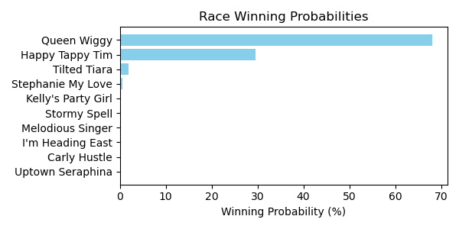

Figure: Winning Probability Distribution

NOTE: THIS RACE HAS HORSES THAT ARE MISSING CRITICAL DATA ELEMENTS

# Race: PEN | 2025-02-21 | Race #10 | Track: PENN NATIONAL

Track: PENN NATIONAL

|  |  |  |  |  |
| --- | --- | --- | --- | --- |
| Saddle Cloth # | Horse Name | Global Speed | Composite | Win Prob (%) |
| 1 | Mat Matters * | 71.1 | -0.95 | 0.01 |
| 2 | Mitropanos * | 71.1 | -0.03 | 0.03 |
| 3 | Jmr Speedy Escape * | 71.1 | 6.50 | 4.77 |
| 4 | Valyrian Sky * | 71.1 | -6.83 | 0.00 |
| 5 | Tactical Humor * | 71.1 | -8.97 | 0.00 |
| 6 | Prom Knight * | 71.1 | 10.24 | 95.16 |
| 7 | Valore * | 71.1 | 0.21 | 0.03 |

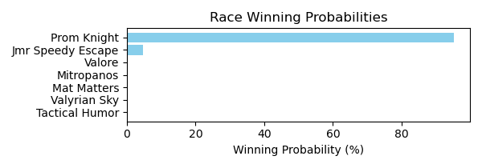

Figure: Winning Probability Distribution

NOTE: THIS RACE HAS HORSES THAT ARE MISSING CRITICAL DATA ELEMENTS

# Race: HOU | 2025-02-21 | Race #2 | Track: SAM HOUSTON RACE PARK

Track: SAM HOUSTON RACE PARK

|  |  |  |  |  |
| --- | --- | --- | --- | --- |
| Saddle Cloth # | Horse Name | Global Speed | Composite | Win Prob (%) |
| 1 | Cafezinho * | 111.3 | -8.75 | 0.00 |
| 2 | Cactus Blossom * | 111.3 | -1.34 | 0.05 |
| 3 | Lexington Diva * | 111.3 | 0.50 | 0.20 |
| 4 | Keep the Bling * | 111.3 | -10.39 | 0.00 |
| 5 | Tituba * | 111.3 | -6.56 | 0.00 |
| 6 | Including Ellie * | 111.3 | -3.80 | 0.01 |
| 7 | Cashmere Dancer * | 111.3 | 0.97 | 0.29 |
| 8 | Arinniti (FR) * | 111.3 | 0.65 | 0.23 |
| 9 | Contrabbanda * | 111.3 | 8.25 | 99.23 |

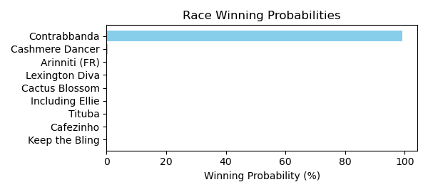

Figure: Winning Probability Distribution

NOTE: THIS RACE HAS HORSES THAT ARE MISSING CRITICAL DATA ELEMENTS

# Race: HOU | 2025-02-21 | Race #3 | Track: SAM HOUSTON RACE PARK

Track: SAM HOUSTON RACE PARK

|  |  |  |  |  |
| --- | --- | --- | --- | --- |
| Saddle Cloth # | Horse Name | Global Speed | Composite | Win Prob (%) |
| 1 | Cheers to Candy * | 66.4 | -2.13 | 0.04 |
| 2 | RISKY WITH WHISKEY * | 66.4 | 5.14 | 14.32 |
| 3 | TIZ ANOTHER BUNNY * | 66.4 | 4.86 | 11.37 |
| 4 | Karanthos * | 66.4 | 6.66 | 48.17 |
| 5 | CAUSE IM THE KING * | 66.4 | 4.98 | 12.53 |
| 6 | WORK ZONE * | 66.4 | 5.08 | 13.56 |
| 7 | The Last Moxy * | 66.4 | -8.33 | 0.00 |
| 8 | Instant Karma * | 66.4 | -7.61 | 0.00 |

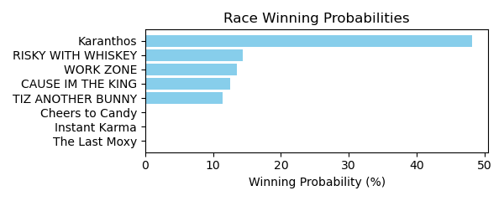

Figure: Winning Probability Distribution

NOTE: THIS RACE HAS HORSES THAT ARE MISSING CRITICAL DATA ELEMENTS

# Race: HOU | 2025-02-21 | Race #4 | Track: SAM HOUSTON RACE PARK

Track: SAM HOUSTON RACE PARK

|  |  |  |  |  |
| --- | --- | --- | --- | --- |
| Saddle Cloth # | Horse Name | Global Speed | Composite | Win Prob (%) |
| 1 | Reckless Red * | 76.3 | -5.18 | 0.01 |
| 10 | Suitable * | 76.3 | 2.38 | 2.83 |
| 2 | Send Off * | 76.3 | -6.34 | 0.00 |
| 3 | Samurai's Grandson * | 76.3 | -0.28 | 0.34 |
| 4 | Weird Year * | 76.3 | 6.69 | 88.50 |
| 5 | Midnight Hunter * | 76.3 | -7.11 | 0.00 |
| 6 | Fifteen Love Back * | 76.3 | -4.53 | 0.01 |
| 7 | Sam Sez * | 76.3 | 0.82 | 0.81 |
| 8 | Affectionto Autism * | 76.3 | -4.55 | 0.01 |
| 9 | Ima Big Bopper * | 76.3 | 3.60 | 7.48 |

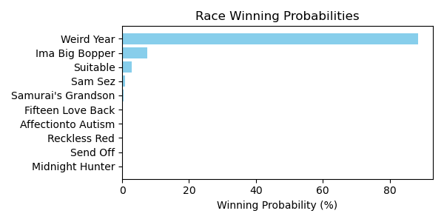

Figure: Winning Probability Distribution

NOTE: THIS RACE HAS HORSES THAT ARE MISSING CRITICAL DATA ELEMENTS

# Race: HOU | 2025-02-21 | Race #5 | Track: SAM HOUSTON RACE PARK

Track: SAM HOUSTON RACE PARK

|  |  |  |  |  |
| --- | --- | --- | --- | --- |
| Saddle Cloth # | Horse Name | Global Speed | Composite | Win Prob (%) |
| 1 | Bishop Creek * | 103.8 | -4.86 | 0.02 |
| 2 | Feather Laine * | 103.8 | -4.73 | 0.02 |
| 3 | Atlantic Storm * | 103.8 | -7.84 | 0.00 |
| 4 | EXPAT * | 103.8 | 4.95 | 46.48 |
| 5 | Follow the Star * | 103.8 | 2.45 | 6.30 |
| 6 | Roaring Rapids * | 103.8 | 4.55 | 33.77 |
| 7 | Kantake * | 103.8 | 3.28 | 12.28 |
| 8 | Philanthroper * | 103.8 | 0.31 | 1.14 |

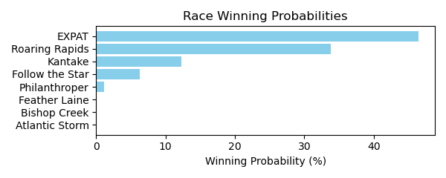

Figure: Winning Probability Distribution

NOTE: THIS RACE HAS HORSES THAT ARE MISSING CRITICAL DATA ELEMENTS

# Race: HOU | 2025-02-21 | Race #6 | Track: SAM HOUSTON RACE PARK

Track: SAM HOUSTON RACE PARK

|  |  |  |  |  |
| --- | --- | --- | --- | --- |
| Saddle Cloth # | Horse Name | Global Speed | Composite | Win Prob (%) |
| 1 | Essay * | 76.4 | -1.72 | 0.01 |
| 2 | Son of a Bling * | 76.4 | -3.71 | 0.00 |
| 3 | I'm a Cowboy * | 76.4 | 2.72 | 0.40 |
| 4 | Texas Holdem * | 76.4 | 6.12 | 6.05 |
| 5 | Red Summerbird * | 76.4 | 8.28 | 34.00 |
| 6 | Bling Mountain * | 76.4 | 4.86 | 2.21 |
| 7 | Tx Code * | 76.4 | 8.93 | 57.31 |
| 8 | Bandera Bling * | 76.4 | -1.26 | 0.02 |

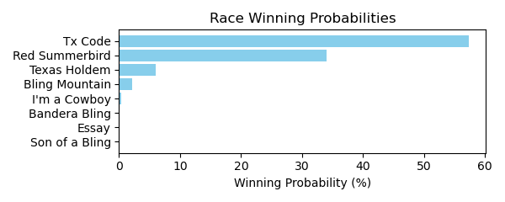

Figure: Winning Probability Distribution

NOTE: THIS RACE HAS HORSES THAT ARE MISSING CRITICAL DATA ELEMENTS

# Race: HOU | 2025-02-21 | Race #7 | Track: SAM HOUSTON RACE PARK

Track: SAM HOUSTON RACE PARK

|  |  |  |  |  |
| --- | --- | --- | --- | --- |
| Saddle Cloth # | Horse Name | Global Speed | Composite | Win Prob (%) |
| 1 | What Maggie Wants * | 76.1 | -7.84 | 0.00 |
| 10 | Faith and Devotion * | 76.1 | 2.98 | 0.79 |
| 11 | Indy La Primera * | 76.1 | -9.32 | 0.00 |
| 2 | Songerie * | 76.1 | 8.68 | 75.43 |
| 3 | Lavender Will * | 76.1 | -6.47 | 0.00 |
| 4 | Imagoldensong * | 76.1 | -8.52 | 0.00 |
| 5 | Spirit of Veterans * | 76.1 | -4.04 | 0.00 |
| 6 | Stacy's Princess * | 76.1 | 2.65 | 0.61 |
| 7 | STELLA RIDGE * | 76.1 | 4.80 | 3.39 |
| 8 | YODA WINNER * | 76.1 | 5.09 | 4.27 |
| 9 | Klassy Rose Chrome * | 76.1 | 6.70 | 15.52 |

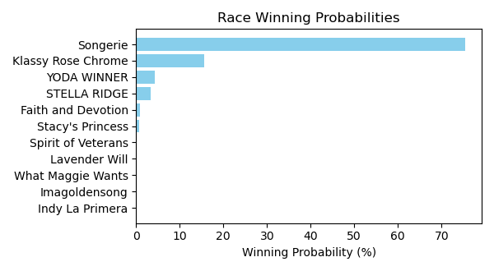

Figure: Winning Probability Distribution

NOTE: THIS RACE HAS HORSES THAT ARE MISSING CRITICAL DATA ELEMENTS

# Race: HOU | 2025-02-21 | Race #8 | Track: SAM HOUSTON RACE PARK

Track: SAM HOUSTON RACE PARK

|  |  |  |  |  |
| --- | --- | --- | --- | --- |
| Saddle Cloth # | Horse Name | Global Speed | Composite | Win Prob (%) |
| 1 | Missingyoucrazy * | 111.6 | 1.07 | 9.47 |
| 2 | Ziti (FR) * | 111.6 | 2.98 | 43.72 |
| 3 | Blueberry Eyes * | 111.6 | 2.18 | 23.07 |
| 4 | Tizawiz * | 111.6 | -3.24 | 0.30 |
| 5 | Chaton Rouge * | 111.6 | 1.78 | 16.65 |
| 6 | Panthera * | 111.6 | 0.65 | 6.75 |
| 7 | Girls Got Game * | 111.6 | -8.20 | 0.01 |
| 8 | Gold Makin Girl * | 111.6 | -6.00 | 0.03 |

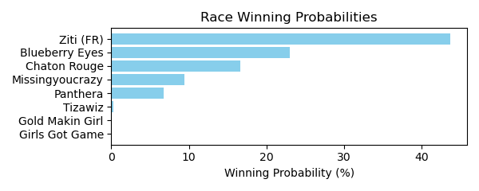

Figure: Winning Probability Distribution

NOTE: THIS RACE HAS HORSES THAT ARE MISSING CRITICAL DATA ELEMENTS

# Race: HOU | 2025-02-21 | Race #9 | Track: SAM HOUSTON RACE PARK

Track: SAM HOUSTON RACE PARK

|  |  |  |  |  |
| --- | --- | --- | --- | --- |
| Saddle Cloth # | Horse Name | Global Speed | Composite | Win Prob (%) |
| 1 | Win Worthy * | 111.4 | 1.83 | 0.21 |
| 10 | Kentucky Peerless * | 111.4 | -0.29 | 0.04 |
| 11 | Absolute Courage * | 111.4 | -5.39 | 0.00 |
| 2 | Deanos Cape * | 111.4 | 6.52 | 9.16 |
| 3 | Catholic Guilt * | 111.4 | 6.87 | 12.14 |
| 4 | Special Moment * | 111.4 | 4.54 | 1.87 |
| 5 | Barbacoa * | 111.4 | 6.72 | 10.71 |
| 6 | Playboy Style * | 111.4 | -3.35 | 0.00 |
| 7 | Shamayim * | 111.4 | 8.99 | 65.82 |
| 8 | Hello Hello Mister * | 111.4 | -5.48 | 0.00 |
| 9 | Cool Memory * | 111.4 | -0.31 | 0.04 |

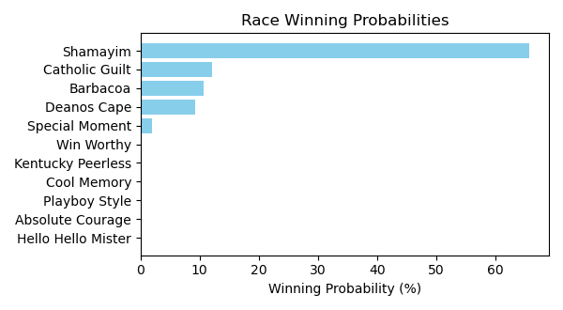

Figure: Winning Probability Distribution

NOTE: THIS RACE HAS HORSES THAT ARE MISSING CRITICAL DATA ELEMENTS

# Race: HOU | 2025-02-21 | Race #10 | Track: SAM HOUSTON RACE PARK

Track: SAM HOUSTON RACE PARK

|  |  |  |  |  |
| --- | --- | --- | --- | --- |
| Saddle Cloth # | Horse Name | Global Speed | Composite | Win Prob (%) |
| 1 | Pollito Tito * | 82.3 | 5.47 | 13.21 |
| 10 | The Devil's Bet * | 82.3 | 7.72 | 79.32 |
| 11 | Binary Code * | 82.3 | -5.31 | 0.00 |
| 12 | Moro Trendsetter * | 82.3 | -5.49 | 0.00 |
| 13 | Expect Glory * | 82.3 | 2.21 | 0.97 |
| 14 | Rockets Red Flair * | 82.3 | -6.89 | 0.00 |
| 2 | Obvious Conclusion * | 82.3 | -0.09 | 0.15 |
| 3 | Super Ekati * | 82.3 | -1.75 | 0.04 |
| 4 | Silent Bling * | 82.3 | 3.73 | 3.28 |
| 5 | Travel Guru * | 82.3 | -9.13 | 0.00 |
| 6 | Second Battalion * | 82.3 | -9.77 | 0.00 |
| 7 | Curly's One Thing * | 82.3 | 3.63 | 3.03 |
| 8 | Bradix * | 82.3 | -5.26 | 0.00 |
| 9 | Fist Bump Ridge * | 82.3 | -7.74 | 0.00 |

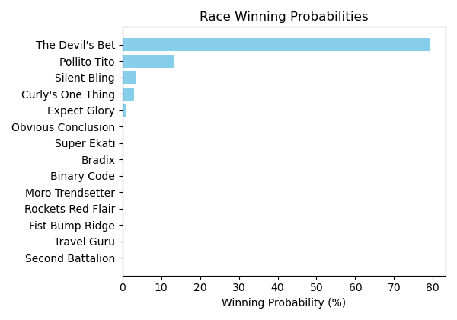

Figure: Winning Probability Distribution

NOTE: THIS RACE HAS HORSES THAT ARE MISSING CRITICAL DATA ELEMENTS

# Race: HOU | 2025-02-22 | Race #1 | Track: SAM HOUSTON RACE PARK

Track: SAM HOUSTON RACE PARK

|  |  |  |  |  |
| --- | --- | --- | --- | --- |
| Saddle Cloth # | Horse Name | Global Speed | Composite | Win Prob (%) |
| 1 | Transactional (GB) * | 111.6 | 5.06 | 45.36 |
| 2 | Keraunos * | 111.6 | 5.02 | 43.87 |
| 3 | Big Commerce * | 111.6 | -2.18 | 0.14 |
| 4 | Wrinkle Road * | 111.6 | -1.74 | 0.20 |
| 5 | Den's Good Grace * | 111.6 | 1.52 | 2.66 |
| 6 | Brilliant Spin * | 111.6 | 1.23 | 2.12 |
| 7 | Summer Lover * | 111.6 | 2.43 | 5.51 |
| 8 | Supreme Leader * | 111.6 | -2.12 | 0.15 |

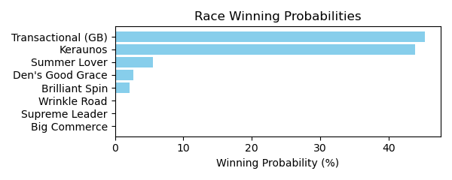

Figure: Winning Probability Distribution

NOTE: THIS RACE HAS HORSES THAT ARE MISSING CRITICAL DATA ELEMENTS

# Race: HOU | 2025-02-22 | Race #2 | Track: SAM HOUSTON RACE PARK

Track: SAM HOUSTON RACE PARK

|  |  |  |  |  |
| --- | --- | --- | --- | --- |
| Saddle Cloth # | Horse Name | Global Speed | Composite | Win Prob (%) |
| 1 | Texas Red Bel * | 76.3 | 6.91 | 56.60 |
| 2 | Eagle Express * | 76.3 | 5.79 | 23.01 |
| 3 | Natural Touch * | 76.3 | 4.30 | 7.00 |
| 4 | Stormy Bisonette * | 76.3 | -5.57 | 0.00 |
| 5 | Mola Mia * | 76.3 | -7.74 | 0.00 |
| 6 | Its My Money Too * | 76.3 | 5.11 | 13.38 |
| 7 | Claudette Heir * | 76.3 | -4.60 | 0.01 |
| 8 | Sharp Likeness * | 76.3 | -9.21 | 0.00 |
| 9 | Mayapretty * | 76.3 | -7.63 | 0.00 |

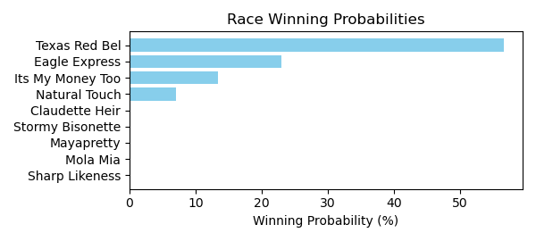

Figure: Winning Probability Distribution

NOTE: THIS RACE HAS HORSES THAT ARE MISSING CRITICAL DATA ELEMENTS

# Race: HOU | 2025-02-22 | Race #3 | Track: SAM HOUSTON RACE PARK

Track: SAM HOUSTON RACE PARK

|  |  |  |  |  |
| --- | --- | --- | --- | --- |
| Saddle Cloth # | Horse Name | Global Speed | Composite | Win Prob (%) |
| 1 | Say as I Say * | 66.3 | 5.44 | 20.70 |
| 2 | OURAY DREAMIN * | 66.3 | 5.43 | 20.43 |
| 3 | AUTISM RIGHTS * | 66.3 | 5.12 | 15.99 |
| 4 | Blake's Song * | 66.3 | -5.52 | 0.00 |
| 5 | CATSGOTACODE * | 66.3 | 5.52 | 21.95 |
| 6 | Retired Blessing * | 66.3 | -5.07 | 0.00 |
| 7 | Belleria Baby * | 66.3 | -9.90 | 0.00 |
| 8 | Glitters Andie * | 66.3 | -3.51 | 0.02 |
| 9 | MAYPEARL * | 66.3 | 5.45 | 20.90 |

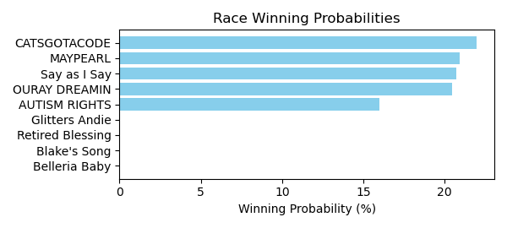

Figure: Winning Probability Distribution

NOTE: THIS RACE HAS HORSES THAT ARE MISSING CRITICAL DATA ELEMENTS

# Race: HOU | 2025-02-22 | Race #4 | Track: SAM HOUSTON RACE PARK

Track: SAM HOUSTON RACE PARK

|  |  |  |  |  |
| --- | --- | --- | --- | --- |
| Saddle Cloth # | Horse Name | Global Speed | Composite | Win Prob (%) |
| 1 | Chief Brady * | 66.7 | 0.60 | 0.02 |
| 2 | Jackman's Ride * | 66.7 | 9.52 | 24.95 |
| 3 | Bandera Azteca * | 66.7 | 3.88 | 0.27 |
| 4 | Trust Daddy * | 66.7 | 8.90 | 15.22 |
| 5 | Talk About Autism * | 66.7 | -5.09 | 0.00 |
| 6 | Balsa * | 66.7 | 1.07 | 0.03 |
| 7 | Hap Hot * | 66.7 | 7.71 | 5.87 |
| 8 | Speight and Malice * | 66.7 | 10.09 | 39.34 |
| 9 | Prayforpeace * | 66.7 | 8.82 | 14.29 |

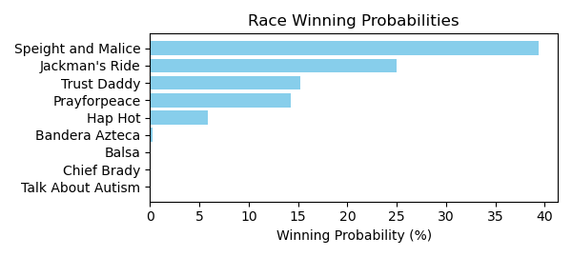

Figure: Winning Probability Distribution

NOTE: THIS RACE HAS HORSES THAT ARE MISSING CRITICAL DATA ELEMENTS

# Race: HOU | 2025-02-22 | Race #5 | Track: SAM HOUSTON RACE PARK

Track: SAM HOUSTON RACE PARK

|  |  |  |  |  |
| --- | --- | --- | --- | --- |
| Saddle Cloth # | Horse Name | Global Speed | Composite | Win Prob (%) |
| 1 | True Blue Sky * | 104.1 | 9.15 | 86.12 |
| 2 | Fella's Sister * | 104.1 | 5.11 | 3.40 |
| 3 | Desert Glow * | 104.1 | -1.40 | 0.02 |
| 4 | Drenched * | 104.1 | 0.30 | 0.07 |
| 5 | Grand Prairie Gal * | 104.1 | 2.83 | 0.55 |
| 6 | San Mateo Kat * | 104.1 | -6.37 | 0.00 |
| 7 | Wilburnsclassylady * | 104.1 | 6.42 | 9.72 |
| 8 | Tura Lura * | 104.1 | 0.90 | 0.12 |

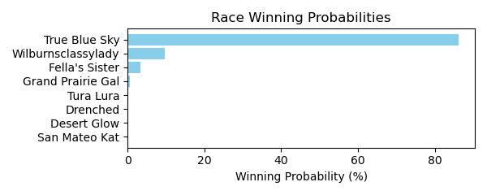

Figure: Winning Probability Distribution

NOTE: THIS RACE HAS HORSES THAT ARE MISSING CRITICAL DATA ELEMENTS

# Race: HOU | 2025-02-22 | Race #6 | Track: SAM HOUSTON RACE PARK

Track: SAM HOUSTON RACE PARK

|  |  |  |  |  |
| --- | --- | --- | --- | --- |
| Saddle Cloth # | Horse Name | Global Speed | Composite | Win Prob (%) |
| 1 | Zippy Season * | 76.0 | -8.05 | 0.01 |
| 10 | Along Came Thunder * | 76.0 | -4.38 | 0.25 |
| 11 | Iced Up * | 76.0 | -10.12 | 0.00 |
| 12 | Breezy Bay * | 76.0 | -7.30 | 0.02 |
| 13 | JAMIE ZEE * | 76.0 | 2.56 | 63.68 |
| 14 | Joyful Pursuit * | 76.0 | -1.49 | 2.49 |
| 2 | Gospel Stunning * | 76.0 | -2.73 | 0.93 |
| 3 | Pebbles B Awesome * | 76.0 | 1.29 | 23.12 |
| 4 | Tribe * | 76.0 | 0.03 | 8.45 |
| 5 | West Texas Ruby * | 76.0 | -10.26 | 0.00 |
| 6 | My Last Chance * | 76.0 | -10.40 | 0.00 |
| 7 | No Moro Here * | 76.0 | -7.10 | 0.03 |
| 8 | Western Sky * | 76.0 | -6.94 | 0.03 |
| 9 | Lemon Marmalade * | 76.0 | -2.66 | 0.98 |

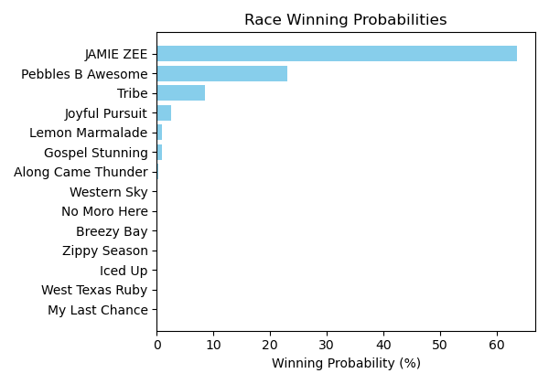

Figure: Winning Probability Distribution

NOTE: THIS RACE HAS HORSES THAT ARE MISSING CRITICAL DATA ELEMENTS

# Race: HOU | 2025-02-22 | Race #7 | Track: SAM HOUSTON RACE PARK

Track: SAM HOUSTON RACE PARK

|  |  |  |  |  |
| --- | --- | --- | --- | --- |
| Saddle Cloth # | Horse Name | Global Speed | Composite | Win Prob (%) |
| 1 | Big Bernie * | 76.7 | 3.99 | 2.94 |
| 2 | Established * | 76.7 | 5.28 | 8.21 |
| 3 | Sir Sterling * | 76.7 | 2.66 | 1.01 |
| 4 | Kentucky Dawn * | 76.7 | -2.99 | 0.01 |
| 5 | Kupuna * | 76.7 | 6.69 | 25.51 |
| 6 | General Shipman * | 76.7 | -0.79 | 0.06 |
| 7 | Halmstad * | 76.7 | 6.59 | 23.53 |
| 8 | Toddchero * | 76.7 | 7.22 | 38.72 |

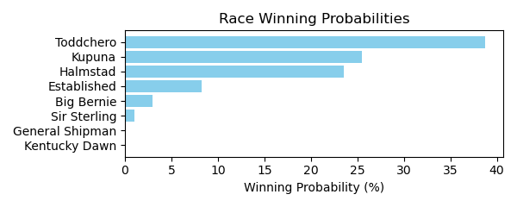

Figure: Winning Probability Distribution

NOTE: THIS RACE HAS HORSES THAT ARE MISSING CRITICAL DATA ELEMENTS

# Race: HOU | 2025-02-22 | Race #8 | Track: SAM HOUSTON RACE PARK

Track: SAM HOUSTON RACE PARK

|  |  |  |  |  |
| --- | --- | --- | --- | --- |
| Saddle Cloth # | Horse Name | Global Speed | Composite | Win Prob (%) |
| 1 | Uptown Tappin * | 111.6 | -4.89 | 0.00 |
| 2 | Coastal Brink * | 111.6 | 8.25 | 45.76 |
| 3 | Gold Prize * | 111.6 | 1.01 | 0.14 |
| 4 | Barefoot Samurai * | 111.6 | 1.82 | 0.27 |
| 5 | Dominant Spirit * | 111.6 | 1.41 | 0.19 |
| 6 | Regal Terka * | 111.6 | 3.60 | 1.11 |
| 7 | Moon Cat * | 111.6 | 5.00 | 3.38 |
| 8 | Singing Dixie * | 111.6 | -4.05 | 0.00 |
| 9 | Excaping the Blues * | 111.6 | 8.34 | 49.14 |

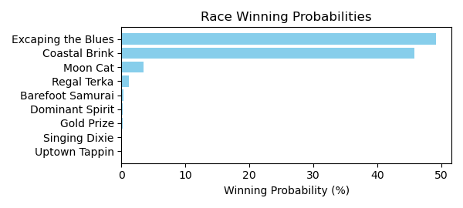

Figure: Winning Probability Distribution

NOTE: THIS RACE HAS HORSES THAT ARE MISSING CRITICAL DATA ELEMENTS

# Race: HOU | 2025-02-22 | Race #9 | Track: SAM HOUSTON RACE PARK

Track: SAM HOUSTON RACE PARK

|  |  |  |  |  |
| --- | --- | --- | --- | --- |
| Saddle Cloth # | Horse Name | Global Speed | Composite | Win Prob (%) |
| 1 | Midnight Twister * | 76.0 | 5.08 | 8.29 |
| 10 | Oklahoma Flame * | 76.0 | -0.44 | 0.10 |
| 11 | Redfortyseven * | 76.0 | -1.73 | 0.04 |
| 12 | Golden Pursuit * | 76.0 | 3.36 | 2.08 |
| 13 | Xander S * | 76.0 | 3.59 | 2.52 |
| 14 | Dustins Denile * | 76.0 | 6.66 | 29.18 |
| 2 | Going to Sanantone * | 76.0 | -3.82 | 0.01 |
| 3 | Gus Cause * | 76.0 | -7.01 | 0.00 |
| 4 | Texano Hero * | 76.0 | -5.39 | 0.00 |
| 5 | Sir Lancelot Ridge * | 76.0 | -1.73 | 0.04 |
| 6 | Sippin Scotch * | 76.0 | 6.88 | 34.96 |
| 7 | Fly Red Bird Fly * | 76.0 | 4.86 | 6.92 |
| 8 | KEEP A COPY * | 76.0 | 5.89 | 15.82 |
| 9 | Chasing the Rush * | 76.0 | -1.41 | 0.05 |

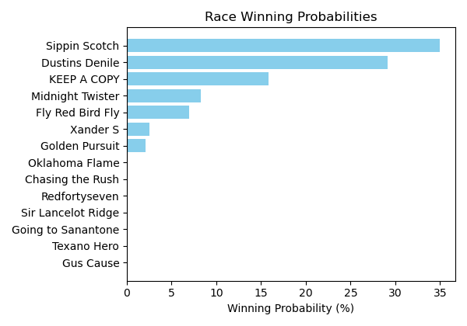

Figure: Winning Probability Distribution

NOTE: THIS RACE HAS HORSES THAT ARE MISSING CRITICAL DATA ELEMENTS

# Race: HOU | 2025-02-23 | Race #2 | Track: SAM HOUSTON RACE PARK

Track: SAM HOUSTON RACE PARK

|  |  |  |  |  |
| --- | --- | --- | --- | --- |
| Saddle Cloth # | Horse Name | Global Speed | Composite | Win Prob (%) |
| 1 | School Teacher * | 111.0 | 1.36 | 3.96 |
| 2 | Fun as All Git Out * | 111.0 | -6.35 | 0.01 |
| 3 | Maddie's Maverick * | 111.0 | -5.77 | 0.01 |
| 4 | Sherrys Ridge * | 111.0 | -7.86 | 0.00 |
| 5 | Cayman Hot * | 111.0 | -1.92 | 0.29 |
| 6 | Miss Motor Mouth * | 111.0 | -8.61 | 0.00 |
| 7 | Mighty Enticing * | 111.0 | -4.76 | 0.03 |
| 8 | Wild Steel * | 111.0 | 5.34 | 95.70 |

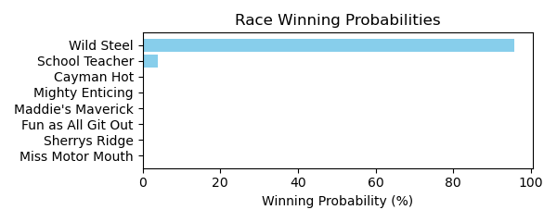

Figure: Winning Probability Distribution

NOTE: THIS RACE HAS HORSES THAT ARE MISSING CRITICAL DATA ELEMENTS

# Race: HOU | 2025-02-23 | Race #3 | Track: SAM HOUSTON RACE PARK

Track: SAM HOUSTON RACE PARK

|  |  |  |  |  |
| --- | --- | --- | --- | --- |
| Saddle Cloth # | Horse Name | Global Speed | Composite | Win Prob (%) |
| 1 | Honest * | 82.3 | 5.87 | 30.08 |
| 2 | God Knows Why * | 82.3 | -4.44 | 0.01 |
| 3 | Bling Baby * | 82.3 | 6.00 | 33.45 |
| 4 | Gee She's Fancy * | 82.3 | -2.18 | 0.05 |
| 5 | Avaling * | 82.3 | 5.11 | 16.39 |
| 6 | Midshipman's Lady * | 82.3 | 5.22 | 17.93 |
| 7 | Sassy Flyer * | 82.3 | 2.38 | 1.84 |
| 8 | All American Lady * | 82.3 | -0.11 | 0.25 |

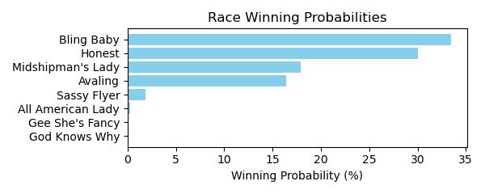

Figure: Winning Probability Distribution

NOTE: THIS RACE HAS HORSES THAT ARE MISSING CRITICAL DATA ELEMENTS

# Race: HOU | 2025-02-23 | Race #4 | Track: SAM HOUSTON RACE PARK

Track: SAM HOUSTON RACE PARK

|  |  |  |  |  |
| --- | --- | --- | --- | --- |
| Saddle Cloth # | Horse Name | Global Speed | Composite | Win Prob (%) |
| 1 | Highlander Honey * | 103.7 | 2.90 | 21.96 |
| 10 | Ize a Blast * | 103.7 | -6.16 | 0.02 |
| 2 | Anna Up * | 103.7 | -4.00 | 0.09 |
| 3 | Candy Oak * | 103.7 | -4.69 | 0.05 |
| 4 | Miss Escapade * | 103.7 | -3.40 | 0.14 |
| 5 | Perceptive * | 103.7 | 3.87 | 47.55 |
| 6 | Teardrop Tiara * | 103.7 | 3.29 | 29.97 |
| 7 | Gospel Extra * | 103.7 | -6.39 | 0.01 |
| 8 | Annamaria * | 103.7 | -9.69 | 0.00 |
| 9 | Gospel Freely * | 103.7 | -2.88 | 0.21 |

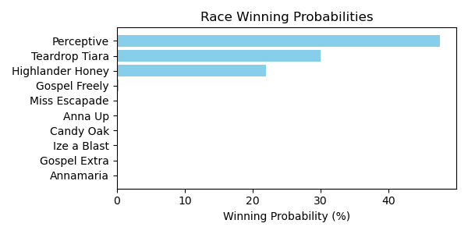

Figure: Winning Probability Distribution

NOTE: THIS RACE HAS HORSES THAT ARE MISSING CRITICAL DATA ELEMENTS

# Race: HOU | 2025-02-23 | Race #5 | Track: SAM HOUSTON RACE PARK

Track: SAM HOUSTON RACE PARK

|  |  |  |  |  |
| --- | --- | --- | --- | --- |
| Saddle Cloth # | Horse Name | Global Speed | Composite | Win Prob (%) |
| 1 | Gospel B. Havior * | 103.9 | -1.20 | 0.06 |
| 2 | Kamikaze * | 103.9 | -2.91 | 0.01 |
| 3 | Utsira * | 103.9 | -8.26 | 0.00 |
| 4 | Contessa's Song * | 103.9 | 2.68 | 1.23 |
| 5 | County Slugger * | 103.9 | 7.61 | 63.46 |
| 6 | Charluche * | 103.9 | -0.52 | 0.10 |
| 7 | Chainsaw City * | 103.9 | -1.10 | 0.06 |
| 8 | Boltoro * | 103.9 | 6.87 | 35.09 |

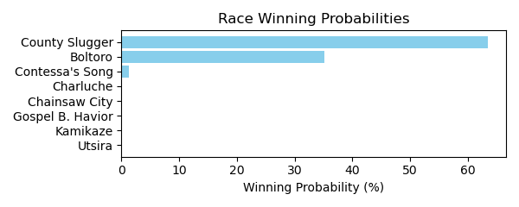

Figure: Winning Probability Distribution

NOTE: THIS RACE HAS HORSES THAT ARE MISSING CRITICAL DATA ELEMENTS

# Race: HOU | 2025-02-23 | Race #6 | Track: SAM HOUSTON RACE PARK

Track: SAM HOUSTON RACE PARK

|  |  |  |  |  |
| --- | --- | --- | --- | --- |
| Saddle Cloth # | Horse Name | Global Speed | Composite | Win Prob (%) |
| 1 | Pudding * | 66.6 | 8.50 | 40.09 |
| 2 | Playing Hardball * | 66.6 | 7.20 | 14.27 |
| 3 | Fort Hood * | 66.6 | 3.71 | 0.87 |
| 4 | My Little Prince * | 66.6 | -6.79 | 0.00 |
| 5 | Champagne Stooper * | 66.6 | 1.91 | 0.21 |
| 6 | Perliano * | 66.6 | 6.35 | 7.23 |
| 7 | Rocking Rocket * | 66.6 | 8.40 | 37.25 |
| 8 | Cinco Steve * | 66.6 | 0.53 | 0.07 |
| 9 | Sidetown * | 66.6 | -1.01 | 0.02 |

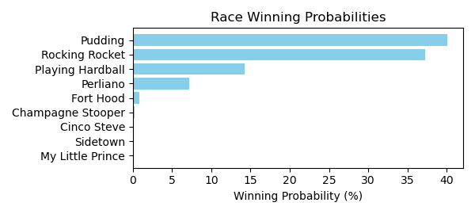

Figure: Winning Probability Distribution

NOTE: THIS RACE HAS HORSES THAT ARE MISSING CRITICAL DATA ELEMENTS

# Race: HOU | 2025-02-23 | Race #7 | Track: SAM HOUSTON RACE PARK

Track: SAM HOUSTON RACE PARK

|  |  |  |  |  |
| --- | --- | --- | --- | --- |
| Saddle Cloth # | Horse Name | Global Speed | Composite | Win Prob (%) |
| 1 | Piccolo Uomo * | 76.2 | -3.55 | 0.01 |
| 10 | Give Him Time * | 76.2 | -7.79 | 0.00 |
| 11 | Brewing * | 76.2 | 8.34 | 93.23 |
| 2 | Blame Dennis * | 76.2 | -6.71 | 0.00 |
| 3 | Wonderful News * | 76.2 | -9.52 | 0.00 |
| 4 | Doc Henry Ridge * | 76.2 | -9.86 | 0.00 |
| 5 | Midnight Talker * | 76.2 | 1.44 | 0.37 |
| 6 | Tough Trooper * | 76.2 | -6.01 | 0.00 |
| 7 | TOO COLD AT HOME * | 76.2 | 4.49 | 4.30 |
| 8 | Fully Funded * | 76.2 | -2.48 | 0.02 |
| 9 | Lone Tree * | 76.2 | 3.59 | 2.08 |

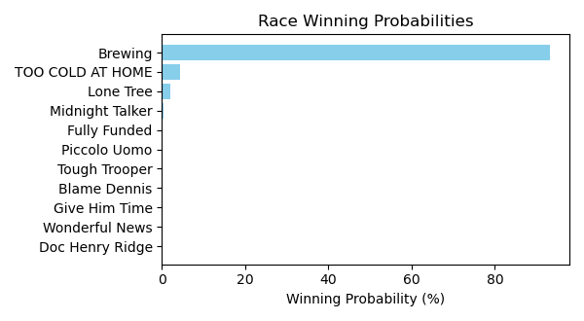

Figure: Winning Probability Distribution

NOTE: THIS RACE HAS HORSES THAT ARE MISSING CRITICAL DATA ELEMENTS

# Race: HOU | 2025-02-23 | Race #8 | Track: SAM HOUSTON RACE PARK

Track: SAM HOUSTON RACE PARK

|  |  |  |  |  |
| --- | --- | --- | --- | --- |
| Saddle Cloth # | Horse Name | Global Speed | Composite | Win Prob (%) |
| 1 | Big Nickel * | 103.6 | 3.82 | 65.10 |
| 2 | Keep Up the Pace * | 103.6 | -4.16 | 0.11 |
| 3 | Map This Out * | 103.6 | 3.04 | 34.73 |
| 4 | Can't Know * | 103.6 | -8.33 | 0.00 |
| 5 | Hank Ridge * | 103.6 | -9.39 | 0.00 |
| 6 | Nightlinger * | 103.6 | -5.65 | 0.03 |
| 7 | Floating Smokey * | 103.6 | -10.14 | 0.00 |
| 8 | Rock Island Rocket * | 103.6 | -6.37 | 0.02 |

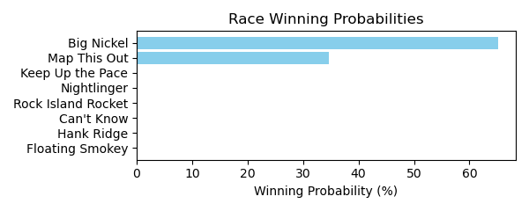

Figure: Winning Probability Distribution

NOTE: THIS RACE HAS HORSES THAT ARE MISSING CRITICAL DATA ELEMENTS

# Race: HOU | 2025-02-23 | Race #9 | Track: SAM HOUSTON RACE PARK

Track: SAM HOUSTON RACE PARK

|  |  |  |  |  |
| --- | --- | --- | --- | --- |
| Saddle Cloth # | Horse Name | Global Speed | Composite | Win Prob (%) |
| 1 | El Mero Mero * | 76.4 | -2.57 | 0.02 |
| 10 | Ooey Gooey Chewy * | 76.4 | 4.90 | 5.98 |
| 11 | Legendary Lore * | 76.4 | 8.02 | 72.88 |
| 2 | My Boy Bling * | 76.4 | -0.33 | 0.09 |
| 3 | Bronte Diem * | 76.4 | -6.08 | 0.00 |
| 4 | Cadillac Cowboy * | 76.4 | 5.77 | 12.05 |
| 5 | Mister Monte Carlo * | 76.4 | 2.27 | 0.73 |
| 6 | Optimal Trip * | 76.4 | 4.30 | 3.71 |
| 7 | Samsplayerslounge * | 76.4 | 4.50 | 4.35 |
| 8 | In Bond We Trust * | 76.4 | -9.64 | 0.00 |
| 9 | Do Your Job * | 76.4 | 0.61 | 0.19 |

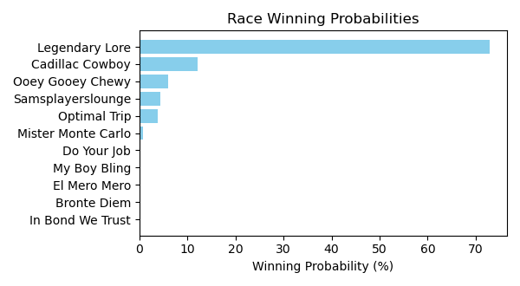

Figure: Winning Probability Distribution

NOTE: THIS RACE HAS HORSES THAT ARE MISSING CRITICAL DATA ELEMENTS

# Race: HOU | 2025-02-23 | Race #10 | Track: SAM HOUSTON RACE PARK

Track: SAM HOUSTON RACE PARK

|  |  |  |  |  |
| --- | --- | --- | --- | --- |
| Saddle Cloth # | Horse Name | Global Speed | Composite | Win Prob (%) |
| 1 | Levy * | 89.3 | -1.07 | 0.04 |
| 10 | Sniveling * | 89.3 | -6.68 | 0.00 |
| 11 | Malibu S S * | 89.3 | -3.38 | 0.01 |
| 12 | Texas Titan * | 89.3 | -9.12 | 0.00 |
| 13 | R D C Posse * | 89.3 | 1.75 | 0.40 |
| 2 | Will the Thrill * | 89.3 | -2.17 | 0.02 |
| 3 | Nightwind * | 89.3 | 4.33 | 3.12 |
| 4 | Federal Hill * | 89.3 | 1.02 | 0.22 |
| 5 | Macho Grande * | 89.3 | 8.60 | 95.17 |
| 6 | Union Data * | 89.3 | 1.61 | 0.35 |
| 7 | Hard Gold * | 89.3 | -2.12 | 0.02 |
| 8 | Fast Traffic * | 89.3 | 2.11 | 0.53 |
| 9 | Big Muckity * | 89.3 | 0.38 | 0.13 |

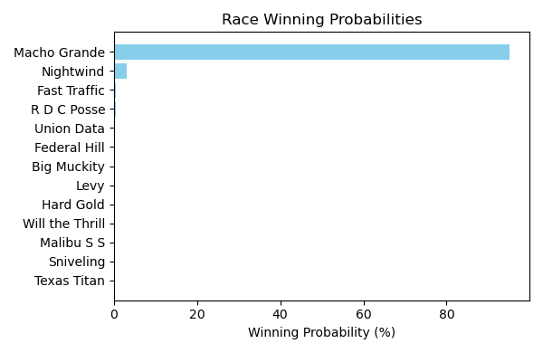

Figure: Winning Probability Distribution

NOTE: THIS RACE HAS HORSES THAT ARE MISSING CRITICAL DATA ELEMENTS

# Race: HOU | 2025-02-23 | Race #11 | Track: SAM HOUSTON RACE PARK

Track: SAM HOUSTON RACE PARK

|  |  |  |  |  |
| --- | --- | --- | --- | --- |
| Saddle Cloth # | Horse Name | Global Speed | Composite | Win Prob (%) |
| 1 | Violet Kitten * | 103.9 | 4.13 | 5.55 |
| 10 | Tiz a Knockout * | 103.9 | 1.12 | 0.50 |
| 2 | Catalyst * | 103.9 | 6.33 | 32.35 |
| 3 | La Ronalda Y G * | 103.9 | -7.14 | 0.00 |
| 4 | Wandering Kirby * | 103.9 | -8.58 | 0.00 |
| 5 | My Sweet Love * | 103.9 | -6.55 | 0.00 |
| 6 | Summertimee * | 103.9 | 0.20 | 0.24 |
| 7 | Razors Edge * | 103.9 | -9.91 | 0.00 |
| 8 | Wonder Wave (IRE) * | 103.9 | 2.27 | 1.25 |
| 9 | Sugarcoat * | 103.9 | 7.11 | 60.10 |

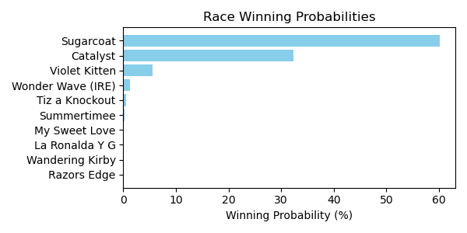

Figure: Winning Probability Distribution

NOTE: THIS RACE HAS HORSES THAT ARE MISSING CRITICAL DATA ELEMENTS

# Race: TSA | 2025-02-21 | Race #1 | Track: SANTA ANITA PARK

Track: SANTA ANITA PARK

|  |  |  |  |  |
| --- | --- | --- | --- | --- |
| Saddle Cloth # | Horse Name | Global Speed | Composite | Win Prob (%) |
| 1 | Oscar Joy * | 82.7 | 2.98 | 1.53 |
| 2 | Private Gem * | 82.7 | 3.41 | 2.16 |
| 3 | Travelin' Show * | 82.7 | 3.77 | 2.87 |
| 5 | Enough Already * | 82.7 | 1.19 | 0.36 |
| 6 | Bolt Supremacy * | 82.7 | 0.37 | 0.19 |
| 7 | Naftis * | 82.7 | 2.40 | 0.96 |
| 8 | Mr. Leasure * | 82.7 | 8.10 | 91.92 |

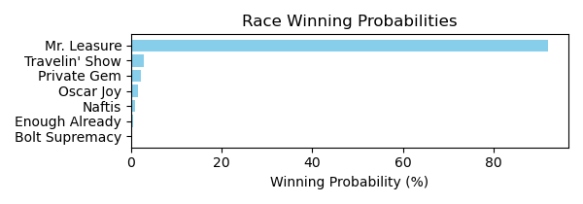

Figure: Winning Probability Distribution

NOTE: THIS RACE HAS HORSES THAT ARE MISSING CRITICAL DATA ELEMENTS

# Race: TSA | 2025-02-21 | Race #2 | Track: SANTA ANITA PARK

Track: SANTA ANITA PARK

|  |  |  |  |  |
| --- | --- | --- | --- | --- |
| Saddle Cloth # | Horse Name | Global Speed | Composite | Win Prob (%) |
| 1 | Pineapple Juice * | 76.4 | -7.20 | 0.00 |
| 2 | Blue Silver * | 76.4 | -2.05 | 0.05 |
| 3 | Gianola * | 76.4 | 6.69 | 57.09 |
| 4 | Golden River * | 76.4 | 0.46 | 0.39 |
| 5 | Momo's Kiddo * | 76.4 | -1.50 | 0.08 |
| 6 | Candy's Wildcat * | 76.4 | -0.75 | 0.15 |
| 7 | Constant Conflict * | 76.4 | 6.32 | 42.24 |

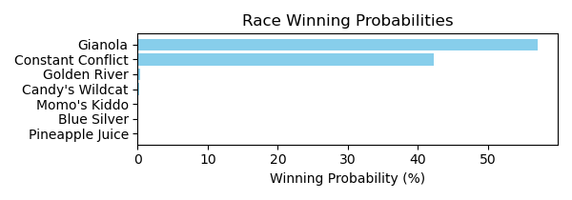

Figure: Winning Probability Distribution

NOTE: THIS RACE HAS HORSES THAT ARE MISSING CRITICAL DATA ELEMENTS

# Race: TSA | 2025-02-21 | Race #3 | Track: SANTA ANITA PARK

Track: SANTA ANITA PARK

|  |  |  |  |  |
| --- | --- | --- | --- | --- |
| Saddle Cloth # | Horse Name | Global Speed | Composite | Win Prob (%) |
| 1 | Old Triangle * | 76.6 | 6.70 | 2.07 |
| 10 | Come Out Fighting * | 76.6 | 0.07 | 0.01 |
| 2 | Mr. Big Heart * | 76.6 | -9.43 | 0.00 |
| 3 | Trinidad * | 76.6 | 3.48 | 0.16 |
| 4 | Wound Up * | 76.6 | 11.51 | 97.23 |
| 5 | Clever Clover * | 76.6 | -1.55 | 0.00 |
| 6 | Stan From Malibu * | 76.6 | -0.95 | 0.00 |
| 7 | Square Cat * | 76.6 | -5.28 | 0.00 |
| 8 | Harcyn * | 76.6 | 4.96 | 0.52 |
| 9 | Idiot's Gold * | 76.6 | -2.20 | 0.00 |

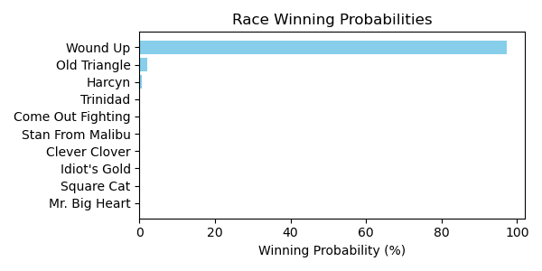

Figure: Winning Probability Distribution

NOTE: THIS RACE HAS HORSES THAT ARE MISSING CRITICAL DATA ELEMENTS

# Race: TSA | 2025-02-21 | Race #4 | Track: SANTA ANITA PARK

Track: SANTA ANITA PARK

|  |  |  |  |  |
| --- | --- | --- | --- | --- |
| Saddle Cloth # | Horse Name | Global Speed | Composite | Win Prob (%) |
| 1 | Shop Till You Drop * | 71.0 | 7.25 | 83.33 |
| 2 | Amelia Bleu * | 71.0 | 1.68 | 0.97 |
| 3 | Feisty Mitole * | 71.0 | 4.29 | 7.82 |
| 4 | Sabres * | 71.0 | -0.56 | 0.16 |
| 5 | Moonlight Tryst * | 71.0 | 3.31 | 3.58 |
| 6 | Putt for Dough * | 71.0 | 3.49 | 4.13 |
| 7 | The Shushala * | 71.0 | -8.18 | 0.00 |
| 8 | Miss Pixy Stix * | 71.0 | -5.00 | 0.00 |

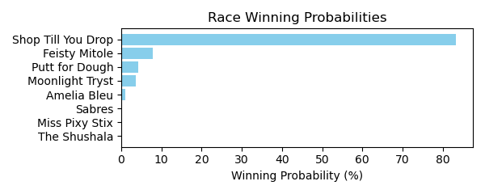

Figure: Winning Probability Distribution

NOTE: THIS RACE HAS HORSES THAT ARE MISSING CRITICAL DATA ELEMENTS

# Race: TSA | 2025-02-21 | Race #5 | Track: SANTA ANITA PARK

Track: SANTA ANITA PARK

|  |  |  |  |  |
| --- | --- | --- | --- | --- |
| Saddle Cloth # | Horse Name | Global Speed | Composite | Win Prob (%) |
| 1 | Atia * | 104.3 | -6.26 | 0.01 |
| 10 | Aggro * | 104.3 | 1.61 | 7.70 |
| 2 | Big Leap * | 104.3 | -2.06 | 0.41 |
| 3 | Authentic Grace * | 104.3 | -6.26 | 0.01 |
| 4 | Delightful Laura * | 104.3 | 0.14 | 2.37 |
| 5 | Lee's Baby Girl * | 104.3 | 4.10 | 56.42 |
| 6 | Allihies * | 104.3 | -9.57 | 0.00 |
| 7 | Giggle Giggle * | 104.3 | -6.94 | 0.01 |
| 8 | TAVOLARA * | 104.3 | 3.43 | 33.06 |
| 9 | Cause I'm Perfect * | 104.3 | -8.49 | 0.00 |

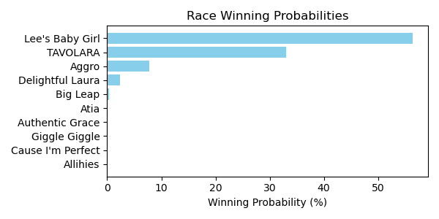

Figure: Winning Probability Distribution

NOTE: THIS RACE HAS HORSES THAT ARE MISSING CRITICAL DATA ELEMENTS

# Race: TSA | 2025-02-21 | Race #6 | Track: SANTA ANITA PARK

Track: SANTA ANITA PARK

|  |  |  |  |  |
| --- | --- | --- | --- | --- |
| Saddle Cloth # | Horse Name | Global Speed | Composite | Win Prob (%) |
| 1 | Barely Funtional * | 104.5 | 7.11 | 16.38 |
| 2 | Malibu Rocks * | 104.5 | 6.72 | 11.93 |
| 3 | Manitowish * | 104.5 | -1.17 | 0.02 |
| 4 | Cowboy Mike * | 104.5 | 8.96 | 71.66 |
| 5 | Il Bellator * | 104.5 | -6.26 | 0.00 |

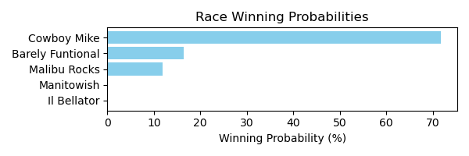

Figure: Winning Probability Distribution

NOTE: THIS RACE HAS HORSES THAT ARE MISSING CRITICAL DATA ELEMENTS

# Race: TSA | 2025-02-21 | Race #7 | Track: SANTA ANITA PARK

Track: SANTA ANITA PARK

|  |  |  |  |  |
| --- | --- | --- | --- | --- |
| Saddle Cloth # | Horse Name | Global Speed | Composite | Win Prob (%) |
| 1 | Take Another Card * | 104.2 | 5.28 | 1.61 |
| 2 | Resolve * | 104.2 | 8.21 | 16.84 |
| 3 | Tigerish * | 104.2 | 4.31 | 0.74 |
| 4 | Tequilaandtherapy * | 104.2 | 5.72 | 2.30 |
| 5 | Canto Della Terra (IRE) * | 104.2 | 9.81 | 60.48 |
| 6 | Amorita * | 104.2 | 6.04 | 2.97 |
| 7 | Firenze Flavor * | 104.2 | 8.07 | 15.06 |
| 8 | Polythene Pam * | 104.2 | -6.27 | 0.00 |

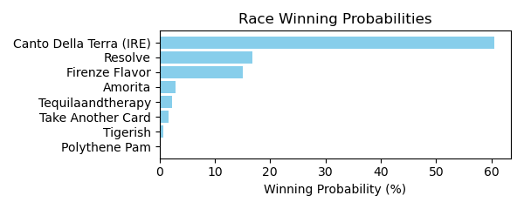

Figure: Winning Probability Distribution

NOTE: THIS RACE HAS HORSES THAT ARE MISSING CRITICAL DATA ELEMENTS

# Race: TSA | 2025-02-21 | Race #8 | Track: SANTA ANITA PARK

Track: SANTA ANITA PARK

|  |  |  |  |  |
| --- | --- | --- | --- | --- |
| Saddle Cloth # | Horse Name | Global Speed | Composite | Win Prob (%) |
| 1 | Surf Song * | 76.4 | 4.29 | 2.88 |
| 2 | Cooey * | 76.4 | 6.63 | 18.69 |
| 3 | VELOCITY * | 76.4 | 5.80 | 9.65 |
| 4 | PRISTINE * | 76.4 | 6.08 | 12.02 |
| 5 | PUTONAHAPPYFACE * | 76.4 | 6.07 | 11.92 |
| 6 | BRILLIANTLY * | 76.4 | 5.73 | 9.11 |
| 7 | FORMULA ROSSA * | 76.4 | 6.01 | 11.41 |
| 8 | DON'T TEMPT HER * | 76.4 | 5.95 | 10.88 |
| 9 | NIKOLINA * | 76.4 | 6.22 | 13.44 |

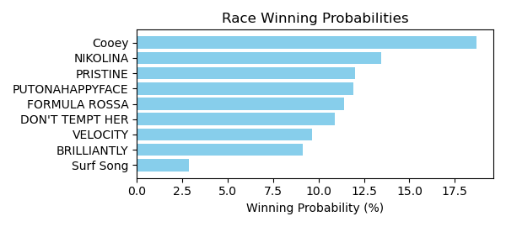

Figure: Winning Probability Distribution

NOTE: THIS RACE HAS HORSES THAT ARE MISSING CRITICAL DATA ELEMENTS

# Race: TSA | 2025-02-21 | Race #9 | Track: SANTA ANITA PARK

Track: SANTA ANITA PARK

|  |  |  |  |  |
| --- | --- | --- | --- | --- |
| Saddle Cloth # | Horse Name | Global Speed | Composite | Win Prob (%) |
| 1 | Unwritten Code * | 76.5 | 7.34 | 21.25 |
| 10 | Katerini * | 76.5 | 1.88 | 0.27 |
| 2 | Cheeky Gal * | 76.5 | -4.10 | 0.00 |
| 3 | Dancing Soul * | 76.5 | -0.96 | 0.03 |
| 4 | Tiergarten * | 76.5 | 4.73 | 2.63 |
| 5 | A Real Jewel * | 76.5 | -4.58 | 0.00 |
| 6 | Satoshi * | 76.5 | -4.82 | 0.00 |
| 7 | Gypsy Lynn * | 76.5 | -5.48 | 0.00 |
| 8 | Dr. Ray D. * | 76.5 | 8.92 | 75.12 |
| 9 | Red Diamond * | 76.5 | 3.07 | 0.70 |

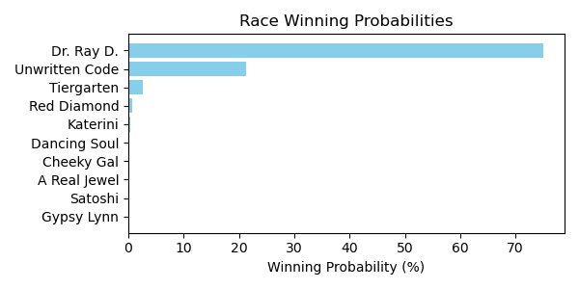

Figure: Winning Probability Distribution

NOTE: THIS RACE HAS HORSES THAT ARE MISSING CRITICAL DATA ELEMENTS

# Race: TSA | 2025-02-22 | Race #1 | Track: SANTA ANITA PARK

Track: SANTA ANITA PARK

|  |  |  |  |  |
| --- | --- | --- | --- | --- |
| Saddle Cloth # | Horse Name | Global Speed | Composite | Win Prob (%) |
| 1 | America's Mark * | 82.4 | 8.18 | 0.61 |
| 2 | Chilly Philly * | 103.9 | 4.57 | 2.53 |
| 3 | Heras Hope * | 76.3 | -0.57 | 0.00 |
| 4 | Thirsty Destiny * | 76.3 | 1.53 | 0.00 |
| 5 | Press Your Luck * | 76.3 | 6.06 | 0.03 |
| 6 | Sunset Grazen * | 103.9 | 1.99 | 0.32 |
| 7 | Lady Mendelssohn * | 103.9 | 9.12 | 96.50 |

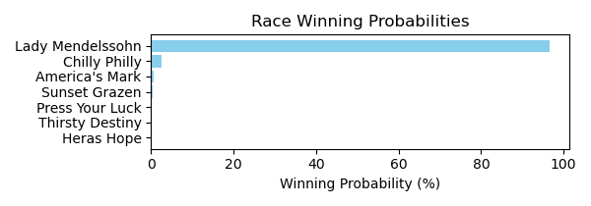

Figure: Winning Probability Distribution

NOTE: THIS RACE HAS HORSES THAT ARE MISSING CRITICAL DATA ELEMENTS

# Race: TSA | 2025-02-22 | Race #2 | Track: SANTA ANITA PARK

Track: SANTA ANITA PARK

|  |  |  |  |  |
| --- | --- | --- | --- | --- |
| Saddle Cloth # | Horse Name | Global Speed | Composite | Win Prob (%) |
| 1 | BRANDON'S GIRL * | 74.0 | 5.40 | 17.96 |
| 2 | Buds N Suds * | 76.2 | 5.42 | 28.32 |
| 3 | Kulbit * | 70.9 | -7.46 | 0.00 |
| 4 | FREE NOMINATION * | 74.0 | 5.20 | 15.26 |
| 5 | Dixie Allure * | 70.9 | 4.00 | 3.19 |
| 6 | Tropical Rain Day * | 82.2 | 2.52 | 9.34 |
| 7 | LADY OF SKY * | 74.0 | 5.15 | 14.68 |
| 8 | Tapatia Leah * | 70.9 | 5.58 | 11.26 |

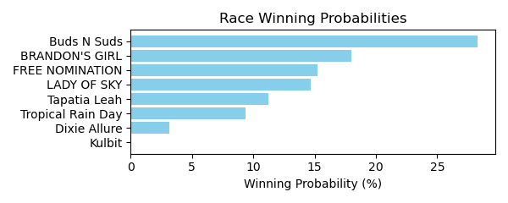

Figure: Winning Probability Distribution

NOTE: THIS RACE HAS HORSES THAT ARE MISSING CRITICAL DATA ELEMENTS

# Race: TSA | 2025-02-22 | Race #3 | Track: SANTA ANITA PARK

Track: SANTA ANITA PARK

|  |  |  |  |  |
| --- | --- | --- | --- | --- |
| Saddle Cloth # | Horse Name | Global Speed | Composite | Win Prob (%) |
| 1 | Queen Maxima * | 82.7 | 6.03 | 0.34 |
| 2 | Laulne (FR) * | 82.7 | 2.01 | 0.01 |
| 3 | Arctic Breeze * | 111.8 | 5.87 | 99.18 |
| 4 | Ma Rae's Girl * | 82.7 | 2.23 | 0.02 |
| 5 | Stay and Scam * | 82.7 | 5.58 | 0.24 |
| 6 | Miss Roberts (GB) * | 82.7 | 5.48 | 0.22 |

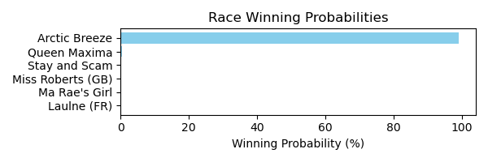

Figure: Winning Probability Distribution

NOTE: THIS RACE HAS HORSES THAT ARE MISSING CRITICAL DATA ELEMENTS

# Race: TSA | 2025-02-22 | Race #4 | Track: SANTA ANITA PARK

Track: SANTA ANITA PARK

|  |  |  |  |  |
| --- | --- | --- | --- | --- |
| Saddle Cloth # | Horse Name | Global Speed | Composite | Win Prob (%) |
| 1 | Aurelian Man * | 104.2 | 7.38 | 13.53 |
| 2 | Taishan * | 104.2 | 6.91 | 9.27 |
| 3 | Atomic Drop * | 104.2 | -0.30 | 0.03 |
| 4 | Impossible Task * | 104.2 | 4.16 | 1.03 |
| 5 | Kingmeister * | 104.2 | 2.73 | 0.33 |
| 6 | Druidic * | 104.2 | 9.53 | 75.81 |
| 7 | Upward Mobility * | 76.5 | -6.37 | 0.00 |
| 8 | Letshaveonemore * | 82.6 | -5.78 | 0.00 |

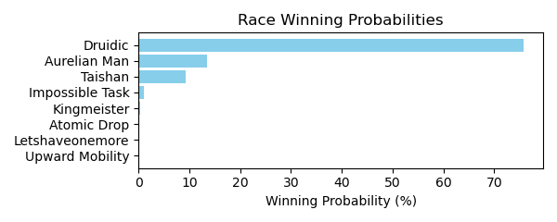

Figure: Winning Probability Distribution

NOTE: THIS RACE HAS HORSES THAT ARE MISSING CRITICAL DATA ELEMENTS

# Race: TSA | 2025-02-22 | Race #5 | Track: SANTA ANITA PARK

Track: SANTA ANITA PARK

|  |  |  |  |  |
| --- | --- | --- | --- | --- |
| Saddle Cloth # | Horse Name | Global Speed | Composite | Win Prob (%) |
| 1 | Speed of Elon * | 104.2 | 3.23 | 2.94 |
| 10 | Fight Back * | 104.2 | 1.67 | 0.84 |
| 2 | King of Clubs * | 82.6 | 8.06 | 1.86 |
| 3 | Annan * | 76.5 | 8.15 | 0.59 |
| 4 | Going Nowhere * | 82.6 | 3.45 | 0.05 |
| 5 | It's My World * | 118.4 | -2.89 | 0.37 |
| 6 | Danzing Wild Cat * | 104.2 | 5.14 | 13.50 |
| 7 | OM BREW * | 97.5 | 7.13 | 17.52 |
| 8 | Miles Finch * | 104.2 | 7.05 | 62.29 |
| 9 | Uncle Evco * | 104.2 | -2.55 | 0.03 |

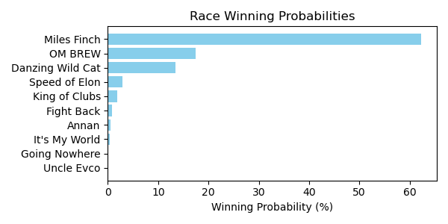

Figure: Winning Probability Distribution

NOTE: THIS RACE HAS HORSES THAT ARE MISSING CRITICAL DATA ELEMENTS

# Race: TSA | 2025-02-22 | Race #6 | Track: SANTA ANITA PARK

Track: SANTA ANITA PARK

|  |  |  |  |  |
| --- | --- | --- | --- | --- |
| Saddle Cloth # | Horse Name | Global Speed | Composite | Win Prob (%) |
| 1 | Wine and Whisky * | 76.5 | -7.01 | 0.00 |
| 10 | Veritas Aequitas * | 104.3 | 8.05 | 53.08 |
| 2 | Enos Slaughter * | 104.3 | -6.81 | 0.00 |
| 3 | Happy Does * | 104.3 | 6.55 | 15.99 |
| 4 | Coolwind * | 104.3 | 1.27 | 0.23 |
| 5 | Rich Gold * | 104.3 | 0.77 | 0.16 |
| 6 | J. B. Books * | 109.0 | -2.08 | 0.04 |
| 7 | Upstart Yankee * | 104.3 | -4.20 | 0.00 |
| 8 | Crown Magic * | 104.3 | 7.35 | 30.44 |
| 9 | Quality Cat * | 104.3 | -0.47 | 0.06 |

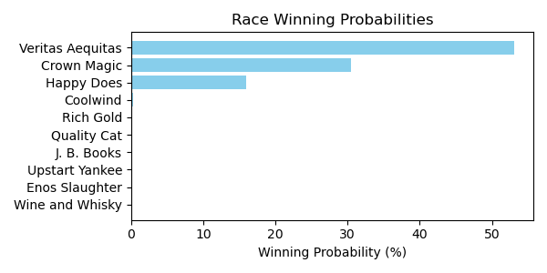

Figure: Winning Probability Distribution

NOTE: THIS RACE HAS HORSES THAT ARE MISSING CRITICAL DATA ELEMENTS

# Race: TSA | 2025-02-22 | Race #7 | Track: SANTA ANITA PARK

Track: SANTA ANITA PARK

|  |  |  |  |  |
| --- | --- | --- | --- | --- |
| Saddle Cloth # | Horse Name | Global Speed | Composite | Win Prob (%) |
| 1 | Sasafran * | 104.0 | 5.82 | 12.97 |
| 10 | Big Whoosh * | 104.0 | -0.53 | 0.08 |
| 12 | Om N Joy * | 82.5 | 2.00 | 0.01 |
| 13 | Mrazek's Old Dream * | 104.0 | -5.38 | 0.00 |
| 2 | Guiltyofhavingfun * | 104.0 | 6.07 | 15.80 |
| 3 | Renatus * | 104.0 | -4.21 | 0.00 |
| 4 | Hello Kid O Kid O * | 104.0 | 6.44 | 21.23 |
| 5 | Z's Wardrobe * | 104.0 | -2.63 | 0.02 |
| 6 | Maga Kai * | 104.0 | -0.24 | 0.10 |
| 7 | SUNTORY TIME * | 99.9 | 7.73 | 26.31 |
| 8 | Odies Memory Lane * | 82.5 | 5.85 | 0.18 |
| 9 | Orange Thunder * | 104.0 | 6.55 | 23.29 |

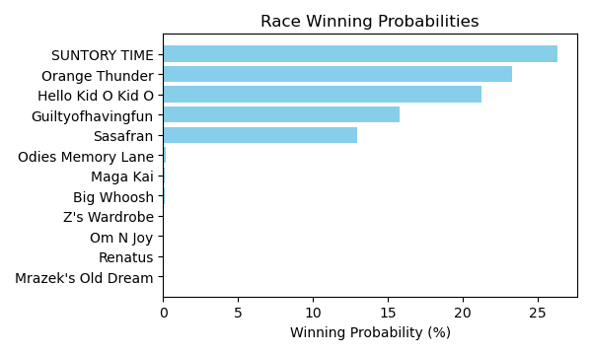

Figure: Winning Probability Distribution

NOTE: THIS RACE HAS HORSES THAT ARE MISSING CRITICAL DATA ELEMENTS

# Race: TSA | 2025-02-22 | Race #8 | Track: SANTA ANITA PARK

Track: SANTA ANITA PARK

|  |  |  |  |  |
| --- | --- | --- | --- | --- |
| Saddle Cloth # | Horse Name | Global Speed | Composite | Win Prob (%) |
| 1 | KID DYNASTY * | 82.6 | 4.36 | 14.15 |
| 2 | KING STEPHEN * | 82.6 | 4.16 | 12.04 |
| 3 | PRAYER * | 82.6 | 4.26 | 13.09 |
| 4 | ROADHOUSE RUMBLE * | 82.6 | 4.15 | 11.95 |
| 5 | CHARLIE FOXTROT * | 82.6 | 4.29 | 13.39 |
| 6 | Lead Pipe Joe * | 82.6 | -5.25 | 0.01 |
| 7 | VOLDEMORT * | 82.6 | 4.05 | 11.01 |
| 8 | TIZ SECURE * | 82.6 | 3.88 | 9.60 |
| 9 | FIVE STAR LOVE * | 82.6 | 4.41 | 14.76 |

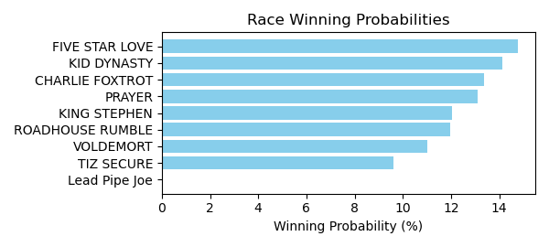

Figure: Winning Probability Distribution

NOTE: THIS RACE HAS HORSES THAT ARE MISSING CRITICAL DATA ELEMENTS

# Race: TSA | 2025-02-22 | Race #9 | Track: SANTA ANITA PARK

Track: SANTA ANITA PARK

|  |  |  |  |  |
| --- | --- | --- | --- | --- |
| Saddle Cloth # | Horse Name | Global Speed | Composite | Win Prob (%) |
| 1 | King Apollo * | 76.7 | 7.99 | 0.47 |
| 10 | Geezer * | 82.8 | 6.99 | 0.72 |
| 11 | Tom Horn * | 104.5 | 6.01 | 25.19 |
| 12 | Father Delay * | 82.8 | 3.91 | 0.06 |
| 13 | Noble Reflection * | 76.7 | 7.34 | 0.28 |
| 14 | Moody Jim (IRE) * | 104.5 | 7.14 | 61.79 |
| 2 | Ghostly Act * | 82.8 | 9.66 | 6.09 |
| 3 | Western Avenue * | 76.7 | 3.57 | 0.01 |
| 4 | Money Makes Money * | 82.8 | 8.98 | 3.53 |
| 5 | Guy Named Joe * | 118.7 | -2.78 | 0.38 |
| 6 | Dancing Rinca * | 76.7 | 9.27 | 1.30 |
| 7 | Santo Dios (ARG) * | 76.7 | 1.71 | 0.00 |
| 8 | dh-Irish Royalty * | 76.7 | 6.72 | 0.17 |
| 9 | News At Ten (GB) * | 82.8 | 0.24 | 0.00 |

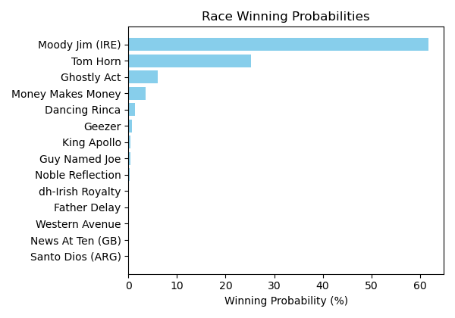

Figure: Winning Probability Distribution

NOTE: THIS RACE HAS HORSES THAT ARE MISSING CRITICAL DATA ELEMENTS

# Race: TSA | 2025-02-22 | Race #10 | Track: SANTA ANITA PARK

Track: SANTA ANITA PARK

|  |  |  |  |  |
| --- | --- | --- | --- | --- |
| Saddle Cloth # | Horse Name | Global Speed | Composite | Win Prob (%) |
| 1 | Star of The Night (IRE) * | 118.5 | -1.03 | 0.02 |
| 10 | Lady Monclaire * | 104.3 | 5.10 | 0.17 |
| 11 | Magic Light * | 104.3 | -3.12 | 0.00 |
| 12 | Kentucky Gal (IRE) * | 118.5 | 6.28 | 7.58 |
| 13 | Over Attracted * | 82.7 | 0.75 | 0.00 |
| 14 | Shuangxi (IRE) * | 82.7 | 0.61 | 0.00 |
| 2 | Eternal Reign (IRE) * | 104.3 | 10.03 | 8.96 |
| 3 | Cornelia Fort * | 82.7 | 1.47 | 0.00 |
| 4 | NEEDLEPOINT (IRE) * | 82.7 | 8.50 | 0.03 |
| 5 | dh-Everything Bugs Me * | 118.5 | 0.19 | 0.06 |
| 6 | Tirupati * | 104.3 | 5.59 | 0.26 |
| 7 | Quick Kate * | 76.6 | -5.80 | 0.00 |
| 8 | Sophisticate * | 118.5 | 9.27 | 82.91 |
| 9 | Prancingthruparis * | 76.6 | 7.19 | 0.00 |

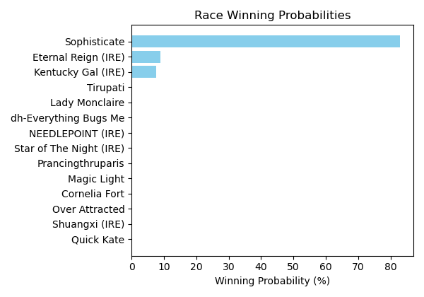

Figure: Winning Probability Distribution

NOTE: THIS RACE HAS HORSES THAT ARE MISSING CRITICAL DATA ELEMENTS

# Race: SUN | 2025-02-21 | Race #1 | Track: SUNLAND PARK

Track: SUNLAND PARK

|  |  |  |  |  |
| --- | --- | --- | --- | --- |
| Saddle Cloth # | Horse Name | Global Speed | Composite | Win Prob (%) |
| 1 | FERRARI MONEY * | 70.9 | 4.20 | 3.44 |
| 2 | Native Charmer * | 70.9 | 7.24 | 39.22 |
| 3 | LADYPACKSAPISTOL * | 70.9 | 4.27 | 3.65 |
| 4 | Alexandra Elaine * | 70.9 | 7.54 | 49.67 |
| 5 | Klimt's Girl * | 70.9 | -7.61 | 0.00 |
| 6 | Toni the Grrreat * | 70.9 | -8.16 | 0.00 |
| 7 | PINK MOSCATO * | 70.9 | 4.39 | 4.02 |

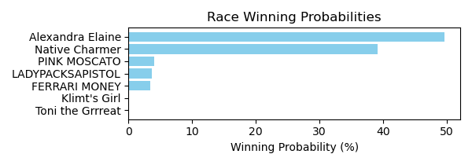

Figure: Winning Probability Distribution

NOTE: THIS RACE HAS HORSES THAT ARE MISSING CRITICAL DATA ELEMENTS

# Race: SUN | 2025-02-21 | Race #2 | Track: SUNLAND PARK

Track: SUNLAND PARK

|  |  |  |  |  |
| --- | --- | --- | --- | --- |
| Saddle Cloth # | Horse Name | Global Speed | Composite | Win Prob (%) |
| 1 | Piney Bluff * | 82.4 | -2.21 | 0.81 |
| 2 | Midnight Split * | 82.4 | 1.85 | 20.73 |
| 3 | Abetemarco * | 82.4 | 2.00 | 23.43 |
| 4 | Storey's Fury * | 82.4 | -4.58 | 0.12 |
| 5 | Lewis Bere (FR) * | 82.4 | -8.70 | 0.00 |
| 6 | Attila the Star * | 82.4 | 2.20 | 27.55 |
| 7 | Pass It Around * | 82.4 | -8.28 | 0.01 |
| 8 | Race for Dough * | 82.4 | 2.19 | 27.35 |

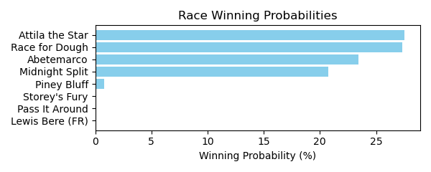

Figure: Winning Probability Distribution

NOTE: THIS RACE HAS HORSES THAT ARE MISSING CRITICAL DATA ELEMENTS

# Race: SUN | 2025-02-21 | Race #3 | Track: SUNLAND PARK

Track: SUNLAND PARK

|  |  |  |  |  |
| --- | --- | --- | --- | --- |
| Saddle Cloth # | Horse Name | Global Speed | Composite | Win Prob (%) |
| 1 | My Yellowstone * | 76.0 | -9.04 | 0.00 |
| 2 | Kiamanasjoyousday * | 76.0 | -6.36 | 0.00 |
| 3 | LEGION HEIRESS * | 76.0 | 3.71 | 3.38 |
| 4 | Mo Money Time * | 76.0 | 7.90 | 96.36 |
| 5 | Aunt Bennie * | 76.0 | -5.27 | 0.00 |
| 6 | Sir Liams Love * | 76.0 | -8.56 | 0.00 |
| 7 | Back Pay * | 76.0 | -6.32 | 0.00 |
| 8 | Attila Style * | 76.0 | 0.51 | 0.26 |

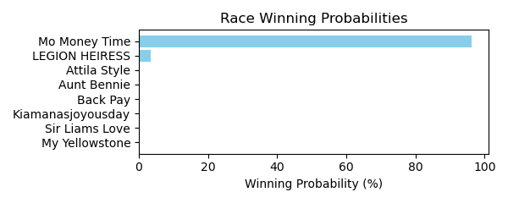

Figure: Winning Probability Distribution

NOTE: THIS RACE HAS HORSES THAT ARE MISSING CRITICAL DATA ELEMENTS

# Race: SUN | 2025-02-21 | Race #4 | Track: SUNLAND PARK

Track: SUNLAND PARK

|  |  |  |  |  |
| --- | --- | --- | --- | --- |
| Saddle Cloth # | Horse Name | Global Speed | Composite | Win Prob (%) |
| 1 | Beach Storm * | 103.7 | -2.35 | 0.03 |
| 2 | Spend Again * | 103.7 | -7.01 | 0.00 |
| 3 | Desert Punk * | 103.7 | -1.45 | 0.07 |
| 4 | Angela's Angel * | 103.7 | -2.41 | 0.03 |
| 5 | Copper State * | 103.7 | -3.55 | 0.01 |
| 6 | Midevil Mayhem * | 103.7 | 7.64 | 99.83 |
| 7 | Smoke Stack * | 103.7 | -3.21 | 0.02 |

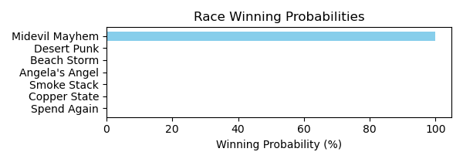

Figure: Winning Probability Distribution

NOTE: THIS RACE HAS HORSES THAT ARE MISSING CRITICAL DATA ELEMENTS

# Race: SUN | 2025-02-21 | Race #5 | Track: SUNLAND PARK

Track: SUNLAND PARK

|  |  |  |  |  |
| --- | --- | --- | --- | --- |
| Saddle Cloth # | Horse Name | Global Speed | Composite | Win Prob (%) |
| 1 | TRAFFICSTORM * | 82.1 | 5.74 | 11.74 |
| 2 | American Ranger Bb * | 82.1 | 7.23 | 38.70 |
| 3 | Bye Bye Russ * | 82.1 | 5.68 | 11.18 |
| 4 | American Knight * | 82.1 | -2.06 | 0.02 |
| 5 | Call Me Hollywood * | 82.1 | -7.25 | 0.00 |
| 6 | Shiny Shores * | 82.1 | -1.18 | 0.05 |
| 7 | Nobody's Perfect * | 82.1 | 6.75 | 26.38 |
| 8 | AMERICAN STORM * | 82.1 | 5.76 | 11.93 |

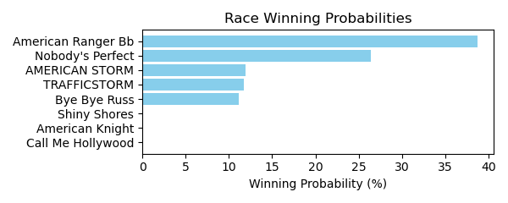

Figure: Winning Probability Distribution

NOTE: THIS RACE HAS HORSES THAT ARE MISSING CRITICAL DATA ELEMENTS

# Race: SUN | 2025-02-21 | Race #6 | Track: SUNLAND PARK

Track: SUNLAND PARK

|  |  |  |  |  |
| --- | --- | --- | --- | --- |
| Saddle Cloth # | Horse Name | Global Speed | Composite | Win Prob (%) |
| 1 | Grey Storm * | 104.1 | -1.24 | 0.28 |
| 2 | Loco Luna * | 104.1 | -5.71 | 0.01 |
| 3 | Grazen Boy * | 104.1 | 3.42 | 11.80 |
| 4 | Capital Joke * | 104.1 | -1.86 | 0.17 |
| 5 | Projection * | 104.1 | 3.73 | 15.11 |
| 6 | Zia Zapper * | 104.1 | 0.25 | 0.93 |
| 7 | Mastering * | 104.1 | 5.68 | 71.70 |

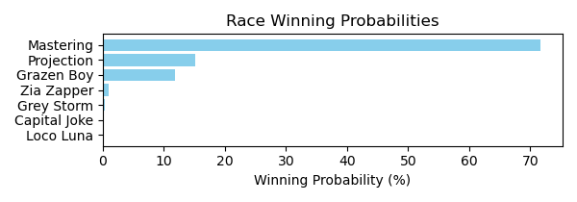

Figure: Winning Probability Distribution

NOTE: THIS RACE HAS HORSES THAT ARE MISSING CRITICAL DATA ELEMENTS

# Race: SUN | 2025-02-21 | Race #7 | Track: SUNLAND PARK

Track: SUNLAND PARK

|  |  |  |  |  |
| --- | --- | --- | --- | --- |
| Saddle Cloth # | Horse Name | Global Speed | Composite | Win Prob (%) |
| 1 | Sir Ruckus * | 66.5 | -4.89 | 0.02 |
| 2 | Auspice * | 66.5 | -9.14 | 0.00 |
| 3 | Runaway Goddess * | 66.5 | -8.65 | 0.00 |
| 4 | Finally an Eddie * | 66.5 | -7.95 | 0.00 |
| 5 | Jamie Can't Dance * | 66.5 | -9.85 | 0.00 |
| 6 | Ronchetti * | 66.5 | 1.08 | 1.95 |
| 7 | Moon Shine Time * | 66.5 | 2.74 | 7.33 |
| 8 | Latigo Ellis * | 66.5 | 5.88 | 90.70 |

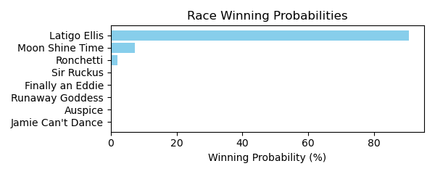

Figure: Winning Probability Distribution

NOTE: THIS RACE HAS HORSES THAT ARE MISSING CRITICAL DATA ELEMENTS

# Race: SUN | 2025-02-21 | Race #8 | Track: SUNLAND PARK

Track: SUNLAND PARK

|  |  |  |  |  |
| --- | --- | --- | --- | --- |
| Saddle Cloth # | Horse Name | Global Speed | Composite | Win Prob (%) |
| 1 | Desertrose Oftexas * | 82.4 | -3.54 | 0.01 |
| 2 | Turn On Arch * | 82.4 | 5.09 | 11.62 |
| 3 | Shelly d'Oro * | 82.4 | -2.65 | 0.02 |
| 4 | Awesome Walker * | 82.4 | -0.74 | 0.11 |
| 5 | Quite Lovely * | 82.4 | 7.42 | 75.02 |
| 6 | Maddie Poppe * | 82.4 | -5.58 | 0.00 |
| 7 | Time Is Precious * | 82.4 | 4.05 | 5.06 |
| 8 | Shell Game * | 82.4 | 4.65 | 8.15 |

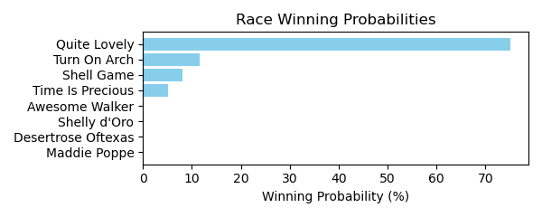

Figure: Winning Probability Distribution

NOTE: THIS RACE HAS HORSES THAT ARE MISSING CRITICAL DATA ELEMENTS

# Race: SUN | 2025-02-21 | Race #9 | Track: SUNLAND PARK

Track: SUNLAND PARK

|  |  |  |  |  |
| --- | --- | --- | --- | --- |
| Saddle Cloth # | Horse Name | Global Speed | Composite | Win Prob (%) |
| 1 | Bella Baby * | 76.3 | -4.28 | 0.01 |
| 2 | Blue Cowgirl * | 76.3 | -7.01 | 0.00 |
| 3 | Rose Girl * | 76.3 | 6.31 | 70.14 |
| 4 | Run Like Kate * | 76.3 | -0.49 | 0.30 |
| 5 | Anna B * | 76.3 | 5.18 | 28.43 |
| 6 | Allergic to Logic * | 76.3 | -6.56 | 0.00 |
| 7 | Boston Princess * | 76.3 | 1.05 | 1.05 |
| 8 | Lucky Vegas * | 76.3 | -2.93 | 0.04 |
| 9 | Birdie Curdy * | 76.3 | -4.30 | 0.01 |

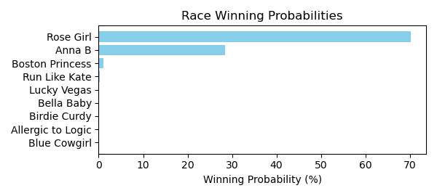

Figure: Winning Probability Distribution

NOTE: THIS RACE HAS HORSES THAT ARE MISSING CRITICAL DATA ELEMENTS

# Race: TAM | 2025-02-21 | Race #1 | Track: TAMPA BAY DOWNS

Track: TAMPA BAY DOWNS

|  |  |  |  |  |
| --- | --- | --- | --- | --- |
| Saddle Cloth # | Horse Name | Global Speed | Composite | Win Prob (%) |
| 1 | Once an Eagle * | 103.8 | 0.91 | 0.32 |
| 2 | Pola of Trouble * | 106.4 | 3.96 | 6.29 |
| 3 | Humor Sense * | 106.4 | 5.11 | 15.80 |
| 4 | One Violent Affair * | 111.1 | 5.91 | 76.02 |
| 5 | Spring Spinning * | 103.8 | -9.24 | 0.00 |
| 6 | Moon Rose * | 89.0 | -1.21 | 0.00 |
| 7 | Naa Dudette * | 103.8 | 2.90 | 1.57 |

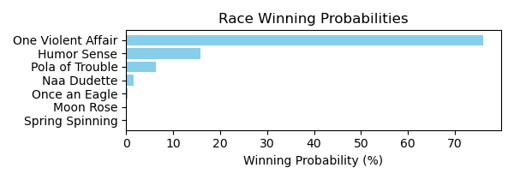

Figure: Winning Probability Distribution

NOTE: THIS RACE HAS HORSES THAT ARE MISSING CRITICAL DATA ELEMENTS

# Race: TAM | 2025-02-21 | Race #2 | Track: TAMPA BAY DOWNS

Track: TAMPA BAY DOWNS

|  |  |  |  |  |
| --- | --- | --- | --- | --- |
| Saddle Cloth # | Horse Name | Global Speed | Composite | Win Prob (%) |
| 1 | Rusty Pistol * | 76.2 | 1.48 | 0.06 |
| 2 | Sharpazano * | 66.5 | 0.19 | 0.00 |
| 3 | Lao Way * | 103.7 | -9.00 | 0.00 |
| 4 | Stanley Cat * | 76.2 | 7.39 | 6.70 |
| 5 | We Got This * | 103.7 | -8.95 | 0.00 |
| 6 | Vigano * | 103.7 | 3.72 | 86.63 |
| 7 | This Time Yes * | 103.7 | -8.73 | 0.00 |
| 8 | SECRET EMPIRE * | 89.0 | 4.18 | 6.59 |

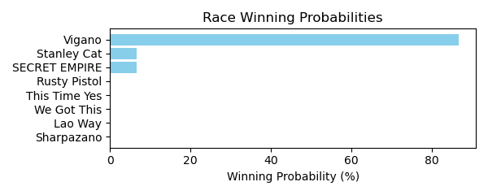

Figure: Winning Probability Distribution

NOTE: THIS RACE HAS HORSES THAT ARE MISSING CRITICAL DATA ELEMENTS

# Race: TAM | 2025-02-21 | Race #3 | Track: TAMPA BAY DOWNS

Track: TAMPA BAY DOWNS

|  |  |  |  |  |
| --- | --- | --- | --- | --- |
| Saddle Cloth # | Horse Name | Global Speed | Composite | Win Prob (%) |
| 1 | Kenric * | 82.2 | -6.53 | 0.00 |
| 10 | Johnny From Boston * | 106.3 | 1.40 | 3.57 |
| 11 | Munger * | 76.2 | -8.95 | 0.00 |
| 12 | Red Abarrio * | 82.2 | -2.23 | 0.00 |
| 2 | Firstflashofmoon * | 82.2 | -1.15 | 0.00 |
| 3 | Gentleman Caller * | 111.0 | -1.11 | 1.22 |
| 4 | In the Weeds * | 111.0 | 4.22 | 86.65 |
| 5 | Frankie R. * | 106.3 | -10.13 | 0.00 |
| 6 | Asaasy * | 103.6 | 2.37 | 4.54 |
| 7 | Trophy Collector * | 82.2 | 5.30 | 0.65 |
| 8 | Starship Magellan * | 106.3 | -4.64 | 0.03 |
| 9 | Zimbawee * | 103.6 | 1.98 | 3.33 |

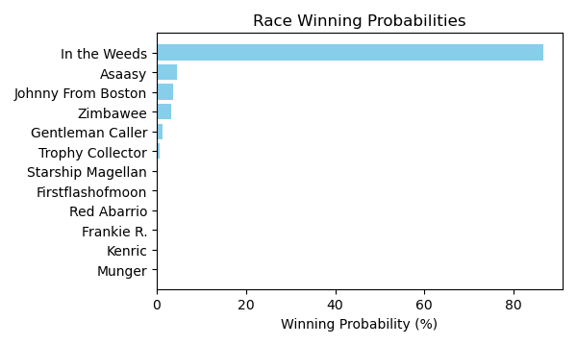

Figure: Winning Probability Distribution

NOTE: THIS RACE HAS HORSES THAT ARE MISSING CRITICAL DATA ELEMENTS

# Race: TAM | 2025-02-21 | Race #4 | Track: TAMPA BAY DOWNS

Track: TAMPA BAY DOWNS

|  |  |  |  |  |
| --- | --- | --- | --- | --- |
| Saddle Cloth # | Horse Name | Global Speed | Composite | Win Prob (%) |
| 1 | Funkenstein * | 111.4 | -6.49 | 0.01 |
| 10 | Mackenzie's Novva * | 89.2 | -6.40 | 0.00 |
| 11 | Burning Man * | 111.4 | -3.82 | 0.06 |
| 12 | Mr Tito's * | 106.7 | 5.42 | 41.16 |
| 13 | He's a Good Dancer * | 71.1 | -3.78 | 0.00 |
| 14 | Joe's Had Enough * | 111.4 | -3.06 | 0.12 |
| 2 | Bryce Canyon * | 111.4 | 4.25 | 40.92 |
| 3 | King Ramos * | 106.7 | 4.21 | 15.55 |
| 4 | Classic King * | 104.0 | -8.44 | 0.00 |
| 5 | Henrythethird * | 111.4 | -8.65 | 0.00 |
| 6 | Redisur * | 111.4 | -5.03 | 0.02 |
| 7 | Eric the Salesman * | 111.4 | -9.59 | 0.00 |
| 8 | Tiz a Prince * | 111.4 | -6.19 | 0.01 |
| 9 | Kartano * | 111.4 | 0.56 | 2.14 |

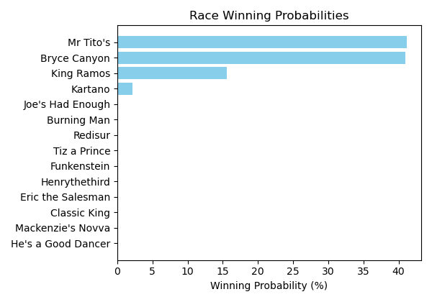

Figure: Winning Probability Distribution

NOTE: THIS RACE HAS HORSES THAT ARE MISSING CRITICAL DATA ELEMENTS

# Race: TAM | 2025-02-21 | Race #5 | Track: TAMPA BAY DOWNS

Track: TAMPA BAY DOWNS

|  |  |  |  |  |
| --- | --- | --- | --- | --- |
| Saddle Cloth # | Horse Name | Global Speed | Composite | Win Prob (%) |
| 1 | Art Nouveau * | 103.7 | 3.97 | 2.34 |
| 10 | Miss C Banker * | 76.2 | 1.29 | 0.00 |
| 11 | Full Exchange * | 103.7 | -0.80 | 0.05 |
| 12 | PARTLY SUNNY * | 100.8 | 5.46 | 4.31 |
| 13 | Sip'n' Speed * | 103.7 | -0.45 | 0.07 |
| 14 | Tap Bonnet * | 103.7 | -0.16 | 0.09 |
| 2 | COME A WALTZING * | 100.8 | 5.60 | 4.83 |
| 3 | Delayed * | 103.7 | 2.69 | 0.84 |
| 4 | Inclusive Justice * | 103.7 | 4.01 | 2.40 |
| 5 | Crafty Collector * | 103.7 | 4.97 | 5.21 |
| 6 | Nouveau * | 106.3 | -7.21 | 0.00 |
| 7 | Dyna Soar * | 111.0 | 3.43 | 6.62 |
| 8 | Marty's Gal * | 82.2 | -6.16 | 0.00 |
| 9 | Michaela * | 111.0 | 6.44 | 73.24 |

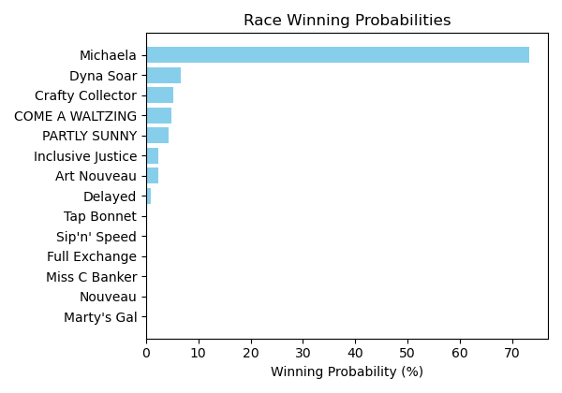

Figure: Winning Probability Distribution

NOTE: THIS RACE HAS HORSES THAT ARE MISSING CRITICAL DATA ELEMENTS

# Race: TAM | 2025-02-21 | Race #6 | Track: TAMPA BAY DOWNS

Track: TAMPA BAY DOWNS

|  |  |  |  |  |
| --- | --- | --- | --- | --- |
| Saddle Cloth # | Horse Name | Global Speed | Composite | Win Prob (%) |
| 1 | Megan Makin Money * | 66.5 | -3.35 | 0.00 |
| 2 | Foxy Lady * | 76.3 | -8.03 | 0.00 |
| 3 | Delta Charm * | 71.0 | -0.67 | 0.00 |
| 4 | Explosive Exchange * | 76.3 | 3.75 | 0.21 |
| 5 | Ideal Breeze * | 89.1 | 5.07 | 8.00 |
| 6 | Wait a Sec * | 89.1 | -6.97 | 0.00 |
| 7 | Ritabook * | 89.1 | 3.96 | 3.29 |
| 8 | Sassy Charlee * | 82.4 | 7.10 | 10.56 |
| 9 | Moretastic * | 89.1 | 7.91 | 77.93 |

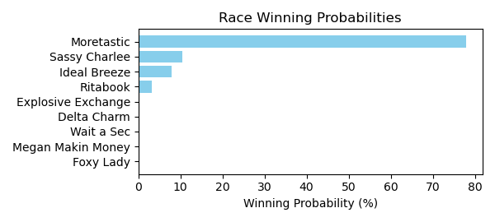

Figure: Winning Probability Distribution

NOTE: THIS RACE HAS HORSES THAT ARE MISSING CRITICAL DATA ELEMENTS

# Race: TAM | 2025-02-21 | Race #7 | Track: TAMPA BAY DOWNS

Track: TAMPA BAY DOWNS

|  |  |  |  |  |
| --- | --- | --- | --- | --- |
| Saddle Cloth # | Horse Name | Global Speed | Composite | Win Prob (%) |
| 1 | Mischievous Han * | 111.4 | 0.25 | 0.77 |
| 10 | Mr Miles * | 111.4 | -5.88 | 0.01 |
| 11 | The Great Oscar * | 104.0 | 6.81 | 33.49 |
| 12 | Peace Cloud * | 104.0 | -2.30 | 0.02 |
| 13 | IRON EDGE * | 97.2 | 4.94 | 1.91 |
| 14 | PISTOL HIP SAM * | 97.2 | 5.36 | 2.69 |
| 2 | CONSOLATION PRIZE * | 97.2 | 4.99 | 1.99 |
| 3 | Sacred Fire * | 82.5 | -7.63 | 0.00 |
| 4 | No Merlot * | 104.0 | -4.33 | 0.00 |
| 5 | BLISTERING * | 62.8 | 5.73 | 0.00 |
| 6 | Twelve Treasures * | 104.0 | 7.51 | 58.59 |
| 7 | Authentic Honour * | 104.0 | -3.38 | 0.01 |
| 8 | Pico Plat * | 82.5 | 2.58 | 0.02 |
| 9 | Cafe La Paix (FR) * | 111.4 | -0.31 | 0.49 |

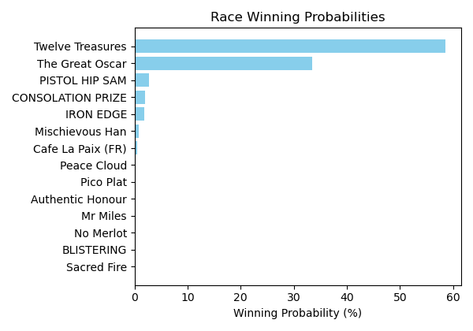

Figure: Winning Probability Distribution

NOTE: THIS RACE HAS HORSES THAT ARE MISSING CRITICAL DATA ELEMENTS

# Race: TAM | 2025-02-21 | Race #8 | Track: TAMPA BAY DOWNS

Track: TAMPA BAY DOWNS

|  |  |  |  |  |
| --- | --- | --- | --- | --- |
| Saddle Cloth # | Horse Name | Global Speed | Composite | Win Prob (%) |
| 1 | Likebelivingnmagic * | 89.2 | 5.46 | 0.80 |
| 10 | Storm's Reflection * | 104.0 | -6.06 | 0.00 |
| 11 | Jabran * | 71.1 | 1.88 | 0.00 |
| 12 | Mr Scatter * | 108.8 | -0.28 | 0.41 |
| 2 | Chasentheone * | 111.4 | 5.93 | 97.71 |
| 3 | Defiant Malice * | 76.4 | -7.10 | 0.00 |
| 4 | Paralegal * | 82.5 | -0.94 | 0.00 |
| 5 | Maptitude * | 76.4 | 4.31 | 0.02 |
| 6 | Handsome Playboy * | 89.2 | -0.85 | 0.01 |
| 7 | Bahamian Native * | 104.0 | 1.31 | 0.56 |
| 8 | Smart Joker * | 76.4 | 8.04 | 0.48 |
| 9 | Road Minister * | 76.4 | -3.07 | 0.00 |

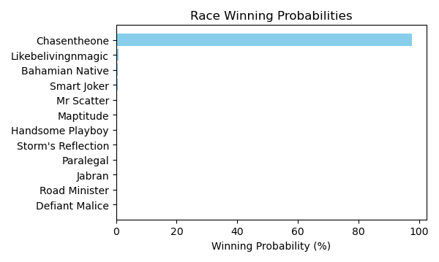

Figure: Winning Probability Distribution

NOTE: THIS RACE HAS HORSES THAT ARE MISSING CRITICAL DATA ELEMENTS

# Race: TAM | 2025-02-21 | Race #9 | Track: TAMPA BAY DOWNS

Track: TAMPA BAY DOWNS

|  |  |  |  |  |
| --- | --- | --- | --- | --- |
| Saddle Cloth # | Horse Name | Global Speed | Composite | Win Prob (%) |
| 1 | Tendresse * | 124.3 | -7.34 | 0.01 |
| 10 | Strike Up * | 104.1 | -3.42 | 0.01 |
| 11 | COUNTERINTELIGENCE (GB) * | 111.5 | 4.72 | 16.70 |
| 12 | This Country * | 135.1 | -0.82 | 22.27 |
| 2 | Enchant * | 104.1 | 3.28 | 1.21 |
| 3 | Don't Touch Me (IRE) * | 76.4 | -8.75 | 0.00 |
| 4 | Mizoula (IRE) * | 135.1 | -2.01 | 8.60 |
| 5 | Autumn's Turn * | 111.5 | -6.17 | 0.00 |
| 6 | Amata * | 89.3 | -7.78 | 0.00 |
| 7 | Hidden Presence * | 124.3 | 2.79 | 46.15 |
| 8 | Ocean Mermaid (GB) * | 89.3 | 3.73 | 0.09 |
| 9 | Zeliha * | 104.1 | 5.04 | 4.95 |

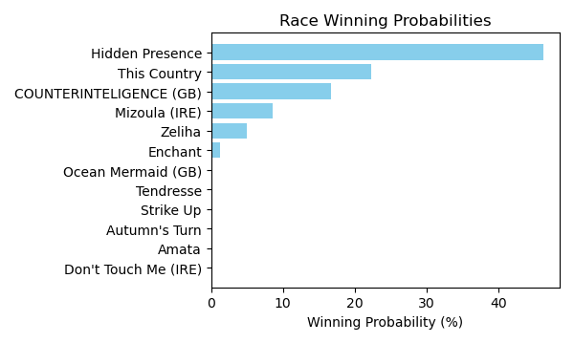

Figure: Winning Probability Distribution

NOTE: THIS RACE HAS HORSES THAT ARE MISSING CRITICAL DATA ELEMENTS

# Race: TUP | 2025-02-22 | Race #2 | Track: TURF PARADISE

Track: TURF PARADISE

|  |  |  |  |  |
| --- | --- | --- | --- | --- |
| Saddle Cloth # | Horse Name | Global Speed | Composite | Win Prob (%) |
| 1 | Stormcatsong * | 76.6 | -6.85 | 0.00 |
| 2 | Caution Cardinal * | 76.6 | 1.13 | 0.08 |
| 3 | Pop d'Oro * | 76.6 | 7.92 | 19.15 |
| 4 | U Can Do U * | 76.6 | 1.78 | 0.14 |
| 5 | Laws of Man * | 76.6 | 9.72 | 80.62 |

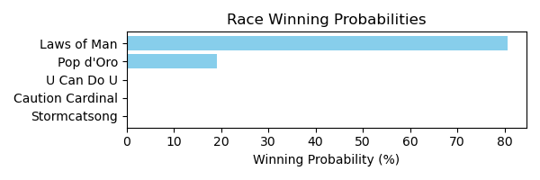

Figure: Winning Probability Distribution

NOTE: THIS RACE HAS HORSES THAT ARE MISSING CRITICAL DATA ELEMENTS

# Race: TUP | 2025-02-22 | Race #3 | Track: TURF PARADISE

Track: TURF PARADISE

|  |  |  |  |  |
| --- | --- | --- | --- | --- |
| Saddle Cloth # | Horse Name | Global Speed | Composite | Win Prob (%) |
| 1 | Now and Zen * | 76.4 | 7.41 | 79.63 |
| 2 | Who Is Pavel * | 76.4 | -3.00 | 0.02 |
| 3 | Knightline * | 76.4 | -9.64 | 0.00 |
| 4 | J C's a Legend * | 76.4 | 5.64 | 19.35 |
| 5 | Further Evidence * | 76.4 | 1.94 | 1.00 |
| 6 | Thirsty Friend * | 76.4 | -9.91 | 0.00 |

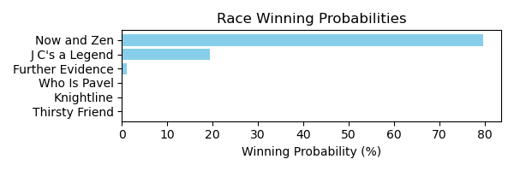

Figure: Winning Probability Distribution

NOTE: THIS RACE HAS HORSES THAT ARE MISSING CRITICAL DATA ELEMENTS

# Race: TUP | 2025-02-22 | Race #4 | Track: TURF PARADISE

Track: TURF PARADISE

|  |  |  |  |  |
| --- | --- | --- | --- | --- |
| Saddle Cloth # | Horse Name | Global Speed | Composite | Win Prob (%) |
| 1 | Canada Candy * | 103.9 | 2.95 | 0.17 |
| 2 | If You Want It * | 103.9 | 10.86 | 92.76 |
| 3 | Can'thelpfallin (IRE) * | 103.9 | 1.55 | 0.05 |
| 4 | Aloha Kitten * | 103.9 | 6.21 | 2.24 |
| 5 | Lock It Down * | 103.9 | -1.85 | 0.00 |
| 6 | Gypsy Wife * | 103.9 | 6.72 | 3.38 |
| 7 | Willing to Burn * | 103.9 | 5.62 | 1.40 |

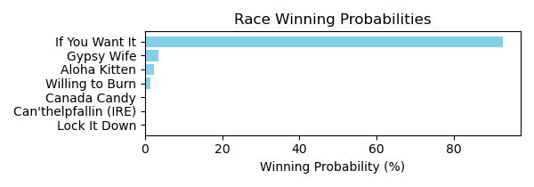

Figure: Winning Probability Distribution

NOTE: THIS RACE HAS HORSES THAT ARE MISSING CRITICAL DATA ELEMENTS

# Race: TUP | 2025-02-22 | Race #5 | Track: TURF PARADISE

Track: TURF PARADISE

|  |  |  |  |  |
| --- | --- | --- | --- | --- |
| Saddle Cloth # | Horse Name | Global Speed | Composite | Win Prob (%) |
| 1 | Let Me Love You * | 103.9 | -6.61 | 0.03 |
| 2 | Unaudited * | 103.9 | 3.33 | 98.54 |
| 3 | Candy Crusher * | 103.9 | -4.18 | 0.24 |
| 4 | Benny Buckets * | 103.9 | -5.49 | 0.09 |
| 5 | Run Baba Run * | 103.9 | -7.50 | 0.02 |
| 6 | Eddie's Wave * | 103.9 | -7.31 | 0.02 |
| 7 | Sunset Storm * | 103.9 | -2.41 | 1.00 |
| 8 | Attain * | 103.9 | -5.83 | 0.06 |

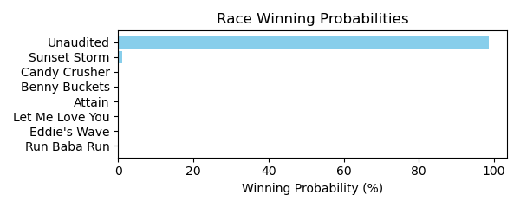

Figure: Winning Probability Distribution

NOTE: THIS RACE HAS HORSES THAT ARE MISSING CRITICAL DATA ELEMENTS

# Race: TUP | 2025-02-22 | Race #6 | Track: TURF PARADISE

Track: TURF PARADISE

|  |  |  |  |  |
| --- | --- | --- | --- | --- |
| Saddle Cloth # | Horse Name | Global Speed | Composite | Win Prob (%) |
| 1 | Cy's Silkstocking * | 70.9 | 6.94 | 99.31 |
| 2 | Parker's Fifteen * | 70.9 | -4.33 | 0.01 |
| 3 | Prancing Matilda * | 70.9 | -3.15 | 0.03 |
| 4 | California Diva * | 70.9 | -8.48 | 0.00 |
| 5 | Onella * | 70.9 | 0.18 | 0.44 |
| 6 | Sorority Party * | 70.9 | -1.29 | 0.14 |
| 7 | Keepyourpranceon * | 70.9 | -2.28 | 0.06 |
| 8 | O C Rhapsody * | 70.9 | -9.05 | 0.00 |

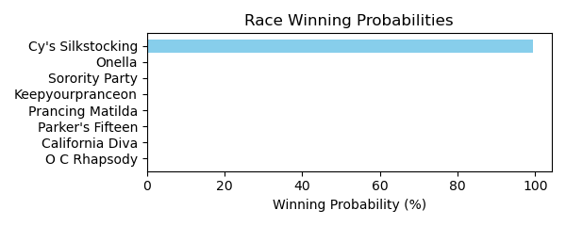

Figure: Winning Probability Distribution

NOTE: THIS RACE HAS HORSES THAT ARE MISSING CRITICAL DATA ELEMENTS

# Race: TUP | 2025-02-22 | Race #7 | Track: TURF PARADISE

Track: TURF PARADISE

|  |  |  |  |  |
| --- | --- | --- | --- | --- |
| Saddle Cloth # | Horse Name | Global Speed | Composite | Win Prob (%) |
| 1 | dq-Swampdrainer * | 104.0 | 7.82 | 29.85 |
| 2 | Rosenquist * | 104.0 | 8.53 | 52.55 |
| 3 | National Generaux (IRE) * | 104.0 | 6.62 | 11.38 |
| 4 | Mangia Pane * | 104.0 | 5.79 | 5.86 |
| 5 | Big Stick * | 104.0 | 1.95 | 0.27 |
| 6 | San Andres * | 104.0 | 0.36 | 0.08 |
| 7 | Levon * | 104.0 | -1.06 | 0.02 |

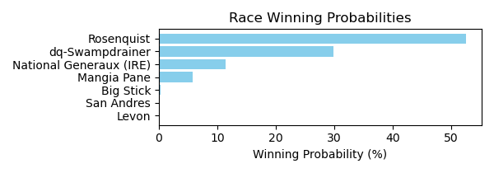

Figure: Winning Probability Distribution

NOTE: THIS RACE HAS HORSES THAT ARE MISSING CRITICAL DATA ELEMENTS

# Race: TUP | 2025-02-22 | Race #8 | Track: TURF PARADISE

Track: TURF PARADISE

|  |  |  |  |  |
| --- | --- | --- | --- | --- |
| Saddle Cloth # | Horse Name | Global Speed | Composite | Win Prob (%) |
| 1 | Dads Estrella * | 76.4 | 8.25 | 22.17 |
| 2 | Go Go Sadie * | 76.4 | 6.44 | 5.23 |
| 3 | Grease Missle * | 76.4 | 0.12 | 0.03 |
| 4 | Ima Trouble Maker * | 76.4 | -2.94 | 0.00 |
| 5 | Lucky Burglar * | 76.4 | 6.93 | 7.71 |
| 6 | Desert Gal * | 76.4 | 6.59 | 5.90 |
| 7 | Calebs Lady * | 76.4 | 3.20 | 0.39 |
| 8 | Stormylux * | 76.4 | 9.46 | 58.56 |

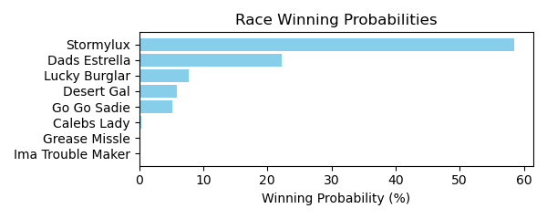

Figure: Winning Probability Distribution

NOTE: THIS RACE HAS HORSES THAT ARE MISSING CRITICAL DATA ELEMENTS

# Race: TUP | 2025-02-24 | Race #3 | Track: TURF PARADISE

Track: TURF PARADISE

|  |  |  |  |  |
| --- | --- | --- | --- | --- |
| Saddle Cloth # | Horse Name | Global Speed | Composite | Win Prob (%) |
| 1 | ROYAL INTEGRITY * | 76.2 | 5.35 | 29.66 |
| 2 | Swiss Dancer * | 76.2 | 2.16 | 2.31 |
| 3 | CASHOUT CAROL * | 76.2 | 5.28 | 28.01 |
| 4 | Blue Spirit * | 76.2 | -5.57 | 0.00 |
| 5 | Frank's Lorraine * | 76.2 | -5.04 | 0.01 |
| 6 | Mocktails Anyone * | 76.2 | 5.72 | 40.00 |
| 7 | Denada * | 76.2 | -5.16 | 0.01 |

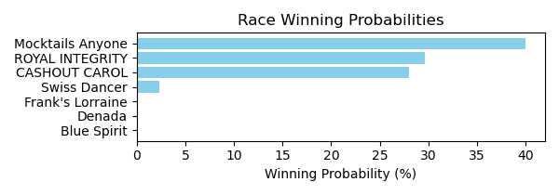

Figure: Winning Probability Distribution

NOTE: THIS RACE HAS HORSES THAT ARE MISSING CRITICAL DATA ELEMENTS

# Race: TUP | 2025-02-24 | Race #4 | Track: TURF PARADISE

Track: TURF PARADISE

|  |  |  |  |  |
| --- | --- | --- | --- | --- |
| Saddle Cloth # | Horse Name | Global Speed | Composite | Win Prob (%) |
| 1 | Aventapp * | 82.5 | 5.36 | 5.18 |
| 2 | Big Beauty * | 82.5 | 8.12 | 47.06 |
| 3 | Veronica's Delight * | 82.5 | 3.59 | 1.25 |
| 4 | Zippin Sevenz * | 82.5 | 2.62 | 0.57 |
| 5 | Twelve Stars * | 82.5 | 7.04 | 19.72 |
| 6 | Fast Giselle * | 82.5 | 7.39 | 26.22 |

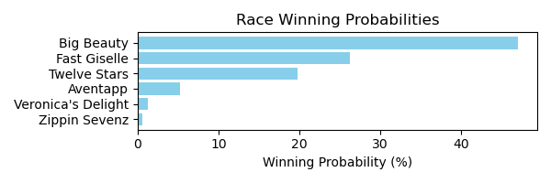

Figure: Winning Probability Distribution

NOTE: THIS RACE HAS HORSES THAT ARE MISSING CRITICAL DATA ELEMENTS

# Race: TUP | 2025-02-24 | Race #5 | Track: TURF PARADISE

Track: TURF PARADISE

|  |  |  |  |  |
| --- | --- | --- | --- | --- |
| Saddle Cloth # | Horse Name | Global Speed | Composite | Win Prob (%) |
| 1 | Winsitwell * | 103.8 | 5.70 | 66.29 |
| 2 | Hollywood Hero * | 103.8 | 3.33 | 9.93 |
| 3 | Muay Thai (IRE) * | 103.8 | 3.55 | 11.83 |
| 4 | Dr Vinnie Boombatz * | 103.8 | -3.04 | 0.06 |
| 5 | Thompson * | 103.8 | -7.25 | 0.00 |
| 6 | Blues Rapper * | 103.8 | 2.59 | 5.52 |
| 7 | Fayruz Tribute * | 103.8 | 2.77 | 6.37 |

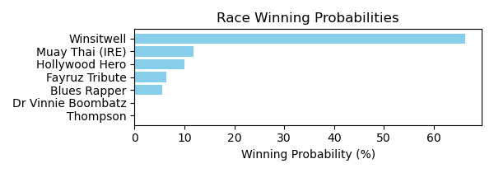

Figure: Winning Probability Distribution

NOTE: THIS RACE HAS HORSES THAT ARE MISSING CRITICAL DATA ELEMENTS

# Race: TUP | 2025-02-24 | Race #6 | Track: TURF PARADISE

Track: TURF PARADISE

|  |  |  |  |  |
| --- | --- | --- | --- | --- |
| Saddle Cloth # | Horse Name | Global Speed | Composite | Win Prob (%) |
| 1 | Forest Acclamation * | 103.8 | 6.33 | 9.27 |
| 2 | Charley Paints * | 103.8 | 1.70 | 0.23 |
| 3 | Shelby Shortstop * | 103.8 | -8.68 | 0.00 |
| 4 | Infinite Love * | 103.8 | 8.46 | 51.03 |
| 5 | Delusional Dream * | 103.8 | 1.97 | 0.28 |
| 6 | Sky Sailing * | 103.8 | 6.52 | 10.73 |
| 7 | Above the Fold * | 103.8 | 7.73 | 28.46 |
| 8 | Tia Suzi * | 103.8 | -2.67 | 0.01 |
| 9 | Leipzig * | 103.8 | -6.57 | 0.00 |

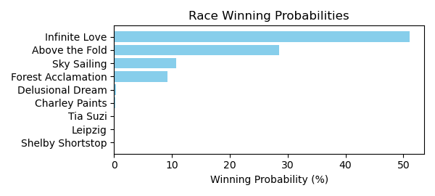

Figure: Winning Probability Distribution

NOTE: THIS RACE HAS HORSES THAT ARE MISSING CRITICAL DATA ELEMENTS

# Race: TUP | 2025-02-24 | Race #7 | Track: TURF PARADISE

Track: TURF PARADISE

|  |  |  |  |  |
| --- | --- | --- | --- | --- |
| Saddle Cloth # | Horse Name | Global Speed | Composite | Win Prob (%) |
| 1 | Railway * | 104.2 | -3.71 | 0.04 |
| 2 | Ready to Storm * | 104.2 | 4.57 | 27.79 |
| 3 | I'm Noble * | 104.2 | 1.26 | 1.97 |
| 4 | Bodemonster * | 104.2 | -2.47 | 0.10 |
| 5 | Keen Heir * | 104.2 | 5.25 | 48.10 |
| 6 | Quarterback Dak * | 104.2 | -0.13 | 0.65 |
| 7 | Street Humor * | 104.2 | 4.24 | 21.36 |

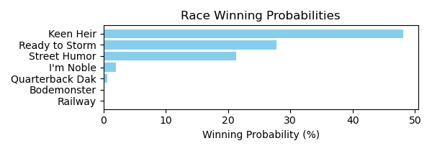

Figure: Winning Probability Distribution

NOTE: THIS RACE HAS HORSES THAT ARE MISSING CRITICAL DATA ELEMENTS

# Race: TUP | 2025-02-24 | Race #8 | Track: TURF PARADISE

Track: TURF PARADISE

|  |  |  |  |  |
| --- | --- | --- | --- | --- |
| Saddle Cloth # | Horse Name | Global Speed | Composite | Win Prob (%) |
| 1 | El Alto Hombre * | 82.7 | 6.65 | 2.11 |
| 2 | Mr. Who * | 82.7 | 2.09 | 0.05 |
| 3 | Truth Seeker * | 82.7 | 7.55 | 4.36 |
| 4 | Diamond Rim * | 82.7 | 9.26 | 17.07 |
| 5 | Itsallgoodman * | 82.7 | 5.30 | 0.72 |
| 6 | Tenth Street Don * | 82.7 | 1.26 | 0.03 |
| 7 | Bearings * | 82.7 | 11.12 | 75.65 |

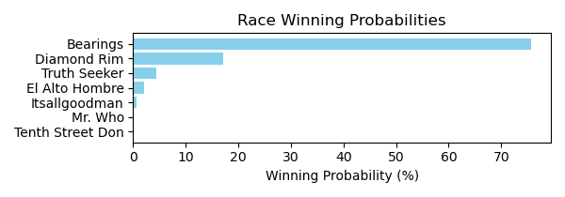

Figure: Winning Probability Distribution

NOTE: THIS RACE HAS HORSES THAT ARE MISSING CRITICAL DATA ELEMENTS

# Race: TUP | 2025-02-24 | Race #9 | Track: TURF PARADISE

Track: TURF PARADISE

|  |  |  |  |  |
| --- | --- | --- | --- | --- |
| Saddle Cloth # | Horse Name | Global Speed | Composite | Win Prob (%) |
| 1 | Coastal Fog * | 71.1 | 5.40 | 24.60 |
| 10 | Theuntouchableone * | 71.1 | -9.16 | 0.00 |
| 2 | Stone Carver * | 71.1 | -0.97 | 0.15 |
| 3 | Corn Pop * | 71.1 | 2.93 | 3.42 |
| 4 | Electrostatic * | 71.1 | -3.63 | 0.02 |
| 5 | Inch * | 71.1 | -6.47 | 0.00 |
| 6 | Groovy Huey * | 71.1 | -5.61 | 0.00 |
| 7 | Our Bold Prince * | 71.1 | -2.91 | 0.03 |
| 8 | Star Entry * | 71.1 | 6.69 | 69.00 |
| 9 | Let's Rejoyce * | 71.1 | 2.67 | 2.78 |

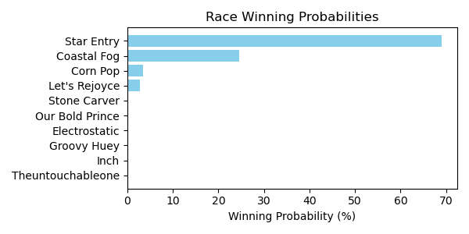

Figure: Winning Probability Distribution

NOTE: THIS RACE HAS HORSES THAT ARE MISSING CRITICAL DATA ELEMENTS

# Race: TUP | 2025-02-25 | Race #3 | Track: TURF PARADISE

Track: TURF PARADISE

|  |  |  |  |  |
| --- | --- | --- | --- | --- |
| Saddle Cloth # | Horse Name | Global Speed | Composite | Win Prob (%) |
| 1 | Unrivaled Queen * | 76.4 | 1.31 | 0.01 |
| 2 | Don't Tell Hydee * | 62.8 | 4.57 | 0.01 |
| 3 | Rubysa * | 76.4 | 5.18 | 0.20 |
| 4 | Diplomatica * | 96.5 | 7.12 | 53.52 |
| 5 | High Gunner * | 76.4 | 5.61 | 0.28 |
| 6 | Drink and a Wink * | 104.0 | 4.99 | 43.78 |
| 7 | Miss Union * | 76.4 | 8.16 | 2.19 |

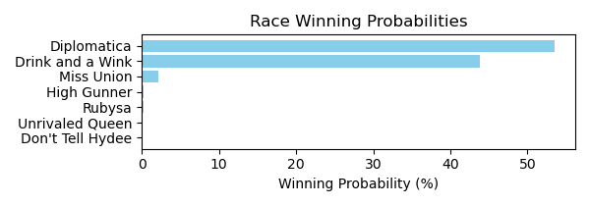

Figure: Winning Probability Distribution

NOTE: THIS RACE HAS HORSES THAT ARE MISSING CRITICAL DATA ELEMENTS

# Race: TUP | 2025-02-25 | Race #4 | Track: TURF PARADISE

Track: TURF PARADISE

|  |  |  |  |  |
| --- | --- | --- | --- | --- |
| Saddle Cloth # | Horse Name | Global Speed | Composite | Win Prob (%) |
| 1 | G G Gilley * | 71.1 | 8.01 | 25.53 |
| 2 | REGARDING HARRY * | 74.5 | 6.63 | 16.88 |
| 3 | Knockout Guy * | 96.5 | -6.79 | 0.03 |
| 4 | Firefight * | 71.1 | -4.61 | 0.00 |
| 5 | Brownstone * | 71.1 | 8.48 | 37.24 |
| 6 | Rebellious Red * | 71.1 | 5.49 | 3.41 |
| 7 | Gonzaga * | 71.1 | -2.30 | 0.01 |
| 8 | BIG STETSON * | 74.5 | 6.63 | 16.90 |

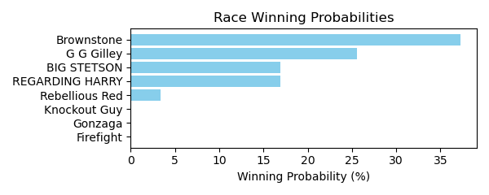

Figure: Winning Probability Distribution

NOTE: THIS RACE HAS HORSES THAT ARE MISSING CRITICAL DATA ELEMENTS

# Race: TUP | 2025-02-25 | Race #5 | Track: TURF PARADISE

Track: TURF PARADISE

|  |  |  |  |  |
| --- | --- | --- | --- | --- |
| Saddle Cloth # | Horse Name | Global Speed | Composite | Win Prob (%) |
| 1 | Aspirational * | 82.4 | 2.94 | 0.29 |
| 2 | Little Bit Tipsy * | 76.3 | 1.80 | 0.03 |
| 3 | Annie Fox * | 103.9 | 2.53 | 15.32 |
| 4 | Ropers N Wranglers * | 103.9 | 4.46 | 71.58 |
| 5 | Charybdis * | 71.0 | 2.53 | 0.02 |
| 6 | Minedandrefined * | 76.3 | 9.10 | 11.84 |
| 7 | Rockbar * | 76.3 | 5.80 | 0.84 |
| 8 | Love Alive * | 71.0 | 4.06 | 0.07 |

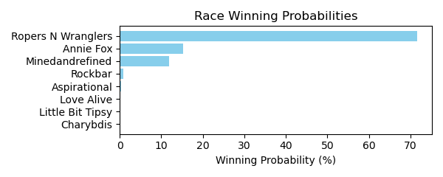

Figure: Winning Probability Distribution

NOTE: THIS RACE HAS HORSES THAT ARE MISSING CRITICAL DATA ELEMENTS

# Race: TUP | 2025-02-25 | Race #6 | Track: TURF PARADISE

Track: TURF PARADISE

|  |  |  |  |  |
| --- | --- | --- | --- | --- |
| Saddle Cloth # | Horse Name | Global Speed | Composite | Win Prob (%) |
| 1 | Sahara Sue * | 71.0 | -4.33 | 0.01 |
| 2 | Bea Mischief * | 82.4 | -5.78 | 0.02 |
| 3 | Night Flyer * | 82.4 | 2.01 | 8.47 |
| 4 | Em N Holl's Fiesta * | 76.3 | 5.95 | 58.88 |
| 5 | Vella * | 76.3 | -2.95 | 0.05 |
| 6 | Deficit Maja * | 66.5 | 7.39 | 26.32 |
| 7 | Unified A. P. * | 76.3 | 2.56 | 3.92 |
| 8 | A Dime for Me * | 71.0 | 3.24 | 2.34 |
| 9 | Game to Play * | 66.5 | -10.17 | 0.00 |

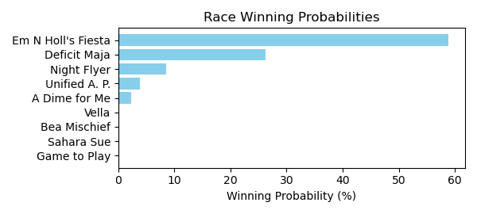

Figure: Winning Probability Distribution

NOTE: THIS RACE HAS HORSES THAT ARE MISSING CRITICAL DATA ELEMENTS

# Race: TUP | 2025-02-25 | Race #7 | Track: TURF PARADISE

Track: TURF PARADISE

|  |  |  |  |  |
| --- | --- | --- | --- | --- |
| Saddle Cloth # | Horse Name | Global Speed | Composite | Win Prob (%) |
| 1 | Happy Chappy * | 76.2 | -1.60 | 0.13 |
| 10 | Daddy Classy Dill * | 66.4 | 8.79 | 74.55 |
| 11 | Can't Want That * | 66.4 | -2.49 | 0.01 |
| 12 | Russian Tothe Wire * | 82.2 | -5.69 | 0.02 |
| 2 | Maui Sunrise * | 66.4 | 3.64 | 1.21 |
| 3 | Jessica Blah Blah * | 82.2 | -7.23 | 0.00 |
| 4 | Diamond Dee * | 66.4 | 7.13 | 19.71 |
| 5 | Bango's Heat * | 66.4 | 5.18 | 4.15 |
| 6 | Sissue * | 66.4 | -6.54 | 0.00 |
| 7 | Fly South * | 70.9 | -3.77 | 0.01 |
| 8 | Measureofdevotion * | 53.7 | 4.72 | 0.22 |
| 9 | Queen Mystic * | 66.4 | -9.18 | 0.00 |

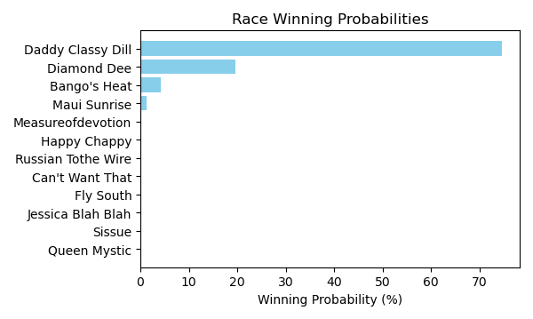

Figure: Winning Probability Distribution

NOTE: THIS RACE HAS HORSES THAT ARE MISSING CRITICAL DATA ELEMENTS

# Race: TUP | 2025-02-25 | Race #8 | Track: TURF PARADISE

Track: TURF PARADISE

|  |  |  |  |  |
| --- | --- | --- | --- | --- |
| Saddle Cloth # | Horse Name | Global Speed | Composite | Win Prob (%) |
| 1 | War Chest * | 111.6 | 9.94 | 95.17 |
| 10 | Thirty Seconds Out * | 104.2 | 3.82 | 0.16 |
| 2 | Flint Stroll * | 104.2 | 1.41 | 0.02 |
| 3 | Club Mesquite * | 111.6 | 5.82 | 3.52 |
| 4 | Aquacat * | 104.2 | 1.86 | 0.03 |
| 5 | Dos Vicios * | 104.2 | -1.89 | 0.00 |
| 6 | Birth of Cool * | 104.2 | 5.60 | 0.67 |
| 7 | You Kidding Me * | 76.5 | -1.51 | 0.00 |
| 8 | Sunny Spot * | 104.2 | 4.18 | 0.22 |
| 9 | Shut Up Michael (IRE) * | 104.2 | 4.06 | 0.20 |

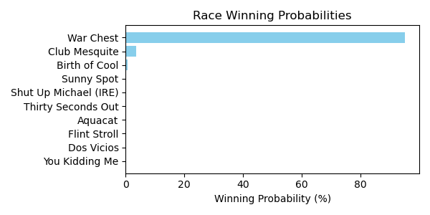

Figure: Winning Probability Distribution

NOTE: THIS RACE HAS HORSES THAT ARE MISSING CRITICAL DATA ELEMENTS

# Race: TUP | 2025-02-25 | Race #9 | Track: TURF PARADISE

Track: TURF PARADISE

|  |  |  |  |  |
| --- | --- | --- | --- | --- |
| Saddle Cloth # | Horse Name | Global Speed | Composite | Win Prob (%) |
| 1 | Mongolian Ninja * | 62.7 | 2.14 | 0.02 |
| 10 | Son o' Sanpete * | 82.2 | -0.33 | 0.13 |
| 11 | Yankee Tea Party * | 82.2 | 6.90 | 41.31 |
| 12 | Tempting Prospect * | 70.9 | 1.08 | 0.04 |
| 2 | Mr. Mustache * | 82.2 | -9.74 | 0.00 |
| 3 | Ukraine Strong * | 70.9 | 8.27 | 12.91 |
| 4 | Crown Prosecutor * | 103.6 | 0.12 | 13.25 |
| 5 | Take My Allowance * | 76.2 | 2.99 | 0.54 |
| 6 | Cruel Endeavor * | 82.2 | 1.15 | 0.41 |
| 7 | Crazy Storm * | 62.7 | 2.43 | 0.02 |
| 8 | Royal Curlin * | 76.2 | 7.67 | 22.74 |
| 9 | Drive for Show * | 82.2 | 4.95 | 8.63 |

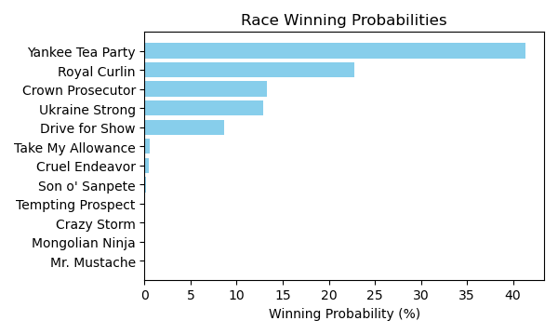

Figure: Winning Probability Distribution

NOTE: THIS RACE HAS HORSES THAT ARE MISSING CRITICAL DATA ELEMENTS

# Race: TTP | 2025-02-21 | Race #1 | Track: TURFWAY PARK

Track: TURFWAY PARK

|  |  |  |  |  |
| --- | --- | --- | --- | --- |
| Saddle Cloth # | Horse Name | Global Speed | Composite | Win Prob (%) |
| 1 | El Franco * | 104.2 | -2.02 | 0.01 |
| 2 | Hard Mission * | 104.2 | 7.27 | 21.48 |
| 3 | Golden Reign * | 76.5 | -4.72 | 0.00 |
| 4 | Maynard * | 104.2 | 4.26 | 1.93 |
| 5 | Commando Joe * | 76.5 | -1.79 | 0.00 |
| 6 | Moonstrike (GB) * | 82.6 | -4.60 | 0.00 |
| 7 | Dontkissdaminister * | 76.5 | -5.27 | 0.00 |
| 8 | Temper Tantrum * | 104.2 | -2.41 | 0.01 |
| 9 | dh-Category Ten * | 104.2 | 8.86 | 76.57 |

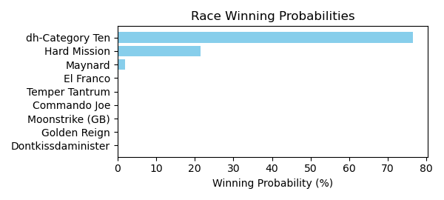

Figure: Winning Probability Distribution

NOTE: THIS RACE HAS HORSES THAT ARE MISSING CRITICAL DATA ELEMENTS

# Race: TTP | 2025-02-21 | Race #2 | Track: TURFWAY PARK

Track: TURFWAY PARK

|  |  |  |  |  |
| --- | --- | --- | --- | --- |
| Saddle Cloth # | Horse Name | Global Speed | Composite | Win Prob (%) |
| 1 | Mariposa de Pista * | 103.7 | -2.07 | 0.15 |
| 10 | Baytown Storm * | 103.7 | -4.70 | 0.02 |
| 11 | Get It Together * | 82.3 | -9.52 | 0.00 |
| 12 | Rabble * | 76.2 | -4.35 | 0.00 |
| 2 | Glorious Musings * | 103.7 | -4.17 | 0.03 |
| 3 | Indy's Universe * | 103.7 | 5.64 | 69.76 |
| 4 | Protonica * | 76.2 | -4.79 | 0.00 |
| 5 | Holy Belle * | 76.2 | -9.00 | 0.00 |
| 6 | Are You a Spy * | 103.7 | -4.98 | 0.01 |
| 7 | Tuenda * | 103.7 | 4.48 | 27.62 |
| 8 | LATE FOR MASS * | 93.5 | 3.96 | 2.39 |
| 9 | Florina * | 103.7 | -4.07 | 0.03 |

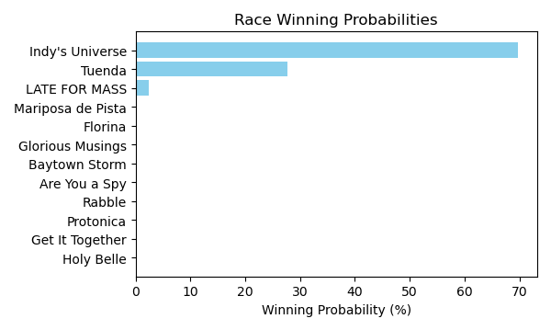

Figure: Winning Probability Distribution

NOTE: THIS RACE HAS HORSES THAT ARE MISSING CRITICAL DATA ELEMENTS

# Race: TTP | 2025-02-21 | Race #3 | Track: TURFWAY PARK

Track: TURFWAY PARK

|  |  |  |  |  |
| --- | --- | --- | --- | --- |
| Saddle Cloth # | Horse Name | Global Speed | Composite | Win Prob (%) |
| 1 | Embrace Me * | 129.2 | -0.94 | 9.58 |
| 2 | Quarrel * | 129.2 | -3.23 | 1.53 |
| 3 | Breezing Along * | 82.7 | 3.90 | 0.04 |
| 4 | Under the Bed * | 104.3 | 7.36 | 50.61 |
| 5 | Starship Belmont * | 104.3 | 3.38 | 2.08 |
| 6 | Indy's Star * | 104.3 | 6.94 | 35.93 |
| 7 | Wonka * | 104.3 | 0.57 | 0.22 |
| 8 | Cat Attack * | 76.5 | -6.84 | 0.00 |

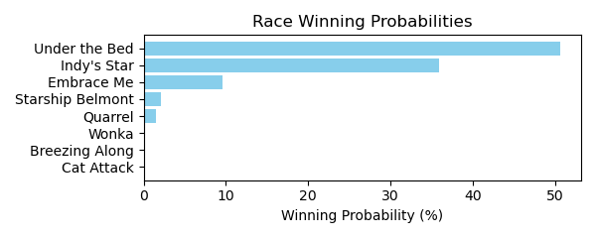

Figure: Winning Probability Distribution

NOTE: THIS RACE HAS HORSES THAT ARE MISSING CRITICAL DATA ELEMENTS

# Race: TTP | 2025-02-21 | Race #4 | Track: TURFWAY PARK

Track: TURFWAY PARK

|  |  |  |  |  |
| --- | --- | --- | --- | --- |
| Saddle Cloth # | Horse Name | Global Speed | Composite | Win Prob (%) |
| 1 | Queen of the Dance * | 103.9 | 3.47 | 41.57 |
| 10 | No Trust * | 82.4 | -5.87 | 0.00 |
| 11 | Bump in the Night * | 82.4 | -5.89 | 0.00 |
| 12 | dh-Abstract Moment * | 103.9 | 0.57 | 4.07 |
| 13 | Stay Faithful * | 82.4 | 3.29 | 0.49 |
| 2 | Frosty Tale * | 103.9 | 1.90 | 11.77 |
| 3 | Laughing Out Loud * | 108.6 | -9.25 | 0.00 |
| 4 | Camp Akeela * | 82.4 | -2.80 | 0.00 |
| 5 | Halcyon Days * | 103.9 | -3.18 | 0.20 |
| 6 | Serene Waters * | 82.4 | 6.36 | 5.68 |
| 7 | I Gotta Bolt * | 82.4 | -3.59 | 0.00 |
| 8 | Callas * | 103.9 | 3.13 | 31.61 |
| 9 | Ms Ks Dynasty * | 103.9 | 0.72 | 4.60 |

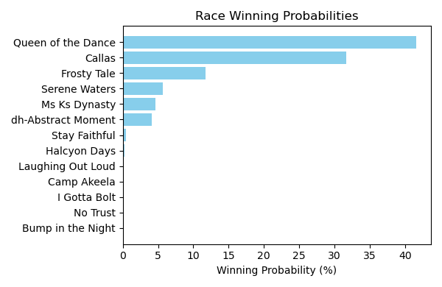

Figure: Winning Probability Distribution

NOTE: THIS RACE HAS HORSES THAT ARE MISSING CRITICAL DATA ELEMENTS

# Race: TTP | 2025-02-21 | Race #5 | Track: TURFWAY PARK

Track: TURFWAY PARK

|  |  |  |  |  |
| --- | --- | --- | --- | --- |
| Saddle Cloth # | Horse Name | Global Speed | Composite | Win Prob (%) |
| 1 | My Friend Louie * | 104.3 | 3.21 | 0.72 |
| 10 | Cruisin and Boozin * | 104.3 | 4.33 | 1.77 |
| 11 | Coach Campbell * | 104.3 | 4.31 | 1.75 |
| 12 | Kentucky Go Go * | 104.3 | -1.30 | 0.02 |
| 13 | Atlantic Dancer * | 104.3 | 3.03 | 0.63 |
| 14 | Friar Newton * | 104.3 | 4.14 | 1.52 |
| 2 | Cabernaydo * | 104.3 | 2.72 | 0.49 |
| 3 | On My Honor * | 82.6 | -1.84 | 0.00 |
| 4 | Top Secret * | 76.5 | 2.71 | 0.00 |
| 5 | Hope Joe's Right * | 111.6 | 7.44 | 93.06 |
| 6 | Right On Right On * | 82.6 | -8.20 | 0.00 |
| 7 | First of His Name * | 104.3 | -0.97 | 0.03 |
| 8 | Boone's Path * | 104.3 | -1.28 | 0.02 |
| 9 | Speed Institute * | 104.3 | -4.70 | 0.00 |

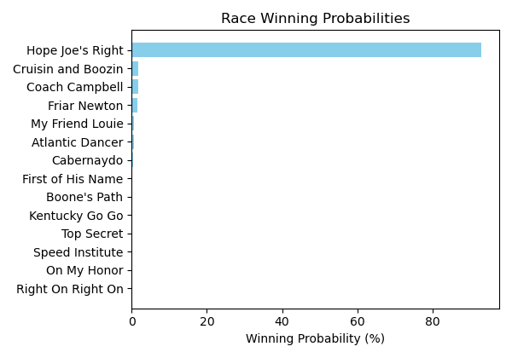

Figure: Winning Probability Distribution

NOTE: THIS RACE HAS HORSES THAT ARE MISSING CRITICAL DATA ELEMENTS

# Race: TTP | 2025-02-21 | Race #6 | Track: TURFWAY PARK

Track: TURFWAY PARK

|  |  |  |  |  |
| --- | --- | --- | --- | --- |
| Saddle Cloth # | Horse Name | Global Speed | Composite | Win Prob (%) |
| 1 | Starship Beauty * | 76.3 | 7.39 | 10.84 |
| 10 | Miss Susan B * | 76.3 | 3.67 | 0.55 |
| 11 | Cloud Rider * | 82.4 | -0.85 | 0.05 |
| 2 | Mink Stole * | 103.9 | 0.37 | 9.83 |
| 3 | Moringa * | 76.3 | -6.30 | 0.00 |
| 4 | Tiz Silver * | 103.9 | -7.48 | 0.02 |
| 5 | Adalene * | 76.3 | -0.60 | 0.02 |
| 6 | Turino * | 111.3 | -8.29 | 0.04 |
| 7 | Rockaway Reef * | 82.4 | 8.30 | 75.76 |
| 8 | Strife * | 76.3 | 4.83 | 1.40 |
| 9 | Evermore * | 82.4 | 3.39 | 1.49 |

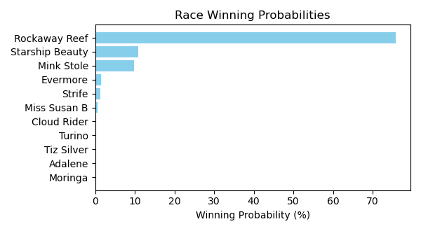

Figure: Winning Probability Distribution

NOTE: THIS RACE HAS HORSES THAT ARE MISSING CRITICAL DATA ELEMENTS

# Race: TTP | 2025-02-21 | Race #7 | Track: TURFWAY PARK

Track: TURFWAY PARK

|  |  |  |  |  |
| --- | --- | --- | --- | --- |
| Saddle Cloth # | Horse Name | Global Speed | Composite | Win Prob (%) |
| 1 | Tiger Division * | 104.1 | 1.03 | 0.02 |
| 10 | Admit * | 104.1 | 7.59 | 3.76 |
| 11 | Presha * | 104.1 | 3.88 | 0.19 |
| 12 | Foxtastic * | 111.5 | 2.40 | 0.26 |
| 13 | Wondrous * | 76.4 | 7.94 | 0.02 |
| 2 | Just Ruthless * | 104.1 | 8.76 | 9.59 |
| 3 | Bracelet * | 104.1 | 7.63 | 3.87 |
| 4 | White Rocks * | 104.1 | 9.75 | 21.04 |
| 5 | She's All Charm * | 76.4 | -1.16 | 0.00 |
| 6 | Somethinabouther * | 111.5 | 9.14 | 56.37 |
| 7 | Pure Majestic * | 104.1 | -7.74 | 0.00 |
| 8 | Girl Math * | 104.1 | 7.68 | 4.03 |
| 9 | Salt * | 108.9 | 4.55 | 0.85 |

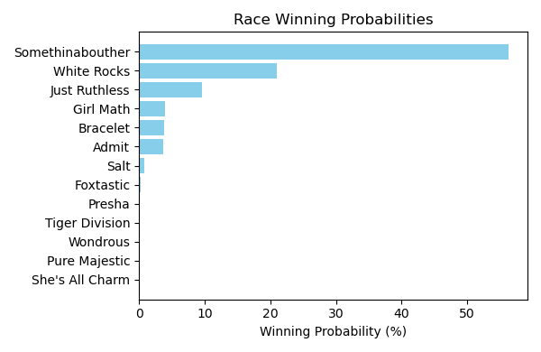

Figure: Winning Probability Distribution

NOTE: THIS RACE HAS HORSES THAT ARE MISSING CRITICAL DATA ELEMENTS

# Race: TTP | 2025-02-21 | Race #8 | Track: TURFWAY PARK

Track: TURFWAY PARK

|  |  |  |  |  |
| --- | --- | --- | --- | --- |
| Saddle Cloth # | Horse Name | Global Speed | Composite | Win Prob (%) |
| 1 | Special Creed * | 82.5 | -5.97 | 0.00 |
| 2 | Countthebrave * | 76.4 | -7.51 | 0.00 |
| 3 | Blue Coast * | 104.0 | 6.67 | 99.07 |
| 4 | Mo Hair Sam * | 76.4 | 1.07 | 0.00 |
| 5 | Graydaria * | 76.4 | 6.95 | 0.49 |
| 6 | Flat to Da Mat * | 76.4 | 6.77 | 0.43 |
| 7 | Killjoy * | 82.5 | -1.55 | 0.00 |
| 8 | El Cordobes * | 104.0 | -6.10 | 0.00 |
| 9 | Baytown Baracus * | 76.4 | -3.92 | 0.00 |

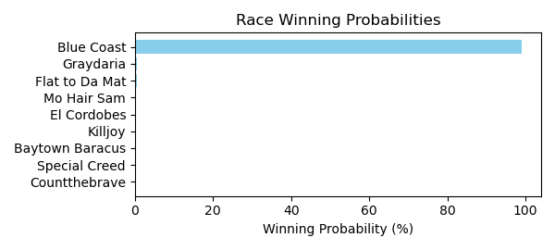

Figure: Winning Probability Distribution

NOTE: THIS RACE HAS HORSES THAT ARE MISSING CRITICAL DATA ELEMENTS

# Race: TTP | 2025-02-21 | Race #9 | Track: TURFWAY PARK

Track: TURFWAY PARK

|  |  |  |  |  |
| --- | --- | --- | --- | --- |
| Saddle Cloth # | Horse Name | Global Speed | Composite | Win Prob (%) |
| 1 | Dyno War * | 103.8 | -6.18 | 0.02 |
| 10 | Decatur Street * | 103.8 | 3.47 | 34.92 |
| 11 | Egyptian Quest * | 103.8 | -2.27 | 0.35 |
| 12 | Daguerre * | 103.8 | -6.78 | 0.01 |
| 13 | Papa D L * | 76.2 | 0.69 | 0.02 |
| 14 | Odorico * | 76.2 | -5.62 | 0.00 |
| 2 | Son of a Gray * | 103.8 | 4.15 | 60.32 |
| 3 | Cue Country Roads * | 111.1 | -3.31 | 0.67 |
| 4 | Cade's Goal * | 103.8 | -4.63 | 0.05 |
| 5 | Willingness * | 103.8 | -6.76 | 0.01 |
| 6 | Adios Kid * | 103.8 | -4.23 | 0.07 |
| 7 | Utopian Treasure * | 103.8 | -4.00 | 0.09 |
| 8 | Tie Breaker Lennie * | 103.8 | 0.47 | 3.18 |
| 9 | Photo Op * | 103.8 | -2.51 | 0.29 |

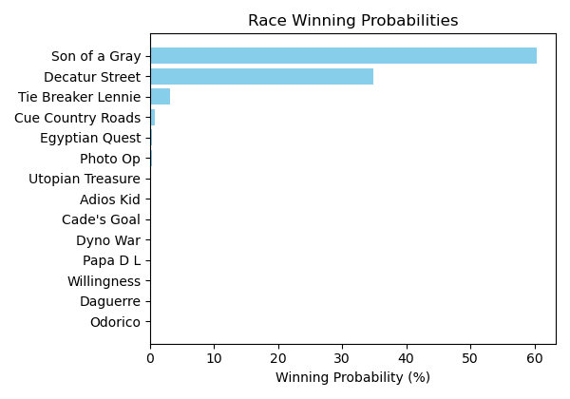

Figure: Winning Probability Distribution

NOTE: THIS RACE HAS HORSES THAT ARE MISSING CRITICAL DATA ELEMENTS

# Race: TTP | 2025-02-21 | Race #10 | Track: TURFWAY PARK

Track: TURFWAY PARK

|  |  |  |  |  |
| --- | --- | --- | --- | --- |
| Saddle Cloth # | Horse Name | Global Speed | Composite | Win Prob (%) |
| 1 | Or Magique * | 76.3 | -5.26 | 0.00 |
| 10 | Kye * | 103.9 | -3.34 | 0.51 |
| 11 | To Monarch * | 82.4 | 2.67 | 0.85 |
| 12 | Tkac * | 103.9 | -5.28 | 0.11 |
| 13 | Blakely's Boy * | 103.9 | -3.01 | 0.67 |
| 2 | EQUAL FORCE * | 91.1 | 4.52 | 21.15 |
| 3 | Ace On the Turn * | 82.4 | -9.04 | 0.00 |
| 4 | Catalina Cat * | 82.4 | 5.93 | 11.52 |
| 5 | Super Snoop * | 103.9 | -5.82 | 0.07 |
| 6 | SUITED AND BOOTED * | 91.1 | 4.33 | 18.17 |
| 7 | Missed Option * | 82.4 | -5.20 | 0.00 |
| 8 | Cold Front * | 76.3 | 4.58 | 1.16 |
| 9 | Hasten * | 111.3 | 0.43 | 45.79 |

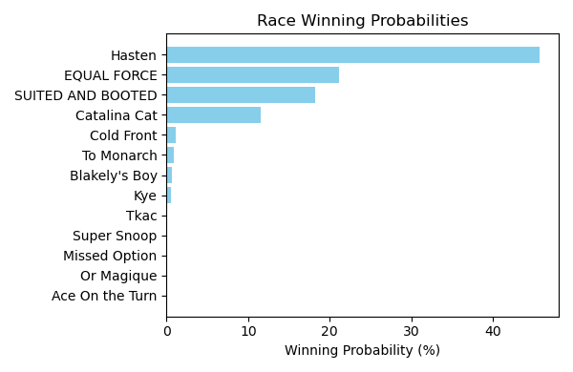

Figure: Winning Probability Distribution

NOTE: THIS RACE HAS HORSES THAT ARE MISSING CRITICAL DATA ELEMENTS

# Race: TTP | 2025-02-23 | Race #1 | Track: TURFWAY PARK

Track: TURFWAY PARK

|  |  |  |  |  |
| --- | --- | --- | --- | --- |
| Saddle Cloth # | Horse Name | Global Speed | Composite | Win Prob (%) |
| 1 | Miss Moon Pie * | 104.0 | -8.04 | 0.00 |
| 2 | Isa Lei * | 104.0 | 5.92 | 5.91 |
| 3 | Endless * | 104.0 | -4.09 | 0.00 |
| 4 | Lucky Ana * | 104.0 | 5.71 | 5.00 |
| 5 | Gogo Chanel * | 104.0 | 9.25 | 84.89 |
| 6 | Cant Keep Me Down * | 104.0 | -0.11 | 0.05 |
| 7 | Councilwoman Jilly * | 104.0 | 5.34 | 3.72 |
| 8 | Megan's Noel * | 104.0 | 2.65 | 0.43 |

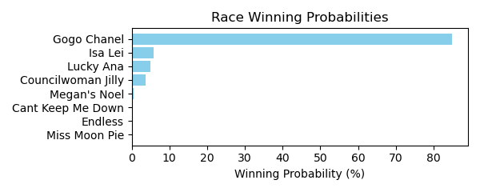

Figure: Winning Probability Distribution

NOTE: THIS RACE HAS HORSES THAT ARE MISSING CRITICAL DATA ELEMENTS

# Race: TTP | 2025-02-23 | Race #2 | Track: TURFWAY PARK

Track: TURFWAY PARK

|  |  |  |  |  |
| --- | --- | --- | --- | --- |
| Saddle Cloth # | Horse Name | Global Speed | Composite | Win Prob (%) |
| 1 | J W Ruckus * | 82.5 | 4.53 | 12.49 |
| 2 | Cog * | 82.5 | 6.28 | 50.57 |
| 3 | Violin Maker * | 82.5 | -3.38 | 0.02 |
| 4 | Buzzer * | 82.5 | -9.66 | 0.00 |
| 5 | Dragon Drew * | 82.5 | 3.09 | 3.94 |
| 6 | Ready Pursuit * | 82.5 | -0.86 | 0.17 |
| 7 | All in Sync * | 82.5 | 4.49 | 12.15 |
| 8 | One for Richie * | 82.5 | 5.16 | 20.66 |

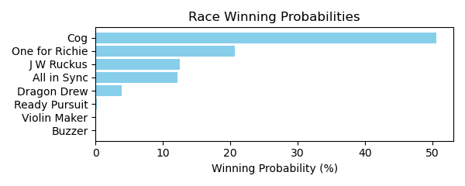

Figure: Winning Probability Distribution

NOTE: THIS RACE HAS HORSES THAT ARE MISSING CRITICAL DATA ELEMENTS

# Race: TTP | 2025-02-23 | Race #3 | Track: TURFWAY PARK

Track: TURFWAY PARK

|  |  |  |  |  |
| --- | --- | --- | --- | --- |
| Saddle Cloth # | Horse Name | Global Speed | Composite | Win Prob (%) |
| 1 | Tiger's Legacy * | 82.9 | 7.49 | 21.20 |
| 2 | Script * | 82.9 | 8.04 | 32.78 |
| 3 | Sigiloso * | 82.9 | 2.85 | 0.52 |
| 4 | Big Hat Willie * | 82.9 | -0.63 | 0.03 |
| 5 | Alder * | 82.9 | -6.16 | 0.00 |
| 6 | Night Time * | 82.9 | 6.98 | 14.02 |
| 7 | Lugan Knight * | 82.9 | 1.37 | 0.16 |
| 8 | Simcoe * | 82.9 | 7.98 | 31.30 |

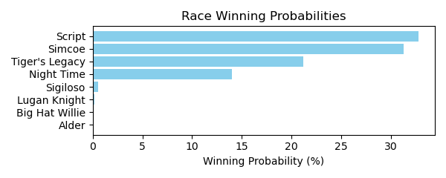

Figure: Winning Probability Distribution

NOTE: THIS RACE HAS HORSES THAT ARE MISSING CRITICAL DATA ELEMENTS

# Race: TTP | 2025-02-23 | Race #4 | Track: TURFWAY PARK

Track: TURFWAY PARK

|  |  |  |  |  |
| --- | --- | --- | --- | --- |
| Saddle Cloth # | Horse Name | Global Speed | Composite | Win Prob (%) |
| 1 | Dark Fury * | 82.5 | -0.51 | 0.11 |
| 10 | Foolish * | 82.5 | 3.68 | 3.21 |
| 11 | Elle's Dancer * | 82.5 | 1.89 | 0.77 |
| 12 | Wanda Susie Doozy * | 82.5 | -6.56 | 0.00 |
| 13 | Carolina Candy * | 82.5 | -5.11 | 0.00 |
| 2 | Indescriptable * | 82.5 | -3.02 | 0.02 |
| 3 | Tennesseehoneybee * | 82.5 | -5.72 | 0.00 |
| 4 | Meet in Secret * | 82.5 | -4.90 | 0.00 |
| 5 | Bellofthebluegrass * | 82.5 | -7.39 | 0.00 |
| 6 | Sally's Gold * | 82.5 | 7.14 | 51.19 |
| 7 | Yuma's Shadow * | 82.5 | 6.97 | 44.54 |
| 8 | I'm a Cookie Lover * | 82.5 | -0.22 | 0.14 |
| 9 | Red Hot Jeanie * | 82.5 | -4.32 | 0.01 |

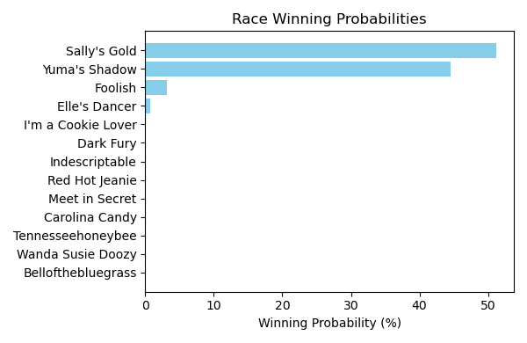

Figure: Winning Probability Distribution

NOTE: THIS RACE HAS HORSES THAT ARE MISSING CRITICAL DATA ELEMENTS

# Race: TTP | 2025-02-23 | Race #5 | Track: TURFWAY PARK

Track: TURFWAY PARK

|  |  |  |  |  |
| --- | --- | --- | --- | --- |
| Saddle Cloth # | Horse Name | Global Speed | Composite | Win Prob (%) |
| 1 | LA SCATTA * | 82.4 | 3.73 | 4.52 |
| 10 | People Get Ready * | 82.4 | 5.17 | 14.33 |
| 11 | BINDI * | 82.4 | 3.56 | 3.97 |
| 12 | Her Holy Name * | 82.4 | -3.51 | 0.01 |
| 13 | Pearl Magic * | 82.4 | -4.19 | 0.01 |
| 14 | Stopsprettyplaces * | 82.4 | -9.51 | 0.00 |
| 2 | Don't Cross Alexis * | 82.4 | 7.19 | 72.40 |
| 3 | LOW MOON * | 82.4 | 3.74 | 4.57 |
| 4 | Super Maxima * | 82.4 | -2.87 | 0.02 |
| 5 | Bonita Vida * | 82.4 | -5.30 | 0.00 |
| 6 | Dang It Ophelia * | 82.4 | -0.57 | 0.15 |
| 7 | Sister Carlie * | 82.4 | -6.71 | 0.00 |
| 8 | M'Lady Sansa * | 82.4 | -5.20 | 0.00 |
| 9 | Pretty in Pearls * | 82.4 | -3.73 | 0.01 |

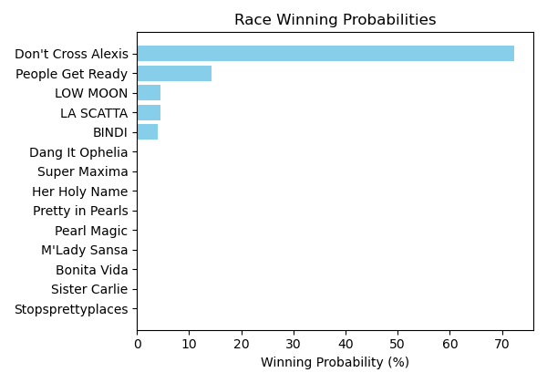

Figure: Winning Probability Distribution

NOTE: THIS RACE HAS HORSES THAT ARE MISSING CRITICAL DATA ELEMENTS

# Race: TTP | 2025-02-23 | Race #6 | Track: TURFWAY PARK

Track: TURFWAY PARK

|  |  |  |  |  |
| --- | --- | --- | --- | --- |
| Saddle Cloth # | Horse Name | Global Speed | Composite | Win Prob (%) |
| 1 | Match Five * | 82.3 | -8.17 | 0.00 |
| 2 | Lalily * | 82.3 | -8.50 | 0.00 |
| 3 | Waitinbythenile * | 82.3 | -5.64 | 0.01 |
| 4 | Statler Inn * | 82.3 | -0.79 | 0.38 |
| 5 | CRUISING GAL * | 82.3 | 5.14 | 43.02 |
| 6 | You Know Me * | 82.3 | -1.65 | 0.19 |
| 7 | Make a Million * | 82.3 | 3.74 | 14.01 |
| 8 | Warm Days * | 82.3 | -7.73 | 0.00 |
| 9 | BOBBY'S WORKOUT * | 82.3 | 5.12 | 42.40 |

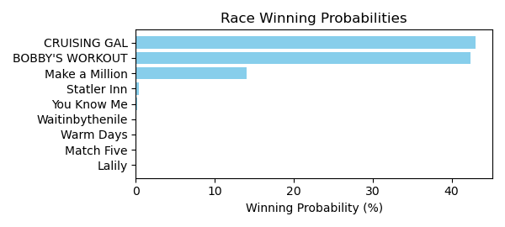

Figure: Winning Probability Distribution

NOTE: THIS RACE HAS HORSES THAT ARE MISSING CRITICAL DATA ELEMENTS

# Race: TTP | 2025-02-23 | Race #7 | Track: TURFWAY PARK

Track: TURFWAY PARK

|  |  |  |  |  |
| --- | --- | --- | --- | --- |
| Saddle Cloth # | Horse Name | Global Speed | Composite | Win Prob (%) |
| 1 | Epic Ride * | 82.8 | 6.87 | 15.36 |
| 2 | B D Valeski * | 82.8 | 1.11 | 0.15 |
| 3 | Hedwig * | 82.8 | 1.99 | 0.31 |
| 4 | Mischievous Rogue * | 82.8 | 6.42 | 10.69 |
| 5 | Clear the Air * | 82.8 | -0.98 | 0.03 |
| 6 | Let My People Go * | 82.8 | 0.36 | 0.08 |
| 7 | Transect * | 82.8 | -6.19 | 0.00 |
| 8 | Okiro * | 82.8 | 4.41 | 2.14 |
| 9 | Surly Furious * | 82.8 | 8.79 | 71.24 |

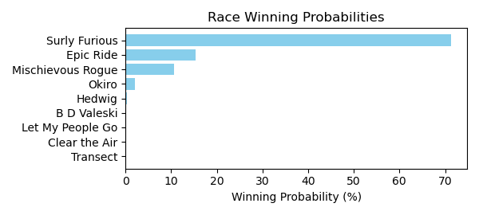

Figure: Winning Probability Distribution

NOTE: THIS RACE HAS HORSES THAT ARE MISSING CRITICAL DATA ELEMENTS

# Race: TTP | 2025-02-23 | Race #8 | Track: TURFWAY PARK

Track: TURFWAY PARK

|  |  |  |  |  |
| --- | --- | --- | --- | --- |
| Saddle Cloth # | Horse Name | Global Speed | Composite | Win Prob (%) |
| 1 | Berea * | 82.4 | -6.54 | 0.00 |
| 10 | Rock the Nile * | 82.4 | 7.37 | 93.77 |
| 2 | Cleomenes * | 82.4 | -9.69 | 0.00 |
| 3 | Ligeia * | 82.4 | 0.73 | 0.47 |
| 4 | dh-Terpeye * | 82.4 | 1.85 | 1.14 |
| 5 | Sassy and Bold * | 82.4 | 0.86 | 0.52 |
| 6 | Fireside Kitten * | 82.4 | -3.68 | 0.01 |
| 7 | Bo Runkle * | 82.4 | 2.18 | 1.48 |
| 8 | Taking Charge Desi * | 82.4 | -1.63 | 0.07 |
| 9 | Partake * | 82.4 | 2.86 | 2.54 |

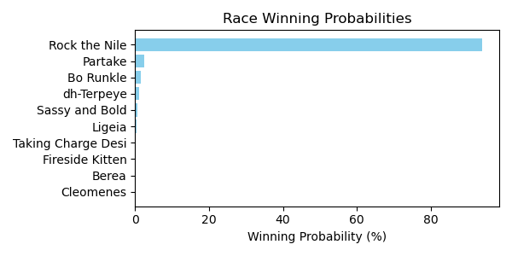

Figure: Winning Probability Distribution

NOTE: THIS RACE HAS HORSES THAT ARE MISSING CRITICAL DATA ELEMENTS

# Race: TTP | 2025-02-23 | Race #9 | Track: TURFWAY PARK

Track: TURFWAY PARK

|  |  |  |  |  |
| --- | --- | --- | --- | --- |
| Saddle Cloth # | Horse Name | Global Speed | Composite | Win Prob (%) |
| 1 | WAIT FOR ME * | 104.1 | 4.19 | 8.31 |
| 10 | Mubarez * | 104.1 | -6.67 | 0.00 |
| 11 | Roc and Ready Jo * | 104.1 | -6.92 | 0.00 |
| 12 | Sinister Smile * | 104.1 | 6.94 | 74.75 |
| 2 | Kicking Clear * | 104.1 | -4.73 | 0.01 |
| 3 | Aqueous * | 104.1 | -6.41 | 0.00 |
| 4 | Midnight Vengeance * | 104.1 | 2.01 | 1.45 |
| 5 | Stargell * | 104.1 | 3.93 | 6.76 |
| 6 | MACH TWO BLUE * | 104.1 | 4.25 | 8.72 |
| 7 | Fletcher Bay * | 104.1 | -7.53 | 0.00 |
| 8 | Outofpi * | 104.1 | -7.70 | 0.00 |
| 9 | Shinigami * | 104.1 | -7.09 | 0.00 |

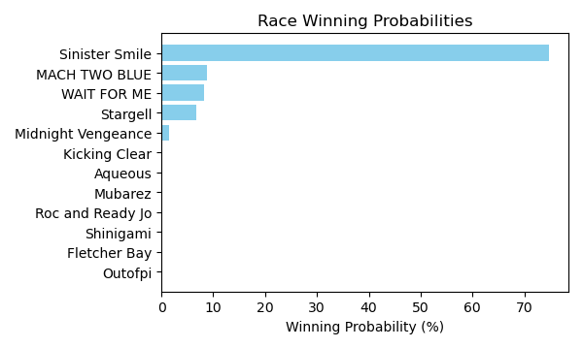

Figure: Winning Probability Distribution

NOTE: THIS RACE HAS HORSES THAT ARE MISSING CRITICAL DATA ELEMENTS

# Race: TTP | 2025-02-23 | Race #10 | Track: TURFWAY PARK

Track: TURFWAY PARK

|  |  |  |  |  |
| --- | --- | --- | --- | --- |
| Saddle Cloth # | Horse Name | Global Speed | Composite | Win Prob (%) |
| 1 | Egyptian King * | 104.0 | 7.90 | 25.91 |
| 10 | Carlin Clan * | 104.0 | -2.73 | 0.01 |
| 11 | Redhill * | 104.0 | -3.99 | 0.00 |
| 12 | Strike Price * | 104.0 | -6.37 | 0.00 |
| 2 | Dancing Noah * | 104.0 | -0.33 | 0.04 |
| 3 | Kykeon * | 104.0 | -7.01 | 0.00 |
| 4 | Shiesty to Chase * | 104.0 | 5.41 | 3.52 |
| 5 | Acting Debut * | 104.0 | 3.08 | 0.55 |
| 6 | King Deivys * | 104.0 | 7.45 | 18.06 |
| 7 | Righteous Star * | 104.0 | -1.15 | 0.02 |
| 8 | Oathbreaker * | 104.0 | 8.75 | 50.93 |
| 9 | Roundball Rock * | 104.0 | 3.79 | 0.96 |

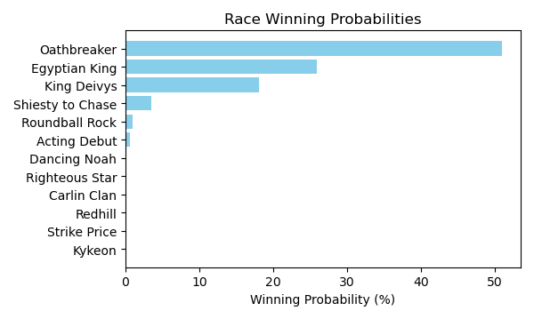

Figure: Winning Probability Distribution

NOTE: THIS RACE HAS HORSES THAT ARE MISSING CRITICAL DATA ELEMENTS